|  |
| --- |
|  |
| BIFROST AVS Vacuum tank MOTION SAT |
|  |

|  | Name | Role/Title |
| --- | --- | --- |
| Owner | Anders Sandström  Federico Rojas Givaudan | Electronics Engineer Motion Control & Automation  Automation Engineer Motion Control & Automation |
| Reviewer | Thomas Gahl | Group Leader Motion Control & Automation |
| Approver | Liam Whitelegg | Instrument Lead Engineer for BIFROST |

TABLE OF CONTENT PAGE

1. Background 4

1.1. Equipment in scope 4

2. Requirements 6

3. CONTROL SYSTEM 6

3.1. Hardware 6

3.2. iPOS8020 BX-CAT Stepper drive 7

3.3. EL5002 SSI Absolute Encoder Interface 7

3.4. Feedback systems 7

3.4.1. LEICA absolute tracker AT960 7

3.4.2. Posital OCD-S101G-1416-S060-PRL 7

4. METHOD 8

4.1. General Inspection 8

4.1.1. Mechanical 8

4.1.2. Electrical 8

4.2. Motion Tests 9

4.2.1. Initial Motion Test 9

4.2.2. Motion range and switch performance 9

4.2.3. High speed test 10

4.2.4. Accuracy 10

4.2.5. Repeatability 10

4.2.6. Data Acquisition 10

4.3. Presentation of results 11

5. Results 12

5.1. General inspection 12

5.2. Initial motion test 12

5.2.1. Switches 12

5.2.2. Gear ratio 12

5.2.3. Backlash 12

5.3. Motion range and switch performance 13

5.4. High speed test 13

5.5. Accuracy 13

5.6. Bidirectional repeatability 14

6. Differences before and after collision 15

6.1. Backlash 15

6.2. Motor position vs encoder position 16

6.3. Accuracy and gear ratio 17

7. CONCLUSIONS 17

8. references 18

list of tables

Table 1: Requirements 6

Table 2. Mechanical Inspection Check-list 8

Table 3. Electrical Inspection Check-list 8

Table 4: Summary of SAT 11

Table 5: Status 12

Table 3: Before collision: Accuracy and gear ratio 17

Table 4: After collision: Accuracy and gear ratio 17

list of Figures

Figure 1: Tank motion system overview. 4

Figure 2. Motion feedback components. 5

Figure 3. Limit switch engagement regions. 5

Figure 4: Backlash test in forward direction 13

Figure 5: Backlash test in backward direction 13

Figure 6: Backlash after collision 15

Figure 6: Before collision: Encoder position error (without backlash) at 688degmotor/s 16

Figure 7: After collision: Encoder position error (without backlash) at 1280degmotor/s 16

# Background

The instrument consists of three main technical subsystems: the beam transport and conditioning system (BTS), the sample exposure system (SES) and the scattering characterization system (SCS). The whole system allows the measurement of collective dynamics in crystalline systems in the field of materials science, optimized for neutron flux and sample environment performance. Bifrost’s scattering characterization system consists of the filtering system and the secondary spectrometer vessel. The secondary spectrometer vessel houses the analysers, the detectors and the crosstalk shielding between energy-and Q-channels.

## Equipment in scope

The spectrometer vessel is a 2m x 3.5m aluminum vacuum tank. It will be mounted on a rail system so that it can rotate in the horizontal plane. It shall be positioned, with respect to a rotation around the sample vertical axis, with a ground mounted system. The rail and carriage system shall keep the tank’s rotation concentric to the sample axis, a stepper motor shall provide the drive whilst a rotary encoder shall provide positional feedback.

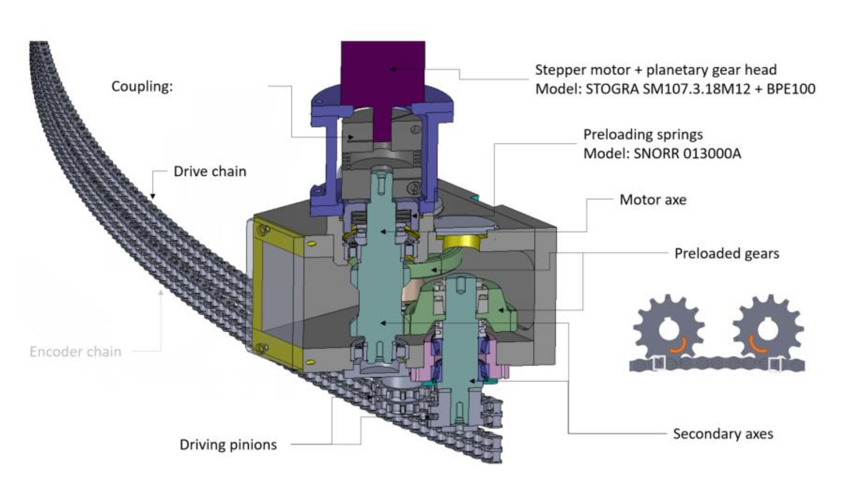

Figure 1: Tank motion system overview.

The drive system employs a secondary axis that exerts a force in the opposite direction to the drive in order to minimise the backlash of the system.

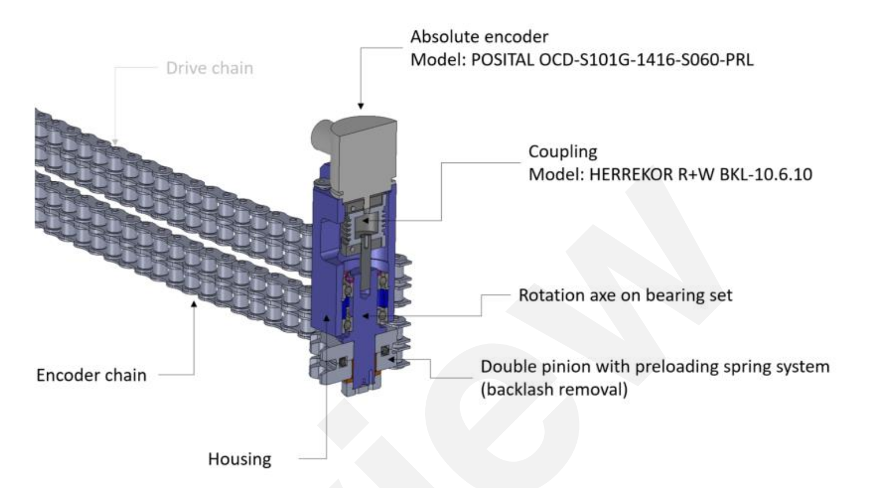

Figure 2. Motion feedback components.

Five limit switches have been positioned around the external radius of the tank. There are two switches at each extreme of the range of motion, with the inner switch producing a stop signal to the controller (“limit switch”) and the outer switch cutting power to the drive system (“kill switch”). The final switch has been positioned to engage at 33°. At this point, further travel of the tank shall only be allowed if the get-lost tube has been translated out of the way (See Figure 3). The switches to be used are industrial limit switches Crouzet 83 871 306

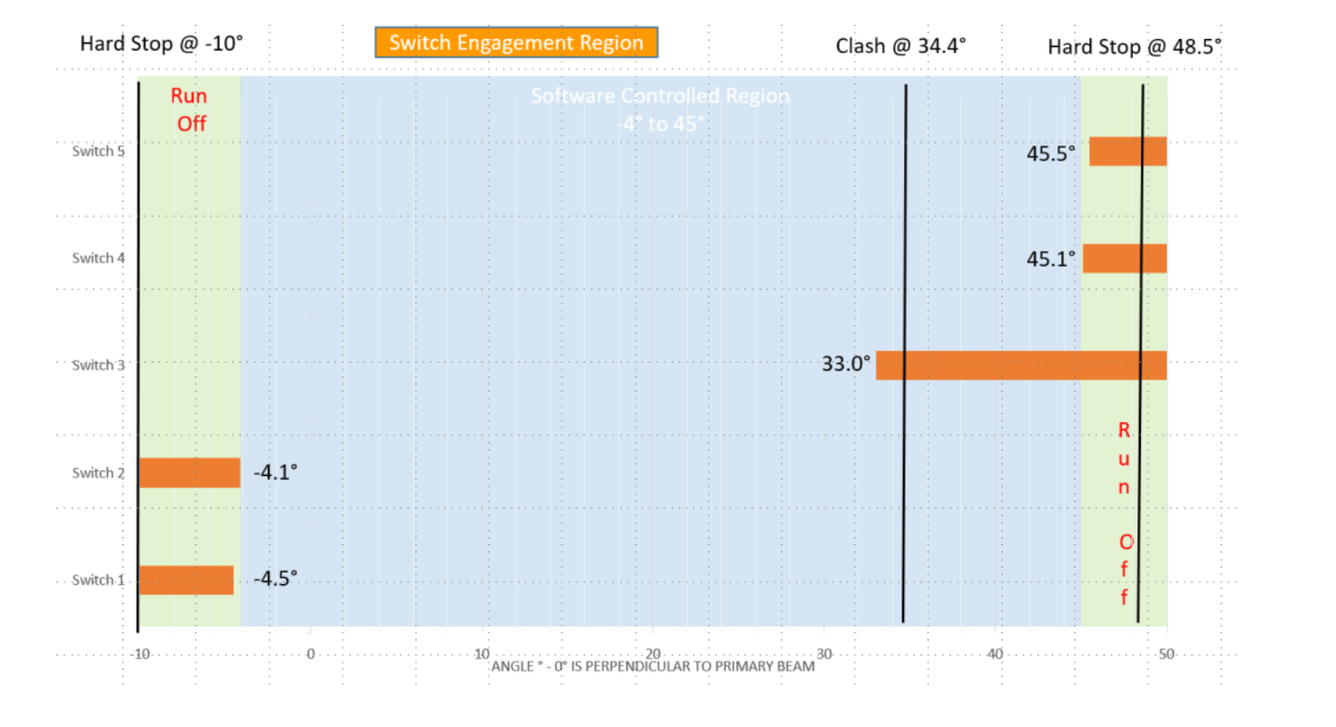

Figure 3. Limit switch engagement regions.

Spectrometer vessel motion components:

* Stepper motor: Stögra SM107.3.18M12+BPE100 (w/gear ratio of 100) [8]
* SSI Encoder: Posital OCD-S101G-1416-S060-PRL [10]
* Limit switches: Crouzet 83 871 306 [11]
* Stroke: Approx. 50 degrees
* Gear ratio: 12381,9095 *degmotor*/degree (according to manufacturer AVS) [12]

# Requirements

The following requirements, as defined in ESS-1088870 [14], were verified in this SAT:

Table 1: Requirements

|  |  |
| --- | --- |
| Requirements | Value |
| Accuracy | 0,1 deg |
| Repeatability | 0,05 deg |
| Range | Central axis to rotate from -4,5 degrees through to 45,5 degrees (0 degrees is perpendicular to the sample position) |
| Velocity | 0,1 deg/s ---> 1240 degmotor/s (gear ratio 12382 calculated by AVS) |
| Accelerations | 410 degmotor/s2 (stop from max speed in 3 seconds) |
| Travel time | The assembly shall travel through the range of motion within 15 minutes (688 degmotor/s) |
| Switching Positions | Switches S1 to S5 according to figure below ±0,1deg |
| Motor current | 10 ARMS |

# CONTROL SYSTEM

The SAT was performed with an EtherCAT [1] based control system, ecmc [2]. The configuration files, raw data and analysis results for the SAT have been added to a git repository [3].

All hardware needed for the tests have been integrated into the same system which then leads to that all sampled data have the same time base.

## Hardware

The following control hardware was used:

1. iPOS8020 BX-CAT: Stepper motor drive [4]
2. EL1004: Digital input for switches [5]
3. EL2819: Digital output to feed switches [6]
4. EL5002: SSI Absolute Encoder interface [7]
5. Laser tracker: LEICA absolute tracker AT960 [9]

## iPOS8020 BX-CAT Stepper drive

The stepper drive was configured to control the specific system as show below:

1. Control mode: Open loop
2. Run current: 10A
3. Standby current: 1A
4. Micro stepping: 256 fold (resolution 51200 steps/rev for the 200 steps motor)
5. Velocity: 688 *degmotor/s* ≈ 0,0557 ˚/s

## EL5002 SSI Absolute Encoder Interface

The EL5002 delivers a single turn resolution up to 32bits. For this application the frame size of 31 and data length 31was used.

## Feedback systems

Two different sensors are used as position feedback for the tests.

1. AT960: LEICA absolute tracker [9].
2. OCD-S101G-1416-S060-PRL: Posital IXARC Absolute Rotary Encoder [10]

### LEICA absolute tracker AT960

The Leica absolute tracker AT960 sensor was used as external measurement and verification system. The AT960 has the following specs:

1. Range: 80m
2. Angular accuracy: ±7,5 + 3µm/m (Typical values)

### Posital OCD-S101G-1416-S060-PRL

The Posital encoder is an optical absolute encoder with SSI interface and a preset signal. It is attached to a second shaft with gear in the second chain as explained in chapter 1.1 Equipment in scope. The Posital OCD-S101G-1416-S060-PRL absolute encoder has the following specs:

1. Accuracy: ±0,0220˚
2. Input voltage: 24V
3. Input frequency: 5000Hz
4. Coding: Gray
5. Resolution: 16 bit Single-turn/14 bit Multi-turn

# METHOD

As a first step, a general inspection of the vacuum tank frame mechanics from a mechanical and electrical perspective will be performed. If no issues were found during the general inspection then motion tests should be performed.

The following tests are planned to be performed:

1. *General inspection*
2. *Initial motion test*
3. *Motion range and switch performance*
4. *High speed test*
5. *Accuracy*
6. *Bidirectional repeatability*

## General Inspection

Inspection of all axis components from a mechanical and electrical perspective. The following checklists should be followed:

### Mechanical

Table 2. Mechanical Inspection Check-list

|  |  |  |
| --- | --- | --- |
|  | Done | Comments |
| 1. *Ensure no loose components* |  |  |
| 1. *Ensure no risk of collisions* |  |  |
| 1. *Status of limit switches and cams* |  |  |
| 1. *Ensure connectors are fixed properly (not loose)* |  |  |

### Electrical

Table 3. Electrical Inspection Check-list

|  |  |  |
| --- | --- | --- |
|  | Done | Comments |
| 1. *Inspection of cabling* |  |  |
| 1. *Test grounding between control box and frame of vacuum tank* |  |  |
| 1. *Measure coil resistance of stepper motor (phase A and B)* |  |  |
| 1. *Measure connection of Limit switches* |  |  |
| 1. *Measure connection of Kill switches* |  |  |
| 1. *Measure connection of Anti-collision switch* |  |  |

## Motion Tests

The motion tests have been divided into the following parts:

1. *Initial motion test*
2. *Motion range and switch performance*
3. *High speed test*
4. *Accuracy*
5. *Bidirectional repeatability*

### Initial Motion Test

Motion of the entire stroke should be tested with a low velocity, 360 degmotor /s. During this test special attention is on the following topics:

1. *Noise from the equipment (observed and noted down).*
2. *Test of switch actuation by the cams.*

After these steps it is necessary to verify the gear ratio of the motion system. With help of the laser tracker a defined stroke is performed and the relation between motor degrees (*degmotor)* and real degrees is calculated. With the same settings we approach a defined position from both directions and calculate the backlash of the system.

1. *Gear ratio*
2. *Backlash*

As a last step, a homing sequence can be executed, setting the stepper open loop counter to the desired value at low limit disengage flank (0 to 1).

### Motion range and switch performance

Measurement of motion range and switch performance can be combined in the same test.

WARNING: In order to reach the hard stops the limit switches needs to be bridged in the motion control system (not used). Therefore, the motion needs to be supervised carefully manually (with access to E-Stop).

The following sequence will be followed during this test:

1. *Move to low hard stop in a very low velocity, record position.*
2. *Move to a position just past low kill switch.*
3. *Set velocity setpoint to 688 degmotor/s.*
4. *Engage/disengage the switch 5 times, record positions*
5. *Move to a position just past low limit switch.*
6. *Engage/disengage the switch 5 times, record positions*
7. *Move to a position just before the anti-collision switch*
8. *Engage/disengage the switch 5 times, record positions*
9. *Move to a position just before the high limit switch.*
10. *Engage/disengage the switch 5 times, record positions*
11. *Move to a position just before the high kill switch.*
12. *Engage/disengage the switch 5 times, record positions*
13. *Move to high hard stop, record position.*
14. *Move back to a position below high limit switch*.

The motion range is defined as the range between the low hard stop and high hard stop.

Switch performance is defined as the position range of the latched values for each switch.

### High speed test

The high-speed test aims to measure the total travel time between low and high limit switch.

The following sequence will be followed:

1. *Move to low limit switch*
2. *Set velocity setpoint to 1240 degmotor/s.*
3. *Issue a forward move at constant velocity*
4. *Let motion stop at high limit switch.*

### Accuracy

Accuracy of the positioning will be calculated by moving to 10 different target position distributed over the motion range starting at -5deg increasing with 5deg up to 40deg. A velocity setpoint of 688 degmotor/s will be used for the test.

The accuracy is represented by the largest difference between target position and the actual value achieved.

### Repeatability

The repeatability measured by moving to 6 different target positions distributed over the stroke,

1. *-5 deg*
2. *0 deg*
3. *10 deg*
4. *20 deg*
5. *30 deg*
6. *40 deg*

Each target position shall be approached 6 times from both positive and negative direction from a 0.5deg offset at a velocity of 688 degmotor/s. The repeatability for each position is represented by the largest difference between the positions achieved during the test.

### Data Acquisition

The following data needs to be acquired during the tests:

* *Position of vacuum tank reported by Laser tracker*
* *Posital Absolute encoder position*
* *Stepper open loop counter position*
* *Switch status*

The following excel sheet can be used for manual data collection during the tests:

<https://github.com/anderssandstrom/ecmc_bifrost_vac_tank_sat/blob/master/docs/testplan/SAT_TEMPLATE_v0_1.xlsx>

In addition to the manual data collection also logging from the motion system is needed:

During the motion tests (2-5) the following data will be sampled form the motion system:

* *Posital Absolute encoder position*
* *Stepper open loop counter position*
* *Switch status*

Data will be acquired with a sampling rate of 100Hz. All raw data and will uploaded to the following git repository:

<https://github.com/anderssandstrom/ecmc_bifrost_vac_tank_sat>

## Presentation of results

The results of the tests should be summarized in a table, like in Table 4:

Table 4: Summary of SAT

|  |  |  |  |  |
| --- | --- | --- | --- | --- |
| **Test:** | **Description:** | **Value** | **Status:** | **Comment:** |
| **1** | **General Inspection** |  |  |  |
| **1.1** | **Mechanical** |  |  |  |
| **1.1.1** | **Observations** |  |  |  |
| **1.1.2** | **Observations** |  |  |  |
| **1.1.3** | **Observations** |  |  |  |
| **1.2** | **Electrical** |  |  |  |
| **1.2.1** | **Observations** |  |  |  |
| **1.2.2** | **Grounding** |  |  |  |
| **1.2.3** | **Motor Phase A** |  |  |  |
| **1.2.4** | **Motor Phase B** |  |  |  |
| **1.2.5** | **Low Limit Switch** |  |  |  |
| **1.2.6** | **High Limit Switch** |  |  |  |
| **1.2.7** | **Anti-Collision Switch** |  |  |  |
| **1.2.8** | **Low Kill Switch** |  |  |  |
| **1.2.8** | **High Kill Switch** |  |  |  |
| **2** | **Initial Motion Test** |  |  |  |
| **2.1** | **Observations** |  |  |  |
| **2.1** | **Observations** |  |  |  |
|  | **Motion Performance** |  |  |  |
| **3** | **Range and switch performance** |  |  |  |
| **3.1** | **Range (hard stop to hard stop)** |  |  |  |
| **3.2** | **Low Limit** |  |  |  |
| **3.3** | **Low Kill** |  |  |  |
| **3.4** | **Anti -Collision** |  |  |  |
| **3.5** | **High Limit** |  |  |  |
| **3.6** | **High Kill** |  |  |  |
| **4** | **High speed test** |  |  |  |
| **5** | **Accuracy** |  |  |  |
| **6** | **Bidirectional repeatability** |  |  |  |

The status of each test should be evaluated and the status presented in one of the three grades presented in Table 5:

Table 5: Status

|  |  |  |
| --- | --- | --- |
|  | **Status** | **Description** |
| **1** | OK | Test result is fulfilling requirement. |
| **2** | Check | The test / observation needs further investigation. |
| **3** | Not OK | The test / observation is not fulfilling requirement. |

# Results

Before Collision

## General inspection

## Initial motion test

### Switches

All switches except the anti-collision switch was found to be engaging properly. The anti-collision switch was therefore adjusted.

### Gear ratio

Basic gear ratios were calculated for both encoder and motor.

Gear ratio motor: 8,10165*10-5degtank/degmotor

Gear ratio encoder: 4.43610-5degtank/countsencoder

These gear ratios were used to generate setpoints for the further tests.

For analysis of the data, gear ratios calculated from the accuracy test are used.

### Backlash

A simple backlash tests was performed at approx. -10deg (only at one position). The test measures only the backlash between encoder and motor shaft but should also reflect the true backlash.

Figure 4 shows a graph describing the backlash test in forward direction and Figure 5 shows the backlash test in backward direction.

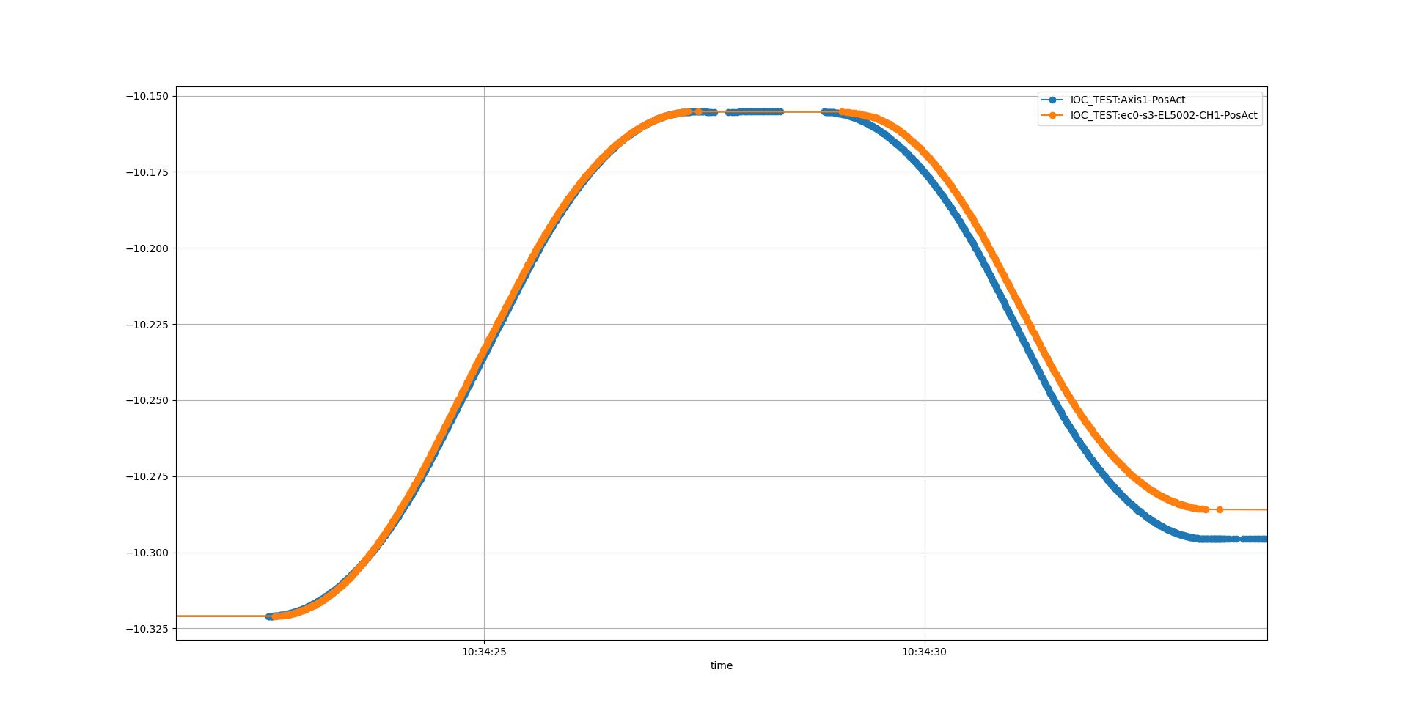

Time

Tank angle

o Motor open loop position

o Encoder position

Figure 4: Backlash test in forward direction

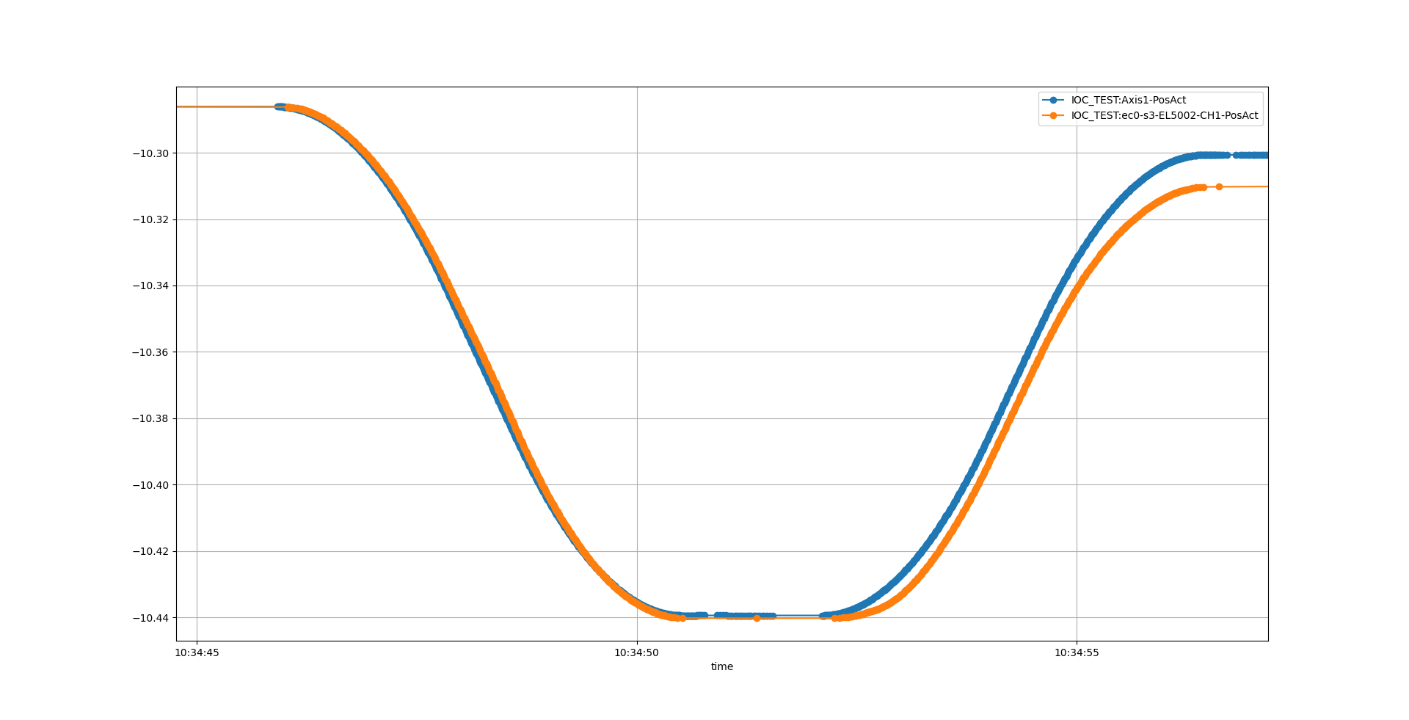

Tank angle

Time

o Motor open loop position

o Encoder position

Figure 5: Backlash test in backward direction

Both tests indicate a backlash of 0.01deg between motor and encoder.

## Motion range and switch performance

## High speed test

No problem was encountered when running in 0.1 deg/s.

The whole stroke was measured

## Accuracy

## Bidirectional repeatability

# Differences before and after collision

In order to judge if the collision have impacted the performance of the motion system some comparisons can be made by comparing data collected before and after. Unfortunately, only a few comparable datasets have been identified but in total four comparisons can be made based on the recorded data:

1. Backlash
2. Encoder error (vs linear open loop counter)
3. Accuracy
4. Gear ratio

## Backlash

From the data acquired during the high-speed tests also backlash in one direction can be checked. Figure 6 shows motor open loop counter and encoder position during the acceleration phase.

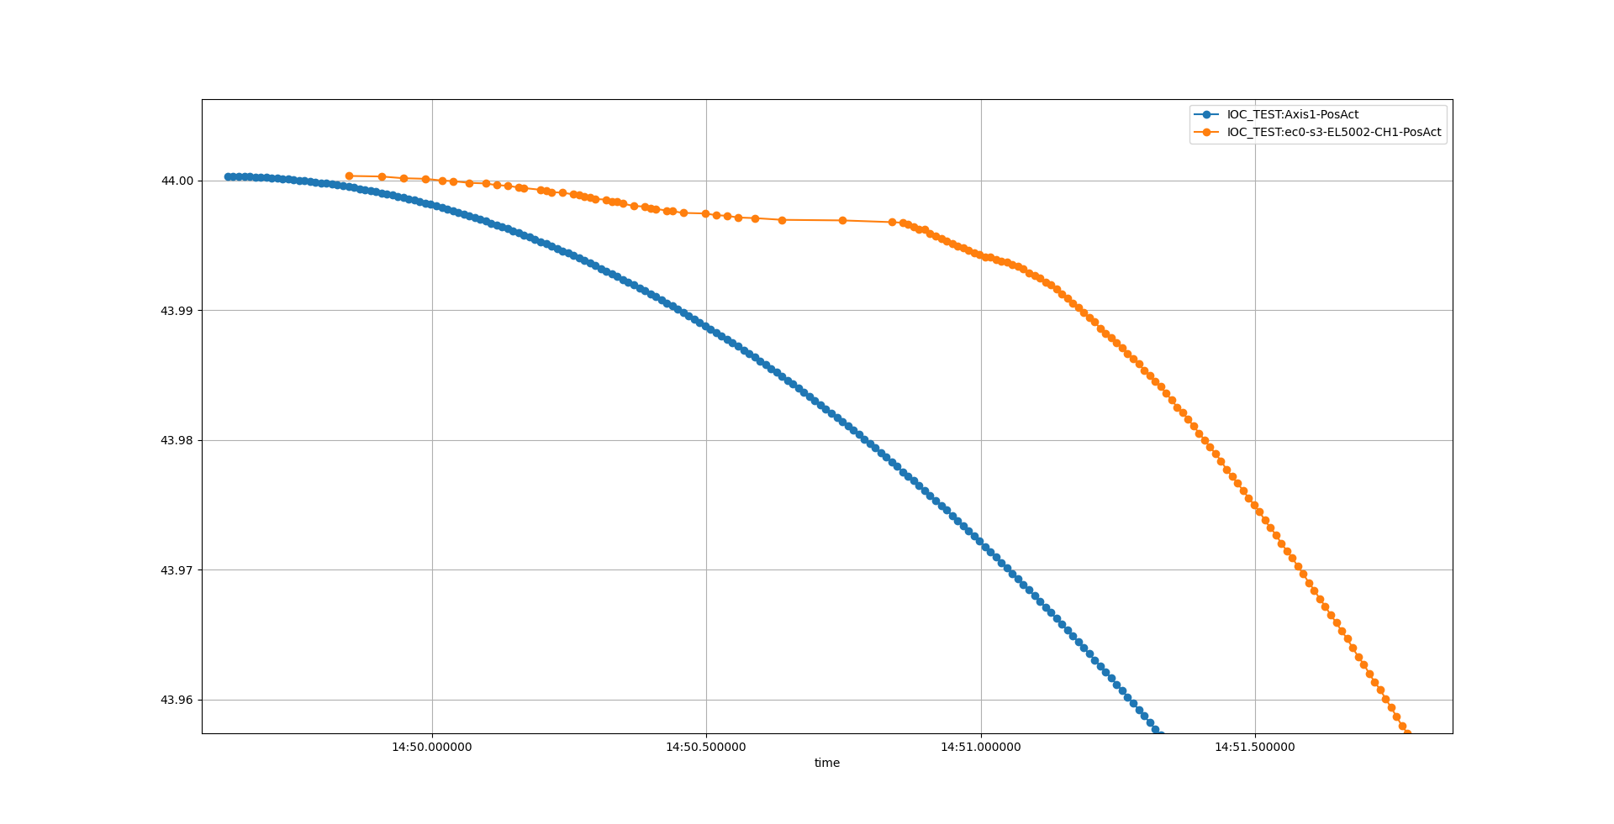

Time

Tank angle

o Motor open loop position

o Encoder position

Figure 6: Backlash after collision

For this move the backlash seems to be approx. 0.02deg compared to 0.01deg before. Another thing worth noting is the behavior of the encoder position curve where the value seems to update unpredictable in the acceleration phase

Note: Before the collision, no data was recorded at this tank angle. Therefore, it’s hard to judge if the increase in backlash is related to the collision.

## Motor position vs encoder position

Data for open loop counter position and encoder position was acquired for tank angles between 9 and 23 degrees both before and after collision. Unfortunately, the velocity was different between the two tests:

* before collision 688degmotor/s
* after collision 1280degmotor/s

Figure 7 shows the deviation of the encoder position from the motor open loop position at angles between 9 to 23 degrees (at a velocity of 688degmotor/s). Figure 8 shows the same data but acquired after the collision but at a higher velocity (1280degmotor/s). In both graphs the backlash is not shown.

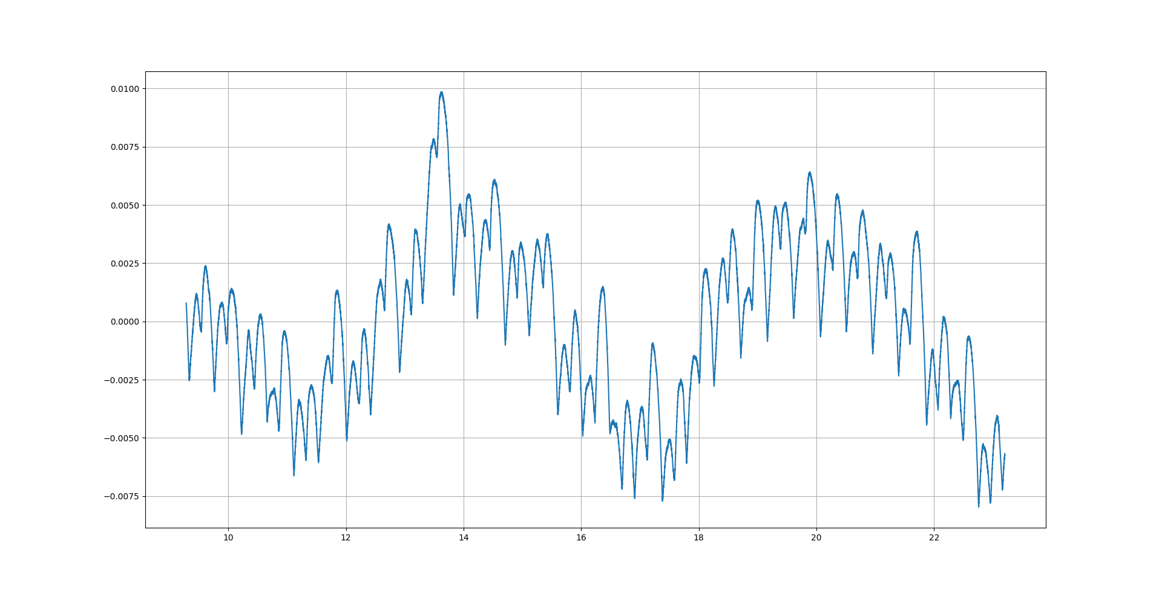

Figure 7: Before collision: Encoder position error (without backlash) at 688degmotor/s

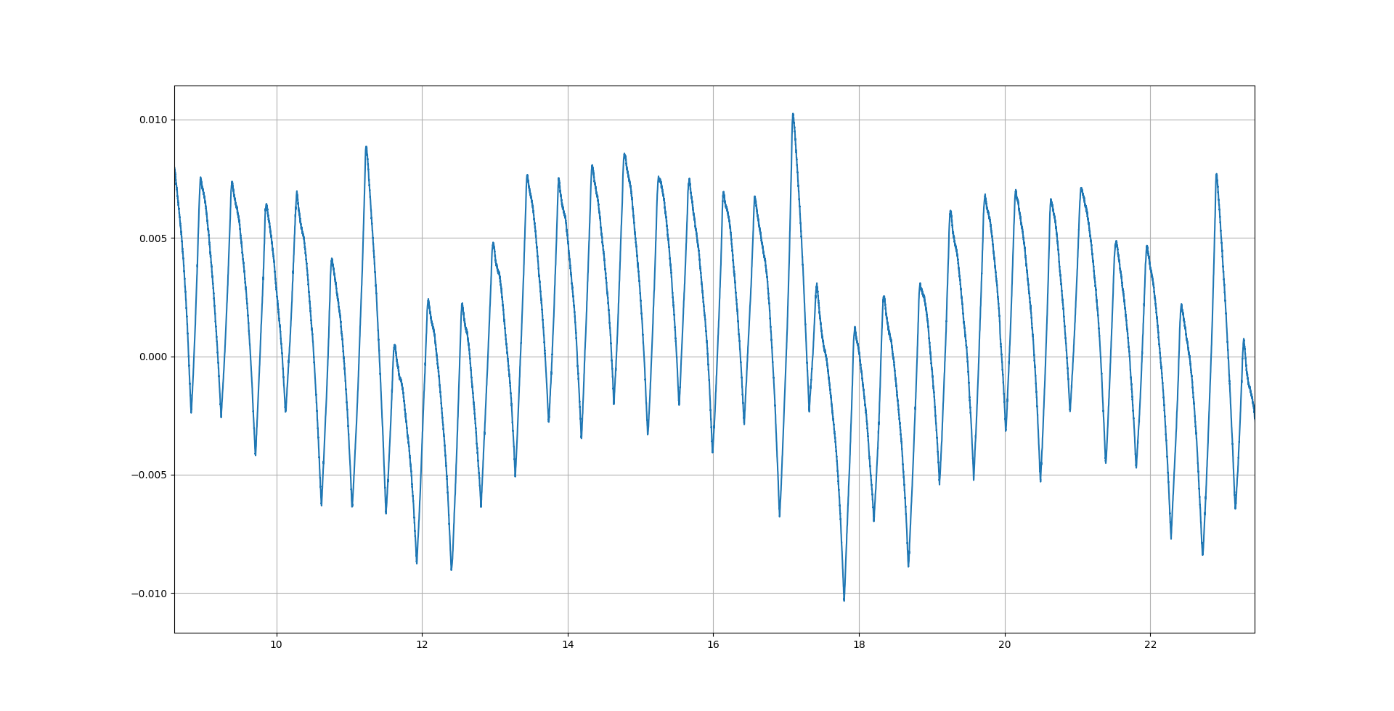

Figure 8: After collision: Encoder position error (without backlash) at 1280degmotor/s

The same cyclic error with a frequency of 5 degrees and an amplitude 0.01deg can be identified in both graphs. However, the amplitude of the higher frequency error has increased after the collision.

## Accuracy and gear ratio

A reduced accuracy test was performed also after the collision. In this test not at all the positions that were measured in the original accuracy tests was included.

Table 6 and Table 7 shows accuracy and gear ratios calculated from both before and after the collision.

Table 6: Before collision: Accuracy and gear ratio

|  |  |  |  |
| --- | --- | --- | --- |
|  | **Gear ratio** | **Offset** | **Accuracy** |
| **Open loop** | 8,10412E-05 | -0,0081 | 0,0273 |
| **Posital** | -4,45114E-05 | 30,7267 | 0,0309 |

Table 7: After collision: Accuracy and gear ratio

|  |  |  |  |
| --- | --- | --- | --- |
|  | **Gear ratio** | **Offset** | **Accuracy** |
| **Open loop** | 8,10047E-05 | -0,2793 | 0,0148 |
| **Posital** | -4,45181E-05 | 30,7399 | 0,0038 |

Both motor open loop position accuracy and encoder position accuracy have improved slightly after the collision. One explanation for this could be that the first accuracy measurement was including more points and therefore higher value could be expected. Worth noting is that the optimal gear ratio has changed slightly which also could be related to the different number of measurement points included in the two tests.

# CONCLUSIONS

# references

1. EtherCAT organization, <https://www.ethercat.org>
2. ecmc, open source motion control, <https://accelconf.web.cern.ch/icalepcs2017/talks/mocpl05_talk.pdf>
3. Control system configurations and raw data, <https://github.com/anderssandstrom/ecmc_bifrost_vac_tank_sat>
4. Technosoft iPOS8020 BX-CAT, <https://technosoftmotion.com/wp-content/uploads/P091.029.iPOS80x0.BX_.UM_.0520.pdf>
5. EL1004, <https://www.beckhoff.com/en-en/products/i-o/ethercat-terminals/el1xxx-digital-input/el1004.html>
6. EL2819, <https://www.beckhoff.com/en-en/products/i-o/ethercat-terminals/el2xxx-digital-output/el2819.html>
7. EL5002, <https://www.beckhoff.com/en-en/products/i-o/ethercat-terminals/el5xxx-position-measurement/el5002.html>
8. Stögra SM107.3.18M12+BPE100 Stepper motor, <https://github.com/anderssandstrom/ecmc_bifrost_vac_tank_sat/blob/master/docs/Datasheets/Stogra_Motor/sm107_e.pdf>
9. LEICA absolute tracker AT960, <https://github.com/anderssandstrom/ecmc_bifrost_vac_tank_sat/blob/master/docs/Datasheets/Laser_tracker/Hexagon%20MI%20AT960%20Datasheet%20A4_en%20(1).pdf>
10. Posital IXARC Absolute Rotary Encoder OCD-S101G-1416-S060-PRL, <https://github.com/anderssandstrom/ecmc_bifrost_vac_tank_sat/blob/master/docs/Datasheets/Posital/OCD-S101G-1416-S060-PRL.pdf>
11. Crouzet mechanical switches 83 871 306. <https://github.com/anderssandstrom/ecmc_bifrost_vac_tank_sat/blob/master/docs/Datasheets/Switches/Crouzet_8387%20series.pdf>
12. Vacuum Vessel and Positioning System FAT. N056.TES.021 - Motion Test report_v3: <https://github.com/anderssandstrom/ecmc_bifrost_vac_tank_sat/blob/master/docs/avs/N056.TES.021.v3_FAT%20motion%20test%20report.pdf>
13. ESS-1138675. BIFROST_SystemDesignDescription_PreTG3_V8: <https://chess.esss.lu.se/enovia/tvc-action/validVersion?versionObjectId=21308.51166.56576.49378&inline=false>
14. ESS-1088870. BIFROST - Sub-System Design Description - Scattering Characterization System: <https://chess.esss.lu.se/enovia/tvc-action/validVersion?versionObjectId=21308.51166.15872.61626&inline=false>
15. ESS-1797916. Vacuum Vessel and Positioning System FAT. N056.TES.020 - Motion Test Procedure_v0: <https://chess.esss.lu.se/enovia/tvc-action/validVersion?versionObjectId=21308.51166.18176.34039&inline=true>

Document Revision history

| Revision | Reason for and description of change | Author | Date |
| --- | --- | --- | --- |
| 1 | First issue | Anders Sandström, Federico Rojas | 2021-06-10 |
|  |  |  |  |
|  |  |  |  |