|  |
| --- |
|  |
| BIFROST AVS Vacuum tank  SAT MOTION PLAN |
|  |

|  | Name | Role/Title |
| --- | --- | --- |
| Owner | Anders Sandström | Electronics Engineer Motion Control & Automation |
| Owner | Federico Rojas | Electronics Engineer Motion Control & Automation |
| Reviewer | Thomas Gahl | Group Leader Motion Control & Automation |
| Approver | Liam Whitelegg | Instrument Lead Engineer for BIFROST |

TABLE OF CONTENT PAGE

1. Requirements 3

2. METHOD 4

2.1. General Inspection 4

2.1.1. Mechanical 4

2.1.2. Electrical 4

2.2. Motion Tests 5

2.2.1. Initial Motion Test 5

2.2.2. Motion range and switch performance 5

2.2.3. High speed test 6

2.2.4. Accuracy 6

2.2.5. Repeatability 6

2.2.6. Data Acquisition 6

2.3. Presentation of results 7

list of tables

Table 1: Requirements 3

Table 2:Status 7

list of Figures

Figure 1: Switch positions 3

.

# Requirements

The following requirements will be verified in this SAT:

Table 1: Requirements

|  |  |
| --- | --- |
| Requirements | Value |
| Accuracy | 0.1 deg |
| Repeatability | 0.05 deg |
| Range | Central axis to rotate from -4.5 degrees through to 45.5 degrees (0 degrees is perpendicular to the sample position) |
| Velocity | 0.1 deg/s ---> 1240 degmotor/s (gear ratio 12382) |
| Accelerations | 410 degmotor/s2 (stop from max speed in 3 seconds) |
| Travel time | The assembly shall travel through the range of motion within 15 minutes (688 degmotor/s) |
| Switching Positions | Switches S1 to S5 according to figure below +-0.1deg |
| Motor current | 10 ARMS |

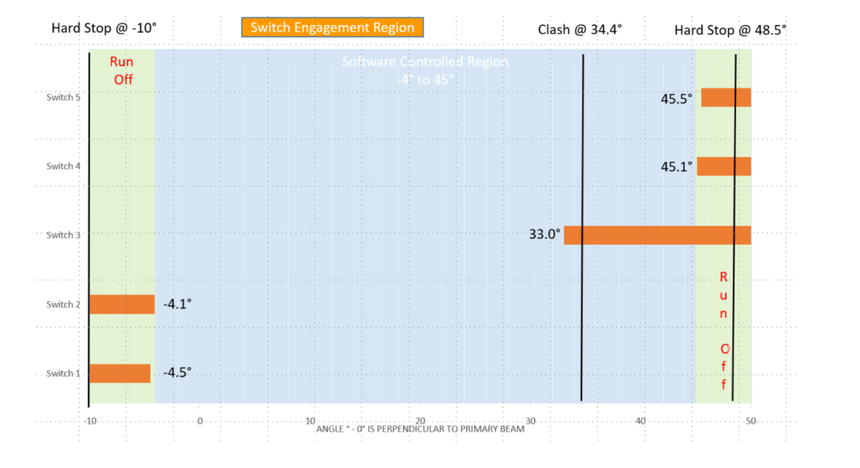

Figure 1: Switch positions

# METHOD

As a first step, a general inspection of the vacuum tank frame mechanics from a mechanical and electrical perspective will be performed. If no issues were found during the general inspection then motion tests should be performed.

The following tests are planned to be performed:

1. *General inspection*
2. *Initial motion test*
3. *Motion range and switch performance*
4. *High speed test*
5. *Accuracy*
6. *Bidirectional repeatability*

## General Inspection

Inspection of all axis components from a mechanical and electrical perspective.

### Mechanical

The following checklist should be followed:

1. *Ensure no loose components.*
2. *Ensure no risk of collisions.*
3. *Status of limit switches and cams.*
4. *Ensure connectors are fixed properly (not loose)*

### Electrical

Tests of electrical wiring:

1. *Inspection of cabling.*
2. *Test grounding between control box and frame of vacuum tank.*
3. *Measure coil resistance of stepper motor (phase A and B).*
4. *Measure connection of switches:*
   * *Limit switches*
   * *Kill switches*
   * *Anti-collision switch*

## Motion Tests

The motion tests have been divided into the following parts:

1. *Initial motion test*
2. *Motion range and switch performance*
3. *High speed test*
4. *Accuracy*
5. *Bidirectional repeatability*

### Initial Motion Test

Motion of the entire stroke should be tested with a low velocity, 360 degmotor /s. During this test special attention is on the following topics:

1. *Noise from the equipment (observed and noted down).*
2. *Test of switch actuation by the cams.*

As a last step, a homing sequence can be executed, setting the stepper open loop counter to the desired value at low limit disengage flank (0 to 1).

### Motion range and switch performance

Measurement of motion range and switch performance can be combined in the same test.

WARNING: In order to reach the hard stops the limit switches needs to be bridged in the motion control system (not used). Therefore, the motion needs to be supervised carefully manually (with access to E-Stop).

The following sequence will be followed during this test:

1. *Move to low hard stop in a very low velocity, record position.*
2. *Move to a position just past low kill switch.*
3. *Set velocity setpoint to 688 degmotor/s.*
4. *Engage/disengage the switch 5 times, record positions*
5. *Move to a position just past low limit switch.*
6. *Engage/disengage the switch 5 times, record positions*
7. *Move to a position just before the anti-collision switch*
8. *Engage/disengage the switch 5 times, record positions*
9. *Move to a position just before the high limit switch.*
10. *Engage/disengage the switch 5 times, record positions*
11. *Move to a position just before the high kill switch.*
12. *Engage/disengage the switch 5 times, record positions*
13. *Move to high hard stop, record position.*
14. *Move back to a position below high limit switch*.

The motion range is defined as the range between the low hard stop and high hard stop.

Switch performance is defined as the position range of the latched values for each switch.

### High speed test

The high-speed test aims to measure the total travel time between low and high limit switch.

The following sequence will be followed:

1. *Move to low limit switch*
2. *Set velocity setpoint to 1240 degmotor/s.*
3. *Issue a forward move at constant velocity*
4. *Let motion stop at high limit switch.*

### Accuracy

Accuracy of the positioning will be calculated by moving to 10 different target position distributed over the motion range starting at -5deg increasing with 5deg up to 40deg. A velocity setpoint of 688 degmotor/s will be used for the test.

The accuracy is represented by the largest difference between target position and the actual value achieved.

### Repeatability

The repeatability measured by moving to 6 different target positions distributed over the stroke,

1. *-5 deg*
2. *0 deg*
3. *10 deg*
4. *20 deg*
5. *30 deg*
6. *40 deg*

Each target position shall be approached 6 times from both positive and negative direction from a 0.5deg offset at a velocity of 688 degmotor/s. The repeatability for each position is represented by the largest difference between the positions achieved during the test.

### Data Acquisition

During the motion tests (2-5) the following data will be acquired:

1. *Position from laser Scanner*
2. *Posital Absolute encoder position*
3. *Stepper open loop counter position*
4. *Switch status*

Data will be acquired with a sampling rate of 100Hz.

All raw data and will uploaded to the following git repository: <https://github.com/anderssandstrom/ecmc_bifrost_vac_tank_sat>

## Presentation of results

The results of the tests should be summarized in a table, like below:

Table 3: Summary of SAT

|  |  |  |  |  |
| --- | --- | --- | --- | --- |
| **Test:** | **Description:** | **Value** | **Status:** | **Comment:** |
| **1** | **General Inspection** |  |  |  |
| **1.1** | **Mechanical** |  |  |  |
| **1.1.1** | **Observations** |  |  |  |
| **1.1.2** | **Observations** |  |  |  |
| **1.1.3** | **Observations** |  |  |  |
| **1.2** | **Electrical** |  |  |  |
| **1.2.1** | **Observations** |  |  |  |
| **1.2.2** | **Grounding** |  |  |  |
| **1.2.3** | **Motor Phase A** |  |  |  |
| **1.2.4** | **Motor Phase B** |  |  |  |
| **1.2.5** | **Low Limit Switch** |  |  |  |
| **1.2.6** | **High Limit Switch** |  |  |  |
| **1.2.7** | **Anti-Collision Switch** |  |  |  |
| **1.2.8** | **Low Kill Switch** |  |  |  |
| **1.2.8** | **High Kill Switch** |  |  |  |
| **2** | **Initial Motion Test** |  |  |  |
| **2.1** | **Observations** |  |  |  |
| **2.1** | **Observations** |  |  |  |
|  | **Motion Performance** |  |  |  |
| **3** | **Range and switch performance** |  |  |  |
| **3.1** | **Range (hard stop to hard stop)** |  |  |  |
| **3.2** | **Low Limit** |  |  |  |
| **3.3** | **Low Kill** |  |  |  |
| **3.4** | **Anti -Collision** |  |  |  |
| **3.5** | **High Limit** |  |  |  |
| **3.6** | **High Kill** |  |  |  |
| **4** | **High speed test** |  |  |  |
| **5** | **Accuracy** |  |  |  |
| **6** | **Bidirectional repeatability** |  |  |  |

The status of each test should be evaluated and the status presented in one of the following three grades:

Table 2: Status

|  |  |  |
| --- | --- | --- |
|  | **Status** | **Description** |
| **1** | OK | Test result is fulfilling requirement. |
| **2** | Check | The test / observation needs further investigation. |
| **3** | Not OK | The test / observation is not fulfilling requirement. |