|  |
| --- |
|  |
| TARGET FAT GALICIA |
|  |

|  | Name | Role/Title |
| --- | --- | --- |
| Owner | Anders Sandström | Electronics Engineer Motion Control & Automation |
| Reviewer |  |  |
| Approver |  |  |

TABLE OF CONTENT PAGE

1. Background 4

1.1. Equipment in scope 4

2. Requirements 4

3. CONTROL SYSTEM 5

3.1. Hardware 5

3.2. EL7037 Stepper drive 5

3.3. EL7201 Resolver interface 5

3.4. Feedback systems 5

3.4.1. Laser triangulation sensor Micro Epsilon ILD2300 5

3.4.2. Resolver, AMCI R11X-J10/N 6

4. METHOD 7

4.1. General Inspection 8

4.1.1. Mechanical 8

4.1.2. Electrical 8

4.2. Motion Tests 8

4.2.1. Initial Motion Test 8

4.2.2. Repeatability and accuracy 9

4.2.3. Switch Performance 9

4.2.4. Resolver Performance 9

4.2.5. Data Acquisition 9

4.3. Presentation of results 10

4.1. Analysis 10

5. Results 11

5.1. 11359 Axis 1 12

6. CONCLUSIONS 12

7. references 13

8. Appendix A Micro Epsilon ILD2300 Calibration REPORT 15

list of tables

Table 1:Status 10

Table 2: Results 11358, axis 1 11

Table 4: Results 11358, axis 2 12

Table 5: Results 11359, axis 1 14

Table 6: Results 11359, axis 2 16

Table 7: Results 11360, axis 1 17

Table 8: Results 11360, axis 2 18

Table 9: Results 11361, axis 1 19

Table 10: Results 11361, axis 2 20

list of Figures

Figure 1: JJ X-RAY: Slit set 4

Figure 2: Test setup 7

Figure 3: Bent levers of limit switches 13

Figure 4: Bent limit switch lever 15

# Background

The target wheel and drive unit FAT took place week 7 2022 at Thune Eureka premises in Galicia Spain. This report contains analysis of some data acquired during the FAT tests.

## Equipment in scope

Each JJ X-RAY slit set consists of two motorized translation stages. Each translation stage can be

individually positioned in the vertical direction, Figure 1.

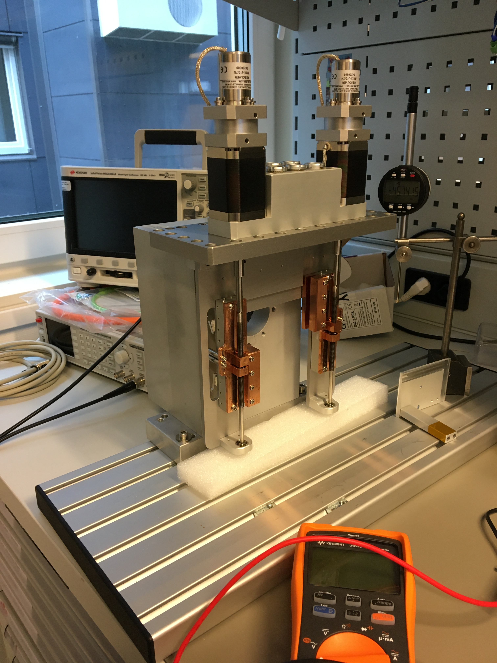

Figure 1: JJ X-RAY: Slit set

Each axis is equipped with the following components:

* Stepper motor: AML-D42.3 (with new bearing type)[8]
* Resolver: AMCI R11X-J10/N [10]
* Limit switches: Saia-Burgess F4T7YC-GP-UL
* Stroke: Approx. 70mm
* Leadscrew (1mm pitch)

# Requirements

The following requirements have been set by the BIFROST team:

1. Stroke: 40mm
2. Accuracy: +-0.1mm
3. Repeatability: +-0.05mm
4. Resolution: 0.01mm minimum

# CONTROL SYSTEM

The SAT was performed with an EtherCAT [1] based control system, ecmc [2]. The configuration files, raw data and analysis results for the SAT have been added to a git repository [3].

All hardware needed for the tests have been integrated into the same system which then leads to that all sampled data have the same time base.

## Hardware

The following control hardware was used:

1. EL7037: Stepper motor drive [4]
2. EL1808: Digital input for switches [5]
3. EL2808: Digital output to feed switches [6]
4. El7201: Resolver interface [7]
5. ILD2300: Micro Epsilon laser triangulation sensor [8].

## EL7037 Stepper drive

The EL7037 stepper drive was configured in a similar way as was done in the JJ X-RAY FAT procedure, [9]:

1. Control mode: Open loop
2. Run current: 0.61A
3. Standby current: 0.087A
4. Micro stepping: 64fold (resolution 12800steps/rev for the 200m step motor)
5. Velocity: 0.75mm/s (slower than the 2.5mm/s what JJX-RAY used at FAT)

## EL7201 Resolver interface

The EL7201 resolver interface delivers a single turn resolution of 20bits (1048576 counts/rev).

## Feedback systems

Two different sensors are used as position feedback for the tests.

1. ILD2300 : Micro Epsilon Laser triangulation sensor [9].
2. Resolver : AMCI R11X-J10/N [10]

### Laser triangulation sensor Micro Epsilon ILD2300

The Micro Epsilon ILD2300 sensor was used as external measurement and verification system. The ILD2300 have the following specs:

1. Range: 50mm
2. Linearity: +-10 μm (protocol: Appendix A Micro Epsilon ILD2300 Calibration)
3. Resolution: 0.8 μm

This sensor can only cover parts of the approximate 70mm stroke.

### Resolver, AMCI R11X-J10/N

The AMCI resolver was delivered with the slits mounted on the second shaft of the motor. The AMCI R11X-J10/N resolver have the following specs:

1. Accuracy: 7 arcmin (0.12deg)
2. Input voltage: 7V
3. Input frequency: 5000Hz
4. Transformation ratio: 0.95+-5%

The accuracy of 7arcmin corresponds to a linear accuracy of 0.32μm.

# METHOD

## Rotation velocity stability

Velocity was measured by differentiating the position value of the rotational encoder. The velocity signal was then averaged over one sector, 10 degrees, in order to filter noise mainly derived from high sample rate of the encoder signal. The velocity stability then calculates as the maximum spread of the velocity signal over a time period.

## Rotation traction difference over revolution

Traction difference over the rotor revolution was measured by analysing the deceleration rate of the rotor with motor disabled (power less).

## Rotor displacement amplitude

The maximum rotor displacement was measured by 5 positional sensors:

* 3 eddy current sensors mounted in the horizontal x,y-plane in the pedestal, displaced 120 degrees.
* 1 eddy current sensor mounted in the z direction in the pedestal
* One optical triangulation sensor measuring the displacement of the circumference of the target wheel outer surface. The optical sensor was also used for calibration of the eddy current sensors by replacing and comparing it to the eddy current sensor positioned at 120 degrees.

### Rampup

#### X-Y

#### Z

#### Rotor circumference

### Steady state

### Rampup

X-Y

Z

Rotor circumference

### Rampdown

### Rampup

X-Y

Z

Rotor circumference

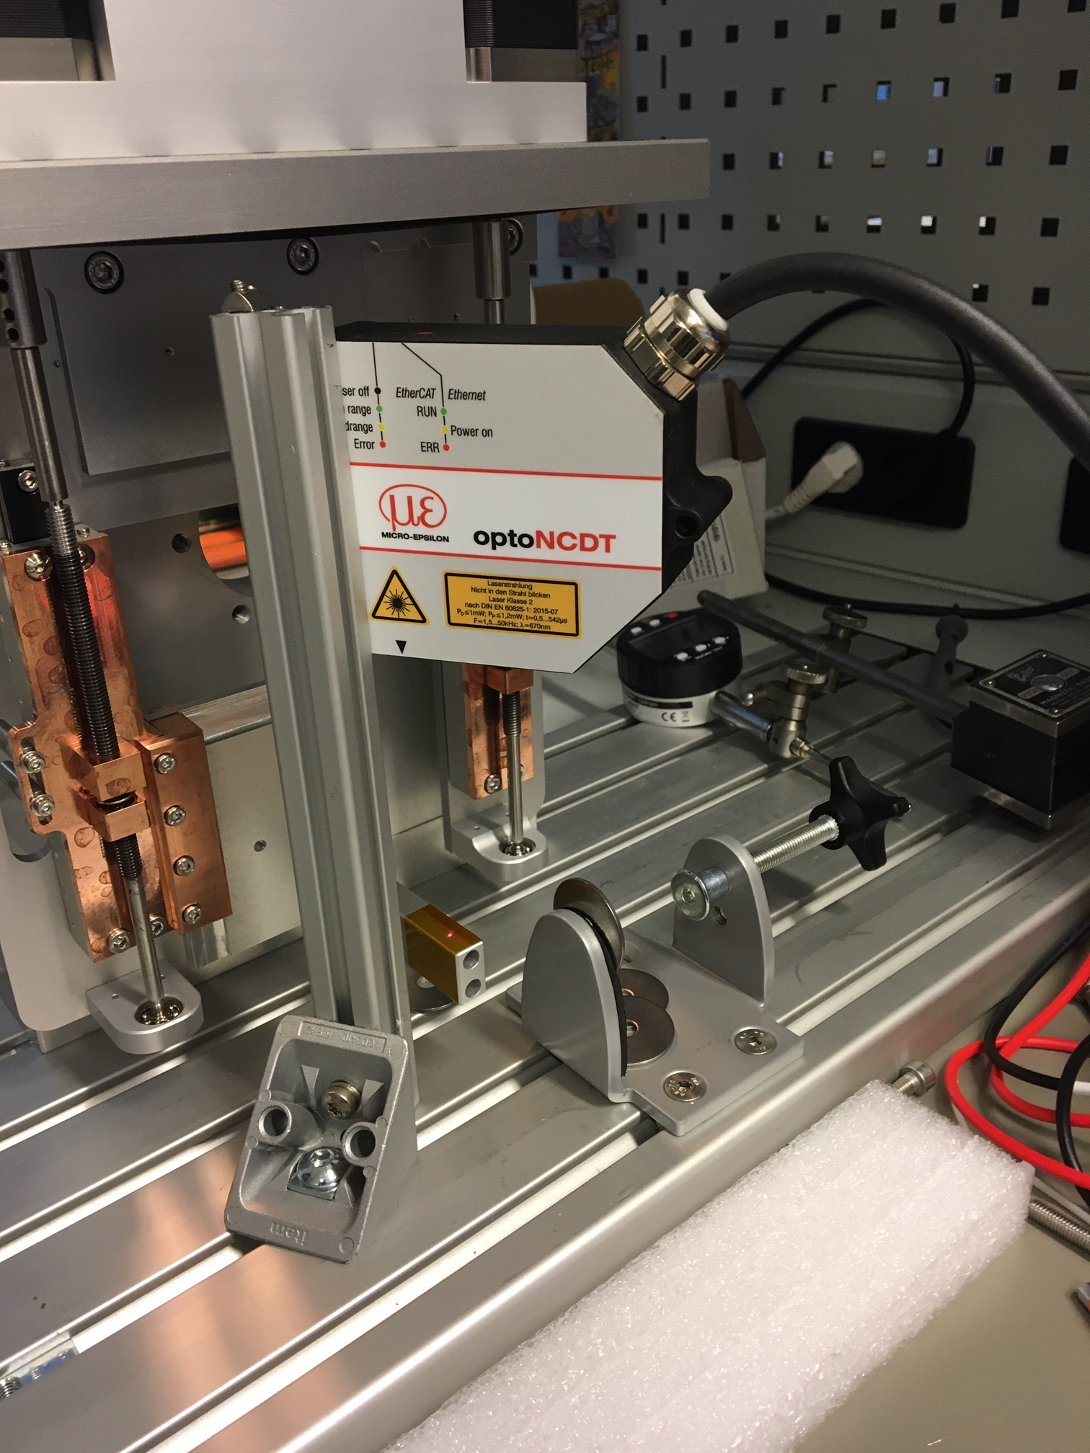

Figure 2: Test setup

## General Inspection

Inspection of all axis components from a mechanical and electrical perspective.

### Mechanical

The following checklist was followed:

* Ensure no loose components.
* Ensure no risk of collisions.
* Status of limit switches and cams
* Lemo connectors fixed

### Electrical

Mainly tests of electrical wiring:

1. Measure coil resistance of stepper motor (A and B).
2. Measure coil resistance of resolver (rotor, sin, cos).
3. Measure limit switch connections.

## Motion Tests

The motion tests have been divided into the following parts:

1. Initial motion test
2. Repeatability (ISO 230-2)
3. Accuracy (ISO 230-2)
4. Switch performance
5. Resolver performance

### Initial Motion Test

Motion of the whole stroke was tested with a low velocity. During this test special attention was on the following topics:

1. Noises from the equipment was observed and noted down.
2. Limit switches was tested and adjusted if needed.

As a last step, a homing sequence was performed by setting the stepper open loop counter to zero at low limit disengage flank (0 to 1).

### Repeatability and accuracy

Repeatability and accuracy was measured by a process defined in the standard ISO230-2 [4].

The following target positions was chosen, zero position defined at low limit switch:

* 15.0 mm
* 25.2 mm
* 35.4 mm
* 45.6 mm
* 55.8 mm

### Switch Performance

The switch performance was measured by latching positions at engage/disengage of the switch. The switches were engaged and disengaged 10 times. The switch performance is represented by position range of latched position values

### Resolver Performance

The resolver performance was measured at standstill at 8 different angles of the resolver (45 degree offset). This to quantify the quality of the signal for different angles of the resolver. The resolver performance is defined as the standard deviation of 75 values at each position.

### Data Acquisition

During the motion tests (2-5) the following data was acquired:

1. ILD2300 sensor position
2. R11X-J10/N Resolver position
3. Stepper open loop counter position
4. Switch status

Data was acquired with a sampling rate of 100Hz.

## Presentation of results

The results for each axis are summarized in tables. Each test, like described above, is evaluated and the status is presented in one of the following three grades:

Table 1:Status

|  |  |  |
| --- | --- | --- |
|  | **Status** | **Description** |
| **1** | OK | Test result is fulfilling requirement. |
| **2** | Check | The test / observation needs further investigation. |
| **3** | Not OK | The test / observation is not fulfilling requirement. |

All raw data and more detailed reports can be found in the following git repository:

<https://gitlab.esss.lu.se/mcag/instruments/bifrost/ecmc_bifrost_slits_sat/-/tree/master/tests_2>

## Analysis

Test sequence and analysis was performed/automated by python and bash scripts. The source code can be found here:

<https://gitlab.esss.lu.se/mcag/sources/fat_sat_tools>

# Results

## 11359 Axis 1

Table 5: Results 11359, axis 1

# CONCLUSIONS

The results of this second SAT presented in chapter 5 can be summarized as follows:

* Accuracy and repeatability:
  + All axes fulfill the requirements with good margin.
* Switches:
  + The switches identified with bent actuation brackets had been fixed/replaced.
  + 11358, axis 1 was found to have worse performance of the low limit switch compared to what was found during the first SAT test.
* Noise:
  + Mechanical grinding noise was still observed from most of the axes. However, the situation has improved a lot since the first SAT.
  + Two of the axes was almost silent.
* 11360 slit set:
  + Electrical connection was fixed and could now be tested for the first time.
  + axis 1: Mechanical grinding noise, the worst numbers of accuracy and performance of all the axes but still within spec.
  + axis2: No mechanical noise and well within spec for accuracy and repeatability.

# references

1. EtherCAT organization, <https://www.ethercat.org>
2. ecmc, open source motion control, <https://accelconf.web.cern.ch/icalepcs2017/talks/mocpl05_talk.pdf>
3. Control system configurations and raw data, <https://gitlab.esss.lu.se/mcag/instruments/bifrost/ecmc_bifrost_slits_sat>
4. ISO 230-2: Test code for machine tools — Part 2: Determination of accuracy and repeatability of positioning of numerically controlled axes
5. EL7037, <https://www.beckhoff.com/english.asp?ethercat/el7037.htm>
6. EL1808, <https://www.beckhoff.com/english.asp?ethercat/el1808.htm>
7. EL2808, <https://www.beckhoff.com/english.asp?ethercat/el2808.htm>
8. EL7201, <https://www.beckhoff.com/english.asp?ethercat/el7201.htm>
9. AML 42.3 Stepper motor, <https://arunmicro.com/products/D42-3_UHV_Compatible_Stepper_Motor/>
10. Micro-Epsilon laser triangulation sensor, <https://www.micro-epsilon.com/displacement-position-sensors/laser-sensor/optoNCDT_2300_basic/>
11. AMCI r11 Resolver, <https://www.amci.com/plc-automation-products/r11-size-11-brushless-resolver-sensors>
12. Bifrost Divergence Slits DTU Physics Test Plan 18032, Revision 4 of Oct 27th, 2020
13. Test report 11358, axis 1: <https://gitlab.esss.lu.se/mcag/instruments/bifrost/ecmc_bifrost_slits_sat/-/blob/master/tests_2/11358/axis1/report.md>
14. Test report 11358, axis 2: <https://gitlab.esss.lu.se/mcag/instruments/bifrost/ecmc_bifrost_slits_sat/-/blob/master/tests_2/11358/axis2/report.md>
15. Test report 11359, axis 1: <https://gitlab.esss.lu.se/mcag/instruments/bifrost/ecmc_bifrost_slits_sat/-/blob/master/tests_2/11359/axis1/report.md>
16. Test report 11359, axis 2: <https://gitlab.esss.lu.se/mcag/instruments/bifrost/ecmc_bifrost_slits_sat/-/blob/master/tests_2/11359/axis2/report.md>
17. Test report 11360, axis 1: <https://gitlab.esss.lu.se/mcag/instruments/bifrost/ecmc_bifrost_slits_sat/-/blob/master/tests_2/11360/axis1/report.md>
18. Test report 11360, axis 2: <https://gitlab.esss.lu.se/mcag/instruments/bifrost/ecmc_bifrost_slits_sat/-/blob/master/tests_2/11360/axis2/report.md>
19. Test report 11361, axis 1: <https://gitlab.esss.lu.se/mcag/instruments/bifrost/ecmc_bifrost_slits_sat/-/blob/master/tests_2/11361/axis1/report.md>
20. Test report 11361, axis 2: <https://gitlab.esss.lu.se/mcag/instruments/bifrost/ecmc_bifrost_slits_sat/-/blob/master/tests_2/11361/axis2/report.md>

Document Revision history

| Revision | Reason for and description of change | Author | Date |
| --- | --- | --- | --- |
| 1 | First issue | Anders Sandström | 2021-12-20 |
|  |  |  |  |
|  |  |  |  |

# Appendix A Micro Epsilon ILD2300 Calibration REPORT

