# Programming using SAM-BA

ERASE

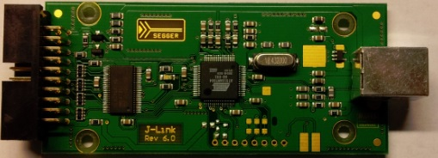

TST

3.3V

SAM-BA is Atmel’s simple programming utility for the built-in boot loader in the SAM7S64, in this case using USB.

1. Erase the chip and restore the boot loader by connecting the ERASE pad to 3.3V and applying power (by connecting USB) for at least 20 seconds before removing power again. This step is only necessary if the SAM-BA bootloader has been disabled or erased.
2. Enter SAM-BA programming mode by connecting the TST pad to 3.3V and applying power for at least 10 seconds before removing power again.
3. The next time you connect USB the boot loader comes up as a virtual USB serial port on your computer, and SAM-BA can connect to the chip.

# Programming/debugging using JTAG

It is possible to use another J-Link to program and debug the board.

Pullup/pulldown pads



Connector pin 1

JTAG port

1. Cut the fine traces between the top and bottom pullup/pulldown pads.
2. Solder three 47k resistors over the three pads.
3. Make a JTAG cable by cutting up a standard JTAG 20 ribbon cable.
4. Solder the wires to the JTAG port as follows (port numbered 1 to 8 left to right)  
   1. VCC – wire 1 and 2  
   2. GND – wire 4  
   3. Reset – wire 3 and 15  
   4. TDI – wire 5  
   5. TMS – wire 7  
   6. TCK – wire 9 and 11  
   7. TDO – wire 13  
   8. GND – wire 14

# Findings

You need to apply power to the buffer/level shifter by applying power to pin 1 on the angled connector.

You enable the output buffer for the top four pins in the connector (3, 5, 7, 9) by setting PA9 high.

PA8 is connected to pin 3

PA0 is connected to the LED

PA1 is connected to the other LED on J-Link rev. 8