Andrew Lee

IT122

10/2/2024

JavaScript2 Week 2 Assignments

**Assignment 1:**

**Assignment 2:**

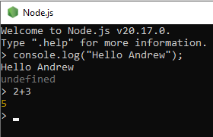

**Assignment 3:**

