**Introduction**

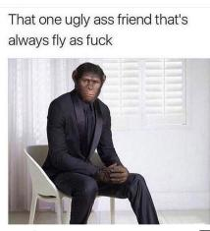

This section describes the reasons i have to choose this area and why I believe it will upgrade my skills in terms of writing and technology.

**ANDERSON BARBOSA**

**Tech writing**

**The finishing**

Expectations

Today is the very beginning of my career as a tech writer. I’m not starting professionally but I could finally finish all the initial training that Paulo has indicated me to do.

I feel very confident after all the information I received, I still need to make something more practical in order to achieve a higher level of confidence.

27/02/2023

**The application date**

The race to conclude all TRAINING

After a long talk through messenger of Instagram, I promissed Paulo that I was going to start the studies immediately.

After a few minutes I entered UDEMY website and purchased two courses at once.

15/01/2023

30/11/2022

**When it all started**

Paulo, the incentivator

It all started a couple of months ago when I decided to get in touch with Paulo, who was one of the most prepared and skilled English teachers that I’ve met in my life.

I remember when I asked him about his new occupation and he had no doubts to explain it quickly and tried immediatelly to convince me of the bennefits and that tech writing could add to my life.

CREATIVE

LEADERSHIP

TEAMWORK

CONFIDENT

**Be a tech writer too**

**SKILLS**

PHOTOSHOP

ILLUSTRATOR

HTML & CSS

JAVA SCRIPT

Python

**PROFESSIONAL**

Andesign31@gmail.com

+55 11- 995403978

Santo André

São Paulo, Brasil