Second Phase – Process Mining Report

## 1. Introduction

This report describes the steps taken to create a Petri Net based on a simulated process and how case data was generated to reflect the flow of activities.

## 2. Petri Net Development

To design the Petri Net, I followed the structure of the BPMN process model and transformed it into a formal representation of the process using places, transitions, and arcs.

The Petri Net was manually drawn and using Power Automate Process Mining , respecting the rules of process modeling, where:  
 - Places represent the states before or after activities .  
 - Transitions are the actual activities .  
 - Arcs connect places to transitions and vice versa to show the process flow.

The Petri Net was designed to reflect the typical application procedure, starting from accessing a portal and ending with the final process with the winners.

## 3. Case Data Creation (CSV)

I created a CSV file manually to simulate event logs based on the Petri Net and BPMN model.  
Each row represents an event performed in a particular case (e.g., an applicant going through the process). The columns in the CSV include:

- Case_Id: Unique identifier for each applicant.  
- Activity: The step performed (e.g., "Submit Application").  
- Initial_Status: The state before the activity.  
- Final_Status: The state after the activity.  
- Timestamp: Time when the activity occurred.

The CSV data was structured to follow the correct order of steps in the Petri Net to ensure the accuracy of the simulation.

## 4. Petri Net Diagram

Below is the automate and manually drawn Petri Net diagram that illustrates the process:

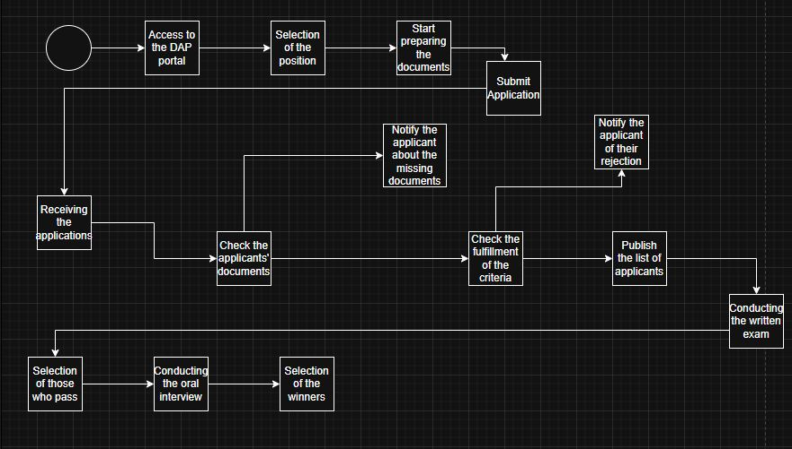

*Figure: Petri Net showing the process flow.*

## 5. Conclusion

This report includes the structured CSV file and Petri Net diagram derived from the BPMN model. It ensures consistency between the theoretical process model and the actual simulated data.