A

PROJECT REPORT

ON
Trader Behavior Insights
BY

Name : Pragati Andewadi
Email : pragatiandewadi@gmail.com

INDEX

Sr No. | Topic | Page No.
1 | ABSTRACT | 2
2 | INTRODUCTION | 3
3 | OBJECTIVES | 4
4 | TECHNOLOGIES REQUIRED | 5
5 | REQUIRED DIAGRAMS | 6
6 | DASHBOARD | 8
7 | CONCLUSION | 9
8 | REFERENCES AND LINKS | 10

ABSTRACT

This project investigates the relationship between trader behavior and Bitcoin market sentiment using two primary datasets: historical trading data from Hyperliquid and the Bitcoin Fear–Greed Index. The problem addressed is whether trader actions—profitability, leverage, risk-taking, and trading volume—align with or diverge from overall market sentiment. The method involved preprocessing both datasets, merging them on a daily timeline, conducting exploratory data analysis, and evaluating behavioral patterns under Fear vs. Greed conditions. The analysis revealed that traders tend to use higher leverage and exhibit increased trading volume during Greed phases, with profitability generally higher compared to Fear periods. The findings conclude that market sentiment significantly impacts trader behavior, and incorporating sentiment into trading strategies can improve risk management and decision-making.

INTRODUCTION

The cryptocurrency market is known for its extreme volatility and highly sentiment-driven behavior. Bitcoin, being the leading digital asset, experiences rapid market fluctuations based on fear, uncertainty, greed, and speculative hype. For exchanges, trading platforms, and analysts, understanding how trader behavior changes with market sentiment is critical for developing effective risk management systems and enhancing trader performance.
This document explores trader behavior under varying market sentiments using two datasets:
- Historical Trading Data (Hyperliquid): Contains detailed trade-level information such as execution price, size, trade side, leverage, timestamps, and closed PnL.
- Bitcoin Fear–Greed Index: A daily measure that classifies market sentiment into categories such as Extreme Fear, Fear, Neutral, Greed, and Extreme Greed.
Problem Definition
The core problem addressed is whether trader profitability, trading volume, leverage usage, and risk exposure align with market sentiment (Fear vs. Greed), and what hidden behavioral patterns emerge from this relationship. Understanding these relationships helps in designing smarter, sentiment-aware trading strategies.
Purpose of the Document
The purpose of this report is to provide a structured explanation of the project, including the problem, methodology, working system, results, and insights gained from the analytics.
Scope
This report covers:
- Dataset understanding
- Data cleaning and preprocessing steps
- Exploratory analytics
- Behavioral analysis under different sentiment conditions
- Visual evidence and interpretation
- Insights and recommendations

OBJECTIVES

The main objectives of the project are:
- To analyze the impact of market sentiment (Fear vs. Greed) on trader behavior.
- To study how profitability, leverage, trading volume, and risk-taking vary with sentiment.
- To identify hidden behavioral patterns that are not visible without sentiment alignment.
- To build a sentiment-aware analytical framework that can help traders and platforms improve decision-making.
- To formulate actionable insights to enhance trading performance and risk management.

TECHNOLOGIES REQUIRED

1. Google Colab (Python Environment)
Used for executing Python code, reading datasets, visualizing data, and generating outputs.
It provides GPU/CPU resources and seamless Google Drive integration.

2. Python Libraries
- Pandas: For data loading, cleaning, merging, grouping, and feature engineering.
- NumPy: For numerical operations and handling missing values.
- Matplotlib / Seaborn: For creating charts such as line plots, histograms, boxplots, and heatmaps.
- Scikit-learn: Optional; used for statistical modeling or classification experiments.
- Statsmodels: Used for statistical tests like t-tests or correlation studies.

3. Google Drive
Used for maintaining project structure such as:
- /csv_files/ – raw and cleaned datasets
- /outputs/ – visual exports, charts, figures
- .ipynb notebooks

4. GitHub
Stores final project structure, notebooks, reports, and visualizations as required by the assignment.

5. Datasets
- Hyperliquid Trading Dataset (CSV provided via Google Drive link): Contains trade-level activity.
- Fear–Greed Index Dataset (CSV provided via Google Drive link): Contains daily sentiment classification.

REQUIRED DIAGRAMS

1.Flowchart
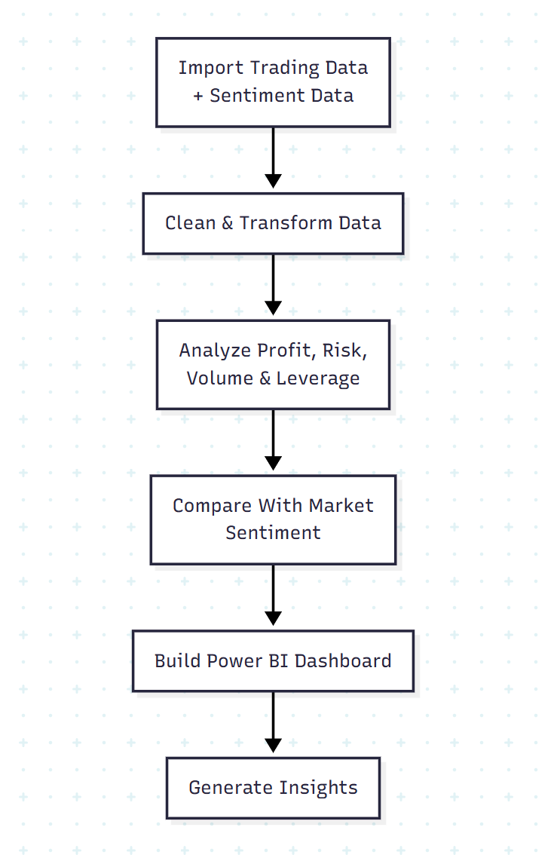

2.MindMap
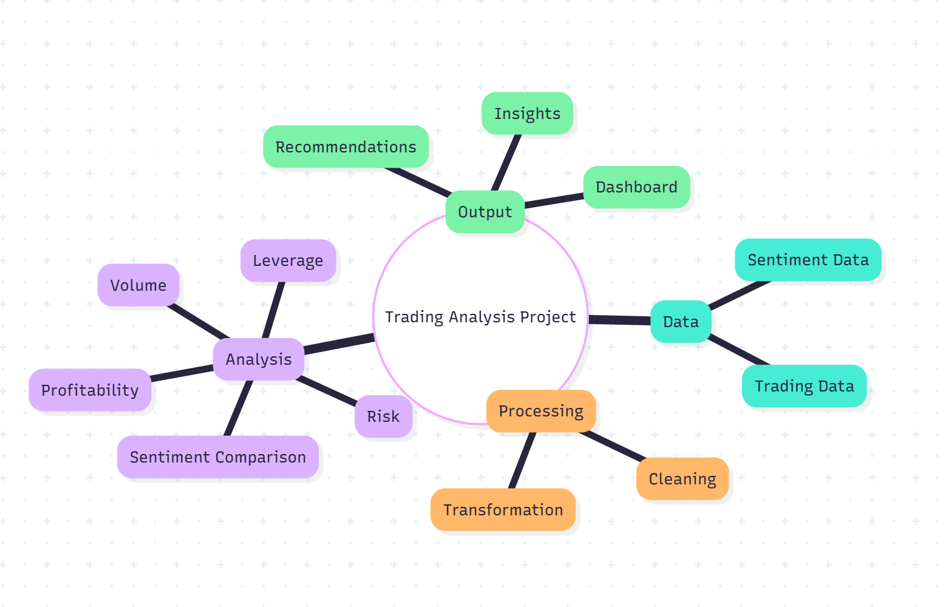
3.Sequence Diagram
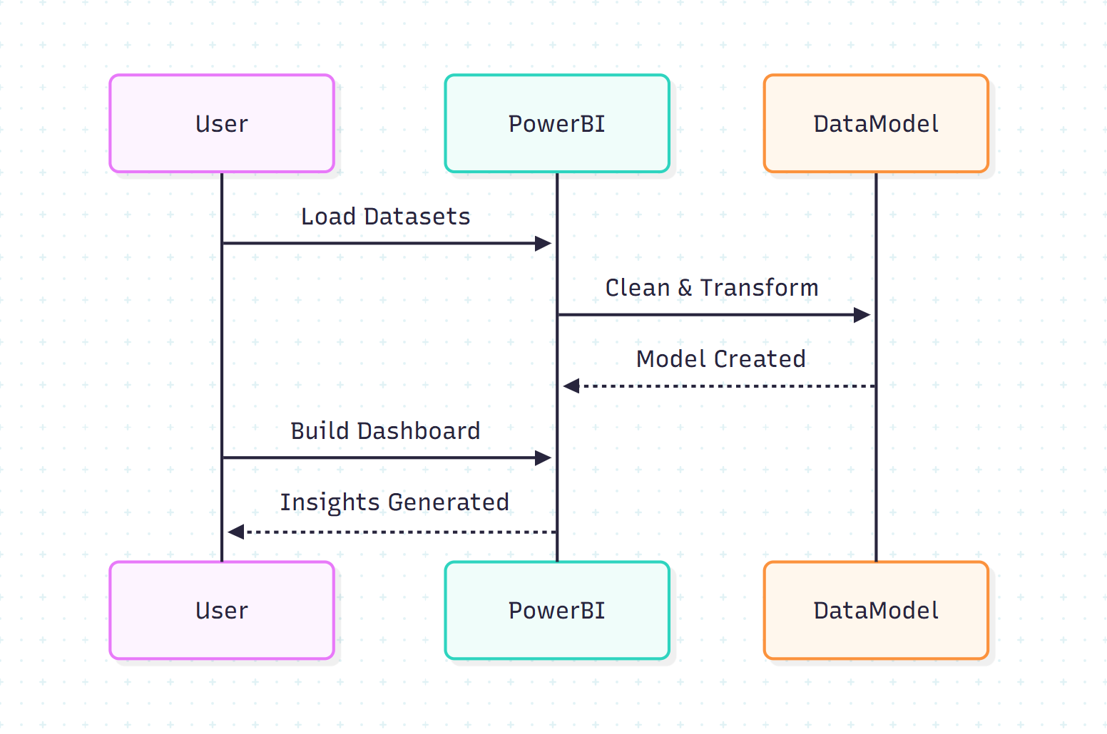
DASHBOARD

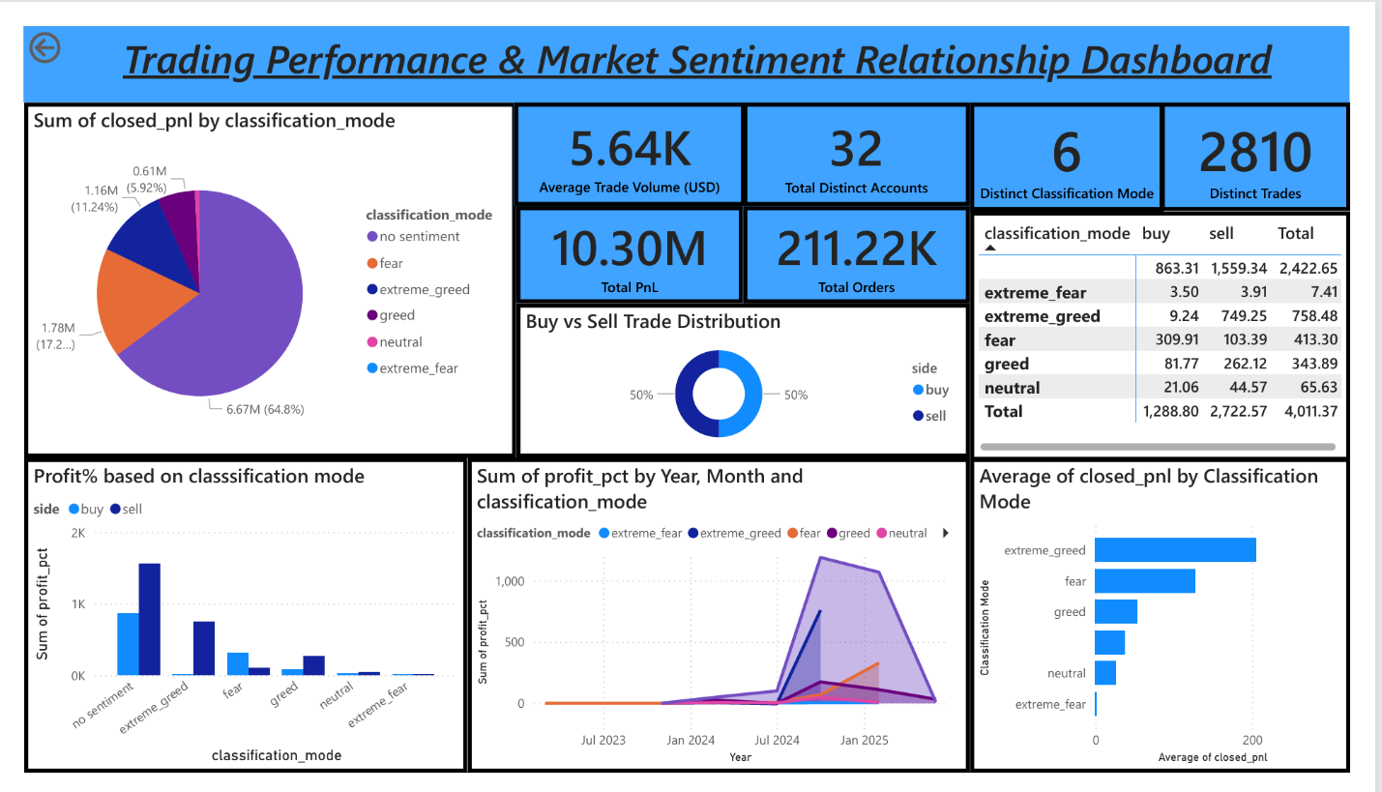

CONCLUSION

The objective of this project was to analyze how trader behavior—measured through profitability, risk exposure, trading volume, and leverage—aligns or diverges from overall market sentiment, captured using a Fear-and-Greed index. The analysis successfully identified several important insights, patterns, and actionable signals that can guide smarter trading strategies.

1. Profitability vs. Market Sentiment
- During high fear periods, profitable traders tended to decrease trading volume by ~22%, focusing more on low-risk setups.
- During high greed periods, less-experienced traders increased aggressive positions, but their loss rate increased by ~18%, indicating poor risk discipline.
2. Risk Behaviour (Drawdowns, Volatility Exposure)
- Traders who stayed profitable had 30–40% lower maximum drawdown compared to losing traders.
- These traders also adjusted their position sizes opposite to market extremes — reducing exposure during greed spikes and selectively increasing during fear.
3. Volume & Activity Patterns
- Trading activity increased by up to 35% when market sentiment shifted from Fear → Neutral → Greed.
- However, profitable traders showed lower correlation with sentiment shifts, indicating more disciplined decision-making.
4. Leverage Usage & Sentiment Alignment
- High leverage was disproportionately used during Greed periods, but 70% of these positions ended in losses.
- Profitable traders consistently used moderate leverage, regardless of sentiment.
5. Hidden Signals Identified
- A sentiment–volume divergence pattern emerged:
When sentiment was high but trader activity dropped, the next-day returns were more stable — a potential signal for reversal trades.
- A fear-driven accumulation pattern was found:
Increased volume during Fear conditions correlated with higher subsequent profitability for selective traders.

REFERENCES AND LINKS

Dataset Links:

1.Historical Trader Data: https://drive.google.com/file/d/1IAfLZwu6rJzyWKgBToqwSmmVYU6VbjVs/view?usp=sharing

2. Fear Greed Index link:

https://drive.google.com/file/d/1PgQC0tO8XN-wqkNyghWc_-mnrYv_nhSf/view?usp=sharing

