**Blackbody Curves & UBV Filters**

***Background Material***

Thoroughly review the pages below:

Spectra: <http://astro.unl.edu/naap/blackbody/spectra.html>

Filters <http://astro.unl.edu/naap/blackbody/filters.html>

Color Index <http://astro.unl.edu/naap/blackbody/colorindex.html>

**Note: Please do not use blue font or yellow highlighted font. These are the colors I use for my commentary when I grade the labs.**

Light and Filters Simulator Overview

Navigate your browser to the filter simulator web page.   
<http://astro.unl.edu/naap/blackbody/animations/filters.html>

This page requires flash to operate properly. If you do not already have flash on your computer you can obtain it here: <http://get.adobe.com/flashplayer/>

The Light and Filters Simulator allows one to observe light from various sources passing through multiple filters and the resulting light that passes through the filters to some detector. An “optical bench” shows the source, slots for filters, and the detected light. The wavelengths of light allowed in the simulator range from 380 nm to 825 nm which more than encompass the range of wavelengths detected by the human eye.

The upper half of the simulator (the part with the black background) graphically displays the source-filter-detector process. A graph of intensity versus wavelength for the source is shown in the leftmost graph; it is labeled “emitted distribution.” The middle graph displays the combined filter transmittance – the percentage of light the filters allow to pass for each wavelength. The rightmost graph displays a graph of intensity versus wavelength (labeled “detected distribution”) for the light that actually gets through the filter and could travel on to some detector such as your eye or a CCD. Color swatches at the far left and right demonstrate the effective color of the source and detector profile respectively.

The lower portion of the simulator contains tools for controlling both the light source and the filter transmittance.

* In the *Light Source Details* panel perform the following actions to gain familiarity.
  + Using the dropdown menu labeled “distribution type” create a **blackbody** source distribution – the spectrum produced by a light bulb which is a continuous spectrum. Practice using the **temperature** and **peak height** controls to control the source spectrum.
  + Using the dropdown menu labeled “distribution type” create a **bell-shaped** spectrum. This distribution is symmetric about a peak wavelength. Practice using the peak **wavelength**, **spread**, and **peak height** controls to vary the source spectrum.
  + Using the dropdown menu labeled “distribution type” practice creating **piecewise** **linear** sources. In this mode the user has complete control over the shape of the spectrum as control points can be dragged to any value of intensity.
    - Additional control points are created whenever a piecewise segment is clicked at that location. Look for the + sign by the cursor indicating that you can create a new control point.
    - Control points may be deleted by holding down the Delete key and clicking them.
    - Control points can be dragged to any location as long as they don’t pass the wavelength value of another control point.
  + Create 3 or 4 control points and vary their location up and down as well as left and right.
* In the *Filter Details* panel perform the following actions to gain familiarity.
  + Review the shapes of the preset filters (the B,V, and R filters) in the **filters list**. Clicking on them selects them and displays them in the graph in the filters panel.
  + Click the **add** button below the **filters list**.
    - Rename the filter from the default (“filter 4”) to your first name.
    - Note the default filter **distribution type** is piecewise linear. Shape the piecewise linear function to something other than a flat line.
  + Click the **add** button below the **filters** **list**.
    - Select **bell-shaped** from the **distribution** **type** pull down menu.
    - Alter the features of the default and rename the filter.
  + If desired, click the **remove** button below the **filters list**. This removes the actively selected filter (can’t remove the preset B,V, and R filters). Filters are not saved anywhere. Refreshing the flash file deletes the filters.

**Filters Simulator Questions**

* Use the piecewise linear mode of the source panel to create a “flat white light” source at maximum intensity. You can do this by dragging the left and right end points to the top. This source will have all wavelengths with equal intensity.
* Drag the V filter to a slot in the beam path (i.e. place them in the **filter rack**).
* Try the B and the R filter one at a time as well. Dragging a filter anywhere away from the **filter rack** will remove it from the beam path.

Question 1: What is the effective color of the detected distribution? With V, Green. With R, Orange. _With B, Navy______

Do a Print Screen (recall the exercise from the unit 01) of the Light and Filter Simulator portion of your simulator window and paste the image below. Be sure I will be able to easily make out the upper portion of the simulator.

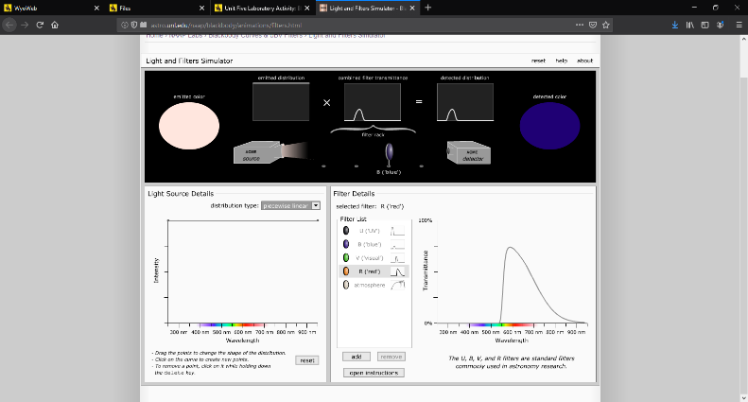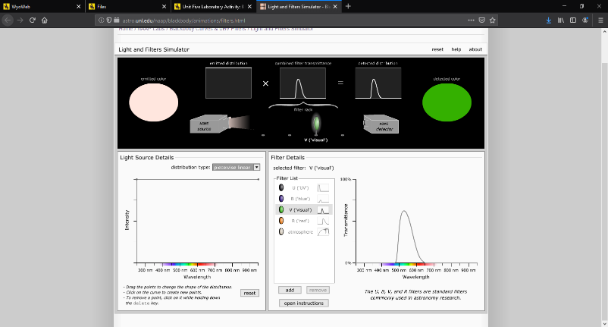

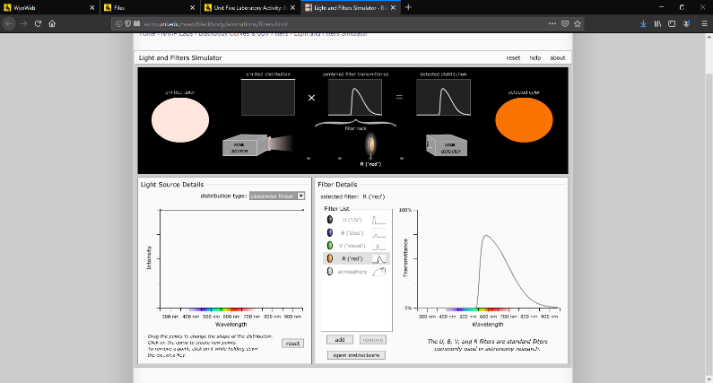

Question 2: With the flat white light source, what is the relationship between the filter transmittance and the detected distribution?

___With the filter applied to the flat white light, it effectively completely transforms the source light to a emitted distribution equal to the filter transmittance. In other words, the filter transmittance and the detected distribution are the same.___

* Add a new piecewise linear filter.
* Adjust the filter so that only large amounts of green light pass. This will require the addition of points.

Question 3: Use this green filter with the flat white light source. Do another print screen and paste the image below.

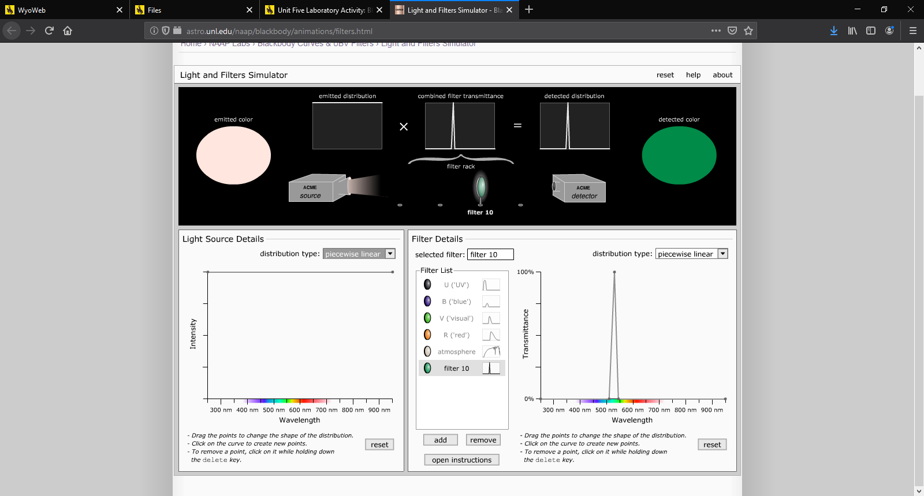

Question 4: Use the **blackbody** option in the *Light Source Details* panel to create a blackbody spectrum that mimics white light. Adjust the temperature of the blackbody and look at its color in the *emitted color* oval in the top portion until it looks white. What is the temperature of this blackbody you created? _6940K______________

* Add a new piecewise linear filter to the **filter list**.
* Modify the new filter to create a 40% “neutral density filter”. That is, create a filter which allows approximately 40% of the light to pass through at all wavelengths.
* Set up the simulator so that light from the “blackbody white light” source passes through this filter.

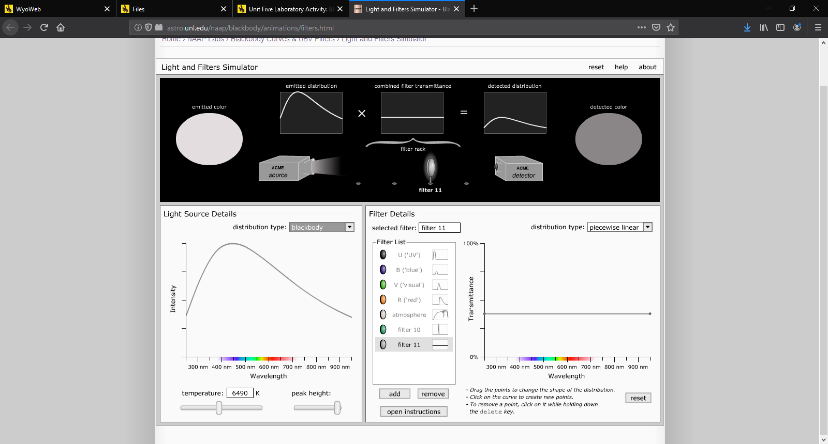Question 5: Do a print screen of the simulator window and paste the image below. (This situation crudely approximates what sunglasses do on a bright summer day.)

Question 6: Remove all filters in the filters rack. Place a B filter in the beam path with the flat white light source. Then add a second B filter and then a third. Describe and explain what happens when you add more than one of a specific filter.

____Since each filter not only prevents certain wavelengths from being transmitted, but also lowers the transmittance percentage of the light “seen” by each filter, by stacking the filters, this decrease compounds on itself resulting in a final transmittance percentage that is only a fraction of what it originally was. __

Question 7: Place a B filter in the beam path with the 40% neutral density filter you created above. Then add a V filter into the beam path. Describe **and explain** what happens when you add more than one filter to the filter rack.

_____Adding in both a B and a V filter completely removes all light from the detected distribution. Since the B filter completely filters out the ranges that are allowed by the V filter, and the V filter completely filters out the wavelengths that are permitted by the B filter, no light is allowed through the filter array. ____

Question 8: Create a piecewise linear filter that when used with the flat white light source would allow red and blue wavelengths to pass and thus effectively allowing purple light to pass. Do a Print Screen and paste the image below. 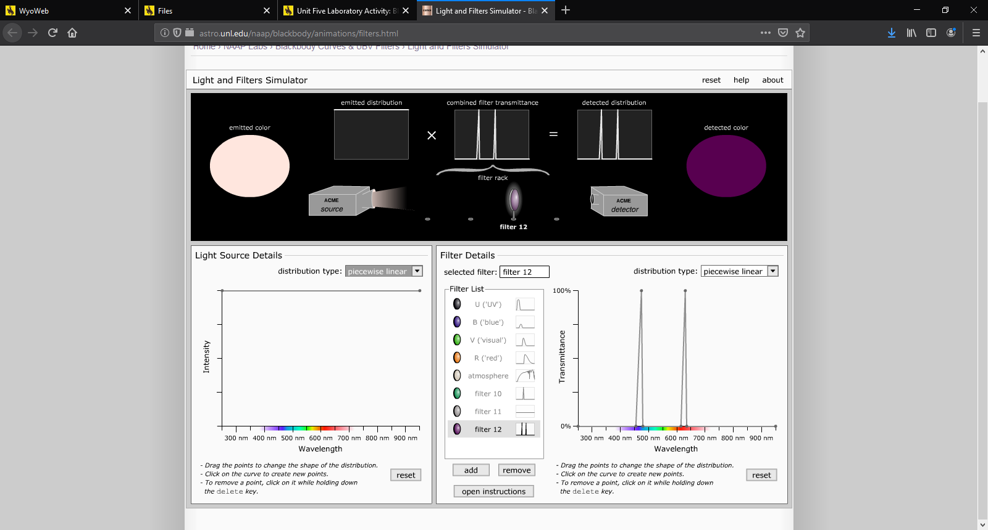

* Remove all filters from the **filters rack**.
* Create a very narrow **bell-shaped** source distribution that is peaked at green wavelengths (somewhere close to 550 nm). Notice the color.
* Expand the spread of the source distribution to maximum. Notice how the color changes.
* Change the distribution source to a **blackbody source** peaked at green wavelengths (a temperature close to 5270 K). Again notice the color.

Question 9: Using observations from the above actions, explain why we don’t observe “green stars” in nature, though there are indeed stars which emit more green light than other wavelengths.

__Since stars emit light with a far wider spread throughout the wavelengths than a simple bell curve distribution, the blackbody emittance far closer resembles the bell curve distribution with a large spread. Even when a bell curve was used, once a sufficiently wide distribution was observed, it appeared identical to the naked eye to the emitted color of the blackbody distribution centered on green wavelengths _____

**Blackbody – Curves Mode Familiarization**

The Blackbody Curve Simulator has two main modes – the *curves mode* and the *filters mode*. The curves mode allows the exploration of blackbody curves including their peak wavelength and the area under the curve which is related to their total energy production.

* Learn how to add and remove curves and change their temperatures.
  + Click the **add curve** button one or more times.
  + Change the temperature slider. Notice which curve changes.
  + Select a different curve and change the temperature.
  + Remove all but 1 or 2 extra curves.
* Learn the **vertical scale** options. Have 2 or 3 curves in the explorer.
  + Change temperature with the **auto scale all curves** mode.
  + Change temperature with the **auto scale to selected curve** mode.
  + Change temperature with the **lock scales** mode.
* Learn the **horizontal scale** options. Select the horizontal scale tab.
  + Note how changing the rightmost limit changes the view.
* Use, if desired, the **indicate peak wavelength** and **highlight area under curve** options.

**Blackbody Curves – Questions**

Question 10: Create a blackbody curve of temperature 6000 K. (Note, you can use the slider or simply enter 6000 into the temperature box.) Does it have a peak? Is it symmetric about this peak?

__Yes, the curve does have a peak. The simulator indicates that the peak is at 483 nm; however, the curve is not symmetrical about its peak. The curve is skewed right._________

Do a Print Screen and paste the image below.

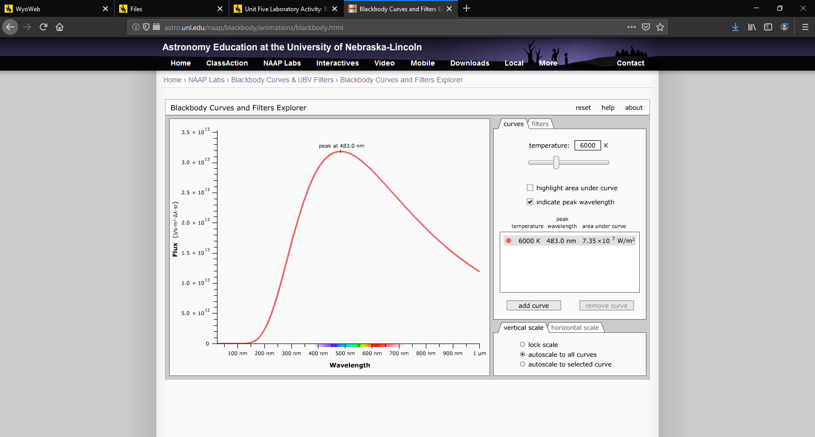

Question 11: Create a second curve using the **add curve** button and use the temperature slider to vary its temperature. Can you find a blackbody curve of another temperature that intersects the 6000 K curve? That is to say, the curves cross at one or more locations, but are not the same curve. Do you believe this would be true for two curves of any temperature?

__I cannot find a curve that appears to intersect with the original other than an identical curve. This makes some logical sense as the tails will only ever approach asymptotically and otherwise the peak of the curve will shift in such a way that they will not ever intersect._______________

Question 12: Make sure that there is only one curve and check **indicate peak wavelength**. Vary the temperature of the curve and note how the peak wavelength changes. Formulate a general statement relating the peak wavelength to temperature.

____In general, as temperature increases, the peak wavelength will decrease and peak Flux will increase. As temperature decreases, the peak wavelength will increase and peak Flux will decrease. _________

Question 13: Select the **highlight area under curve** option and lock the vertical scale. Vary the temperature of the curve and note how the area under the curve changes. Formulate a general statement relating the area under curve to temperature.

____In general, as the temperature increases, the area under the curve increases. Likewise, as the temperature decreases, the area of the curve also decreases. ______

Do a Print Screen and paste the image below.

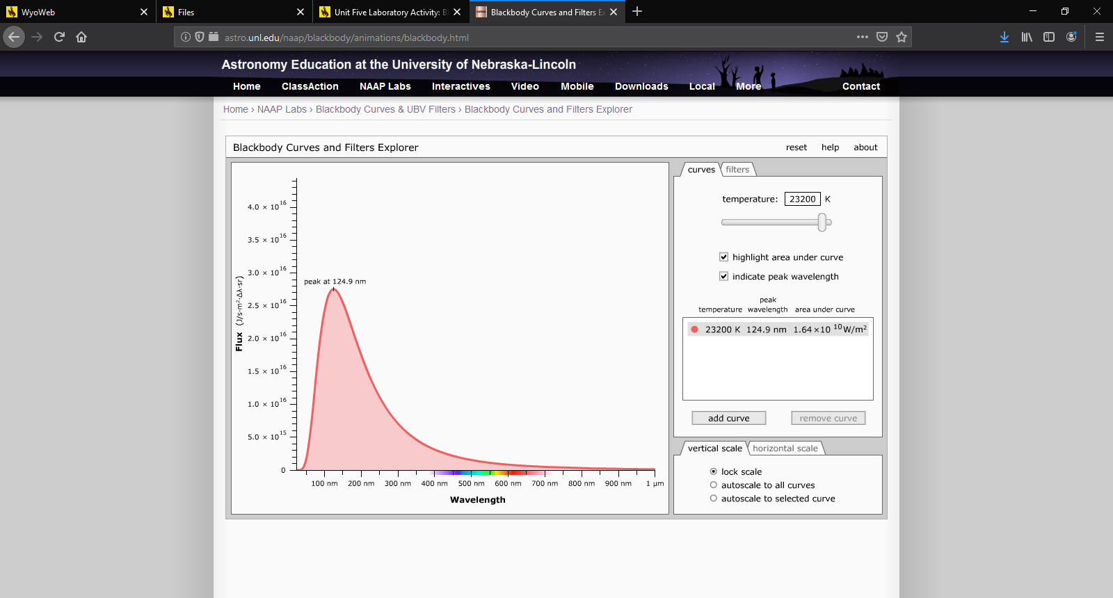

Question 14: (Calculator Required) Complete the following table below. The “Area Ratio” is the area for the curve divided by the area for the curve in the row above. This will tell you how many times greater the new ratio is compared to the previous one.

|  |  |  |
| --- | --- | --- |
| Curve Temperature | Area under the curve (Watts/square meter) | Area Ratio |
| 3000 K | 4 590 000 | 16.013  16.054  15.932 |
| 6000 K | 73 500 000 |
| 12,000 K | 1 180 000 000 |
| 24,000 K | 18 800 000 000 |

Can you specify a more precise statement relating the area under curve to temperature?

____The area underneath the curve increases at a rate of 16 times for every doubling of the curve temperature in an exponential relationship. _______

**Blackbody Explorer – Filters Mode**

The second mode is the filters mode and explores the use of UBVR filters with blackbody curves. Remove all but one curve from the Blackbody Curves.

* Unselect **highlight area under curve** and **indicate peak wavelength**. Select the **filters** tab.

The light from a blackbody curve that passes through the UBVR filters are shown as colored areas under the curve. *It is this area which is later translated into a number for color magnitude. Remember that a magnitude is a logarithmic version of the flux (i.e. the amount of light) that passes through a filter and that lower numbers reflect larger fluxes.* Note that this area depends on both the source and the filter. What is listed as a V value is the apparent magnitude of a star (assumed to blackbody which isn’t exactly true) through the V filter.

Question 15: Vary the temperature and in the table below note the temperature at which each filter peaks. Where are the filters most sensitive, i.e. which temperature will give the strongest response in a detector?

|  |  |
| --- | --- |
| **Curve** | **Peak Temperature** |
| **U** | 11100 |
| **B** | 8450 |
| **V** | 7060 |
| **R** | 5720 |

Question 16: Use the color index feature to create a B-V index. This will compare the apparent magnitude of a star through the B filter to that through the V filter.

|  |  |
| --- | --- |
| **Temperature** | **B – V** |
| **3000 K** | 1.65 |
| **4000 K** | 1.06 |
| **5000 K** | 0.69 |
| **6000 K** | 0.45 |
| **8000 K** | 0.15 |
| **10,000 K** | -0.02 |
| **15,000 K** | -0.24 |
| **20,000 K** | -0.34 |
| **25,000 K** | -0.39 |

Question 17: At what temperature is B – V = 0? _9680_____________

Write a conclusion for this laboratory activity. Be thorough and write at a college level. Use correct spelling and grammar.

In conclusion, this lab not only demonstrates the tools that astronomers can use to discover various properties of the stars they’re using, but also the ways in which blackbody emitters behave in space. First, this lab shows that filters upon light are an incredibly effective tool for determining the type of emissions coming from stars. By varying the type of filter and measuring the emitted light that is allowed through, conclusions about the temperature of stars can be mad through nothing more than their light. Next, this lab explored the relationship between temperature and the amount of Flux that would be emitted from a light source. Finally, we are able to see that by measuring the difference between two filter’s of light’s observed emittance the peak wavelengths of blackbody light can be measured, giving further insight into the temperature of the emitting stars. Using this information, astronomers could glean even more information about stars, such as where they are in their lifecycle, where they sit on an HR diagram, or even if the star is dying. This lab demonstrated these techniques in a clear visual manner that measuring light is an important tool for understanding space.

