The images in the instructions below may look somewhat different than what you see on your screen as they were collected on an older version of the software. I will update images as soon as possible.
The pages associated with this manual are copyrighted by Project CLEA.

Goals
You should be able to use photometry to determine the relative apparent and absolute magnitude of stars in a cluster in order to calculate the distance to the cluster.

Objectives:

If you learn to .......
- Use a simulated photometer to measure the apparent UBV magnitudes of stars.
- Make and compare H-R diagrams to find the relationship between absolute and apparent magnitudes.

You should be able to ......
- Determine the distance to a star cluster.

Introduction
The computer program you will use a realistic simulation of a UBV photometer attached to a moderate sized research telescope. The telescope is controlled by a computer that allows you to move from star to star and make measurements. Different filters can be selected for each observation, and the integration time (the length of time the photometer samples the starlight) is adjustable. The computer also does much of the busy work needed to convert photon counts into apparent magnitude and provides an estimate of the quality of the collected data.
You will use this instrument to collect data on 24 stars in the region of the Pleiades star cluster. The apparent magnitudes will be measured for each star, in each of three colors (though one color is not in the visible portion of the spectrum). We will assume all of these stars are approximately the same distance away. This is a necessary assumption, and reasonable because all of the stars are members of the same cluster. If we did not make this general assumption, the apparent magnitudes of the stars would also depend on their individual distances, an effect we cannot easily take into account in this lab.
From this information you will plot a Hertzsprung-Russell (H-R) diagram which will display the apparent magnitude of the cluster of stars as a function of their color index. The color index, B-V, is the apparent blue magnitude (B) minus the apparent visual magnitude (V).
Knowing the apparent and absolute magnitude of a star, you can determine its distance (in parsecs) from equation 1 below:
d = 10 x 10^{[(m-M)/5]} | (1)
where
- m = the apparent magnitude
- M = the absolute magnitude
- d = the distance in parsecs
Be careful of parentheses and exponents in equation 1.
Let’s do an example with this equation:
Suppose you find that a B - V value of 0.5 gives you an apparent magnitude of m = 10.8 and an absolute magnitude of M = 2.1 (from the Table I stars) (these numbers are bogus and for example only).
Then: m - M = 10.8 - 2.1 = 8.7
8.7/5 = 1.74
10^{1.74} = 55
(I have rounded this value off. The 10^{x} button on a calculator is often the INV LOG button, or a similar sequence of buttons.)
10*55 = 550 parsecs
550 parsecs * 3.26 light years/parsec = 1800 light years (I've rounded off again)

Operating the Computer Program
Start the VIREO program.
If the program is running properly the CLEA logo screen should appear in a short time. Note the Menu at the top. Click on File/Login to get the student accounting dialog box.
Entering Student Accounting Information
Enter your name (first and last), and those of your lab partners (if any). Do not use punctuation marks. Press tab after each name is entered, or click in each student block to enter the next name. Ignore the table number box. You can change and edit your entries by clicking in the appropriate field and making your changes. When all the information has been entered to your satisfaction, click OK to continue, and click Yes when you are asked if you are finished logging in. The opening screen of the VIREO program will appear.
Figure 1: the VIREO screen after logging in

Open the Observatory
Click the File/Run Exercise/ “Photoelectric Photometry of the Pleiades” option on the menu bar on the opening screen. After a moment a screen will appear waiting for you to access a telescope. Click Telescope/Optical. At this point you can choose the 0.4 m telescope immediately or you can request time on a larger telescope. Larger telescopes will collect more light and allow faster data collection. This can be very handy when you are collecting information on dim stars. (How will you know a dim star from a bright star?) I recommend skipping dim stars till the end. Then request time on a big telescope and collect data on those stars. Access the 0.4 m telescope.
The telescope dome window will appear. The dome is currently closed. See the figure below. Open the dome by clicking on the “Open” button.
Figure 2: the telescope dome control panel

The center of the screen is the view of the night sky (when the dome is open). Click the Telescope Control Panel button. It is currently “Off” in the figure above. Clicking on it will turn it on. Controls and readouts are to the left and right of the view. See the figure below. Take a moment to study the various controls available to you using the following explanation:
Figure 3: the telescope control panel

Telescope and Controls and Readouts
Tracking Turns on/turns off the telescope drive. Turning tracking ON causes the telescope to counteract the effect of the Earth’s rotation and is necessary in order to take measurements. Turning tracking OFF allows the star field to drift through the field of view as the Earth turns. Turn tracking on. The green light next to the button will light and the star field will stop moving.
Slew Rate Controls the rate of telescope movement when the N, E, S, W direction controls are pressed. The slew rate can be set to 1, 2, 4, 8, or 16. The larger the number, the faster the movement rate. Slow speeds are useful for centering a star image. Faster rates are useful for quickly moving from star to star.
N, S, E, W Directional controls. Click one of these buttons to cause the telescope to move north, south, east, or west. When the telescope is moving, a red light next to the direction button glows. Movement in the selected direction continues while you hold down the button.
Right Ascension Displays the celestial coordinates of the center of the field of view. Right Ascension is displayed in hours, minutes and seconds.
Declination is displayed in degrees, minutes and seconds.
On the right side of the screen you will see a switch to view from either the Finder Scope (the current view) or the main Telescope. You will use the finder scope when moving around the sky as it offers a larger field of view. You will use the main telescope when you are ready to take measurements with the Photometer. Note that only the Photometer is selectable in this lab.

CLEA Photometer Window (you will see this new window after centering a star in the instrument view and clicking on Take Reading)
Filter Clicking this button cycles the color filters through U (ultraviolet) , B (blue) and V (visible).
Seconds Selects the duration of any given integration, or how long light is collected for each reading. The time can be set from 0.1 to 100 seconds. The dimmer a star, the longer the integration time will have to be in order to get an accurate measure of the light.
Integrations Adjusts the number of times a measurement is repeated. Multiple readings are averaged.
Start Count Clicking this button begins a set of measurements, (how many is determined by the setting of Integrations), of a particular time each (how long for each measurement is determined by the setting Seconds), through the filter selected by the Filter button.
NOTE: Before you can start taking readings of stars you must first take initial "sky" readings through all three colored filters. If you forget to take a sky reading, an error message is displayed and a real reading is not taken.
Some additional information is displayed once a reading of the sky or a star is taken:
Obs UT The UTC, or Universal Coordinated Time, at the prime meridian at Greenwich, England.
JD The Julian Date of the OBS UT. The Julian Date is a continuous count of the number of days and fractions of a day since the year -4712. The new Julian Day starts at noon UTC.
Elapsed The number of Seconds that have elapsed since any particular reading began.
Completed The number of Integrations done so far in the sequence of readings being taken.
Raw Counts The photometer simulates a photon-counting photometer. The count of the number of photons captured during the individual reading.
SN Ratio We assume that the only error in the counting of the photons is their randomness defined by quantum mechanics. The square root of the sum of the Raw Counts is the fractional error in the reading. A SN Ratio of 100 is needed for a fractional error of 1% (which is 0.01 magnitude). The higher the SN Ratio the lower the fractional error. The SN Ratio, if not high enough, can be raised by increasing the Seconds or the number of Integrations.
Mean Sky Count/Sec The number of mean counts contributed by the sky through a particular filter (determined when the sky reading is taken) divided by the seconds, giving a normalized photon rate in counts per second.
Magnitude The apparent magnitude of the star, through a particular color filter, based on the mean of the counts adjusted by the appropriate Mean Sky Count/Sec.

Now It’s Time to Move to a Star
Once the observatory is opened, the directional controls can be clicked to move the telescope around in the sky. The red square in the center of view is the field of view seen by the photometer when you engage the Photometer mode. When you are in the Photometer mode, the small red circle in the center of the field of view is called the photoelectric aperture and is the portion of the sky being examined by the photometer. The desired star must be carefully centered within the aperture. Otherwise, some of the light from the star spills out of the aperture and is missed during measurement.
The rotation of the earth will cause the stars to drift through the view. Observe this phenomenon by carefully watching the stars with Tracking turned off.

1) Earth rotates in which compass direction? East
2) With tracking off the stars drift in which compass direction? West
Telescopes are equipped with a motor drive which moves the telescope in a direction opposite to the drift and at the same rate. The motor (often called the clock drive) cancels the effect of the earth’s rotation and the star seems to stand still permitting extended study. Click on Tracking and note how the stars cease to drift. You must have the telescope tracking before you can operate the photometer.
The directional controls, N, E, S, W, move the telescope with respect to the sky. Moving the telescope to the west appears to make the stars move to the east. Try it. The Slew Rate control adjusts in steps and changes how much the telescope is moved when the directional controls have been activated. Try various settings of the Slew Rate and move the telescope around in all directions.

Set up and Take SKY Readings
Since the aperture is much larger than the star under study, and the sky is not perfectly dark, the sky within the aperture contributes a certain number of photons. These unwanted photons are counted by taking a sky reading. The star to be measured is then centered in the aperture and a star reading is taken. It is important that both the sky and the star reading be taken through the same color filter. Then the true photon count for the star by itself is approximated by the star reading minus the sky reading.
Make sure the Tracking is on, and click on the View button to see through the telescope. The red square in the center is now a small red circle. This is what the photometer will be viewing. Access the Photometer by clicking the Access button in the Instrument area of the control panel. A new window opens up (see the figure below).
Figure 4: the photometer control panel
Some of the points of interest in this control panel:
Filter Clicking this slider to choose the color filters required. U (ultraviolet) , B (blue) and V (visible), R (red), I (infrared).
Integration Seconds Selects the duration of any given integration, or how long light is collected for each reading. The time can be set from 0.1 to 100 seconds. The dimmer a star, the longer the integration time will have to be in order to get an accurate measure of the light. (Remember you may want to request a larger telescope for dimmer stars.)
Integrations Adjusts the number of times a measurement is repeated. Multiple readings are averaged.
Start Clicking this button begins a set of measurements, (how many is determined by the setting of Integrations), of a particular time each (how long for each measurement is determined by the setting Seconds), through the filter selected by the Filter button.
NOTE: Before you can start taking readings of stars you must first take initial "sky" readings through all three colored filters. If you forget to take a sky reading, an error message is displayed and a real reading is not taken.
While using the 0.4m telescope, what are the sky readings for the three filters used (U, B, and V)? U: [5, 2, 7] B: [4, 5, 10] V: [15, 22, 14]
Some additional information is displayed once a reading of the sky or a star is taken:
Elapsed The number of Seconds that have elapsed since any particular reading began.
Completed The number of Integrations done so far in the sequence of readings being taken.
Raw Counts The photometer simulates a photon-counting photometer. The count of the number of photons captured during the individual reading.
SN Ratio We assume that the only error in the counting of the photons is their randomness defined by quantum mechanics. The square root of the sum of the Raw Counts is the fractional error in the reading. A SN Ratio of 100 is needed for a fractional error of 1% (which is 0.01 magnitude). The higher the SN Ratio the lower the fractional error. The SN Ratio, if not high enough, can be raised by increasing the Seconds or the number of Integrations.
Mean Sky Count/Sec The number of mean counts contributed by the sky through a particular filter (determined when the sky reading is taken) divided by the seconds, giving a normalized photon rate in counts per second.
Magnitude The apparent magnitude of the star, through a particular color filter, based on the mean of the counts adjusted by the appropriate Mean Sky Count/Sec.

Move the telescope until the aperture (red circle) is free of any star. Select a Filter. Set Seconds to 10 seconds, and Integrations to 5. Then click on Take Reading and wait for the reading. Repeat the procedure for each color filter and record the results. Be sure to Record Readings after you have measured with all 3 filters (U, B, and V). This will start your data collection process. You will also want to save this file after every couple of stars in case the data needs to be reviewed.
Using the 0.4 m telescope what are the sky readings for the various filters? You will need to retake the sky readings if you decide to use a larger telescope. This may be worth the extra time when you are measuring faint stars.
3) The sky reading for the V filter is __150, 164, 167, 147, 158__.
4) The sky reading for the B filter is _76, 63, 62, 62, 69___.
5) The sky reading for the U filter is __58, 38, 60, 46, 46_____.

Take a Reading and Record the Results
Now it is time to measure the stars. Be sure the Photometer Control Panel is switched to Object in the Reading box. The right ascension and declination of the aperture center are displayed in the lower left of the screen. Select a filter (U, B, or V) (I recommend starting with the U filter).
You can have the telescope automatically move to the stars on the “Hot List.” From the Telescope Control Panel window chose Slew/Observation Hot List/View/Select from List. A window with all of the star coordinates opens up. Start with Star 1. Double click the star. A new window opens showing the star’s coordinates. Click OK and say Yes to have the telescope slew to that star. Carefully center a star in the aperture and take a reading. (Again, the number of integration is probably fine at 3, the number of seconds will depend upon the brightness of the star. But you want a SN Ratio of more than 100.) The computer will take a series of integrations depending upon the setting of Integrations, and display the individual and average photon counts in the raw count box on the right.
Select an integration time (0.1 s, 1 s, 10 s, 100 s). Use short integration times for bright stars to save time, and long integrations for faint stars. Integration times are in seconds. Bright stars generate many photons, and cause high counts. NOTE: Keep track of stars requiring integration times of 100 s to get a SN ratio of 100 or more. Save these stars for later and try to get time on the larger telescopes to measure them. The larger telescopes will be able to measure them in less than 100 s and still get a SN ratio of 100 or more. That will save you time in the end.
6) Using the star numbers from the "Hot List," which stars required times of 100 seconds on the 0.4 m telescope in order to get a SN ratio of at least 100? 7, 9ub, 11ub, 15ub, 18,
Note: an integration time of 100 s may be required of one filter but not necessarily the other filters. It might be worth noting which filter seems to give the lowest signal to noise ratio. It could be worth mentioning this in the conclusion and trying to explain why.
7) As you look at these stars in the telescope, what characteristic did they all have in common?
All three of them were very dim when viewed through the control panel.
After the integrations are completed, the computer considers the appropriate sky reading for the filter you used and the apparent magnitude of the star is displayed in the lower right corner of the photometer.
Also displayed is the signal-to-noise ratio or SN Ratio of the reading. A high SN Ratio means you have a lot of desired photons, and only a little noise. You should strive for SN Ratios of 100 or more. You can increase the SN Ratio by increasing the integration time because the SN Ratio is directly proportional to the square root of the total collected raw counts.
Carefully center the star in the aperture and measure the B and V apparent magnitudes. Collect data through the U Filter, too. Click on File/Data/Record/Review. You should get a window similar to what you see below. Click OK to save this data. But you are not done saving.
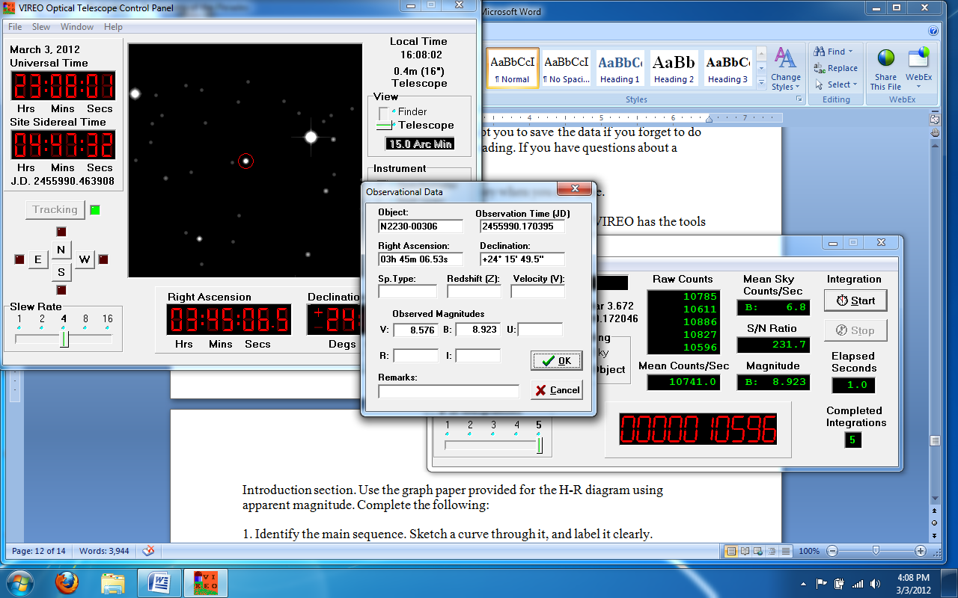
Figure 5: the Observational Data window for saving data
Once you have taken your observations you can save the data to disk (the above save did not do that). From the main VIREO window click on Tools/Results Editor/Observational Results/Save Data.
8) Do a screen copy of the VIREO Optical Telescope Control Panel window, the Observational Data window, and the VIREO Photometer Control window (similar to Figure 5 above, but with all three windows visible) and paste it into the lab report document.
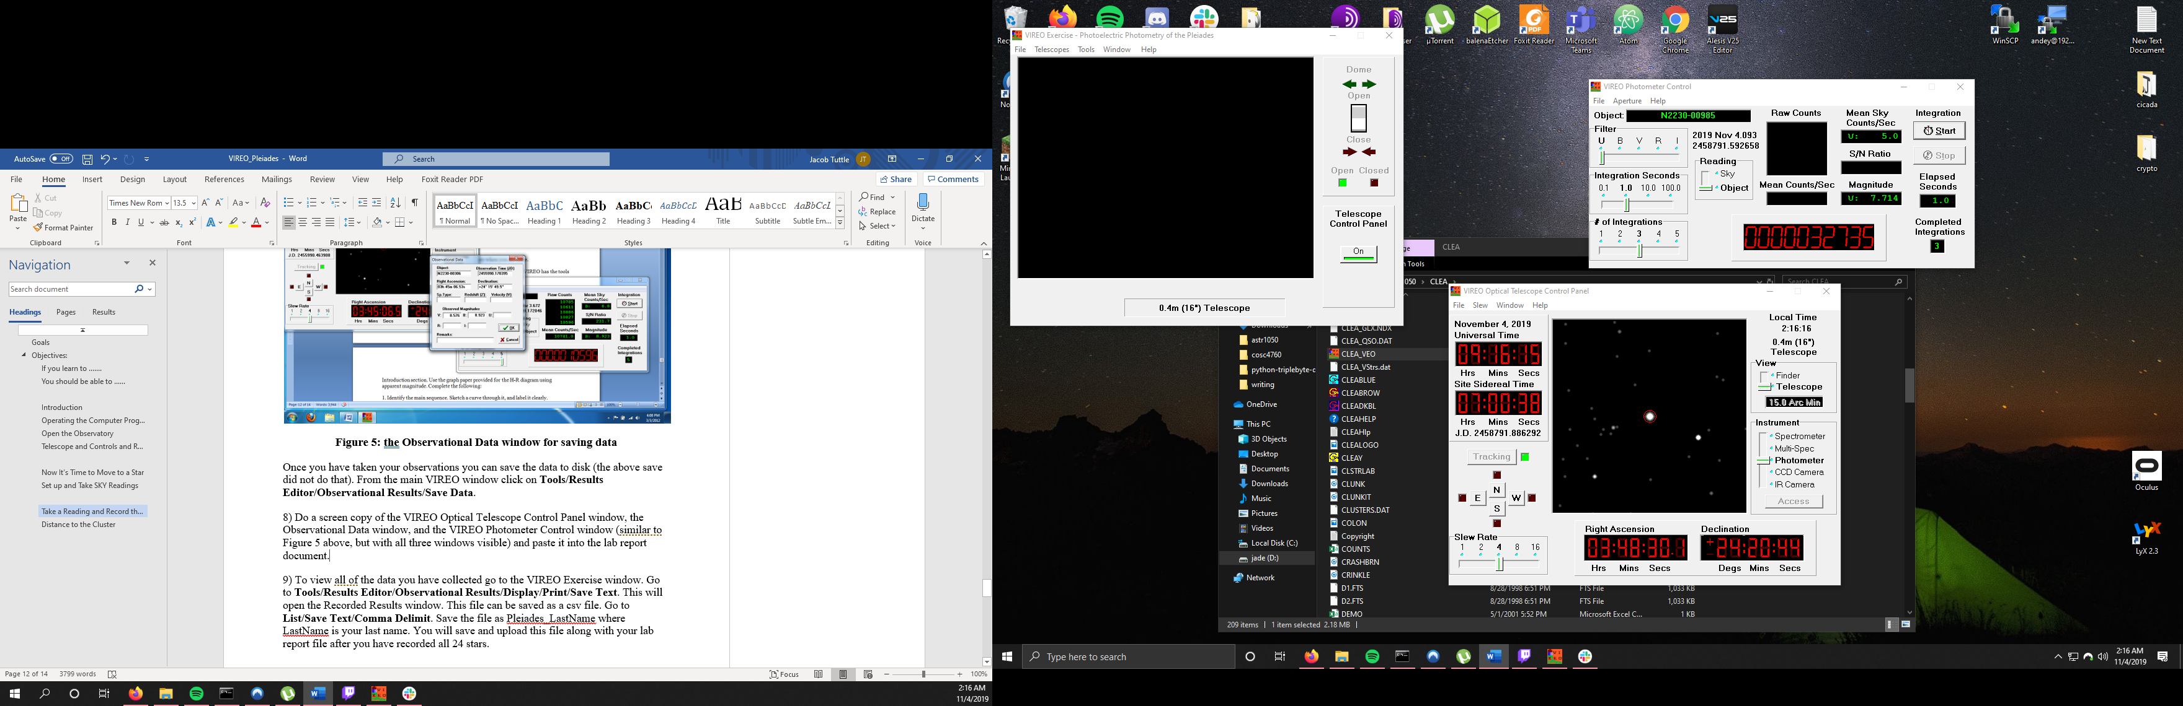
9) To view all of the data you have collected go to the VIREO Exercise window. Go to Tools/Results Editor/Observational Results/Display/Print/Save Text. This will open the Recorded Results window. This file can be saved as a csv file. Go to List/Save Text/Comma Delimit. Save the file as Pleiades_LastName where LastName is your last name. You will save and upload this file along with your lab report file after you have recorded all 24 stars.
Continue recording for all 24 stars. Turn off the tracking and close the observatory when you are done.
Once you have all 24 sets of star data you are ready for analysis. VIREO has the tools that will help you do this task. To analyze the H-R diagram go to Tools/H-R Diagram Analysis from the main Pleiades window. The Color-Magnitude Diagram window will open. You will want to display the Zero Age Main Sequence curve along with your data points. To do so select Tools/ Zero Age Main Sequence. The diagram will look similar to the window below only you will have many more stars than are displayed there. The sliders on the side can be used to align the Zero Age Main Sequence with the main sequence of stars from your diagram. You will note the value of V – M_{V} is displayed in the lower corner when you have it aligned to your taste. V – M_{V} is the same as m – M in the formula given earlier in the lab. This is referred to as the distance modulus.
Figure 6: an H-R Diagram

The Zero Age Main Sequence is not yet aligned in Figure 6. Once it is aligned the lower right corner will display the distance modulus. When you have it aligned to your satisfaction copy the image to the lab report document.
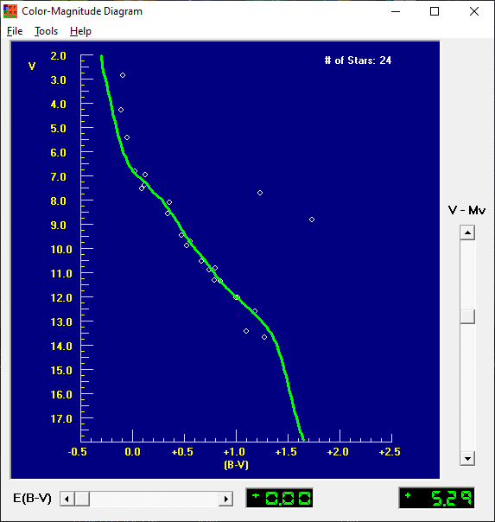
11) In the upper right portion of the H-R Diagram you will see stars off the main sequence. These are red giants. Identify these stars by their star number on the “Hot List.” 17, 1

Distance to the Cluster
12) Use the equation (1) in the Introduction to calculate the distance to the cluster in parsecs. Show your steps slowly and carefully so I can follow them.
10*10^(5.29/5) = 114 parsecs
13) In 1958, H.L. Johnson and R.I. Mitchell calculated the distance to this cluster to be about 410 light-years (you need to covert this to parsecs). How does your calculated value compare? My calculated value produces a result of approximately 372 light-years. This distance could be a combination of a number of variables, the differences in SN ratio (some values were considerably higher than 100 giving a far more accurate reading than others) or some problem related to the precision of the telescope used in the lab.
14) Using only your graphs and results, calculate the apparent magnitude of the Sun if it were located in the Pleiades cluster. Explain your procedure in a narrative, and show all your math. You will need to look up the color index of the sun.
Using work from Ramirez (arXiv:1204.0828v1 [astro-ph.SR]) it has been shown that the sun has a B-V value of 0.653 which results in an apparent magnitude of 10 on the HR diagram generated within this lab.

Below is the CSV data since the lab submission page online would only accept a DOC or DOCX machine
Object ID,MJD(Days),RA,,,Dec,,,U,B,V,R,I,Z,Spectrum,Comments
N2230-01442,8791.515251,3,41,18.0,23,58,00,12.609,10.546,8.810,,,,,
N2230-00478,8791.518211,3,42,55.1,24,29,36,9.966,9.948,9.468,,,,,
N2230-00526,8791.519711,3,44,06.6,24,20,12,12.449,12.115,11.320,,,,,
N2230-00306,8791.521516,3,45,06.5,24,15,50,9.074,8.922,8.580,,,,,
N2230-01585,8791.522012,3,45,12.5,24,28,02,3.740,4.181,4.291,,,,,
N2230-00156,8791.522867,3,45,40.2,24,37,39,10.322,10.266,9.710,,,,,
N2230-01554,8791.528454,3,45,42.4,25,03,26,15.304,14.535,13.439,,,,,
N2230-00319,8791.535872,3,45,43.2,24,16,13,11.401,11.213,10.548,,,,,
N2230-00990,8791.538166,3,45,48.4,24,52,43,13.906,13.058,12.040,,,,,
N2230-01908,8791.543845,3,46,27.3,24,15,18,7.628,7.512,7.394,,,,,
N2230-02089,8791.544644,3,46,27.8,23,35,35,13.555,13.017,12.018,,,,,
N2230-01621,8791.547966,3,46,34.2,23,37,27,8.775,8.461,8.101,,,,,
N2230-01627,8791.548484,3,46,50.5,23,14,22,10.491,10.427,9.903,,,,,
N2230-02081,8791.549219,3,46,59.3,24,31,12,6.654,6.831,6.810,,,,,
N2230-01820,8791.549966,3,47,01.4,24,22,24,14.866,13.781,12.599,,,,,
N2230-02202,8791.559182,3,47,29.1,24,06,18,2.432,2.779,2.869,,,,,
N2230-02192,8791.559800,3,47,36.9,23,36,34,10.047,8.938,7.708,,,,,
N2230-02091,8791.563735,3,47,50.8,24,40,45,16.091,14.960,13.687,,,,,
N2230-02449,8791.583667,3,48,13.4,25,05,56,11.864,11.641,10.903,,,,,
N2230-02207,8791.585672,3,48,20.8,23,25,16,5.050,5.374,5.427,,,,,
N2230-01601,8791.586048,3,48,30.1,24,20,44,7.164,7.072,6.949,,,,,
N2230-01175,8791.587024,3,49,07.5,24,00,40,11.964,11.627,10.830,,,,,
N2230-01127,8791.590949,3,49,25.1,23,47,42,12.512,12.199,11.345,,,,,
N2230-00985,8791.592457,3,49,56.6,24,20,56,7.714,7.638,7.544,,,,,

