This is a file saved in MS Word format. Fill in the tables below, answer the questions at the end, save it and upload it to the Unit 1 Laboratory Activity Assignment dropbox. During the save process, use “Save As” and remember to change the file name to lab01_lastname where lastname is your last name. Failure to do so will mean no points. Future labs will save in a similar fashion.

Fill in the information described in the left cells in the blank cells to their right.

First Name | Jacob | Favorite Color | Pink
Last Name | Tuttle | Favorite Movie | The Imitation Game
Current City and State of Residence | Laramie, Wy | Favorite Book | Cult of the Dead Cow
Last math class passed | Math 2300 Discrete Structures | Semester of the last math class passed | Spring 2019

An internet class takes time and scheduling. In the table below, fill in your schedule for the week. Include time to sleep and eat, time for studying for this class and other classes (Important: specify which classes when you label study time. For example specify when you study ASTR1050, POLS1000, MATH1400, etc. using course numbers to be specific.) Include time for work and commuting to work or school, time for your family … everything. Use this schedule as much as possible for the rest of the term. You will end up making alterations from week to week, but having study time scheduled will help you to keep on track.

 | Sunday | Monday | Tuesday | Wednesday | Thursday | Friday | Saturday
12:00 AM | Sleep | Sleep | Sleep | Sleep | Sleep | Sleep | Sleep
01:00 AM
02:00 AM
03:00 AM
04:00 AM
05:00 AM
06:00 AM | End sleep | End sleep | End sleep | End sleep | End sleep | End sleep | End sleep
07:00 AM |  | Yoga |  | Yoga |  | Yoga
08:00 AM |  | TEALS |  | TEALS |  | TEALS
09:00 AM |  | TEALS | 3020 | TEALS | 3020 |  | 1050 Reading
10:00 AM | 1050 Lab | 4760 | 3020/  3015 | 4760 | 3020/  3015 | 4760 | 1050  Reading
11:00 AM | 1050 Lab | Lunch | 3015 | Lunch | 3015 | Lunch | 1050  Reading
12:00 PM | Lunch | Work | Lunch | 1050 HW | Work | Work | Lunch
01:00 PM |  | Work | 1050 HW | 3020 HW | Work | Work | 4760 HW
02:00 PM | 3015 HW | Work | 3020 HW | 3020 HW | Work | Work | 3015 HW
03:00 PM | 4760  Reading | Work |  | 3020 Lab | Work | Work | 3015 Reading
04:00 PM | 4760 Reading | 4760 Reading | CF Practice | 3020 Lab | Lunch | Work | 3015 Reading
05:00 PM |  | 4760 HW | CF Practice |  | Work
06:00 PM | Dinner | Dinner | Dinner | Dinner | Work | Dinner | Dinner
07:00 PM |  | Tri Practice |  | Tri Practice | Work
08:00 PM |  | Tri Practice |  | Tri Practice | Work
09:00 PM |  |  |  |  | 4760 HW
10:00 PM | Reading | Reading | Reading | Reading | Reading | Reading | Reading
11:00 PM | Decom-press | Decom-press | Decom-press | Decom-press | Decom-press | Decom-press | Decom-press

The questions below pertain to the Project CLEA software you downloaded. You will need to install the software in order to answer the questions. So please install and run the software. You will need to log in to each program in order to answer the questions. Some of the answers may be greyed out.

When you run the Revolutions of the Moons of Jupiter software, what is the second choice under the menu setting File/Preferences?

Run…

When you run the Astrometry of Asteroids program, what is the first choice under the menu setting File/Load Image Files?

Login…

Run the VIREO program. Go to File/Run Exercise…

When you run the “Photoelectric Photometry of the Pleiades” exercise, what is the second choice under the Tools menu setting?

HR Diagram Analysis

When you run the “Radio Astronomy of Pulsars” exercise. What is the top choice under the menu setting Telescopes?

Radio

When you run the “Hubble Redshift Distance Relation” exercise, what is the bottom choice under Telescopes/Optical?

Access 4.0 Meter

While you run the Hubble Redshift Distance Relation software copy the screen to the clipboard and paste the image below. To do this press Shift-Ctrl-Prt Scr at the same time. Some keyboards may not have Prt Scr. You may need to do a Google search to find out how to do a screen capture on your computer. This copies the image of your entire desktop to the clipboard. Then move the cursor to the line below in this document and right-click and choose paste. The image should be pasted into this document. Save the document and upload to the eCollege dropbox when completed. If you have trouble with any software while taking this class you can use this process to help me see what kind of trouble you might be having.
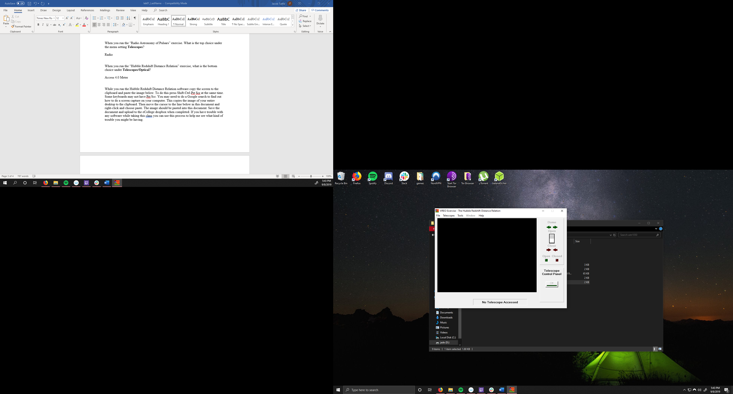

Important Note: Most, if not all labs this semester will require a screen shot. Be sure the entire task bar (the area along the bottom of the screen) is visible and legible in the image. Among other things I want to be able to determine software running on your computer. This is required!!!

