**Table I: Right Ascension and Declination of 0628-28**

|  |  |
| --- | --- |
| Right Ascension | Declination |
| 6.30.49.5 | -28.34.44 |

**Table II: Pulse Times**

|  |  |
| --- | --- |
| Time of First Pulse (T1) | 0.73 |
| Time of Second Pulse (T2) | 1.99 |
| Period of Pulsar (T2 - T1) | 1.26 seconds |

**Table III: Pulse times over 10 cycles**

|  |  |
| --- | --- |
| Time of First Pulse (T0) | 0.24 |
| Time 10 Periods Later (T10) | 12.76 |
| Period of Pulsar = (T10 - T0)/10 | 1.252 seconds |

**Table IV: Periods versus Frequencies**

|  |  |  |  |  |
| --- | --- | --- | --- | --- |
| Frequency | Time of First Pulse | Time of Last Pulse | Number of Periods | Period of Pulsar |
| 400 MHz | 0.60 | 15.52 | 12 | 1.243 |
| 600 MHz | 0.12 | 15.04 | 12 | 1.243 |
| 800 MHz | 1.16 | 14.84 | 11 | 1.243 |
| 1000 MHz | 1.08 | 14.76 | 11 | 1.243 |
| 1200 MHz | 1.04 | 14.72 | 11 | 1.243 |
| 1400 MHz | 1.24 | 14.96 | 11 | 1.247 |

1. What is the relationship between the frequency detected by the telescope and the period of the pulsar?
2. The higher the frequency, the higher the period.
3. The higher the frequency, the smaller the period.
4. The period is the same for all frequencies.
5. The period is changing with no dependency upon frequency.
6. How does the pulsar signal strength depend on frequency?
   1. The higher the frequency, the stronger the signal.
   2. The higher the frequency, the weaker the signal.
   3. The signal strength does not change with frequency.
   4. The signal strength is changing, but apparently at random.
7. If I am hunting for pulsars in the sky I have not detected before, the best frequency to tune the receiver is __400 MHz__.
8. Why?

The background noise is very minimal when compared to the spikes that are seen in observations of this pulsar at that frequency.

**Table V: Period of Different Pulsars**

|  |  |  |  |  |  |  |  |
| --- | --- | --- | --- | --- | --- | --- | --- |
| Pulsar | Frequency | Starting Pulse Time | Last Pulse Time | Number of Periods Elapsed | Period | Relative Strength | Age Rank (A is Youngest) |
| 0628-28 | 600 | 0.12 | 15.04 | 12 | 1.243 | Second strongest | C |
| 2154+40 | 600 | 1.24 | 14.96 | 9 | 1.524 | Second weakest | D |
| 0740-28 . | 600 | 5 | 5.64 | 4 | 0.160 | Strongest | B |
| 0531+21 (Crab) | 1000 | 2.59 | 2.82 | 7 | 0.032 | weakest | A |

12. What can you say about the arrival times of pulses at higher frequencies? Do they arrive earlier or later than the pulses at lower frequencies?

The pulses arrive at different times. As the frequency increases, we see that pulses arrive marginally sooner. We know that due to interstellar dispersion, the arrival times for higher frequencies are marginally sooner.

Watch for consistency in your distances. If the three (3) distances in Table VI are not around the same value (say within 10% of each other) you have probably made a mistake. None of the distances are negative. If you get a negative answer you are making an error.

#### Table VI: Pulsar Dispersion Data for 0628-28 (File Name _____________________________)

|  |  |  |  |  |
| --- | --- | --- | --- | --- |
| T400 | | 6.84 | | |
| T600 | | 6.34 | | |
| T800 | | 6.18 | | |
| Frequencies | | T2 - T1 | (1/f2)2 - (1/f1)2 | D (pc) |
| f1 | f2 |  |  |  |
| 600 | 400 | 0.5 | 3.472E-6 | 1156.627 |
| 800 | 400 | 0.66 | 4.688E-6 | 1130.924 |
| 800 | 600 | 0.16 | 1.215E-6 | 1057.487 |

#### Table VII: Pulsar Dispersion Data for 2154+40 (File Name _____________________________)

|  |  |  |  |  |
| --- | --- | --- | --- | --- |
| TA | | 3.13 | | |
| TB | | 2.55 | | |
| TC | | 2.33 | | |
| Frequencies | | T2 - T1 | (1/f2)2 - (1/f1)2 | D (pc) |
| f1 | f2 |  |  |  |
| 700 | 500 | 0.58 | 1.959E-6 | 2418.842 |
| 900 | 500 | 0.80 | 2.765E-6 | 2323.580 |
| 900 | 700 | 0.22 | 8.062E-7 | 2191.717 |

#### Table VIII: Pulsar Dispersion Data for the Crab Nebula (File Name _____________________________)

|  |  |  |  |  |
| --- | --- | --- | --- | --- |
| TA | | 2.06 | | |
| TB | | 2.04 | | |
| TC | | 2.01 | | |
| Frequencies | | T2 - T1 | (1/f2)2 - (1/f1)2 | D (pc) |
| f1 | f2 |  |  |  |
| 900 | 700 | 0.02 | 8.062E-7 | 199.247 |
| 1100 | 700 | 0.05 | 1.214E-6 | 330.712 |
| 1100 | 900 | 0.03 | 4.081E-7 | 590.422 |

#### Table VIII: Pulsar Dispersion Data for Pulsar 0740-28 (File Name _____________________________)

|  |  |  |  |  |
| --- | --- | --- | --- | --- |
| TA | | 2.06 | | |
| TB | | 1.96 | | |
| TC | | 1.92 | | |
| Frequencies | | T2 - T1 | (1/f2)2 - (1/f1)2 | D (pc) |
| f1 | f2 |  |  |  |
| 900 | 700 | 0.10 | 8.062E-7 | 996.235 |
| 1100 | 700 | 0.14 | 1.214E-6 | 925.993 |
| 1100 | 900 | 0.04 | 4.081E-7 | 787.229 |

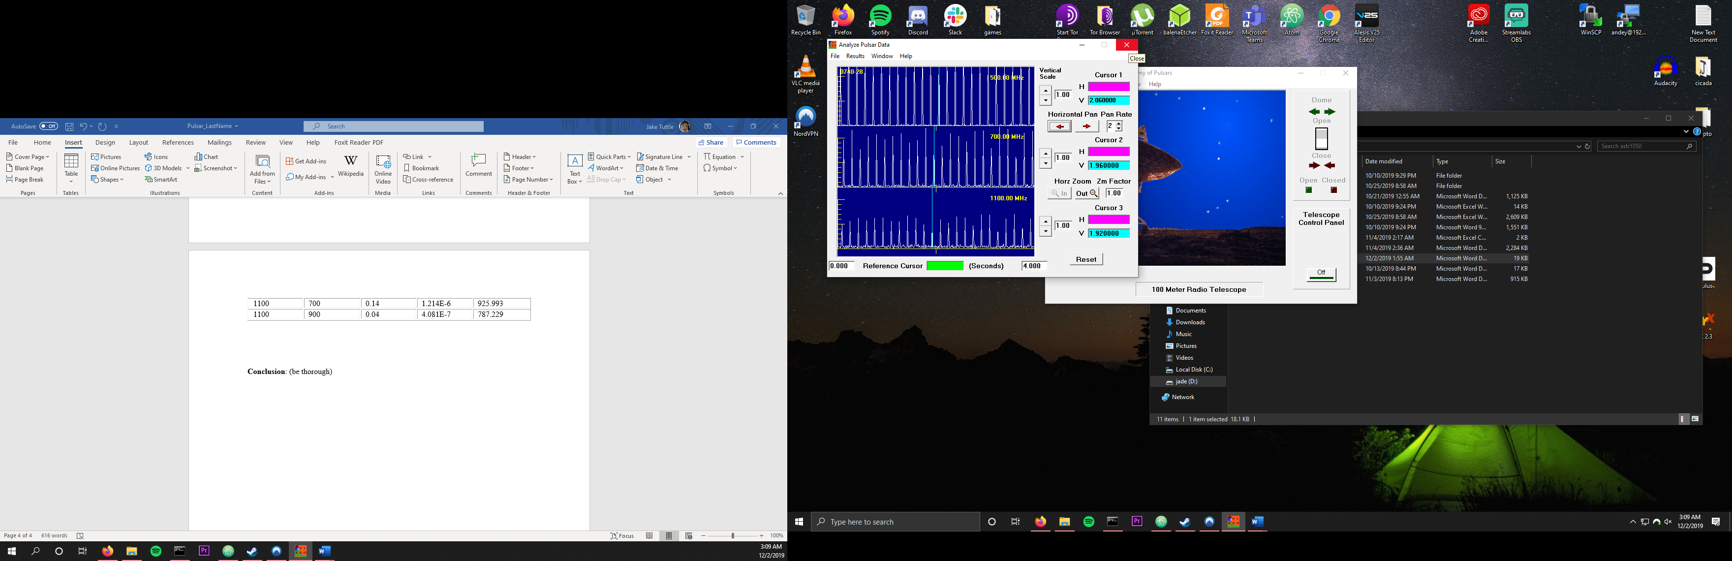

**Conclusion**: (be thorough)

In conclusion, this lab demonstrated the power of measuring something as simple as a change in frequency to determine the distances of objects in space. As we’ve discussed previously, knowing the distances of objects has proven to be invaluable in forming our understanding of the universe as a whole, so this lab allowed us to easily practice those measurement techniques used by astronomers as a collective. While knowing exact errors without the expected results is difficult in a lab such as this, the given calculations 0628-28 were consistent with my calculations, and care was taken throughout the lab to avoid measurement errors, the main problem that plagued my previous lab. Values were always positive, and they produced values that would be consistent with expected values.