DRAFT (not for submission). Inclusion is provisional: the reviewer has decided 40 of 135 records at title/abstract and none at full text, so the included set, the PRISMA counts and every table rest partly on AI suggestions. Every number is advisory until checked against its source page. Remove this note when columns H to L of the screening workbook are complete and the chain has been re-run from the extraction step.

QUESTIONNAIRES TO IDENTIFY GLAUCOMA PATIENTS FOR LOW VISION REHABILITATION
Two questions flag acuity loss in under a minute, but glaucoma also needs a field item.
BY [AUTHOR 1], [DEGREE]; [AUTHOR 2], [DEGREE]; AND [AUTHOR 3], [DEGREE]
AT A GLANCE
- A single question about reading a posted fast-food menu identified acuity of 20/40 or worse with sensitivity 0.89 and specificity 0.81, and a question about reading keyboard letters identified acuity of 20/200 or worse with sensitivity 0.89 and specificity 0.71, in one research cohort in which the items were both chosen and tested.¹
- Both items are keyed to acuity; no self-report item in this review has been tested in a glaucoma clinic or against a clinician’s judgement that the patient needs rehabilitation, and the only direct test of items against a field defect found sensitivities of 0.20 to 0.50.²
- A technician can ask the two items plus a short set of proposed field, night and glare items and combine the answers with the last acuity and visual field; the add-on items and the referral rule are proposals to be piloted, not validated tests.
A familiar scene in a glaucoma clinic: a patient with advanced open-angle glaucoma reads 20/30 with each eye, has stopped driving at night, has given up the newspaper and bumps into people in the supermarket. Nobody has mentioned low vision rehabilitation (LVR), because nobody has asked. Glaucoma is among the most common causes of irreversible visual impairment, and LVR is the main support for patients whose loss cannot be reversed.³ Yet the referral gap is wide. In a retrospective study at one academic center, most patients with severe open-angle glaucoma qualified as having low vision but only a small minority [VERIFY] were referred for an LVR evaluation, and referral tracked acuity rather than field loss.³ Among American Glaucoma Society members, the specialists who referred most were those who followed the American Academy of Ophthalmology (AAO) Preferred Practice Pattern (PPP) recommendations.⁴ The Vision Rehabilitation PPP asks ophthalmologists to consider rehabilitation for any patient whose vision loss affects function, whatever the acuity [VERIFY: exact PPP referral criteria].⁵
The practical question for a clinic is who should be asked, what, and by whom. A technician measures acuity and runs the field; a screening question that fits into that work-up costs nothing. This article reviews the evidence on self-report questionnaires and single screening items that identify adults who may need LVR, examines a two-question acuity screen derived from a 100-item survey,⁶ and proposes a technician work-up protocol for a glaucoma or LVR clinic. It is a systematic search with narrative synthesis, not a meta-analysis.

HOW GLAUCOMA DISABLES BEYOND ACUITY
Glaucoma spares the acuity chart until late. It takes the peripheral and then the paracentral field, contrast sensitivity and tolerance of glare and dim light first, and those losses drive the disability patients report. In 147 Japanese glaucoma patients who completed a 30-item visual disability questionnaire, the total disability index correlated with better-eye mean deviation at r = -0.64; the walking and going-out domains, which hold items such as “Do you fail to see people or cars approaching you from the side?”, correlated with mean deviation at r = -0.61 and -0.63.⁷ In older adults with glaucoma, self-rated reading ability fell with field loss, and patients read less often than glaucoma suspects did.⁸ In 100 low vision patients who completed the Activity Inventory, the mobility measure tracked the outer 10 to 30 degrees of the Humphrey field (rho = 0.61) far better than acuity (rho = -0.27),⁹ and in a 35-item mobility questionnaire the Rasch measure correlated with the binocular kinetic field at r = -0.762 but with high-contrast acuity at only r = 0.41.¹⁰
The legal definitions reflect this. In Canada, as in the United States, legal blindness is a best-corrected acuity of 20/200 or worse in the better eye or a visual field of 20 degrees or less, so a glaucoma patient can be legally blind with normal acuity.^{1,11} Any screen that keys only to acuity will, by construction, miss that patient. This is the central tension of the article: the best-validated brief items are acuity items, and the patients a glaucoma clinic most needs to find are often not acuity-impaired.

FULL-LENGTH QUESTIONNAIRES
The questionnaires used to measure LVR need and outcome are mostly long (Table 1). The National Eye Institute Visual Function Questionnaire (NEI VFQ-25) has 25 items in 12 subscales plus an optional 14-item appendix.^{12,13} The Veterans Affairs Low Vision Visual Functioning Questionnaire (VA LV VFQ-48) asks four questions about each of 48 activities by trained telephone interviewers and takes 25 to 35 minutes.¹⁴ The Activity Inventory is an adaptive interview of 50 goals, each with its own tasks, scored by Rasch analysis.¹⁵ The Impact of Vision Impairment questionnaire (IVI) has 28 items in three Rasch-scored subscales.¹⁶ The Low Vision Quality-of-Life Questionnaire (LVQOL) is the shortest of the general instruments at 25 summed items and 5 to 10 minutes.¹⁷
Three instruments were built with field loss in mind. The Glaucoma Quality of Life-15 (GQL-15) has peripheral-vision and dark-adaptation-and-glare factors by design,¹⁸ and its nine-item Rasch-derived short form, the Glaucoma Activity Limitation-9 (GAL-9), was chosen in one maculopathy clinic as an in-consultation screen because of its mobility scenarios and short length.¹⁹ The Andhra Pradesh Eye Disease Study questionnaire (APEDS-VFQ) groups its 16 items by functional demand, including contrast, illumination and peripheral vision.²⁰ None of the three has accuracy data against LVR need, and no GQL-15 study met our criteria.
How well validated are they? We rated every measurement-property result with the COnsensus-based Standards for the selection of health Measurement INstruments (COSMIN) criteria and found nothing better than “doubtful” quality for any property of any instrument, mainly because no study pre-specified hypotheses or tested unidimensionality.²¹ The results rated sufficient rest on single studies: LVQOL test-retest reliability (intraclass correlation 0.72) and responsiveness (6.8-point improvement after rehabilitation);¹⁷ VA LV VFQ-48 responsiveness (effect size 1.9 after inpatient rehabilitation);¹⁴ and IVI responsiveness (reading subscale effect size 0.50).¹⁶ Correlations with acuity were moderate at best: 0.50 for the LVQOL,¹⁷ 0.28 for the APEDS-VFQ,²⁰ and -0.014 for the NEI VFQ-25 composite in 184 LVR clients.²² Where a field measure was taken, mobility scores tracked it better than acuity in two low vision samples;^{9,10} in the glaucoma sample, acuity and field correlated with total disability about equally (r = 0.74 and -0.64).⁷
These instruments measure outcome, not need, and only the LVQOL, GAL-9 and GQL-15 are short enough for a technician work-up (Table 2).

WHERE THE TWO QUESTIONS CAME FROM
The Legge group built a 100-item survey of yes-or-no questions about recognizing everyday objects at fixed distances, calibrated each item with item-response theory, and showed that the ability estimated from the whole survey correlated with measured acuity at r = -0.73 in 385 adults recruited across the acuity range at four US sites.⁶ Because item difficulty maps linearly onto logMAR, each item is in effect a one-question acuity test at a set threshold.
In the companion paper, the same 385 participants were used to ask which single items, pairs and triplets best classified low vision, defined as 0.3 logMAR (20/40) or worse, and acuity-defined legal blindness, 1.0 logMAR (20/200) or worse, against binocular habitual-correction acuity.¹ The cohort had a mean age of 55.7 years, 57.4% were women, 16.9% had glaucoma, 19.2% had macular degeneration, and 68.6% had acuity worse than 0.3 logMAR.¹ The two winners were Q97, “In a fast-food restaurant, can you usually read the posted menus?”, for low vision, and Q30, “When seated in front of a computer, are you able to read the letters on the keyboard keys?”, for legal blindness; a “No” answer is a positive screen.¹

HOW ACCURATE ARE THEY?
The menu item had sensitivity 0.89 (95% confidence interval [CI], 0.85-0.92) and specificity 0.81 (95% CI, 0.73-0.87) for acuity of 0.3 logMAR or worse; the keyboard item had sensitivity 0.89 (95% CI, 0.80-0.94) and specificity 0.71 (95% CI, 0.66-0.76) for acuity of 1.0 logMAR or worse (Table 3, Figure 2).¹ The paper’s area-under-the-curve (AUC) values of 0.85 and 0.80 are the mean of sensitivity and specificity at a single cut point, not areas under a curve, as the authors state; the confidence intervals are ours, from reconstructed 2 x 2 tables.¹
Adding a second item helped a little. The best pair for low vision, the menu item plus a newspaper item, reached sensitivity 0.86 and specificity 0.88, and the best pair for legal blindness, the keyboard item plus a street-sign item, reached 0.88 and 0.77; a third item added nothing.¹ A pair is positive only on “No” to both, so it always trades sensitivity for specificity. The whole 100-item survey, scored as predicted acuity, was less accurate than its single best item (sensitivity 0.94, specificity 0.66 for low vision).¹
Three caveats. First, the menu and keyboard items were never evaluated together: each appears only in the table for its own threshold, so a clinic that asks both is running two one-item tests.¹ Second, the items were selected by ranking all 100 items by accuracy in the same 385 people that supply the reported accuracy, with no hold-out or external sample; picking the best of 100 noisy estimates inflates the winner, so every figure here is a derivation-sample estimate that should fall on replication.^{1,23} Third, predictive values depend on prevalence: the positive predictive value of 0.93 that the paper reports for one-item low vision screening comes from a sample in which 68.6% were acuity-impaired and will not transfer to a glaucoma clinic where most patients read 20/40 or better.¹ On the Quality Assessment of Diagnostic Accuracy Studies 2 (QUADAS-2) tool, the study is at high risk of bias in the index-test domain and unclear in the other three, with high applicability concerns (Figure 4).²³ We rate the certainty of the two accuracy estimates as low, and a “Yes” to either question is never proof that rehabilitation is not needed.

OTHER BRIEF SCREENERS
Few comparators exist, none better founded (Table 3). In a Quebec community sample aged 65 and over, a positive answer to either of two Statistics Canada survey questions, trouble reading ordinary newsprint or trouble seeing a face at 12 feet with usual correction, had sensitivity 0.83 (95% CI, 0.52-0.98) and specificity 0.83 (95% CI, 0.71-0.92) for presenting acuity of 6/12 or worse; but only 65 of 144 eligible people were examined and verification depended on the answers, so the authors warn that the estimates cannot be applied to an unselected population.²⁴ The seven-item Visual Impairment as a Risk for Falls Questionnaire, developed in 89 older patients from enriched optometry clinics, was sensitive (0.88; 95% CI, 0.77-0.95) but unspecific (0.48; 95% CI, 0.30-0.67) for any charted impairment, and its three field-oriented items reached sensitivities of only 0.20 to 0.50 against a peripheral field defect.² A Spanish LVQOL total score at a cut-off of 105 or 106 separated 170 visually impaired patients from 195 healthy volunteers with sensitivity 0.954 and specificity 0.918, an easier task than finding, among clinic patients, those who need help.²⁵
Two relevant papers could not be retrieved in time: a screening tool for reduced habitual vision, defined to include field defects, in hospital rehabilitation inpatients,²⁶ and the concordance between self-reported visual difficulty and measured impairment in the National Health and Aging Trends Study.²⁷ Across every brief screener we found, specificity was the stable property; sensitivity was high only where the reference was acuity and the sample enriched (Figure 3).

WILL IT WORK FOR GLAUCOMA?
For the patients it was designed to find, probably; for the patients a glaucoma clinic most needs to find, not on its own. The authors say so themselves: their items “do not detect legal blindness due to visual-field loss alone” and “may misclassify individuals with preserved acuity but severely constricted visual fields,” and they name field-oriented items as future work.¹ No included study tested any questionnaire or item against a clinician’s judgement that the patient needs LVR; every accuracy figure in this review is against measured acuity or a charted composite. So “screen positive” means “acuity-impaired,” not “needs rehabilitation.”
Further assumptions travel with the items. They were answered inside the 100-item survey, by a mode the paper does not state, and the authors warn that performance “might differ if administered independently”.¹ They assume familiarity with fast-food menus and keyboards and were tested in English only; the authors ask for cultural and linguistic adaptation before use elsewhere.¹ Self-report of peripheral loss is poor: half or more of the patients with a field defect in the falls-risk study answered “No” to the questions aimed at it.²
Which items could be added for glaucoma? Nothing in our set has item-level accuracy against any reference, so every candidate is a pilot item, not a recommendation. The strongest evidence is domain-level, from the one glaucoma sample with perimetry: the walking and going-out domains of the Japanese questionnaire, which hold the side-approach item and “Do you feel uneasy going out at night because of your visual problems?”, correlated with mean deviation at r = -0.61 and r = -0.63.⁷ The GAL-9 offers English equivalents for side, night and dim-light scenarios, and its total score correlated with contrast sensitivity at rho = -0.62 (95% CI, -0.72 to -0.49), but in 125 maculopathy patients with glaucoma excluded.¹⁹ A glare item is the weakest proposal: “walking in high glare areas” was the hardest of 35 mobility items in 30 low vision patients, and no included paper tested glare against an item.¹⁰ A global mobility question, “Do you have mobility problems because of your vision?”, was answered yes by 18.0%, 31.0% and 71.4% of patients with mild, moderate and severe contrast loss.¹⁹

PUTTING IT INTO PRACTICE
The Box is what we propose a technician should do while the patient is in the chair. The two acuity items carry the only accuracy evidence and take under a minute. The add-on items cover what the acuity items cannot see and are worded as closely as possible to the items that showed the strongest field and contrast signal, though none has been tested as a screen. The referral rule is deliberately inclusive, because an unnecessary LVR consultation costs little and a missed one costs years of avoidable disability. Everything in the Box except the two single-item accuracies is untested, so a clinic adopting it should treat the first months as a pilot: record the answers, the field and acuity, and the eventual LVR disposition, and compare them.

HOW WE SEARCHED
We searched PubMed and Scopus on 4 October 2026 (2000 onward, English or French) for adult studies of self-report questionnaires or screening items evaluated against measured vision, a full-length instrument or clinician-judged LVR need; the strings are in the supplement. The searches identified 166 records (PubMed, 78; Scopus, 88), and 8 further records came from sources known to the authors. After 39 duplicates were removed, 135 records were screened and 81 excluded; 54 reports were sought, 6 could not be retrieved, 48 were assessed and 17 excluded, leaving 31 included reports (Figure 1), plus the survey development paper, which shares its cohort with the screening paper and counts with it as one dataset. One reviewer screened; a second will check a 20% sample. Data extraction, QUADAS-2 and COSMIN assessments were done per study and tabulated without pooling, following the Synthesis Without Meta-analysis guideline, because no comparison had more than one independent accuracy dataset and thresholds and reference standards differed in every study.^{21,23,28} Certainty was rated with the Grading of Recommendations Assessment, Development and Evaluation (GRADE) approach for test accuracy, without a pooled estimate.
Use of artificial intelligence. We used Anthropic large language models (Claude Fable 5.1, claude-fable-5-1, and Claude Sonnet 5.5, claude-sonnet-5-5; October 2026) to test the search strings, produce advisory screening suggestions recorded separately from the reviewer’s decisions, convert PDFs to text, produce first-pass data extraction and draft QUADAS-2 and COSMIN assessments, write and run the analysis scripts, and draft this text. The reviewer’s decision differed from the model’s first-pass suggestion in 15 of 40 records screened so far (37.5%) [UPDATE when all 135 are decided]. Every number in this article remains to be verified by the authors against the source page [VERIFY: replace with the counts of corrected values once checking is done]. The authors take full responsibility for the content; the full Methods are in the supplement.

FUTURE DIRECTIONS
The study the field needs is straightforward: give the two acuity items and a short set of field, night and glare items to consecutive glaucoma clinic patients, independently of any longer survey, and compare the answers with the same visit’s acuity, the better-eye mean deviation or an Esterman binocular field, contrast sensitivity, and a masked LVR clinician’s judgement of need. That would supply the four things missing from every study here: external validation, a glaucoma population, a field reference and a need reference. Until then, the two items in the Box are the best-evidenced brief screen available, and the add-on items are a reasoned guess.

CONCLUSION
A glaucoma clinic can screen for LVR need during the technician work-up with two yes-or-no questions that have derivation-sample sensitivity near 0.9 for acuity loss,¹ provided it also asks about the side, the night and the glare, and reads the last field. The questions find the patients who cannot see the chart; the clinic still has to find the patients who can.

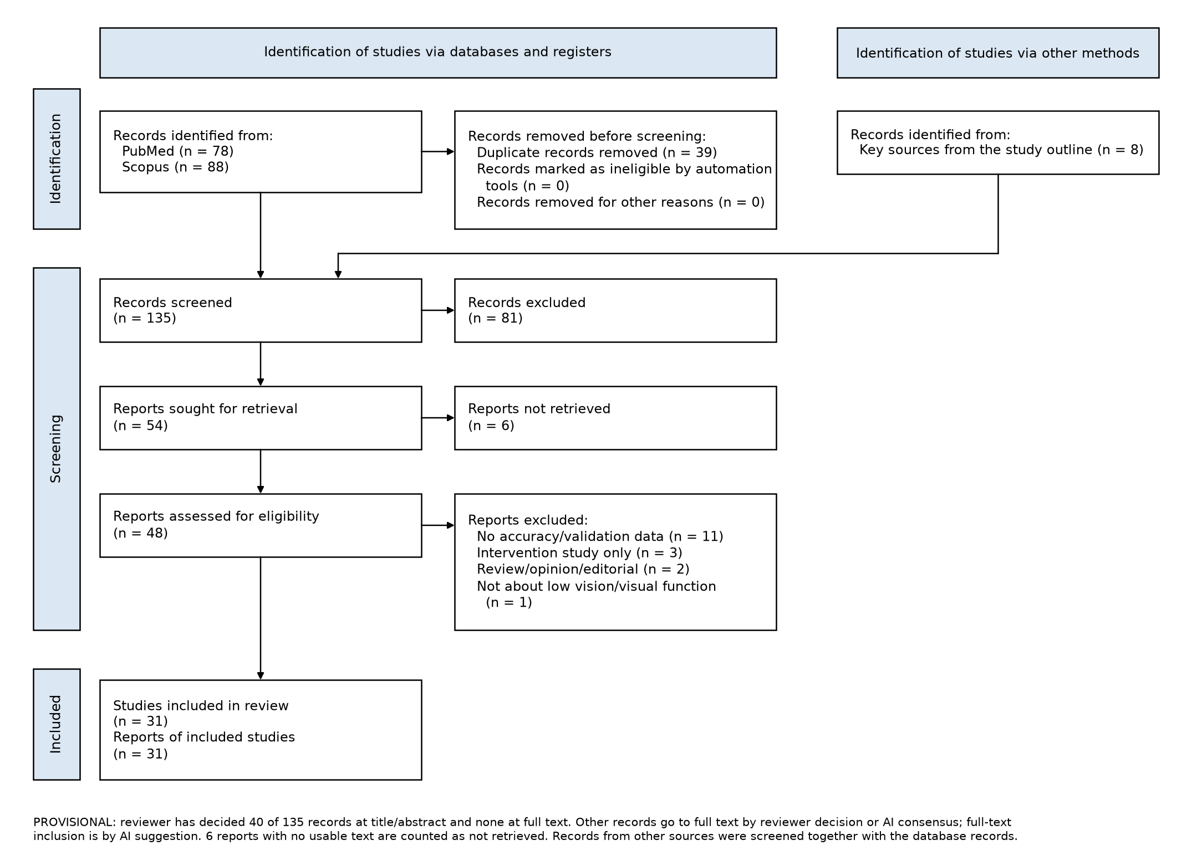
Figure 1. PRISMA 2020 flow of records through the review (provisional: 95 of the 135 title/abstract decisions and all full-text decisions are AI suggestions pending the reviewer’s; records from other sources were screened in the same pipeline as database records). Abbreviation: PRISMA = Preferred Reporting Items for Systematic Reviews and Meta-Analyses.
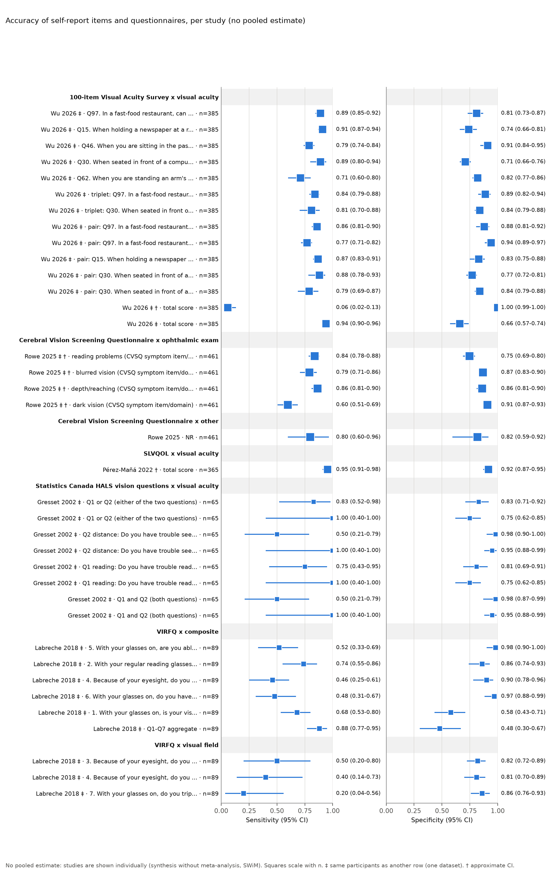
Figure 2. Sensitivity and specificity of each self-report item or questionnaire threshold, per study, with 95% Wilson confidence intervals and no pooled estimate; rows sharing a dataset come from the same participants and count once. Abbreviations: CI = confidence interval; VA = visual acuity.
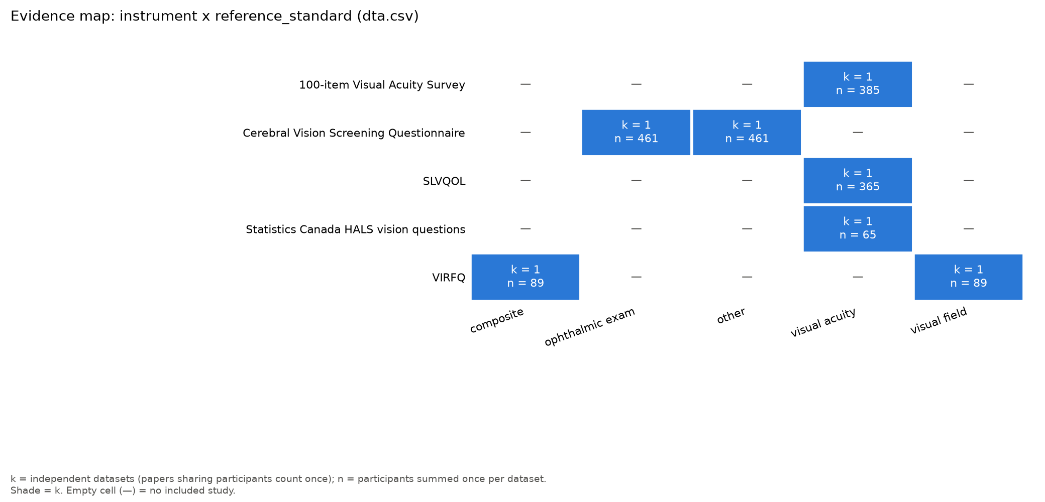
Figure 3. Evidence map of index test by reference standard, showing the number of independent datasets and participants in each cell and the empty column for clinician-judged rehabilitation need.
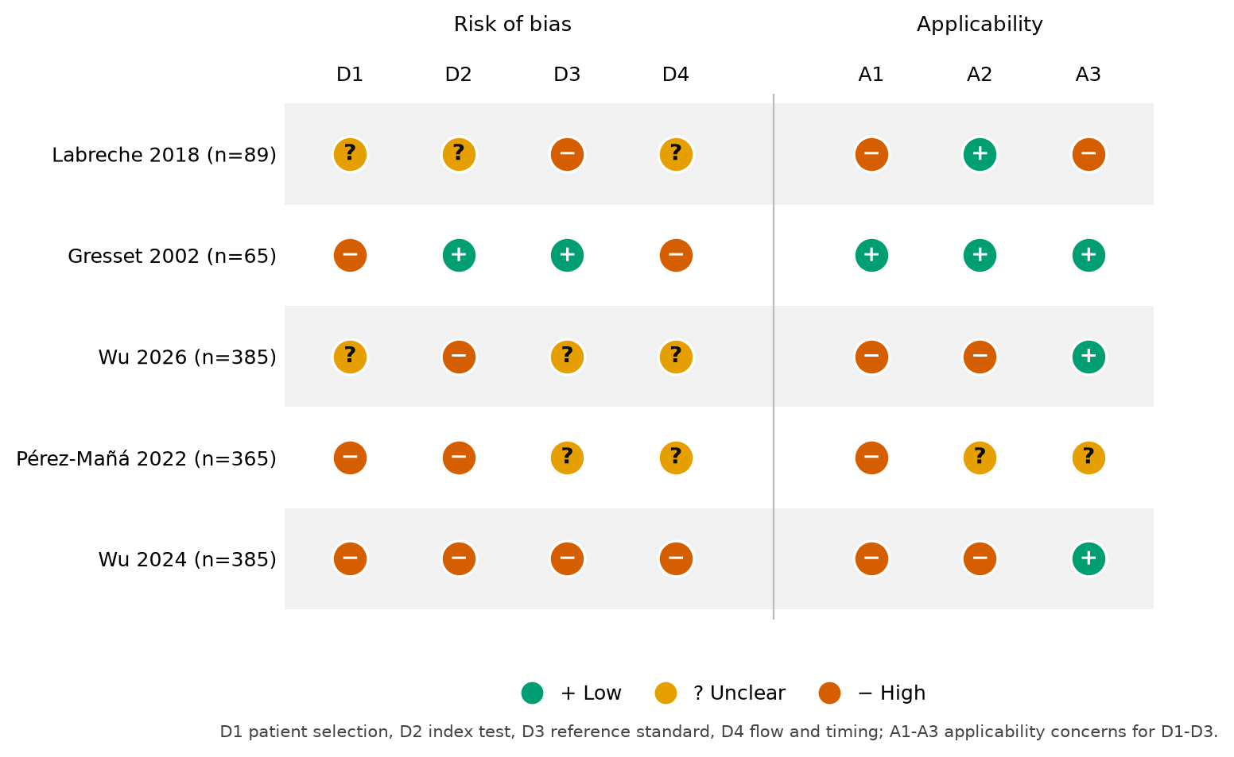
Figure 4. QUADAS-2 risk-of-bias and applicability judgements for the five accuracy studies; the two Legge-group rows describe one cohort. Abbreviation: QUADAS-2 = Quality Assessment of Diagnostic Accuracy Studies 2.

Table 1. Self-report instruments found by the review and what they can see.
Instrument | Items | Minutes | Mode | Field or contrast content | Measurement-property evidence in this review (COSMIN)
NEI VFQ-25^{12,13} | 25 (+ 14-item appendix) | about 10 (unverified) | interviewer or self | partial: one peripheral-vision item, night-driving items; no contrast item | structural validity and responsiveness indeterminate (k = 1 each)
VA LV VFQ-48¹⁴ | 48 | 25-35 | telephone, trained interviewer | partial: navigation and peripheral-detection items; no contrast item | responsiveness sufficient (low certainty); reliability indeterminate
Activity Inventory^{9,15} | 50 goals + their tasks (count unverified) | 20-30 (unverified) | adaptive interview | partial: mobility goals; mobility measure vs outer field rho = 0.61 | hypotheses testing sufficient (very low certainty)
IVI¹⁶ | 28 | 10-15 (unverified) | self (mailed), telephone | partial: mobility subscale; built for central loss | responsiveness sufficient (low); structural validity insufficient (low)
LVQOL^{17,25} | 25 | 5-10 | self or interviewer | partial: one lighting item; no field item | reliability, responsiveness and hypotheses sufficient (low)
GQL-15¹⁸ | 15 | about 5 (unverified) | self or interviewer | yes: peripheral-vision and dark-adaptation-and-glare factors | no included study
GAL-9¹⁹ | 9 | about 3 (unverified) | self or interviewer | yes: night, dim light, light-dark transitions, uneven ground, objects from the side | one hypothesis confirmed in maculopathy; not rated
APEDS-VFQ²⁰ | 16 | NR | interviewer | yes: items grouped under contrast, illumination and peripheral vision | structural validity insufficient (low); VA hypothesis not met
EQ-5D vision bolt-on²⁹ | 5 + 1 | 0.3-0.4 | self | none: one global vision item | test-retest reliability insufficient (very low)
Two-item acuity screen¹ | 2 | < 1 (derived) | technician asks | none: acuity only by design | accuracy only (Table 3)
Statistics Canada HALS questions²⁴ | 2 | < 1 (derived) | interviewer | none: reading and face-recognition items | accuracy only (Table 3)
Abbreviations: APEDS-VFQ = Andhra Pradesh Eye Disease Study Visual Function Questionnaire; COSMIN = COnsensus-based Standards for the selection of health Measurement INstruments; GAL-9 = Glaucoma Activity Limitation-9; GQL-15 = Glaucoma Quality of Life-15; HALS = Health and Activity Limitation Survey; IVI = Impact of Vision Impairment; LVQOL = Low Vision Quality-of-Life Questionnaire; NEI VFQ-25 = National Eye Institute Visual Function Questionnaire-25; NR = not reported; VA = visual acuity; VA LV VFQ-48 = Veterans Affairs Low Vision Visual Functioning Questionnaire-48. “Unverified” marks catalogue facts not yet confirmed against the development paper. Certainty is a modified GRADE rating per property. Full table in the supplement.
Table 2. Feasibility of each instrument for a technician work-up.
Instrument | Scoring | Equipment | Licence | Technician-ready?
Two-item acuity screen¹ | none (“No” = positive) | none | free (items printed in the paper) | yes, with caveats: no training or scoring, but derivation-sample accuracy only, the two items were never tested as a pair, and no field or contrast item
HALS questions²⁴ | none | none | free (public survey items) | yes in form; accuracy from one verified subsample of 65 that the authors say cannot be generalized
GAL-9¹⁹ | sum of 9 items | paper form | free | yes in form; no accuracy data, and the only included study excluded glaucoma
GQL-15¹⁸ | sum of 15 items | paper form | free | yes in form; no included study reports its accuracy
LVQOL¹⁷ | sum of 25 items | paper form, large print | free | yes: 5 to 10 minutes, no training; but an outcome measure, with a cut-off tested only against healthy volunteers
APEDS-VFQ²⁰ | sum or Rasch | interview script | free | partly: interviewer-led, validated in an Indian rehabilitation population; no accuracy or field analysis
NEI VFQ-25¹³ | 12 subscales by hand | paper form or script | free | partly: about 10 minutes and 12 subscales make it an outcome measure
IVI¹⁶ | Rasch conversion table | paper form | permission required | partly: self-completed but 10 to 15 minutes and “generally lengthy”
VA LV VFQ-48¹⁴ | Rasch table, trained interviewers | telephone script | free | no: 25 to 35 minutes
Activity Inventory¹⁵ | Rasch, author software | interview, software | free for academic use | no: adaptive interview (minutes unverified); the right tool after referral
Abbreviations as in Table 1. Catalogue facts (minutes, licence) are unverified against the development papers; see the supplement.
Table 3. Accuracy of brief self-report items and questionnaire cut-offs, per study, with no pooled estimate.
Study | Index test (positive if) | Reference standard | n (positive) | Sensitivity (95% CI) | Specificity (95% CI) | QUADAS-2 overall
Wu 2026¹ | Q97 fast-food menu (“No”) | binocular habitual VA 0.3 logMAR or worse | 385 (264) | 0.89 (0.85-0.92) | 0.81 (0.73-0.87) | high
Wu 2026¹ | Q30 keyboard letters (“No”) | binocular habitual VA 1.0 logMAR or worse | 385 (73) | 0.89 (0.80-0.94) | 0.71 (0.66-0.76) | high
Wu 2026¹ | Q97 + Q15 newspaper (“No” to both) | VA 0.3 logMAR or worse | 385 (264) | 0.86 (0.81-0.90) | 0.88 (0.81-0.92) | high
Wu 2026¹ | Q30 + Q12 street sign (“No” to both) | VA 1.0 logMAR or worse | 385 (73) | 0.88 (0.78-0.93) | 0.77 (0.72-0.81) | high
Wu 2026¹ | whole 100-item survey (predicted VA) | VA 0.3 logMAR or worse | 385 (264) | 0.94 (0.90-0.96) | 0.66 (0.57-0.74) | high
Gresset 2002²⁴ | either HALS question (newsprint; face at 12 feet) | presenting VA 6/12 or worse | 65 (12)† | 0.83 (0.52-0.98) | 0.83 (0.71-0.92) | high
Gresset 2002²⁴ | either HALS question | presenting VA 6/21 or worse | 65 (4)† | 1.00 (0.40-1.00) | 0.75 (0.62-0.85) | high
Labreche 2018² | any of 7 VIRFQ items | charted VA, contrast or field impairment | 89 (60) | 0.88 (0.77-0.95) | 0.48 (0.30-0.67) | high
Labreche 2018² | “difficulty noticing objects off to the side” | peripheral field defect | 89 (10) | 0.50 (0.20-0.80) | 0.82 (0.72-0.89)‡ | high
Pérez-Mañá 2022²⁵ | Spanish LVQOL total score at cut-off 105 or 106 | impaired patients vs healthy volunteers | 365 (170) | 0.95 (0.91-0.98)† | 0.92 (0.87-0.95)† | high
Abbreviations: CI = confidence interval; HALS = Health and Activity Limitation Survey; LVQOL = Low Vision Quality-of-Life Questionnaire; QUADAS-2 = Quality Assessment of Diagnostic Accuracy Studies 2; VA = visual acuity; VIRFQ = Visual Impairment as a Risk for Falls Questionnaire. Confidence intervals are the source’s own where reported, otherwise Wilson intervals from the reported or reconstructed 2 x 2 tables; † counts or intervals back-calculated from reported proportions (approximate); ‡ the source prints 65/79 and 86% for this cell, which disagree, so the fraction is used. The Wu 2026 rows share one cohort. Full table with every threshold in the supplement.

BOX. Proposed technician screen for low vision rehabilitation need in a glaucoma clinic (a proposal to pilot; only step 1 has accuracy evidence).
Step 1. Ask the two acuity items, verbatim¹:
- “In a fast-food restaurant, can you usually read the posted menus?” Yes / No
- “When seated in front of a computer, are you able to read the letters on the keyboard keys?” Yes / No
A “No” to item 1 is a positive screen for acuity of 20/40 or worse (derivation-sample sensitivity 0.89, specificity 0.81); a “No” to item 2 is a positive screen for acuity of 20/200 or worse (sensitivity 0.89, specificity 0.71).¹ The two items have not been tested together. Skip or adapt the items for patients unfamiliar with fast-food menus or keyboards, and record that the item was adapted.
Step 2. Ask the proposed glaucoma add-on items (untested as screening items; wording adapted from the cited instruments):
- “Do you fail to see people or cars approaching you from the side?” Yes / No^{7,19}
- “Do you feel uneasy going out at night, or in dim light, because of your vision?” Yes / No^{7,19}
- “Is walking in bright glare difficult because of your vision?” Yes / No¹⁰
- “Do you have mobility problems because of your vision?” Yes / No¹⁹
Step 3. Pull from the chart: the last better-eye corrected acuity; the last visual field (better-eye mean deviation, and whether the central 10 degrees or the inferior field is involved); contrast sensitivity if measured.
Referral rule (proposed, untested): offer an LVR evaluation when any of the following holds: “No” to item 1 or item 2; “Yes” to any of items 3 to 6 together with a documented glaucomatous field defect in the better eye [VERIFY: field threshold to be set by the clinic]; better-eye acuity of 20/40 or worse [VERIFY: align with the AAO PPP referral criteria]; or a field of 20 degrees or less in the better eye, the legal-blindness criterion.^{1,11} Record all six answers in the chart whether or not a referral follows, so that the pilot can be audited.
Time: the two acuity items take under a minute (the source study did not time them); the six items and the chart check should fit within the technician history [untested].
What this box cannot claim: the single-item accuracies come from one enriched research cohort in which the items were both chosen and tested; nothing here has been tested in a glaucoma clinic or against a clinician’s judgement of rehabilitation need.

References
- Wu YH, Yu D, Goldstein J, Kwon M, Wang C, Legge GE. Screening questions to identify low vision and acuity-defined legal blindness. Invest Ophthalmol Vis Sci. 2026;67(1):28. doi:10.1167/iovs.67.1.28
- Labreche T, Nandakumar K, Althomali M, Leat SJ. Development and validation of Visual Impairment as a Risk for Falls Questionnaire. Age Ageing. 2018;47(3):444-450. doi:10.1093/ageing/afx202
- Ernst J, Huang J, Tsosie J, Ramsey DJ. Factors associated with referral to low vision for patients with advanced glaucoma. Life (Basel). 2025;16(1):12. doi:10.3390/life16010012
- Kaleem MA, West SK, Im LT, Swenor BK. Referral to low vision services for glaucoma patients: Referral patterns and characteristics of those who refer. J Glaucoma. 2017;26(2):e115-e120. doi:10.1097/IJG.0000000000000600
- Jackson ML, Virgili G, Shepherd JD, et al. Vision rehabilitation preferred practice pattern. Ophthalmology. 2023;130(3):P271-P335. doi:10.1016/j.ophtha.2022.10.033
- Wu YH, Yu D, Goldstein JE, et al. Estimating visual acuity without a visual acuity chart. Transl Vis Sci Technol. 2024;13(9):20. doi:10.1167/tvst.13.9.20
- Sumi I, Shirato S, Matsumoto S, Araie M. The relationship between visual disability and visual field in patients with glaucoma. Ophthalmology. 2003;110(2):332-339. doi:10.1016/S0161-6420(02)01742-6
- Nguyen AM, van Landingham SW, Massof RW, Rubin GS, Ramulu PY. Reading ability and reading engagement in older adults with glaucoma. Invest Ophthalmol Vis Sci. 2014;55(8):5284-5290. doi:10.1167/iovs.14-14138
- Tabrett DR, Latham K. Factors influencing self-reported vision-related activity limitation in the visually impaired. Invest Ophthalmol Vis Sci. 2011;52(8):5293-5302. doi:10.1167/iovs.10-7055
- Bibby SA, Maslin ER, McIlraith R, Soong GP. Vision and self-reported mobility performance in patients with low vision. Clin Exp Optom. 2007;90(2):115-123. doi:10.1111/j.1444-0938.2007.00120.x
- HealthLink BC. Legal blindness. Accessed October 26, 2026. https://www.healthlinkbc.ca/health-topics/legal-blindness
- Mangione CM, Lee PP, Gutierrez PR, Spritzer K, Berry S, Hays RD. Development of the 25-list-item National Eye Institute Visual Function Questionnaire. Arch Ophthalmol. 2001;119(7):1050-1058. doi:10.1001/archopht.119.7.1050
- Stelmack JA, Stelmack TR, Massof RW. Measuring low-vision rehabilitation outcomes with the NEI VFQ-25. Invest Ophthalmol Vis Sci. 2002;43(9):2859-2868.
- Stelmack JA, Szlyk JP, Stelmack TR, et al. Measuring outcomes of vision rehabilitation with the Veterans Affairs Low Vision Visual Functioning Questionnaire. Invest Ophthalmol Vis Sci. 2006;47(8):3253-3261. doi:10.1167/iovs.05-1319
- Massof RW, Deremeik JT, Park WL, Grover LL. Self-reported importance and difficulty of driving in a low-vision clinic population. Invest Ophthalmol Vis Sci. 2007;48(11):4955-4962. doi:10.1167/iovs.06-0566
- Selivanova A, Fenwick E, Man R, Seiple W, Jackson ML. Outcomes after comprehensive vision rehabilitation using vision-related quality of life questionnaires: Impact of Vision Impairment and National Eye Institute Visual Functioning Questionnaire. Optom Vis Sci. 2019;96(2):87-94. doi:10.1097/OPX.0000000000001327
- Wolffsohn JS, Cochrane AL. Design of the low vision quality-of-life questionnaire (LVQOL) and measuring the outcome of low-vision rehabilitation. Am J Ophthalmol. 2000;130(6):793-802. doi:10.1016/S0002-9394(00)00610-3
- Nelson P, Aspinall P, Papasouliotis O, Worton B, O’Brien C. Quality of life in glaucoma and its relationship with visual function. J Glaucoma. 2003;12(2):139-150. doi:10.1097/00061198-200304000-00009
- Agathos CP, Shanidze NM, Fletcher DC. Importance of screening for contrast sensitivity, falls, and mobility limitations in older adults with maculopathy. Am J Ophthalmol. 2025;280:481-492. doi:10.1016/j.ajo.2025.08.051
- Gothwal VK, Bagga DK. Andhra Pradesh Eye Disease Study – Visual Function Questionnaire: Further improvements in psychometric properties using Rasch analysis. Ophthalmic Epidemiol. 2012;19(5):306-316. doi:10.3109/09286586.2012.712192
- Mokkink LB, de Vet HCW, Prinsen CAC, et al. COSMIN risk of bias checklist for systematic reviews of patient-reported outcome measures. Qual Life Res. 2018;27(5):1171-1179. doi:10.1007/s11136-017-1765-4
- La Grow SJ. Predicting perceived quality of life scores from the National Eye Institute 25-item Visual Function Questionnaire. Optom Vis Sci. 2007;84(8):785-788. doi:10.1097/OPX.0b013e31812f5f24
- Whiting PF, Rutjes AWS, Westwood ME, et al. QUADAS-2: A revised tool for the quality assessment of diagnostic accuracy studies. Ann Intern Med. 2011;155(8):529-536. doi:10.7326/0003-4819-155-8-201110180-00009
- Gresset J, Baumgarten M. Prevalence of visual impairment and utilization of rehabilitation services in the visually impaired elderly population of Quebec. Optom Vis Sci. 2002;79(7):416-423. doi:10.1097/00006324-200207000-00009
- Pérez-Mañá L, Cardona G, Pardo-Cladellas Y, et al. Validation of the Spanish version of the Low Vision Quality of Life Questionnaire. J Optom. 2022;15(3):199-209. doi:10.1016/j.optom.2021.01.004
- Stalin A, Khan S, Labreche T, et al. Development of a screening tool for reduced vision among inpatients of hospital rehabilitation units. Optom Vis Sci. 2025;102(4):221-227. doi:10.1097/OPX.0000000000002236
- Potter T, Almidani L, Diaz M, Varadaraj V, Mihailovic A, Ramulu PY. Concordance between self-reported visual difficulty and objective visual impairment. Ophthalmology. 2024;131(12):1447-1456. doi:10.1016/j.ophtha.2024.06.009
- Campbell M, McKenzie JE, Sowden A, et al. Synthesis without meta-analysis (SWiM) in systematic reviews: reporting guideline. BMJ. 2020;368:l6890. doi:10.1136/bmj.l6890
- Surawatsatien N, Pongsachareonnont PF, Waoraweewon S, Homkong G, Keereekeaw A, Sakthong P. Translation and testing psychometric properties of the Thai version of vision bolt-on EQ-5D in patients with visual impairment. Value Health Reg Issues. 2026;51:101498. doi:10.1016/j.vhri.2025.101498

[AUTHOR 1 NAME IN CAPITALS], [DEGREE] - [Role], [Institution], [City] - [email] - Financial disclosure: [None / list]
[AUTHOR 2 NAME IN CAPITALS], [DEGREE] - [Role], [Institution], [City] - [email] - Financial disclosure: [None / list]
[AUTHOR 3 NAME IN CAPITALS], [DEGREE] - [Role], [Institution], [City] - [email] - Financial disclosure: [None / list]

Supplementary material
- S1. Search strategies as run (PubMed, Scopus, 4 October 2026), the minimal edit and the eight-arm revision with their recall tests, and the PRISMA-S search log (paper/search_log.md, paper/search_strategy_note.md).
- S2. Full Methods including eligibility criteria, selection process, data items, risk-of-bias methods, synthesis methods and the complete AI-assistance disclosure (paper/methods_draft.md).
- S3. PRISMA 2020, PRISMA-DTA and SWiM checklists (paper/checklists/).
- S4. Full instrument comparison and feasibility tables for all instruments found (paper/tables/full_comparison_table.md, paper/tables/full_feasibility_table.md).
- S5. COSMIN risk-of-bias ratings per study and property, and the per-instrument summary of findings (paper/tables/cosmin_table.md, analysis/instruments/summary_of_findings.md).
- S6. QUADAS-2 judgements with rationale, and the AGREE II narrative appraisals of the two guidelines (analysis/risk_of_bias/).
- S7. Per-study accuracy table with every threshold and subgroup, the plot of studies in ROC space, the certainty-of-evidence table and the evidence map for non-accuracy outcomes (paper/tables/accuracy_table.md, paper/figures/roc_space.png, analysis/synthesis/certainty.md, paper/tables/evidence_map_effects.md).

