Sample Input Output

Here is a sample run of the programming, where the user orders a large pizza with three toppings.

First, the program asks the size of the pizza.
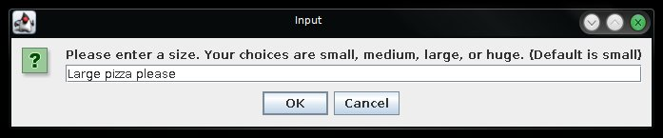
After hitting enter, the program reports the chosen size.
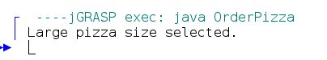

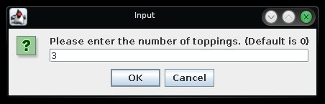The program then asks the user the number of toppings.

After hitting enter, the program reports the entered amount of toppings, does some math, and gives the user information about the order.

Actual Output
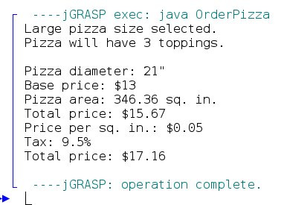Expected output
Large pizza size selected.
Pizza will have 3 toppings.

Pizza Diameter: 21”
Base price: $13
Pizza area: 346.36 sq. in.
Total price: $15.67
Price per sq. in.: $0.05
Tax: 9.5%
Total Price: $17.16

