Source Code
Student.java
import java.text.DecimalFormat;
/**
A class representing a Student's record, that is, the student's name,
total score of all their quizzes, and the amount of quizzes they've taken.<br>
COPYRIGHT &copy; 2014 Gabriel Anderson. All Rights Reserved.
@author Gabriel Anderson
@since 13 October 2014
@version 1.0
*/
public class Student
{
private String name;
private int quizCount;
private int totalScore;
private static int INITIAL_TOTAL_SCORE = 0;
private static int INITIAL_QUIZ_COUNT = 0;
private static final DecimalFormat doubleDecimal = new DecimalFormat("0.00");
/**
Constructs an new student.
@param newName The name of the new student.
*/
public Student(String newName)
{
name = newName;
totalScore = INITIAL_TOTAL_SCORE;
quizCount = INITIAL_QUIZ_COUNT;
}
/**
Query the name of a student.
@return Name of this student.
*/
public String getName()
{
return name;
}
/**
Add a quiz score to the student's record.
@param score The score to add to the student's record, out of a hundred.
*/
public void addQuiz(int score)
{
quizCount++;
totalScore += score;
}
/**
Query the student's record for the number of quizzes recorded.
@return The number of quizzes the student has taken.
*/
public int getQuizCount()
{
return quizCount;
}
/**
Query a student's record for the total score of all the quizzes added for a student.
@return Total score of all the quizzes added for a student.
*/
public int getTotalScore()
{
return totalScore;
}
/**
Query a student's record for the student's average score.
@return The student's Average quiz score.
*/
public double getAverageScore()
{
if(quizCount == 0)
return 0;
else
return (double)totalScore / (double)quizCount;
}
/**
Get the student's information in a string format intended for printing.
<br>The string looks like this:
<br>Name: <i>&lt;student_name&gt;</i>
<br>Quiz count: <i>&lt;number_of_quizzes_entered&gt;</i>
<br>Total score: <i>&lt;total_points&gt;</i>
<br>Average score: <i>&lt;average_score&gt;</i>
@return The student's information in a nicely formatted string.
*/
@Override
public String toString()
{
return "\nName: " + getName()
+ "\nQuiz count: " + getQuizCount()
+ "\nTotal score: " + getTotalScore()
+ "\nAverage score: " + doubleDecimal.format(getAverageScore());
}
}

StudentTester.java
/**
Runs a test on a Student object.<br>
COPYRIGHT &copy; 2014 Gabriel Anderson. All Rights Reserved.
@author Gabriel Anderson
@since 13 October 2014
@version 1.0
*/
public class StudentTester
{
public static void main(String[] args)
{
// An average student. They have their ups and downs.
// Also, they test the decimal formatter in toString.
// So that's good.
Student gabe = new Student("Gabriel Anderson");
gabe.addQuiz(81);
gabe.addQuiz(57);
gabe.addQuiz(82);
System.out.println("Expected student info:"
+ "\nName: Gabriel Anderson"
+ "\nQuiz count: 3"
+ "\nTotal points: 220"
+ "\nAverage score: 73.33");
System.out.println("\nActual student info:" + gabe.toString() + "\n");
// Little Bobby is a new student, and hasn't taken any quizzes.
Student bob = new Student("Bobby Bobertson");
System.out.println("Expected student info:"
+ “\nName: Bobby Bobertson"
+ "\nQuiz count: 0"
+ "\nTotal points: 0"
+ "\nAverage score: 0.0");
System.out.println("\nActual student info:" + bob.toString() + "\n");
// Issac Newton, the star student.
Student newton = new Student("Issac Newton");
newton.addQuiz(100);
newton.addQuiz(100);
newton.addQuiz(100);
newton.addQuiz(100);
newton.addQuiz(100);
newton.addQuiz(100);
newton.addQuiz(100);
System.out.println("Expected student info:"
+ "\nName: Issac Newton"
+ "\nQuiz count: 7"
+ "\nTotal points: 700"
+ "\nAverage score: 100.0");
System.out.println("\nActual student info:" + newton.toString() + "\n");
}
}

Program output
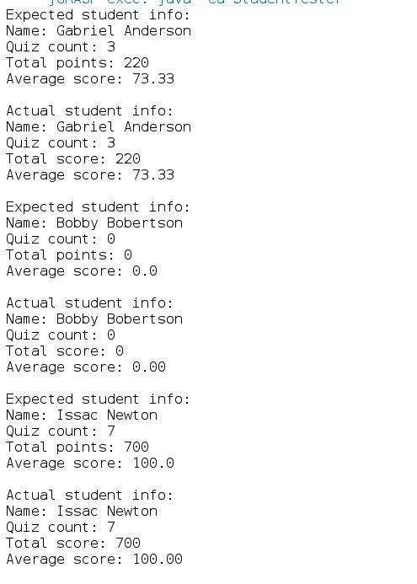

Test Plan
Version 1 is very simple, and doesn't require much testing. All of the methods are very easy to test by using Student.toString(), and comparing the actual output with the expected output. First, a summary of the methods.
1. Student(String name) should produce a Student object with a total score of zero, a quiz count of zero, and a name provided as a string in the function call.

2. getName() should produce the string given to the constructor.

3. addQuiz(int score) should increases the Student object's quizCount by a one integer and the

4. totalScore of the Student object should increase by the value of the score parameter.
5. The methods getQuizCount() and getTotalScore() simply return the respective implicit values associated with the class.

6. The method getAverage() computes the average score, and is the only method to return a double. This one has to be watched carefully, as there can be a divide by zero error when the student has no quizzes submitted and the average is calculated. To avoid this, the function checks for a quizCount of zero, and returns zero when that is the case.

7. toString uses all the methods of the class (except for addQuiz) to generate a formatted report detailing the student's name, total quizzes taken, total score, and average score. This can be used to check the functionality of the class.

As long as a combination of Student(), addQuiz(), and toString produce the expected output, the class should be bug free. So, a simple but effective test plan would be to create three different Student objects. One of the objects has a distribution of scores to generate a non-terminating decimal number. This object will test the formatting of the toString() function. The second object will have no scores added. This ensures the check for divide by zero in the getAverage() function is working. A third will have a good number of test scores a 100, which is considered the ideal score for a teacher. This will make it much easier to spot inconsistencies in the scoring mechanism, because the values will be easy to predict.

Testing one of these objects looks like this.

// An average student. They have their ups and downs.
// Also, they test the decimal formatter in toString.
// So that's good.
Student gabe = new Student("Gabriel Anderson");
gabe.addQuiz(81);
gabe.addQuiz(57);
gabe.addQuiz(82);
System.out.println("Expected student info:"
+ "\nName: Gabriel Anderson"
+ "\nQuiz count: 3"
+ "\nTotal points: 220"
+ "\nAverage score: 73.33");
System.out.println("\nActual student info:" + gabe.toString() + "\n");
The output for this would then be...

Expected student info:
Name: Gabriel Anderson
Quiz count: 3
Total points: 220
Average score: 73.33
Actual student info:
Name: Gabriel Anderson
Quiz count: 3
Total score: 220
Average score: 73.33

See the previous sections Source Code and Program Output for a complete implementation and run of this test plan.

Excel table of inputs and expected outputs
 | Gabriel Anderson | Bobby Bobertson | Issac Newton
Scores | 81 |  | 100
 | 57 |  | 100
 | 82 |  | 100
 |  |  | 100
 |  |  | 100
 |  |  | 100
 |  |  | 100
Quiz Count | 3 | 0 | 7
Total Points | 220 | 0 | 700
Average Score | 73.33333333 | #DIV/0! | 100

