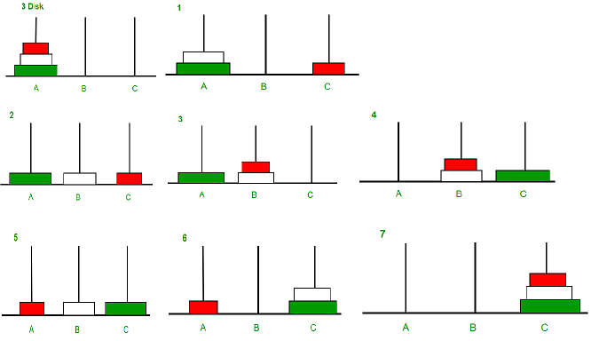Hanoi Tower

Algoritma Sorting

Shell Sort

baca:=0;

For i:= (m Div 2) Downto 1 Do

For j:= 1 To m-i Do

If A[j]>A[j+i] Then

Begin

Ganti(A[j],A[j+i]);

Inc(baca);

End;