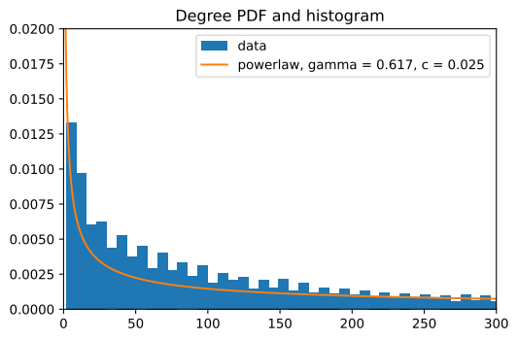
Looks like a scale free graph, fit power-law according to P(k) = c * k^{-γ}

→ Found γ = 0.617 and c = 0.025 (scale factor depends on normalisation of data, exponent doesn’t).

