Msig-DB URL:
http://www.gsea-msigdb.org/gsea/msigdb/search.jsp

Gene set URL:
https://www.gsea-msigdb.org/gsea/msigdb/cards/KRAS.LUNG.BREAST_UP.V1_DN

Size of gene set: 141

Gene Set:
ACKR3
ADAMTS20
ADD2
ADGRE1
AKAP6
AKR1B10
ALDH5A1
ALOX12B
AMBN
ANKRD1
APOB
ART1
ATP6V1B1
BDKRB1
C5AR2
CACNA1I
CALCB
CALML3
CALML5
CCDC121
CD248
CD36
CD6
CDH12
CDH16
CLCA2
CLDN8
COBL
COL2A1
COL5A2
CRABP2
CXCL14
CYP21A2
DEFB1
DPT
DTNB
DTX2
EPB41L4A
EPHX2
ERAP2
FGFR3
FLT1
FMO6P
FRAS1
GABRA4
GADD45G
GAMT
GDNF
GLS2
GLYAT
H3C1
HCN2
HHLA1
HRK
HTR1B
HTR1E
IFI44L
IFNA16
IGF2-AS
IGFBP2
IL5RA
INPP5D
IVL
KCNMB1
KIF25
KRT13
KRT16
KRT38
KRT4
LGALS7
LGALS9
LY6D
MAP2K6
MAST3
MEGF8
METTL7A
MMP28
MTHFR
MXD3
MXRA8
MYL9
NCR3
NOS1
NOX5
NSUN6
NTF3
NYNRIN
OLFML2A
P2RX1
PAQR6
PARP3
PBX1
PCDHB1
PDE3A
PDE6B
PGGHG
PIK3C2B
PLBD1
PROC
PTPRU
PVALB
RAG1
RAMP3
RARRES2
RBM17
RPL13P5
RTP4
RUNDC3B
RYR1
S100A7
SCARF1
SCN7A
SERPINA10
SERPINB13
SIDT1
SLC12A3
SLC3A1
SLC6A9
SOBP
SOX11
SPAG11A
SPTBN2
SYNDIG1
TAS2R4
TBR1
TGM1
THNSL2
TM4SF4
TNFSF10
TNNI3
TRIM48
TRIM9
TRPM2
TSBP1
TSHB
TTLL1
UPK3B
VAV3
VAX2
VPS50
YPEL1

DAVID URL:
https://david.ncifcrf.gov/

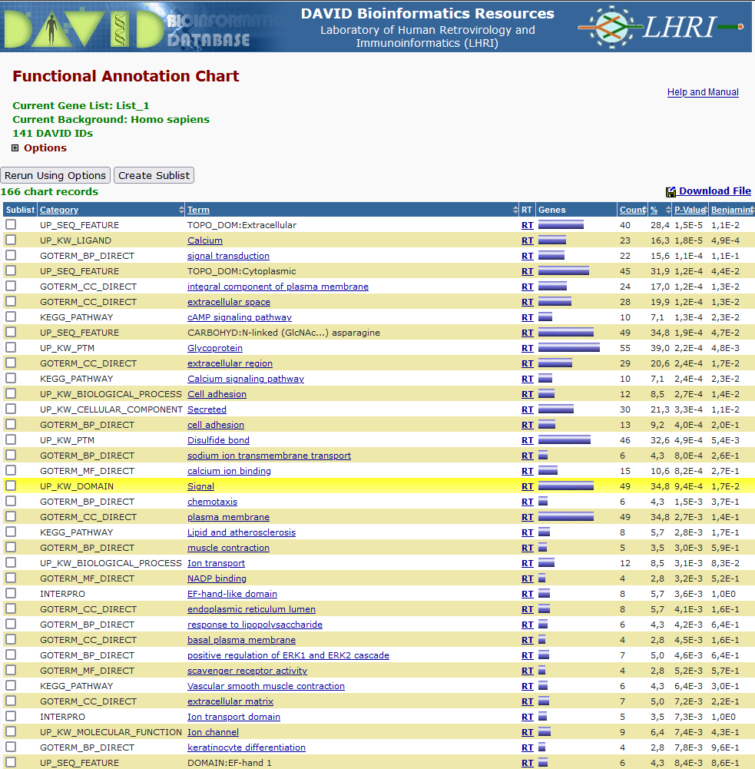
Functional annotation Chart:
