Overview of

West Coast Groundfish Fishery-Independent Surveys

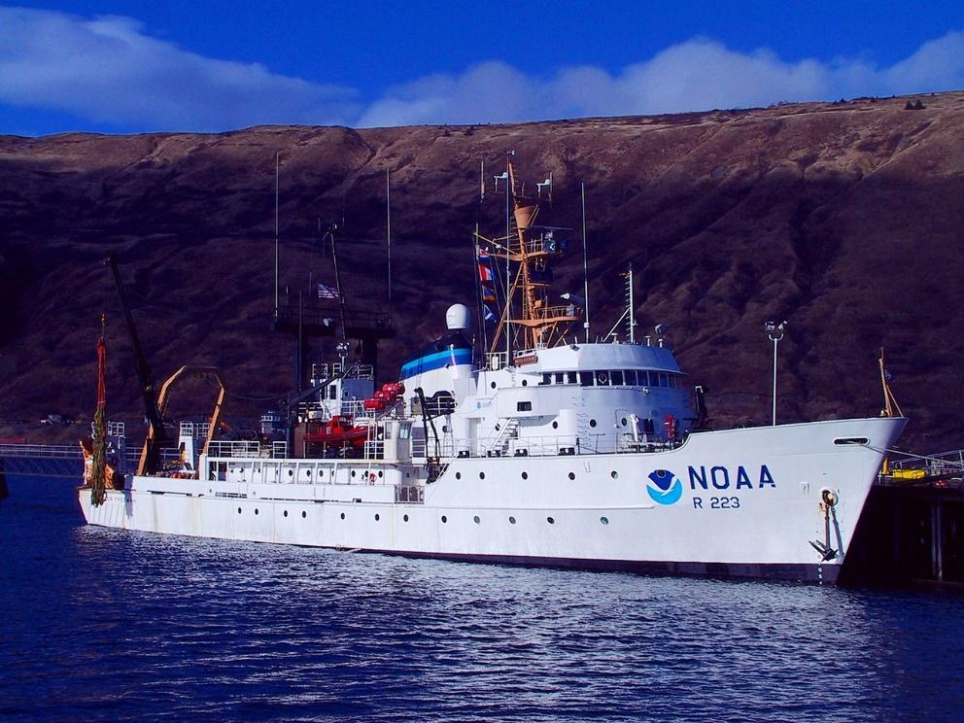

Compiled by:

Stacey Miller

Andi Stephens

Curt Whitmire

Jim Hastie

Updated 14 April 2021

Northwest Fisheries Science Center, U.S. Department of Commerce, National Oceanic and

Atmospheric Administration, National Marine Fisheries Service, 2725 Montlake Boulevard East,

Seattle, Washington 98112

**Contents**

Introduction 1

NMFS Triennial Shelf Surveys 1977-2004 2

AFSC Slope Survey 1984-2001 4

NWFSC Slope Survey 1998-2002 5

NWFSC West Coast Groundfish Bottom Trawl Survey 2003-Present 7

NWFSC Hook and Line Survey (2004-Present) 9

Select References 11

Appendix A. Comparison of NMFS Triennial Shelf Survey and NWFSC West Coast Groundfish Bottom Trawl Survey. 12

Appendix B: Maps of Spatial Extent of NMFS Bottom Trawl Surveys 17

Cover photo: R/V Miller Freeman

# Introduction

Fishery-independent bottom trawl surveys have been used to survey west coast groundfish populations since 1977, starting with the advent of the National Marine Fisheries Service (NMFS) Triennial Shelf Surveys (1977-2004). These surveys provide a wealth of information about fish populations, including biological and catch-rate information to inform stock assessments. Over time, the methods, design, timing, and spatial extent (both latitudinal and by-depth) of these surveys have varied due to changing focus on different fish species, shifts among the entities operating the surveys, and improvements in technology and gear, as well as available resources including National Ocean and Atmospheric Administration (NOAA) ship time.

This document provides a brief overview of the fishery independent surveys often used in west coast groundfish stock assessments. Since the initial Triennial Shelf Survey, additional surveys have included the Alaska Fisheries Science Center (AFSC) Slope Survey (1984-2001), the Northwest Fisheries Science Center (NWFSC) Slope Survey (1998-2002), and the current NWFSC West Coast Groundfish Bottom Trawl (WCGBT) Survey (conducted annually since 2003). The differences in survey design and spatial extent through time are shown in the table below (Table 1) and described in more detail in the sections that follow.

Additional resources describing the surveys are listed in the References Section. An appended table exhaustively describes the differences between the earliest survey, the Triennial Shelf Survey, and the latest, the WCGBT Survey. Maps of the spatial extent of each survey by year are provided in Appendix B.

**Table 1. Summary information for West Coast Bottom Trawl Surveys.** **The information included below represents the maximum extents over the course of the time series. In some cases (e.g. NMFS Triennial Shelf and AFSC Slope Surveys) depth and latitudinal ranges varied between years. See individual survey sections for details.**

|  |  |  |  |  |  |
| --- | --- | --- | --- | --- | --- |
| **Survey** | **Years Conducted** | **Years Used in Assessments** | **Maximum Depth Range** | **Maximum Spatial Extent** | **Design** |
| NMFS Triennial Shelf | 1977-2004 (conducted every three years) | 1980-2004 | 55-500 m  (30-275 fm) | Point Conception (34°30'N lat.) to the U.S.–Canada border | Transect |
| AFSC Slope | 1984-2001,  excepting  1994 &1998 | 1996[1], 1997,  1999-2001 | 184-1,280 m  (100-700 fm) | Point Conception (34°30'N lat.) to the U.S.–Canada border | Transect |
| NWFSC Slope | 1998-2002 | 1998-2002 | 184-1,280 m  (100-700 fm) | U.S.–Mexico border to  U.S.–Canada border | Transect |
| NWFSC WCGBT | 2003-present | 2003-present | 55-1,280 m  (30-700 fm) | U.S.–Mexico border to  U.S.–Canada border | Random Stratified Sampling |

# NMFS Triennial Shelf Surveys 1977-2004

**History:** The Northwest and Alaska Fisheries Science Center (NW-AFSC) conducted the first fishery-independent bottom trawl survey of west coast groundfish on the continental shelf of the U.S. West Coast beginning in 1977. After the NW-AFSC split into separate science centers (i.e. the Alaska Fishery Science Center [AFSC] and the Northwest Fisheries Science Center, [NWFSC]), this survey continued to be operated by the AFSC on a triennial basis through 2001. The NWFSC conducted the survey in 2004, using the same design and protocols used by the AFSC during the 2001 survey.

**Focus:** Initially, the Triennial Shelf Survey was focused on sampling Pacific hake (*Merluccius productus*), sablefish (*Anoplopoma fimbria*) and rockfish (*Sebastes*) species. Sampling designs were evaluated and revised throughout the years in efforts to improve the precision of biomass estimates for targeted species, including juvenile sablefish and shelf rockfish such as yellowtail (*Sebastes flavidus*) and canary rockfish (*Sebastes pinniger*). In 1995, the sampling design featured less targeted sampling than had been previously utilized, reflecting a more multispecies approach to monitoring all groundfish found in trawlable habitats. With this revision, the survey depth range was extended from 366 m out to 500 m. This design continued through the end of the survey (2004).

**Design:** The basic design of the survey included a series of equally-spaced transects from which searches for tows in a specific depth range were initiated. Theoretically, this survey was designed to sample randomly along a transect. However, operationally, sampling was conducted more like a fixed-station survey, as skippers went back to what was known to be good, trawlable habitat.

In general, the surveys were conducted in the mid-summer through early-fall: the 1977 survey was conducted from early-July through late-September. The surveys from 1980 through 1989 ran from mid-July to late-September; the 1992 survey spanned from mid-July through early-October; the 1995 survey was conducted from early-June to late-August; the 1998 survey ran from early-June through early-August; and the 2001 and 2004 surveys were conducted from May through July.

**Vessels:** Sampling typically took place on two chartered Alaskan-class commercial trawlers (19.8–52.1 m) using a transect-based design; however, four vessels were deployed in 1977 (Dark and Wilkins 1994). There were a total of 16 different vessels used over the course of the Triennial Shelf Survey.

**Gear:** High-opening Nor’Eastern trawl, 5 inch mesh with a 1.25 inch mesh liner. The net was towed at a speed of 1.5 m/sec (or 3 knots) over ground. See Appendix A for further details.

**Spatial Extent:** Haul depths ranged from 91-457 m during the 1977 survey with no hauls shallower than 91 m. The surveys in 1980, 1983, and 1986 covered the West Coast south to 36.8°N latitude and a depth range of 55-366 m. The surveys in 1989 and 1992 covered the same depth range but extended the southern range to 34.5°N (near Point Conception). From 1995 through 2004, the survey covered the depth range 55-500 m and surveyed south to 34.5°N.

**Operational Shift:** In 2004, the NWFSC’s Fishery Resource and Monitoring division (FRAM) conducted the Triennial Shelf Survey following the protocols as documented by the AFSC for the 2001 survey. The 2004 survey began and ended slightly earlier than the Triennial Shelf Surveys conducted from 1995-2001. Additional details are included in Keller et al. (2017). Two Alaskan-class chartered fishing vessels were used for the survey, equipped with the same sampling gear as earlier AFSC Triennial Shelf Surveys.

**Practical Considerations:** The 1977 survey is considered to have a high proportion of hauls that did not adequately establish contact with the bottom (“water hauls”). Therefore stock assessors are advised data from that year should not be used unless analysts can make a specific case for its use on a species-by-species basis.

Furthermore, the survey design changed every year up to 1995, including changes in timing of survey operations. An analysis of the data in 2007 led to advice advocating for separating the series into two parts (1980-1992, 1995-2004) to allow for possible changes in catchability due to the timing of survey operations.

# AFSC Slope Survey 1984-2001

**History:** The AFSC Slope Survey along the west coast of the U.S. began in 1984 and occurred annually from 1988–2001, with the exception of 1994 and 1998, when surveys were not conducted. Prior to 1997, only a limited portion of the coast was covered in each year. However, in 1996, the survey covered all areas off of Washington and Oregon.

**Focus:** Species found on the continental slope to 1,280 m.

**Design:** The sampling design was transect-based, with track lines at 16.7 km intervals from 1989–1996 and at 50-km intervals from 1997–2001. Density of the tracklines decreased in 1997, when the survey area was expanded to encompass Point Conception to the U.S.–Canada border. One station was allocated per 13.0 km of linear track line length throughout the 1989–2001 period.

Standardized hauls were targeted for a 30-minute duration, with sampling occurring throughout the 24-hour day–night cycle. The survey typically occurred from mid-October to late-November from 1990–2001, but was conducted from mid-September to mid-October in 1989.

**Vessels:** In 1988 and after 1990, the AFSC Slope Survey consistently used the 65.5 m NOAA RV Miller Freeman. The 32.9 m FV Half Moon Bay was used in 1984 and the 31.1 m FV Golden Fleece in 1989.

**Gear:** Poly Nor’Eastern trawl. Although the net was the same as that used in the Triennial Shelf Surveys (5-inch mesh with 1.25-inch liner), a different footrope was used to improve bottom contact. Gear studies conducted in 1994 (Lauth et al. 1998) resulted in modifications to the rigging and towing protocols when the survey resumed in 1995. The net was towed at a speed of 1.5 m/sec (or 3 knots) over ground.

**Spatial Extent:** Although the AFSC Slope Survey targeted a consistent depth range (184–1,280 m) throughout its history, the geographic coverage was highly variable until the later years of the survey (1997–2001). Partial survey coverage of the U.S. west coast occurred during 1988–96 and complete coverage (north of 34° 30‟ S) during 1997, 1999, 2000, and 2001. See Appendix B and Figures 1 and 2.

**Practical Considerations:** Since 2007, nearly all of west coast groundfish stock assessments only use the four years of consistent and complete survey coverage (1997, 1999-2001). Assessments of slope species with multiple areas a split at/or north of 42 degrees (i.e. Pacific Ocean Perch), should consider use of 1996 as well (limiting all years to the same latitudinal range within the assessment area).

# NWFSC Slope Survey 1998-2002

**History:** In the late 1990s, the AFSC began transitioning surveys of west coast groundfish to the NWFSC. During the transition period of 1998 through 2001, both the AFSC and NWFSC conducted West Coast slope surveys and provided overlapping data.

**Focus:** Species found on the continental slope to 1,280 m.

**Design:** The survey sampled 80 fixed east–west transects of latitude, separated by 10 minutes of latitude. Five stations in each transect were selected from two depth categories: shallow strata (184 -549 m) and deep strata (550-1,280 m). The category with the greatest linear distance was assigned three randomly-selected depth ranges to sample, while the category with the lesser linear distance was assigned two randomly-selected depth ranges to sample. There were a total of 400 possible stations to sample from each year, with 302–327 successful tows on average per year. The survey was conducted from mid-August to mid-October in 1998 but was somewhat earlier in 1999 and 2000 (late-June to late- September).

**Vessels:** Chartered fishing vessels (<93 ft) from the West Coast Groundfish Commercial Fishery.

**Gear:** An Aberdeen style net with a small-mesh (2-inch stretched measure or less) liner in the codend (to retain pre-recruits). The tow duration of each haul was targeted for 15 minutes at a speed of 2.2 knots over ground (Turk et al. 2001, Builder et al. 2002). Acoustic and bottom contact instruments attached to the nets recorded various aspects of their mechanical performance, while other data on the operational conditions (e.g., depth, amount of towing cable deployed, towing speed, tow duration, and weather conditions) were recorded from instruments on the vessels.

**Spatial Extent:** In 1998, the NWFSC Slope Survey was conducted from Cape Flattery, Washington (48°10' N), to Morro Bay, California (35°N), beginning in late-August through mid-October.

In 1999 and 2000, the NWFSC Slope Survey was again conducted from Cape Flattery, Washington (lat. 48°10'N), to Morro Bay, California (lat. 35°N), although timing was slightly earlier than previous year, beginning in early-July through late-September.

In 2001, the spatial extent of the survey area was expanded to include the area south of Morro Bay to Point Conception (lat 34°30'N), therefore encompassing the U.S.–Canada border to Point Conception. This expanded survey included 84 fixed east–west transects separated by 10 minutes of latitude (10 nm). The depth strata remained the same as in prior years. There were a total of 420 stations that were sampled, with 334 successful tows completed.

In 2002, the survey was extended to the U.S.–Mexico border by adding transects within the Southern California Bight area south of Point Conception, for a total of 94 fixed east–west transects separated by 10 minutes of latitude (10 nm) and the same two depth strata as previously described. Randomly selected stations were allocated along each transect, as previously described, by depth category, giving a total of 470 stations. The 10 additional transect lines added 50 stations in the area from Point Conception to the U.S.–Mexico border.

# NWFSC West Coast Groundfish Bottom Trawl Survey 2003-2019

**History:** In 2003, the NWFSC Slope Survey was expanded to include the shelf region (55–183 m), previously sampled as part of the AFSC Triennial Survey. This expanded survey, now called the West Coast Groundfish Bottom Trawl Survey, continues to be conducted annually.

**Focus:** Shelf and slope species.

**Design:** The WCGBT Survey has utilized a random stratified sampling design. The design subdivides the entire U.S. West Coast (55–1,280 m water depth) into approximately 13,000 adjacent cells of equal area. Since 2003, a number of cells have become inaccessible to the survey, for various reasons, leaving 11,387 active cells for the 2019 survey. In 2003, 620 cells (155 cells per each of the four chartered fishing vessels from the U.S. West Coast groundfish fishery) were randomly selected for sampling within 15 depth/latitudinal strata. Since 2005, a primary subset of 188 randomly selected cells (within six depth/latitudinal strata) has been assigned to each of four chartered vessels. In 2004 only three vessels were used because the NWFSC also conducted the final year of the Triennial Survey and did not have sufficient staff to cover four vessels. The total number of cells targeted for the survey year is apportioned across geographic area and depth categories, then primary stations are drawn from the survey cell pool, by strata, using a pseudorandom number generator.

Each cell is sequentially assigned to an individual vessel. The process is repeated to identify two alternate sampling sites per location; additional constraints are imposed to ensure alternate sites are neither so close to an untrawlable primary site that may exhibit the same untrawlable features, nor at an impractical transit distance. In 2003, a total of 574 successful tows were completed out of 643 attempts. In 2004, a total of 564 stations were selected (for only three vessels) and 505 sites successfully sampled. From 2005 to 2012, a total of 752 primary cells with two alternate stations per site were assigned, with the number of successful tows ranging from 573–722.

In 2013, 564 stations were selected for a three-vessel survey because of funding limitations; however, sampling by the third vessel was discontinued on 30 September due to the government shutdown and the number of stations sampled were reduced. In total, 18 sampling days and approximately 65 stations, all south of Monterey Bay, were lost because of the government shutdown. In 2019, 376 stations were selected for the annual survey because another funding shortfall restricted the survey, this time reducing the chartered vessels to two vessels.

**Vessels:** The survey design calls for four chartered commercial trawl fishing vessels each year. The vessels operate in pairs, with two vessels conducting their cruises between late-May and July (commonly referred to as pass 1) and the second pair starting in mid-August and concluding in late-October (referred to as pass 2). In 2004 and again in 2013, only three vessels were used. In 2013, the second pass with a single vessel was also cut short due to the U.S. Government shutdown. In 2019, the survey used two vessels (one vessel per pass). This survey was not conducted in 2020, due to the COVID-19 pandemic.

**Gear:** 4-panel Aberdeen-style net, 5 ½ inch mesh, with a 1.5 inch mesh liner towed at a speed of 2.2 knots over ground (Keller et al. 2017). See Appendix A for additional details.

**Spatial Extent:** Waters off the U.S. West Coast from the maritime border with Mexico (approximately 32 o 30’N) to the maritime border with Canada (approximately 48 o10’ N), and from 55–1,280 meters depth.

# NWFSC Hook and Line Survey (2004-2019)

**History:** In 2002, a cooperative effort between members of the Southern California sportfishing industry and scientists from the NWFSC, Southwest Fisheries Science Center (SWFSC), and Pacific States Marine Fisheries Commission (PSMFC) was begun to develop strategies for studying shelf rockfish within the Southern California Bight (SCB). In spring 2003, two pilot research cruises were conducted aboard three chartered vessels with the objective to field test some of the fishing gear and sampling protocols discussed during a series of meetings between researchers and industry representatives. The first cruise was conducted aboard two sportfishing vessels (part of the commercial passenger fishing vessel [CPFV] industry) using rod and reel gear to sample 2 predetermined sites. The second cruise utilized one vessel from the commercial groundfish fishery sampling with vertical setline gear. Beginning in 2004, all subsequent hook and line survey cruises have been conducted aboard sportfishing vessels.

**Focus:** The NWFSC Hook and Line (H&L) Survey uses rod and reel gear to sample fish in areas that are difficult to survey using traditional methods such as research trawl nets. These areas include hard seafloor habitats like rocky reefs, boulder fields, and large undersea cliffs and pinnacles. Most of the species targeted by the H&L Survey are rockfish, which are taxonomically classified in the genus *Sebastes*. Key species of rockfish include bocaccio (*S. paucispinis*), cowcod (*S. levis*), greenspotted rockfish (*S. chlorostictus*), and the vermilion rockfish complex (*S. miniatus* and *S. crocotulus*).

**Design:** Since 2005, the H&L Survey has been conducted during late-September through early-October. Two vessels sample for approximately 11 days each, divided into two legs of five or six days each. Due to vessel availability, the 2004 survey was conducted in mid-November and the 2003 pilot cruises were conducted in May and June. Sampling is constrained to daylight hours and typically begins 10–15 minutes after sunrise and ends shortly before sunset. Beginning in 2014 annual sampling was increased by 42 sites in 2014 to 80 sites thereafter (2015-2019), bringing the total number of sites sampled each year to ~200. These new sites are located in the center of the Southern California Bight inside two large areas that have been closed to most sport and commercial bottom fishing since 2001 known as the Cowcod Conservation Areas.

**Vessels:** From 2004-2013 two sportfishing vessels were concurrently chartered for 10–11 days each; beginning in 2014, a third vessel was added to accommodate the increase in sampling with the addition of the Cowcod Conservation Areas to the area studied. This survey was not conducted in 2020, due to the COVID-19 pandemic.

**Gear:** All sampling is conducted using standardized hook and line gear deployed from rods and reels.

**Spatial Extent:** All sites sampled are within the SCB. The northern extent of sampling is Point Arguello (34°30′N), and the southern extent is 60 Mile Bank along the U.S.-Mexico Exclusive Economic Zone (32°00′N). Minimum and maximum sampling depths are set at 37 m and 229 m, which is an approximation of the common depth range for bocaccio (Love et al. 2002). Sampling did not occur within the Cowcod Conservation Areas (CCAs) until 2014. In 2015, additional sites within the CCA were added. The survey is habitat specific, targeting only rocky reefs or other areas of hard bottom and structure. Sample sites have been geographically consolidated into 19 sampling areas to ensure spatial coverage throughout the SCB.

# Select References

Builder Ramsey, T., T.A. Turk, E.L. Fruh, J.R. Wallace, B.H. Horness, A.J. Cook, K.L. Bosley, D.J. Kamikawa, L.C. Hufnagle, and K.R. Piner. 2002. The 1999 Northwest Fisheries Science Center Pacific West Coast Upper Continental Slope Trawl Survey of Groundfish Resources off Washington, Oregon, and California. [U.S. Department of Commerce, NOAA Technical Memo. NMFS-NWFSC-55, 143 p.](https://www.nwfsc.noaa.gov/assets/25/5607_06162004_130254_tm55.pdf)

Dark T.A. and M.E. Wilkins. 1994. Distribution, Abundance, and Biological Characteristics of Groundfish off the Coast of Washington, Oregon, and California, 1977-1986. NOAA Technical Report NMFS 117.

Keller, A. A., J. R. Wallace, and R. D. Methot. 2017. The Northwest Fisheries Science Center’s West Coast Groundfish Bottom Trawl Survey: History, Design, and Description. [U.S. Department of Commerce, NOAA Technical Memorandum NMFS-NWFSC-136. DOI: 10.7289/V5/TM-NWFSC-136.](https://www.nwfsc.noaa.gov/assets/25/8655_02272017_093722_TechMemo136.pdf)

Harms, J.H., J.A. Benante, and R.M. Barnhart. 2008. The 2004–2007 hook and line survey of shelf rockfish in the Southern California Bight: Estimates of distribution, abundance, and length composition. [U.S. Department of Commerce, NOAA Technical Memorandum. NMFS-NWFSC-95, 110 p.](https://www.nwfsc.noaa.gov/assets/25/833_12022008_162813_RockfishSurveyTM95WebFinal.pdf)

Lauth, R. R., S. S. Syrjala, and S. W. McEntire. 1998. Effects of gear modifications on the trawl performance and catching efficiency of the West Coast Upper Continental Slope Groundfish Survey Trawl. Marine Fisheries Review, 60:1–26.

Lauth, R.R. 2000. The 2000 Pacific west coast upper continental slope trawl survey of groundfish resources off Washington, Oregon, and California: Estimates of distribution, abundance, and length composition. NTIS No. PB2001-105327.

Turk, T.A., et.al. 2001. The 1998 Northwest Fisheries Science Center Pacific West Coast Upper Continental Slope Trawl Survey of Groundfish Resources off Washington, Oregon, and California. U.S. Department of Commerce, NOAA Technical Memorandum. NMFS-NWFSC-50, 122 p.

Weinberg, K. L., M. E. Wilkins, F. R. Shaw, and M. Zimmermann. 2002. The 2001 Pacific West Coast Bottom Trawl Survey of Groundfish Resources: Estimates of Distribution, Abundance, and Length and Age Composition. [U.S. Department of Commerce, NOAA Technical Memorandum NMFS-AFSC-128](https://www.afsc.noaa.gov/race/media/publications/archives/pubs2002/techmemo128.pdf).

# Appendix A. Comparison of NMFS Triennial Shelf Survey and NWFSC West Coast Groundfish Bottom Trawl Survey.

*Victor Simon and Aimee Keller (NWFSC) and Mark Wilkins (AFSC) contributed the information in this table.

|  |  |  |
| --- | --- | --- |
|  | **NMFS Triennial Shelf Survey** | **WCGBT Survey** |
| **Survey Design** |  |  |
| Year range | 1977-2004[2] | 2003-Present |
| Depth range | 1977: 91-457 m  1980-92: 55-366 m  1995-2004: 55-500 m | 55–1,280 m |
| Latitudinal range | 1977: 34 o00’N - 48º19’N  1980: 36 o48’N - 50º N  1983-86: 36º48’N - 49º15’N  1989-95: 34o30’N - 49 o 40’N  1998: 34o30’N - 49º15’N  2001: 34o30’N - 49 o 06’N | 32 o30’ - 48 o10’N |
| Latitudinal stratification | Various: 1977, 1980-83, 1986, 1989-92, 1995-2004 (See Maps) | Not applicable |
| Station allocation | Transect – track lines are spaced at ~10 nm intervals | Stratified random block |
| Station selection | Systematic random design[3] | Randomly selected without replacement |
|  | **NMFS Triennial Shelf Survey** | **WCGBT Survey** |
| Search time | ~120 minutes | 60 minutes sequentially for each of 3 cells per station |
| Depth zones in survey design | 55-183 m  184-366 m  367-500 m | 55-183 m  184-549 m  550-1,280 m |
| No. of vessels / year | 2 | Designed as 4-vessel survey. In 2004 & 2013, 3 vessels were used.  In 2019, 2 vessels were used due to budget limitations. |
| Total number of vessels | 16 | 8 |
| Vessel class | Quite variable in early years (1977-1995): ranged 76 ft-125 ft  More recent years (1989-2004): Alaska Class Commercial Trawlers | West Coast Commercial Fishing Trawlers |
| Vessel size | 65-147 ft | 65-92 ft |
| Vessel horsepower | <500-1,710 horsepower | 400-600 horsepower |
|  | **NMFS Triennial Shelf Survey** | **WCGBT Survey** |
| **Gear/Tow Protocol** |  |  |
| Trawl type | High-opening Nor’Eastern trawl | 4-panel Aberdeen-style |
| Net material | 1977-1986: Nylon  1986-2004: Polyethylene | Polyethylene |
| Mesh size (net) | 5 inch | 5 inch |
| Mesh size (codend) | 3.5 inch | 5 inch |
| Mesh liner | 1.25 inch | 1.5 inch |
| Headrope | 89 ft (27.2 m) | 85 ft (25.9 m) |
| Footrope | 121ft (37.4 m) | 104 ft (31.7 m) |
| Roller gear | 120 ft rubber bobbin roller gear, with 14 inch bobbins with 4 inch disk spacers | None – solid footrope |
| Door size and weight | 2.1 × 1.5 m steel V-doors weighing approximately 567 kg each | 5 ft × 7 ft steel V-doors |
| Wire specs | Specifications were not set during early surveys; 5/8 and ¾ inch diameter and 800 m length specifications were set for later surveys | 1200 fm of 5/8 inch steel-core wire rope |
|  | **NMFS Triennial Shelf Survey** | **WCGBT Survey** |
| Scope | Varies non-linearly with depth. Scope set by skipper in early years and by results of empirical settling experiments since the early 1990’s. | Varies non-linearly with depth. |
| Trawl warps | Tows were made with winch brakes set at wire marks. |  |
| Towing Speed | 3.0 ± 0.2 knots (speed over ground) | 2.2 ± 0.5 knots (speed over ground) |
| No. minutes net on bottom | 30 minutes | 15 minutes |
| Sensors routinely deployed? (post- 1998) | SCANMAR acoustical net mensuration system since 1986. Bathythermograph (since 1992) and bottom contact sensors (since 2001). | Yes |
| **Sampling Protocol** |  |  |
| Sub-sampling protocol | 1977- approx. 1995: Whole-haul sampled catches weighing ~1.2 mt or less  Since approx. 1998: Whole-haul all catches | Whole-haul sampled unless catches are more than 1,000 lb/454 kg); In such cases, subsample of the catch is drawn and sorted. All individuals of the critical species (Dover sole, sablefish, and shortspine and longspine thornyhead) are measured, unless there are too few to constitute a useful length sample (<50). |
|  |  |  |
|  | **NMFS Triennial Shelf Survey** | **WCGBT Survey** |
| Selection of tows for biological sampling | All | All |
| Length samples: random or stratified? | Random | Random |
| Age samples: random or stratified? | Some random, most stratified. Varied by year, species. | Random |

# Appendix B: Maps of Spatial Extent of NMFS Bottom Trawl Surveys

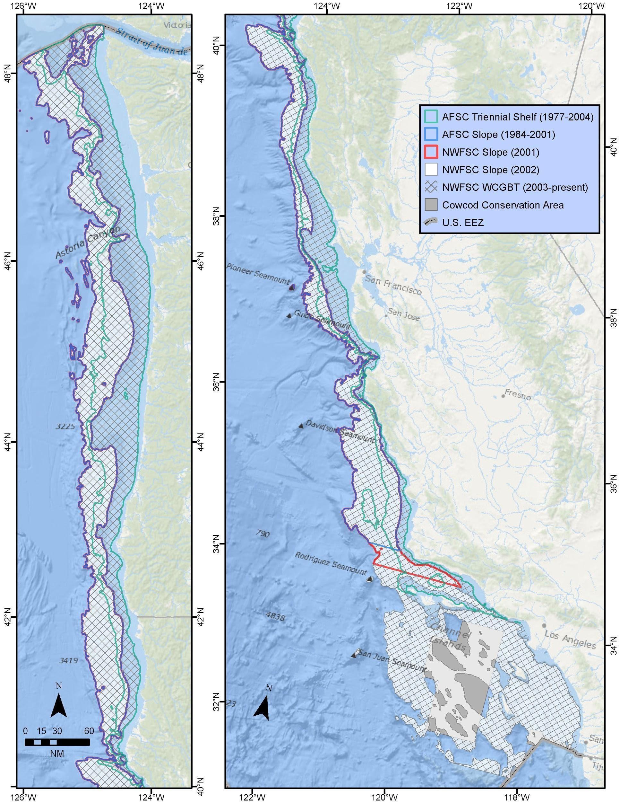

Figure 1. Overview of spatial extents of National Marine Fisheries Service Bottom Trawl Surveys in U.S. waters. This map does not show areas sampled in Canadian waters (e.g. NMFS Triennial Shelf Survey). The spatial extents for each survey are shown separately on subsequent maps.

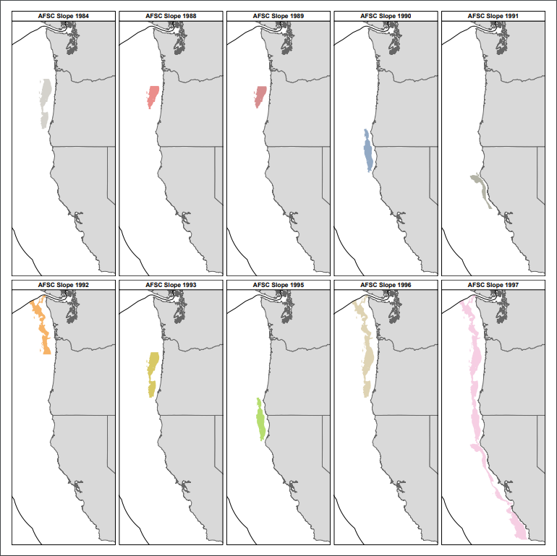

Figure 2. Spatial coverage of Alaska Fisheries Science Center Slope Survey by year.

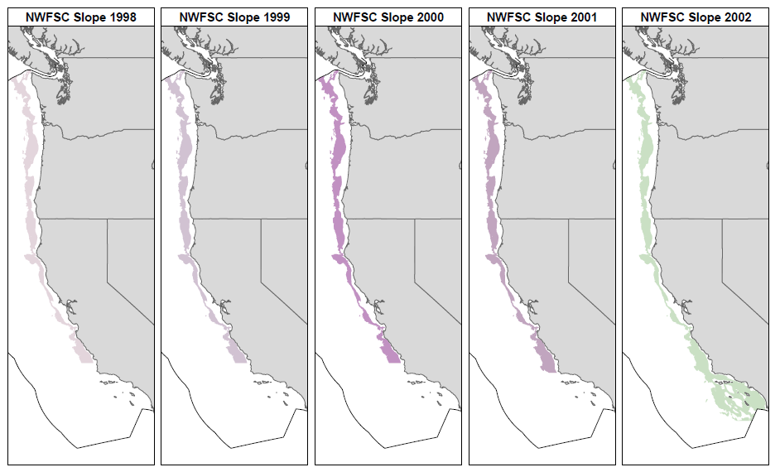

Figure 3. Spatial coverage of Northwest Fisheries Science Center Slope Survey by year.

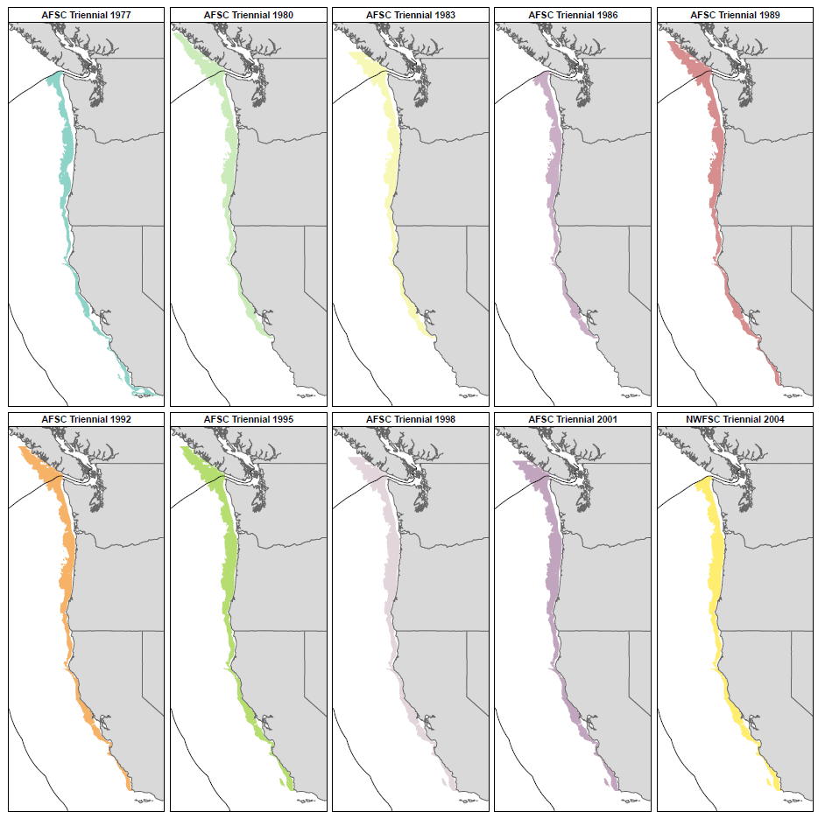

Figure 4. Spatial extent of National Marine Fisheries Service Triennial Shelf Survey by year.

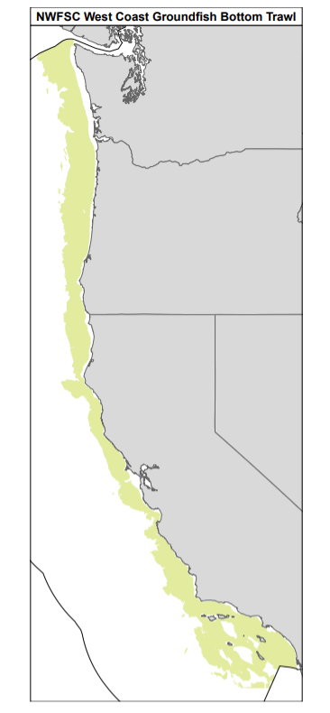

Figure 5. Spatial extent of Northwest Fisheries Science Center West Coast Groundfish Bottom Trawl Survey.

1. In 1996, the survey only covered areas off Washington and Oregon and therefore, only used in assessments of slope species with multiple areas.
2. The 1977 survey is considered to have a high proportion of “water hauls” and lower data quality. Assessments typically do not include 1977.
3. The survey was designed to be systematic random transects, however, in practice many of the stations were sampled regularly.