*Website*

**About Us**

*Welcome to Own Beautè, your number one source for all natural cosmetics. We're dedicated to giving you the very best service, with a focus on uniqueness and quality of our products.*

*Founded in 2017, Own Beautè has come a long way from its beginnings. When Pilani Joana first started out, her passion for biologic cosmetics, drove her to study and produce unique products for every customer and gave her the impetus to turn hard work and inspiration into to a booming online store. We now serve customers all over Italy and are thrilled to be a part of the eco-friendly wing of the cosmetic industry.*

*We hope you enjoy our products as much as we enjoy offering them to you. If you have any questions or comments, please don't hesitate to contact us.*

*Sincerely,  
Pilani Joana*

For any queries don’t hesitate to contact us at:

Email: [*ownbeaute93@gmail.com*](mailto:ownbeaute93@gmail.com)

*Mobile number: +39 3473647618*

Instagram page: <https://www.instagram.com/own_beaute/>

Facebook page: <https://www.facebook.com/bio.beaute.58>

*Products:*

*Categories:*

*Face care*

*Subcategory: Cosmetics*

*Personalized lipstick*

*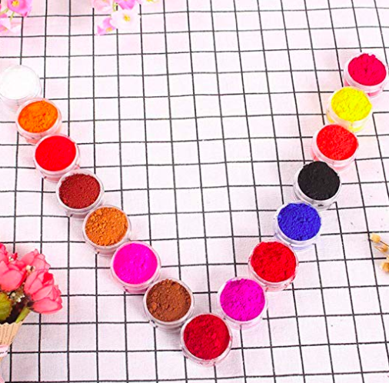*

*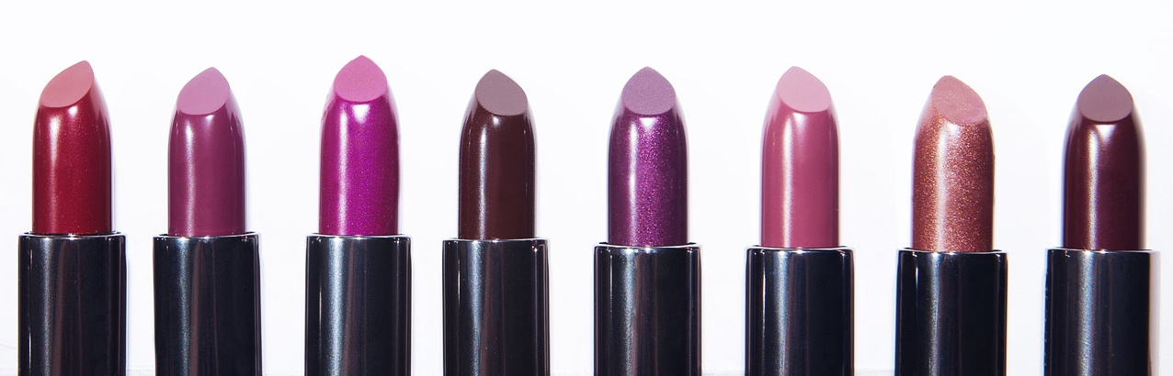*

*Dedicated to all makeup lovers that want to conquer the world with their uniqueness. The personalized lipstick is projected that everyone can choose from 4-6 colours to make a colour as they desire. It has all natural and organic ingredients and has the purpose to moisturize and nourish the lips.*

*Makeup fixer*

*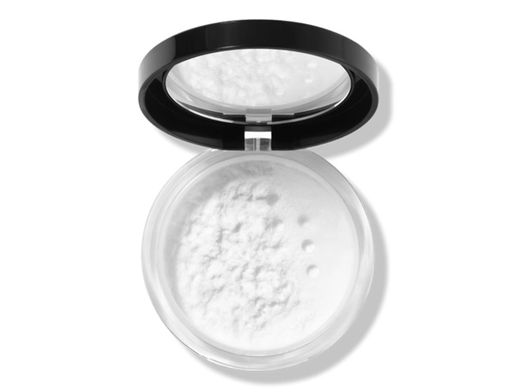*

*Transparent and light weighted the makeup fixer is thought to give a mattifying affect to the face. It can be used with and without make up for those who have an oily skin, as it has no colour does not limit you in its uses. Applied when you are wearing makeup makes it sweat and waterproof so it lasts longer throughout the day and if you use it in a clean face it creates the perfect skin oil free.*

*How to apply the makeup fixer:*

* *Take a small amount off the container ( drop it on the container lid and then take it with a sponge or a fluffy brush).*
* *Apply it to the skin smoothly in different parts.*
* *Brush it away as the skin only needs a small amount of this product.*
* *It leaves a glowing skin.*

*Bee balm*

*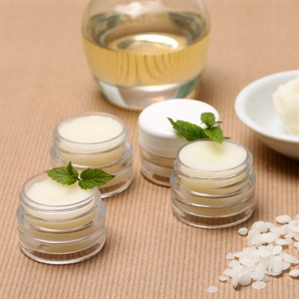*

*Nourish and soothe dry lips with our moisturizing bee balm. Smooth on this balm to hydrate lips from dryness in the winter and around the year.*

*The product is available in different scents as, unscented, mint, fruity and chocolate.*

***How to Apply Lip Balm***

* *Apply liberally*
* *Reapply as needed to help moisturize and soften lips*
* *Can be used day and night*

*Body care*

*Coloured body scrub*

*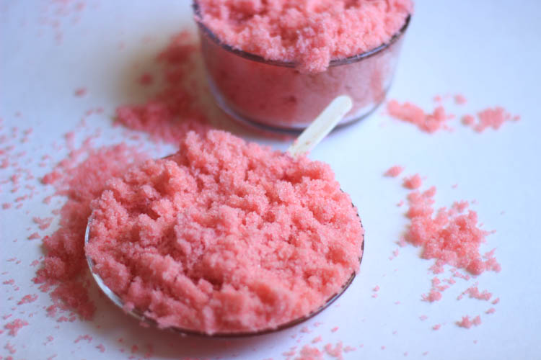*

*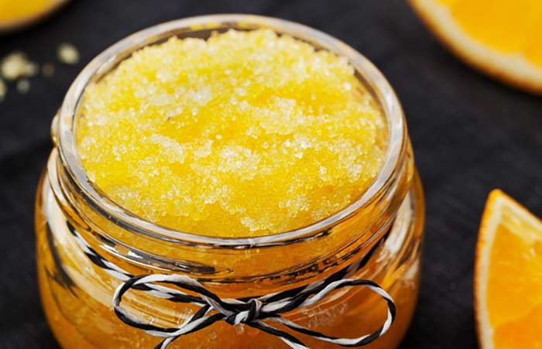*

*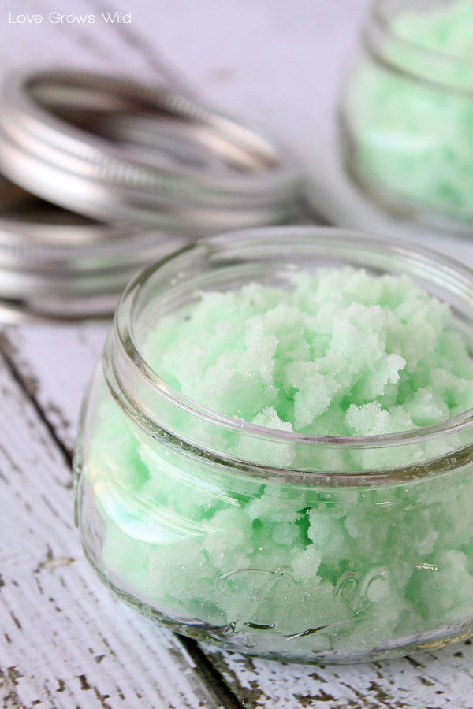*

*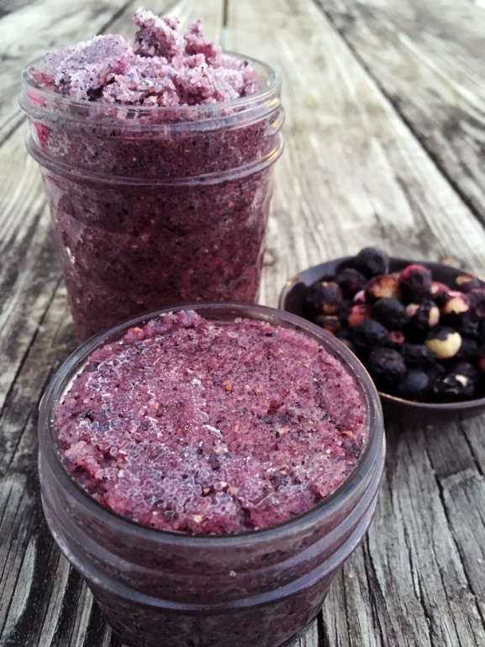*

*Colourful and fun but at the same time healthy, the coloured body scrub is designed to give the most amazing experience during the shower. You can choose from different colours and fragrances as cotton candy, minty fresh, citrus dream and tropical berry. The scrub has the property to exfoliate and nourish the skin by giving and amazing glow after it’s use.*

*How to apply :*

* *In the shower when the body is fully wet.*
* *Apply the body scrub with your hands.*
* *Massage the skin for 5-10 minutes.*
* *Wash your body as always.*

*Hair care*

*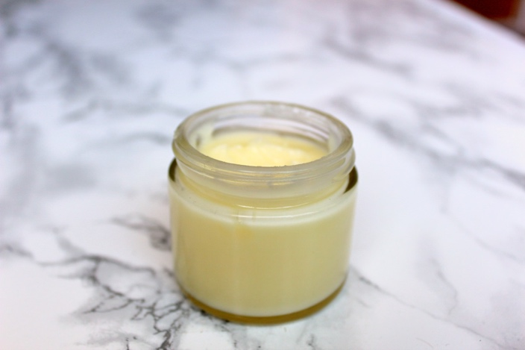*

*Helix hair mask*

*Ultra nourishing and filled with vitamins the helix hair mask is produced for those who have very damaged hairs. The mask contains different butters and essential oils that help the hair to grow healthy and to be more strong and shiny. Don’t be scared by the fact that it is an oil based mask, because is designed to be light and without oil residue after washing it. What I can guarantee is that you will never change this hair mask after you tried it.*

*How to apply:*

* *Better if you can apply the mask before showering so it stays on for the amount of time needed.*
* *From the container take a small amount of the mask.*
* *Apply it to the hair ends (the hair must be wet and don’t go over the ear area) going through the hair with your fingers.*
* *Leave it act for 10-15 min.*
* *Then wash them as always.*

*Others*

*Coconut oil*

*Coconut oil is used widely from hair care to skin care. It is useful in the treatment of a number of medical conditions, some of which are explained in greater detail below.*

* ***Cures fatigue:****The saturated fats present in coconut oil, being a great source of energy, effectively cure fatigue and energy malnutrition.*
* ***Antioxidant and anti-aging properties:****The antioxidant properties of coconut oil come from its saturated fats like capric acid, caprylic acid, caproic acid, and myristic acid. They counter adverse effects of aging, macular degeneration, graying of hair, and sagging of the skin.*
* ***Antimicrobial properties:****The acids discussed above convert themselves into great antimicrobial and anti-fungal agents like monocaprin and monolaurin when acted upon by certain enzymes. These derivatives protect our body, both internally and externally, from conditions like Athlete’s Foot, rashes, itches, ringworm, and*[*dermatitis*](https://www.organicfacts.net/dermatitis.html?utm_source=internal&utm_medium=link&utm_campaign=smartlinks)*.*
* ***Reduces hair loss:****This property of coconut oil is the most famous, at least on the Indian Subcontinent. It keeps hair black, prevents it from graying and*[*hair loss*](https://www.organicfacts.net/hair-loss.html?utm_source=internal&utm_medium=link&utm_campaign=smartlinks)*.*
* ***Candida:****The antimicrobial properties of coconut oil, discussed above, have been found to be effective against candida.*
* ***Vermifuge:****Coconut oil can be used against intestinal roundworms and tapeworms.*
* ***Dandruff:****It prevents peeling away of the skin on the scalp and conditions like dandruff by keeping the skin moist and smooth.*
* ***Digestive disorders:****This oil, taken regularly in proper quantity, can help cure chronic digestive problems.*

*INGREDIENTS*

*We have the pleasure to inform you that we only use ingredients from natural origin, produced manually or purchased by certificated sellers. Ingredients used by us are:*

* *She butter*

## *What is Shea Butter?*

*Shea butter is made from a type of fat that is found in the nuts of an African tree – the shea tree. Scientifically known as Vitellaria paradoxa, when the fat is extracted from the nut, it can be processed in various ways to make it more versatile and useful, both in food preparation and cosmetic products. As a triglyceride, this butter is primarily composed of oleic and stearic acids, both of which have a wide range of effects on human health.*

*In Europe and North America, shea butter is typically found in cosmetics and certain chocolate recipes, but in other parts of the world, this rich fat is also popular as an ingredient in food. Contrary to what some people believe, it is edible, provided you use it in moderation. Similar to olive oil, shea butter comes in various forms, such as organic, unrefined, and raw, which designate how much processing and bleaching it has undergone.*

## *Shea Butter Nutrition*

*The nutritional details of shea butter are quite limited, as it is only composed of a series of organic acids, including oleic acid, stearic acid, linoleic acid, linolenic acid, palmitic acid, and arachidic acid. These fatty acids often have other effects, such as antioxidant or anti-inflammatory impacts on the body. Depending on the level of processing and the addition of any other aromatic or chemical compounds for cosmetic products, the nutritional composition of this butter may change. There are 120 calories in a single tablespoon of shea butter, as well as trace amounts of other minerals, such as vitamin E, vitamin A, and vitamin C.*

## *Shea Butter Benefits*

*The most recognized benefits of shea butter include effects like moisturizing the skin, reducing inflammation, preventing premature aging, protecting cardiovascular health, and lightening the skin, among others.*

### *Moisturizing*

*The fatty acids in this butter are known to penetrate the skin and deliver nutrients and antioxidants deep into the skin, keeping it hydrated and healthy.*

### *Hair Care*

*Using shea butter on your scalp and hair can help to increase growth, prevent hair loss, and reduce inflammation. This simple fix can lead to less dandruff.*

### *Anti-Inflammatory*

*Applying this substance to itchy or irritated areas of the body can help to quickly relieve discomfort and soothe conditions like psoriasis, acne, eczema, or rosacea.*

### *Skin Care*

*Regularly applying this fat-rich butter to your skin can eliminate rough skin and boost skin tone by encouraging circulation and repair of damaged skin cells.*

### *Premature Aging*

*The antioxidant activity of certain active compounds in this butter, such as linoleic and linoleic acid can help to prevent oxidative stress in the skin, which can reduce the likelihood of wrinkles, age spots, and other signs of premature aging.*

### *Stretch Marks*

*Following rapid weight change (pregnancy, crash diet, etc.), your body may develop stretch marks that can be difficult to eliminate. Thanks to the skin-lightening properties of this natural butter, you can make the stretch marks less noticeable.*

### *Diaper Rash*

*Popular with new parents, shea butter can help protect your child against one of the most irritating and annoying conditions of infancy – diaper rash. Daily application of a small amount can keep them feeling good all day!*

*Avocado butter*

## *A natural and better alternative to vitamin and mineral supplements:*

*You can buy vitamins, minerals and various supplements in various forms from a wide variety of health food stores. However, what the experts agree on practically unanimously is that vitamins and minerals taken in supplement form are not as effective as those taken naturally in the diet.  Why is this?*

*One reason is that many substances work best when in the presence of others, producing what is known as a synergistic effect; they work better together than each would separately.  This synergy is not always present in supplements.*

*Additionally, and probably even more importantly, many vitamins and minerals that are manufactured synthetically, are available in a different form than those occurring naturally. This alternate form is often  not so easily assimilated into the body.*

## *The Secret Skincare Ingredients of Avocado Butter:*

*So what has this to do with avocado butter?  This natural extract of avocado is rich in vitamins A, D, and E, unsaturated fatty acids, and lecithin, all of which are beneficial to your general health and that of your skin. Synthetic equivalents cannot possibly contain the same components in a natural form, nor be as easily used by the body as their pure, natural counterparts found in the avocado plant.*

*Hence, although synthetic skin care products can benefit your skin, they cannot do so as effectively and gently as natural substances such as avocado butter. This is why it is the prime ingredient in our*[*Avocado Eyes Anti-Aging Eye Cream*](https://www.castlebaths.com/eye-cream-1.html)*. The butter itself is produced from the flesh of the fruit, not from the extracted oil. The flesh is hydrogenated in the same way that vegetable oils are hydrogenated to produce margarine.*

*Coconut butter*

*You can think that it is the same product as coconut oi but I have to say totally no*. The main difference between coconut butter and coconut oil is that coconut oil is oil extracted from the coconut while coconut butter is made from the meat of the coconut, and includes actual pieces of coconut meat in it.

It has strong nutritive properties for hair and skin, restoring it completely.

The coconut butter is used for damaged tissue and helps It to rebuild again and stronger.

As the coconut oil the coconut the coconut butter has the same properties only they are stronger since it contains pices from the fruit itself.

*Cocoa butter*

## ***What Is Cocoa Butter?***

[*Cocoa beans*](https://en.wikipedia.org/wiki/Cocoa_bean)*are native to parts of Central and South America and have been harvested to make natural skin moisturizers in places like Mesoamerica and the Caribbean for centuries. Because it has a mild fragrance, a smooth texture (due to its “emollient” properties) and is ultra-hydrating, cocoa butter is a very popular ingredient today around the world in all sorts of commercial beauty products.*

#### **Prevents Skin Dryness and Peeling**

*Cocoa butter makes an excellent skin moisturizer, plus it does more than just hydrate the skin — it helps actually heal it from the inside out too. It’s a great source of natural antioxidants that are found in cocoa beans (the same kinds found in real, dark chocolate that are tied to benefits like heart health and improved cognitive functioning). Saturated fats are especially beneficial for healing dry, cracked skin because they’re easily absorbed and remain on the skin for hours.*

#### **Heals**[Chapped Lips](http://www.webmd.com/beauty/lips-smile/end-chapped-lips)

*One of the most popular ways to use cocoa butter is on the lips, especially in homemade lip balms. It can be used with essential oils like grapefruit, vanilla, orange or*[*peppermint oil*](https://draxe.com/peppermint-oil-uses-benefits/)*to make flavorful lip palms that are also hydrating for delicate skin.*

*Cocoa butter is an*[*emollient*](http://www.nhs.uk/conditions/emollients/Pages/Introduction.aspx)*, which means it adds a protective layer of hydration to your lips, useful for blocking the effects of very cold temperatures, sun damage or indoor heat, which can leave your lips dry.*

#### **Fights Signs of Aging**

*Cocoa butter contains compounds called cocoa mass polyphenols, which some studies have found can help diminish signs of aging, plus soothe sensitive skin suffering from*[*dermatitis*](http://www.mayoclinic.org/diseases-conditions/dermatitis-eczema/basics/definition/con-20032183)*or rashes.*[*Polyphenols*](http://www.wikihow.com/Boost-Your-Intake-of-Polyphenol-Antioxidants)*are types of antioxidants that promote health both internally when eaten and when used topically on the skin. Cocoa’s polyphenols have been found to fight various chronic diseases, degeneration of the skin, sensitivities and even cell mutations.*

*Research shows that its polyphenols have several positive indicators for skin health, including improved skin elasticity and skin tone, better [collagen](https://draxe.com/what-is-collagen/" \t "_blank)retention/production, and better hydration. When comparing cocoa butter to commercially available products, both showed positive results, but only cocoa butter is free from potentially harmful or irritating ingredients.*

#### **Soothes Burns, Rashes and Infections**

*Rub a small amount of pure cocoa butter into burnt skin to help skin replenish. Just make sure it’s pure and doesn’t contain any alcohol, fragrances/perfumes or other additives that can lead skin to become even more inflamed and sensitive.*

#### **Helps Treat Mouth Sores**

*If the inside of your mouth is prone to developing painful sores or your lips develop recurring blisters, use a bit of cocoa butter to keep them moisturized.*

#### **Makes a Great Shaving Cream**

*You can use cocoa butter in your tub to shave and hydrate skin at the same time. It melts easily in warm water and won’t clog your drain. Use a small handful before shaving to prevent nicks and to leave just-shaven skin feeling nice and smooth. After showering is another great time to slather it on, since heat opens up pores and makes it absorb products better.*

* *Can be used to prevent stretch marks, especially if you have dry skin normally, but it doesn’t seem to reverse stretch marks that have already formed.*

*Essential oils*

*Essential oils have been used for thousands of years in various cultures for medicinal and health purposes. Because of their* antidepressant, stimulating, detoxifying, antibacterial, antiviral and calming properties, essential oils are recently gaining popularity as a natural, safe and cost-effective therapy for a number of health concerns.

The particles in essential oils come from distilling or extracting the different parts of plants, including the flowers, leaves, bark, roots, resin and peels. In fact, just one drop of an essential oil can have powerful health benefits.

What is an essential oil?

Typically created through the process of distillation — which separates the oil and water-based compounds of a plant by steaming — essential oils are highly concentrated oils that have a strong aroma. In fact, sometimes they are called volatile aromatic oils because of their high concentration of the aromatic compounds. They also are simply called aromatherapy oils.

How do essential oils work? By concentrating the oils of these plants, you are literally separating the most powerful healing compounds of a plant into a single oil.

## *Essential Oil Benefits*

#### Boost Skin and Hair Health

*Using essential oils in your skin, hair and beauty products is a natural and effective way to keep up your personal care regimes without having to use products that are made with chemicals and hydrogenated oils. Essential oils can calm irritated skin, reduce signs of aging, like age spots, improve acne, protect your skin from sun damage and thicken your hair.*

*According to a review published in*Evidence-Based Complementary and Alternative Medicine*, “at least 90 essential oils can be identified as being recommended for dermatological use, with at least 1,500 combinations.” What gives essential oils their skin benefits is their ability to fight against pathogens that are responsible for dermatological infections. Essential oils can also help to improve inflammatory skin conditions, like dermatitis, eczema and lupus, improve the general appearance of your skin and even aid wound healing.*

*There are also quite a few studies that have found essential oils to be helpful for hair growth. One such study, conducted in 2015, evaluated the efficacy of rosemary oil on patients with androgenetic alopecia, or male or female pattern baldness. Patients were randomly assigned to rosemary oil or minoxidil (a medication commonly used for hair loss) for a six-month treatment period. Researchers found that both groups experienced a significant increase in hair count at the six-month endpoint. They also indicated that scalp itching was more frequent in the minoxidil group.*

*The essential oils we use for skin and hair health include lavender, Roman chamomile, frankincense, tea tree, geranium, myrrh, helichrysum, rosemary and clary sage.*

*Honey*

*Honey is the key ingredient in our body and face products for it numerous properties. We use it raw and natural to guarantee the best quality of our products.*

*Honey properties:*

*Antibacterial properties that make it usable for the treatment of eczema and psoriasis pathology.*

*Antifungal properties that make it ideal to treat mucus of the skin formed in different spots of the body.*

*Anti inflammatory properties that help treat acne and sensible skin. It is used to treat scars as it has protective properties too.*

*It has various nutritive compounds that nourish deeply the skin and hair.*

*Sea salt*

*The main ingredient of body scrubs, as it is an:*

## *Exfoliator*

*Sea salt is an excellent exfoliating treatment, to gently remove the dead skin cells. It can also be used as a rub to exfoliate and soften tough skin.*

## *Detoxifier*

*Sea salt is a natural detoxifier, as the salt absorbs the toxins from the skin.*

*Increases circulation, antiseptic effects, soft skin without a greasy feel and reduction in fluid retention are just some of the additional benefits of sea salt for the skin.*

*Beeswax*

Beeswax (is our emulsifier for almost all the creamy products) it helps to keep an emulsion from separating into its oil and liquid components, especially in cosmetics and personal care products that require a creamy consistency. These waxes also increase the thickness of the lipid (oil) portion of solid and stick-like products such as lipstick, giving them structure, allowing for a smooth application, and keeping them solid. When used in eye makeup, the waxes stiffen but do not harden the product, and the flexibility and plasticity of the waxes facilitate application. These waxes may also function in depilatory products to remove unwanted hair mechanically.

Home</a></li>

<li><a href="#">Face Care</a></li>

<li><a href="#">Body Care</a></li>

<li><a href="#">Hair Care</a></li>

<li><a href="#">Other</a></li>