[Step-By-Step Tutorial/Guide] Raspberry Pi with UniFi Controller and Pi-hole from scratch (headless)
This is a step-by-step tutorial for anyone looking for a straight forward installation of both the UniFi Controller and Pi-hole (Advertisement Blocking DNS server) without needing to hook up the Raspberry Pi to a monitor with a keyboard and mouse (= headless). You don't have to install both if you only wish to use one.
If you still have questions or if I forgot to explain some part you're stuck at, please post here so I can add this to the tutorial.
Dutch version: https://gathering.tweakers.net/forum/list_messages/1873125
____________________________________________________________________________________________________________________________________________
>> 12 Nov 2021 : Updated to work with the new Raspberry Pi OS 11, Bullseye!
>> 13 Nov 2021 : Added an instructional video to show the steps on Windows 11.
____________________________________________________________________________________________________________________________________________
If you prefer to watch an instructions video, you can do so (best to view on Youtube so you can view it in a bigger size):
0:00 Hardware Requirements
0:25 Software Requirements
0:46 Installing Raspberry Pi OS Lite
1:34 Enable SSH
3:04 Scan for IP address
3:20 SSH into Raspberry Pi
3:55 Execute the installation script
4:26 PiHole configuration
5:17 Opening UniFi Controller and PiHole
____________________________________________________________________________________________________________________________________________

0. What you will physically need

- Raspberry Pi 3 model B(+) or Pi 4 with a MicroSD card of at least 4GB
- Ethernet cable to connect it to an existing network
- capability to connect the MicroSD card to a computer via a card reader

1. Download the necessary tools and raspbian operating system image

1. Raspberry Pi OS Lite (= without desktop interface)
https://www.raspberrypi.com/software/operating-systems/
Direct: https://downloads.raspberrypi.org/raspios_lite_armhf/images/raspios_lite_armhf-2021-11-08/2021-10-30-raspios-bullseye-armhf-lite.zip

2. Rufus to install the image on to the MicroSD card.
https://rufus.ie/
Direct: https://github.com/pbatard/rufus/releases/download/v3.17/rufus-3.17.exe

3. Advanced IP Scanner to figure out the assigned IP address of your Raspberry Pi.
http://www.advanced-ip-scanner.com
Direct: http://www.advanced-ip-scanner.com/download/Advanced_IP_Scanner_2.5.3850.exe

4. If you are not using Windows 10 or 11, you can use PuTTY instead of the command prompt to connect to your Raspberry Pi.
https://www.chiark.greenend.org.uk/~sgtatham/putty/latest.html
Direct: https://the.earth.li/~sgtatham/putty/latest/w64/putty-64bit-0.76-installer.msi

5. If you are having issues with the partitions on your MicroSD card, I recommend using MiniTool Partition Wizard. This program makes it very easy to start from scratch by removing every partition on your MicroSD and creating a new Fat32 partition.
https://www.partitionwizard.com/free-partition-manager.html
Direct: https://cdn2.minitool.com/?p=pw&e=pw-free

2. Install Raspbian on the MicroSD
Open up Rufus to install Raspbian.
- Make sure your MicroSD card is selected
- Press SELECT and select the downloaded raspios-xxxx.zip
Tip: you don’t have to extract the .zip
- Press START
- Accept the warning about removing all of the data on the MicroSD (-> All data on that microSD card will be deleted!)
- wait until the process is done.
- Windows may ask you to format the Linux partition, do not do this, just cancel the request.
(click on the image to view it entirely)
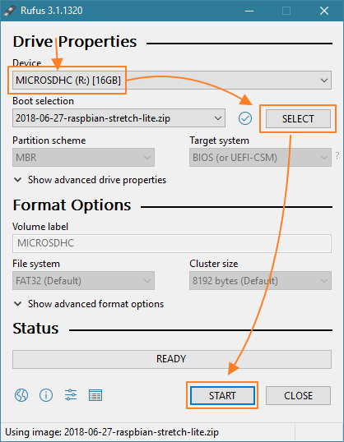
.
.

3. Enable SSH to remotely control the Raspberry Pi
Enable SSH before starting the Raspberry Pi by adding a new text file to the main folder of the MicroSD card (boot partition).
Rename this text file to ssh and remove the .txt extension.
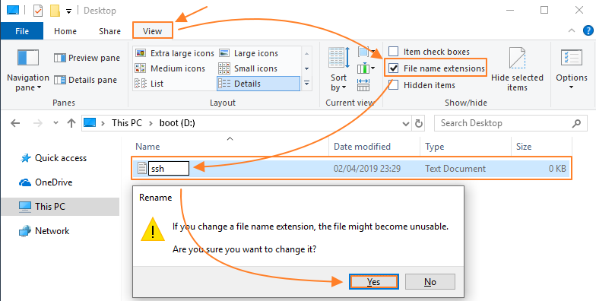
The MicroSD is ready now, insert it into your raspberry pi, connect an ethernet cable and turn on the Raspberry Pi.
.
Note: It is possible that Windows/Rufus has not assigned a driveletter to the "boot" partition. If you cannot see the drive in file explorer, do a right-mouse click on start, click on disk management and assign a letter to the "boot" partition by right clicking on it and assign a drive letter. You can also use the MiniTool Partition Wizard to do this.
.
.

4. Lookup the IP address
If you’re using Advanced IP Scanner, you can simply press SCAN and wait until the Raspberry Pi shows up.
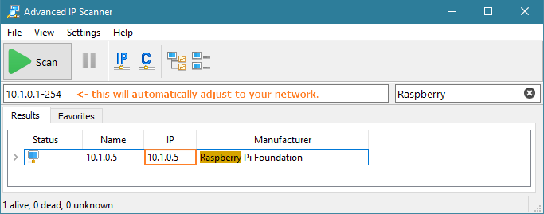
.

5. Login via SSH
.
1. Open up the command prompt (search for cmd in start or the dedicated search box)
Tip: You should be able to paste commands by right clicking into the command prompt.
.
2. Login with the SSH command
Note: change the IP address with the IP address of your Raspberry Pi (obtained in step '4. Lookup the IP address')
ssh 10.1.0.5 -l pi
.
3. As we have not defined an SSH key, it will ask if we trust the host.
Type: yes and press enter.
The authenticity of host '10.1.0.5 (10.1.0.5)' can't be established.
ECDSA key fingerprint is SHA256:XXX. Are you sure you want to continue connecting (yes/no)? yes
.
4. When typing in the password, you will not see characters being displayed, simply type it and enter
The default password is: raspberry
.
.
____________________________________________________________________________________________________________________________________________
Use the script to save time (or skip this part if you wish to do every step manually)
By running the following line of code, every necessary command will automatically run for you. You choose which version of UniFi to install.
You can view the script by looking on my Github page: https://github.com/SmokingCrop/UniFi/blob/master/install-unifi-pihole-English.sh
.
To install the UniFi controller and Pi Hole, copy/paste/run the following line of code:
(versiunea mea)
sudo wget “https://github.com/andibaciu/raspberry/raw/main/install-unifi-pihole-English.sh" -O install-unifi-pihole.sh && sudo chmod +x install-unifi-pihole.sh && ./install-unifi-pihole.sh
(versiunea originala)
wget "https://github.com/SmokingCrop/UniFi/raw/master/install-unifi-pihole-English.sh" -O install-unifi-pihole.sh && chmod +x install-unifi-pihole.sh && ./install-unifi-pihole.sh
.
To only install the UniFi controller, copy/paste/run the following line of code:
(versiunea mea)
wget " https://github.com/andibaciu/raspberry/raw/main/install-unifi-pihole-English.sh" -O install-unifi-pihole.sh && chmod +x install-unifi-pihole.sh && ./install-unifi-pihole.sh no-pihole
(versiunea originala)
wget "https://github.com/SmokingCrop/UniFi/raw/master/install-unifi-pihole-English.sh" -O install-unifi-pihole.sh && chmod +x install-unifi-pihole.sh && ./install-unifi-pihole.sh no-pihole
____________________________________________________________________________________________________________________________________________
.
.

6. Change the default password
It's very unsafe to keep the default password, so we'll change it.
Enter the passwd command, it'll ask you to type the current password once and your new password twice.
pi@raspberrypi:~ $ passwd
Changing password for pi.
(current) UNIX password:
Enter new UNIX password:
Retype new UNIX password:
passwd: password updated successfully
.

7. Add the Raspbian Stretch sources.list for MongoDB compatability
As the UniFi controller uses an old MongoDB version, it's necessary to add the old Raspbian Stretch sources.list. Otherwise the UniFi controller will not work with the latest Raspbian OS.
echo 'deb http://archive.raspbian.org/raspbian stretch main contrib non-free rpi' | sudo tee /etc/apt/sources.list.d/raspbian_stretch_for_mongodb.list
.

8. Download and install updates
To make sure you have all the latest updates and to clean up any unused/old ones, execute the following command:
sudo apt update && sudo apt full-upgrade -y && sudo apt autoremove -y && sudo apt-get autoclean -y
.

9. Install Java 8
The default available Java version from Oracle is too old to make the 6.X UniFi controller work. Instead of doing multiple extra commands to upgrade this version, we're just going to install OpenJDK. It also requires the 'jsvc' and 'libcommons-daemon-java' packages.
sudo apt install openjdk-8-jre-headless jsvc libcommons-daemon-java -y
.

10. Install haveged
In order to fix the slow start-up of the UniFi controller, we have to install haveged. The reason for the slow start-up is the lack of user interaction (no mouse movements) causing issues with the mechanisms for 'harvesting randomness'.
sudo apt install haveged -y
.

11. Install MongoDB
The UniFi controller uses MongoDB. You can skip this, but then the installation of the UniFi controller will notice on its first try that it is missing and will install it anyways and then try to install UniFi again. So it's better to just install it already.
sudo apt install mongodb-server mongodb-clients -y
.

12. Install the UniFi Controller
Poti sa vezi o lista a versiunilor de UniFi Controller aici :
https://www.ui.com/download/unifi/unifi-ap-ac-lr/default/unifi-network-controller-51027-debianubuntu-linux-and-unifi-cloud-key
I'll show two ways of installing the UniFi Controller.
Method A: manually installing the Controller by using the download link on the website/update blog.
- Easily install any Controller version you want, whenever you want. As soon as the blog comes out.
- If you're not using the script, it'll take more commands to update your Controller in the future
(I personally prefer method A)
.
Method B: Setting up the repository so you can install and update with the apt command.
- Once it is setup, you can install/update the Controller like any other program with apt.
- When a new Controller version is out, it takes like a week before you'll be able to install it.
- It's recommended to still go the blog of the update to know if any changes will affect your setup!
.
.
12.1 Install the UniFi Controller with method A
1. Use the link with the wget command to download the Controller installation package.
wget https://dl.ui.com/unifi/6.5.55/unifi_sysvinit_all.deb
.
2. Install UniFi and its dependencies.
sudo dpkg -i unifi_sysvinit_all.deb; sudo apt install -f -y
.
Go to your UniFi Controller via the IP address and port:
E.g: https://10.1.0.5:8443

You’ll want to set a reserved (fixed) IP address in the UniFi Controller for the Raspberry Pi.
.
You can go to the (beta) releases page and copy the Debian download link at the bottom of the posts ("UniFi Network Application for Debian/Ubuntu and UniFi Cloud Key") if you want a different version than the one used in this tutorial.
https://community.ui.com/releases?q=Network+Application
https://www.ui.com/download/unifi/
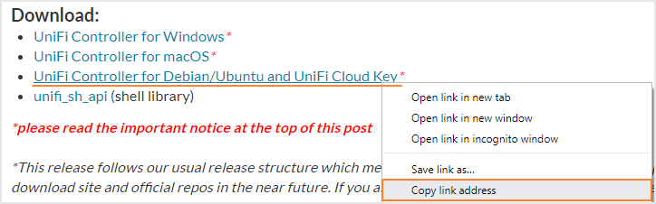
.
.
12.2 Install the UniFi Controller with method B
1. Install apt-transport-https in order to be able to use the 'deb' lines over HTTPS in the /etc/apt/sources.list
sudo apt install apt-transport-https -y
.
2. Add a new source to the list of sources from which packages can be obtained with 'apt'
echo 'deb https://www.ui.com/downloads/unifi/debian stable ubiquiti' | sudo tee /etc/apt/sources.list.d/100-ubnt-unifi.list
.
3. Add the GPG keys
sudo wget -O /etc/apt/trusted.gpg.d/unifi-repo.gpg https://dl.ui.com/unifi/unifi-repo.gpg
.
4. Update the packages after adding the new source and Install the UniFi package
sudo apt update && sudo apt install unifi -y
.
Go to your UniFi Controller via the IP address and port:
E.g: https://10.1.0.5:8443
You’ll want to set a reserved (fixed) IP address in the UniFi Controller for the Raspberry Pi.
.
.

13. Install Pi-hole
Execute the following command and configure Pi-hole

curl -sSL https://install.pi-hole.net | bash
> Choose an interface: (*) eth0 (= ethernet cable)
> Choose your DNS provider: Custom 1.1.1.1, 8.8.8.8 (= fast cloudflare dns & basic Google dns) or any other option
> Choose your adblocking providers: leave them all enabled
> IPv4 and/or IPv6: both
> PiHole wants to set a static IP. Let it do its thing. I guess they haven’t heard of DHCP reservation/central management yet.
> Install the Web admin interface and the web server
> privacy mode for FTL: 0 Show everything
Change the password used to log into the web admin interface

pi@raspberrypi:~ $ pihole -a -p
Enter New Password (Blank for no password):
Confirm Password:
[✓] New password set

Go to your Pi Hole web admin interface via the IP address and /admin:
E.g: http://10.1.0.5/admin

--I'm only able to write 10 000 characters per post. Check the accepted answer below--

Accepted solution

SmokingCrop
3 years ago

11. Updating the UniFi Controller and Pi-hole with future updates

.
.
Before Upgrading, please take a minute to take a back-up of your UniFi controller.
There is always a chance that something goes wrong while updating your UniFi controller!
.
.

11.1 Updating the UniFi Controller with method A

I've also made a simple script for updating your system, Controller and Pihole in one go (If you have used Method A to install the controller).
Simply enter ./update.sh in the future to use the script again without having to redownload it.

wget "https://github.com/SmokingCrop/UniFi/raw/master/update-unifi-pihole-English.sh" -O update.sh && chmod +x update.sh && ./update.sh
or keep following the tutorial:
____________________________________________________________
In order to update the UniFi Controller manually you can use the following commands:
.
1. Remove the old downloaded UniFi Controller package
rm unifi_sysvinit_all.deb
.
2. Download the new UniFi Controller package, adjust the link below for the version you want to install.
wget https://dl.ubnt.com/unifi/x.x.xx/unifi_sysvinit_all.deb
.
3. Upgrade the UniFi Controller.
sudo dpkg -i unifi_sysvinit_all.deb
.
.

11.2 Updating the UniFi Controller with method B

Updating is easy but it may not be available right away, in that case, you will need to wait a few days longer before you can update (usually about a week after they have released the blog).
Simply execute the following commands. This will also upgrade your other programs.
sudo apt update; sudo apt upgrade -y
.
.

11.3 Updating Pihole
It's very easy to update Pihole with the following command:
pihole -up

