## Project concept

Latest version of Project concept: <https://github.com/andics/Big-Bang-Files.git>

The neurocranium is composed of flat bones fastened together by calvarial sutures, which represent bands of fibrous connective tissue. The sutures allow no active motions, but act as flexible joints and permit adjustive overlap of the calvarial bones as the head becomes compressed during the childbirth.

Throughout the development they function as intramembranous bone growth sites in response to the intrinsic separating forces from the growing brain requirements. When the brain reaches its optimal shape and size during the early adulthood, the process of suture maturation usually begins with a series

of morphological changes. The reorganization in the micro-structural finally leads to complete remodeling and obliteration of the sutural area. Until now, the correlation between suture closure and age-at-death has been examined by conventional quantifying methods based on a superficial

subjective assessment of the suture patency on the endo- and exo-cranial surfaces together or individually, using descriptive rank- ordered scoring scales of various grades.

Methods for endo- and exo-cranial surface assessment have existed for hundreds of years. No special equipment is required to extract data from a skull using such methods, therefor the concluded age estimates are not very accurate.

Nowadays, the availability of technology like the CT scanner allows an inside view of a skull’s structure, which can further be used to not only explore the endo and exo-cranial surface, but the cross-sectional depth of the suture as well. This type of in-depth analysis of a suture is a new approach, and only three studies have been made on the topic.

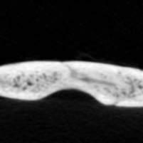In two of the studies a human is responsible for evaluating the level of bone fusion along the suture, which is incredibly time consuming, subjective and therefore, sometimes inaccurate. There has been only one attempt to automatize this process with the use of a simple algorithm, but the results were not promising, as the algorithm lacked the ability to consider enough factors in the suture image. If we take image sagittal0014.png from the “old_person_sagittal”, and run the previously used algorithm on it, the only information we’ll receive about the suture is that it is “closed” on this image.

While the suture is very vague, it can still be seen that the bones aren’t completely fused as the color of the suture isn’t completely white. How far they are from complete fusion directly depends on how close to white the color of the suture is. Computationally, this is relatively easy to calculate on a grayscale image but can hardly be done along the whole length of the suture by a human. Those bits of extra information on a certain image, like the color of the suture or the depth of the suture, are neglected by all currently known techniques for age estimation. Considering this extra information can be a key to improving the accuracy of age estimation based on cranial sutures, with real world applications in multiple fields including archeology, criminology and anthropology.

The CT scans for this project are provided by the Bulgarian Academy of Sciences. The scanning was performed using an industrial µCT system Nikon XT H 225, developed by Nikon Metrology.

All of the skulls belonged to Bulgarian soldiers who died in the First and the Second Balkan Wars and the First World War. Their skeletal remains were preserved in the Military Mausoleum Ossuary, at the National Museum of Military History (Bulgaria). The individuals were fit for service which means they were without severe disorders and malformations. Information about the AAD was taken from the museum’s archive, where it was kept.

A typical skull dataset consists of multiple horizontal slice images at different heights along the whole skull. Looking at those images from the top of the skull to the bottom can be seen in dataset_video.mp4. At the beginning of the video, a very long crack going through the middle of the image can be noticed. This crack is the sagittal suture, looked at from different horizontal slices. Now take a look at skull_verticall_view.png.

Looking at the orientation of the bone on the image and imagining a horizontal slice going through the skull at that point, the images at the beginning of the video start to make more sense. A cross-sectional slice of the bone at a certain point is defined as an image, perpendicular to the surface at that point. A good example of such slice can be seen on the picture. Once we have that in mind, we can conclude that to see an image of the depth (thickness, cross-section) of the suture at a particular point, we would need a slice that is perpendicular to the surface at that point. This is clearly not the case with the top of the skull and the horizontal slices we are provided with. In fact, those horizontal slices are perfectly perpendicular to the surface at very few points on the skull, so we can’t directly extract our cross-sectional suture slices from the dataset needed for analyzing the sutures later.

For this reason, the first part of the project is to generate images perpendicular to the surface of the skull, in order to get a view of the bone cross-section. This is achieved by firstly generating a 3d model of the skull from the provided image volume. The suture’s start and end points are selected by the user on the 3d model. If the shape of the suture is more complex than just a straight line, the software allows for an unlimited number of points to define the length of the suture. The program then automatically generates images perpendicular to the surface of the skull along the length of the suture (between the start and end point). A good example of this ability can be seen in suture_points.png.

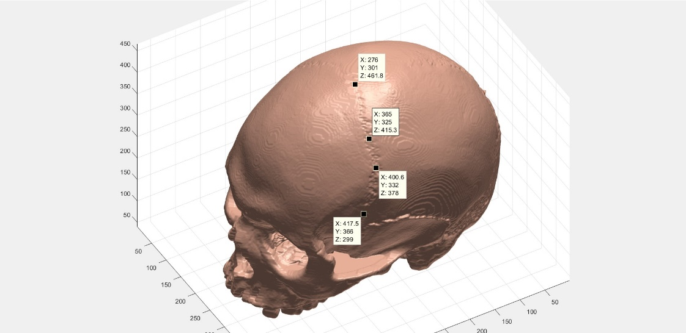

Preferences like the number of images wanted, or the size of the generated images can also be specified by the user.

The generated images are then exported to a specified folder, where they’re stored for future analysis.

The existing studies are only able to consider cross-sectional suture images at the top of the head, as the surface of the skull there is relatively flat. This allows for a vertical plane to generate multiple relatively cross-sectional images.

Even at this stage, the project already provides a better opportunity to analyze a suture, as it can generate cross-sectional images, not only at the top of the skull, but at any point of the skull (Unlike the [1] study).

The sutures in the generated images are labeled and used to train a Semantic Segmentation network to detect sutures in new images. So far the network has been trained on 7500 images from skulls of various age. Every detected suture region is processed using fuzzy C-Means clustering and thresholding to filter out any errors from the neural network.

For the now filtered suture region, a number of metrics are measured. The recorded variables are stored in different excel files corresponding to each separate skull that the algorithm has examined.

This data has been analyzed by a statistical software (Minitab) to create a regression equation involving the measured metrics and resulting to the ‘Predicted Age’ variable.

Links to existing studies:

[1] Estimating age by assessing the ossification degree of cranial sutures with the aid of Flat-Panel-CT <https://www.legalmedicinejournal.com/article/S1344-6223(09)00112-6/fulltext>

[2] High-resolution flat-panel volumetric CT images show no correlation between human age and sagittal suture obliteration—Independent of sex

<https://www.sciencedirect.com/science/article/pii/S0379073810001787>

[3] Age estimation by multidetector CT images of the sagittal suture

https://link.springer.com/article/10.1007/s00414-013-0883-y