# Project outcomes

The following is a series of consecutive actions resulting in the generation of an image.

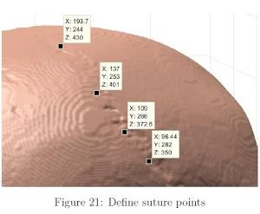

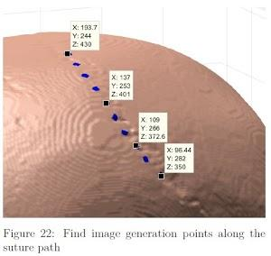

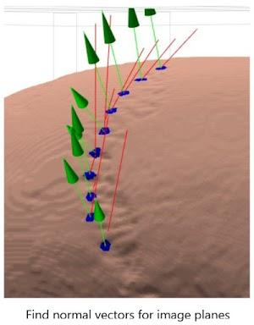

The vectors are then used to generate the specified images.

Two folders of generated slice images can be found in the support_files folder.

Cross- sectional images can be generated for any point of the skull, which is something that has never been done automatically before. Previous studies extract cross-sectional data by adjusting a 3D model in an imaging software by hand. They were only able to consider images at the top of the head, as the skull surface is relatively flat there, so it allows for multiple cross-sectional images to be generated with a relatively small correction in the angle of the intersecting plane. At the current stage of the project, the results are more accurate than ones produced by already existing studies, as cross sectional data is available for any point of the suture.

The project has so far produced more than 18 000 images of cross-sectional suture images from more than 20 skulls. From those, I've labeled and trained the Semantic Segmentation network with 7500 images. The neural network uses a segNet structure with an input size of 192x192x3.

Currently the average accuracy of the segmentation network on the test set 92%. This number can be improved significantly as the number of labeled images increases.

The described previously metrics have been analyzed by a statistical software. Significant correlation between ‘Age at death’ and ‘Gray Ratio’ has been proven.

*-0.8241 < -0.5751, reject H0 , accept H1*

*p – population correlation coefficient*

*r – Pearson’s Product Moment Correlation Coefficient*

*H0 : p = 0*

*H1 : p < 0*

*1-tailed test, at the 0.5 % significance level*

**=** -0.8241

*Critical value for n = 19 : -0.5751*

*-0.8241 < -0.5751, reject H0 , accept H1*

Furthermore, the measured variables have been used to create a regression model used to predict the age of new independent skulls.

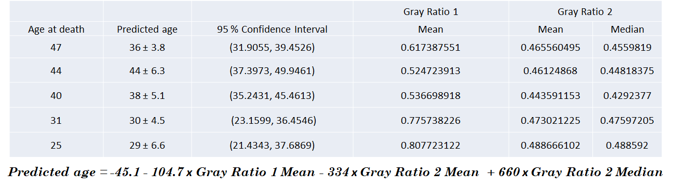The regression equation has been generated using 14 of the database skulls, and has been tested on 5 independent ones to test it’s accuracy.

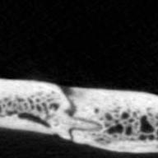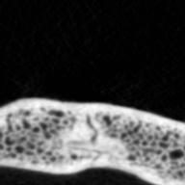The first produced result can clearly be seen as relatively far from the actual Age at death. The cross- sectional images for this individual have been examined by an anthropologist, and they truly suggest a younger age for the particular skull. The example bellow shows a comparison between two cross- sectional suture images (for the first two individuals) at the same position along the length of the sagittal suture:

Age at Death – 44 years

Age at Death – 47 years

If we follow the logic that the older a person is, the more fused their sutures are, the above comparison wouldn’t make sense. While generally this logic does apply, the process of suture fusion is quite individual in some cases. Similarly to puberty, it can begin and develop earlier in some individuals (outliers) than in others. It is not yet known what causes the sutures to fuse faster or slower in some individuals. The examined skulls could also be affected by external factors. For example:

Osteoporosis is a condition which can significantly affect the degree of suture fusion, regardless of age, as it can degrade bone matter even in the skull. Another factor could be lifestyle; if someone has been systematically exposed to starvation, their sutures have likely underdeveloped as well. Such external factors can not always be considered, and can cause some inaccuracy, which is of course inevitable regardless of the age estimation method.

Overall, this accuracy is impressive considering that the most accurate of the currently existing techniques for cranial suture age estimation have an uncertainty of +-15 years.

My approach for skull assessment uses multiple cross-sectional images and measures different variables about the detected on them sutures.

This suture assessment method completely removes human subjectivity and is showing to be more accurate than any currently existing technique. A main goal for future development, which will take place during the next moth, is to run the algorithm trough more skull samples. This can improve the accuracy of the regression formula and further prove the validity of the achieved results.

Such testing is definitely achievable, as the total size of the database consists of 200 skulls, from which I’ve examined about 20.

The only bottleneck to this process is the time taken to generate and examine the cross- sectional images for each skull (about 4-5 hours). Currently I am using 4 computers to increase the computational power for faster image generation. Those images will be analyzed in a similar manner to guarantee that the produced results are reliable even on larger samples.