Putu Andika Eka Putra  
F11127807  
Electrical engineering

Assignment 1

Due 10/24/2022

1. Verify the simulation results of Example 3.18 (pp.162~168)

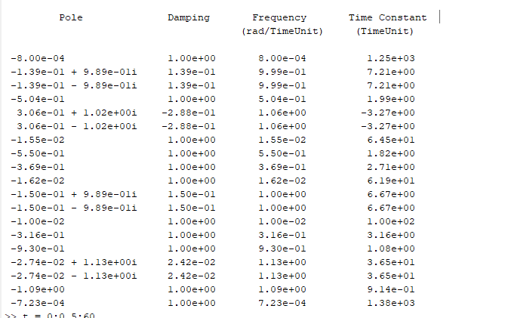

I got slightly different output from the simulation. I have double checked the input variable and the command.

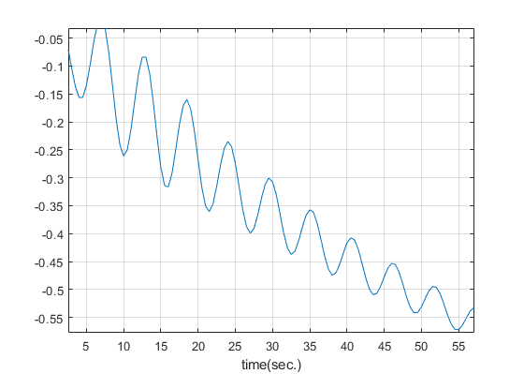2. Print the step responses of the system.

For example t = 0:0.5:60;

[y,t] = step (syst,t); Plot (t,y(:,2)); grid on xlabel(‘time(sec.)’) ylabel

3. Observations about the assignment.



Even though the result is a little bit different , when we look at the eigenvalues there is also 3.06e-01 ± 1.02i which give an indication that the system is unstable which give possibility to escape the missile. An adjustment to sysc is needed in order to hit an aircraft sysa and subsequently make the system asymptomatically stable.