Putu Andika Eka Putra (Pu an di) F11127807

Assignment 2

Design a compensator for the inverted pendulum on a moving cart.

1. controllability and observability

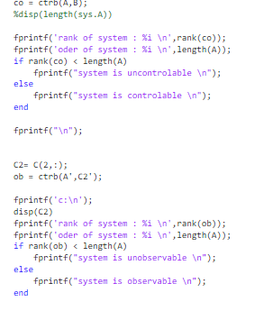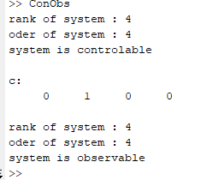

System is controllable and observable.

1. full-state feedback regulator

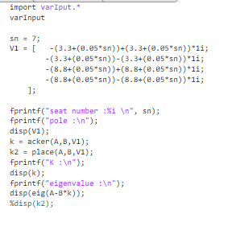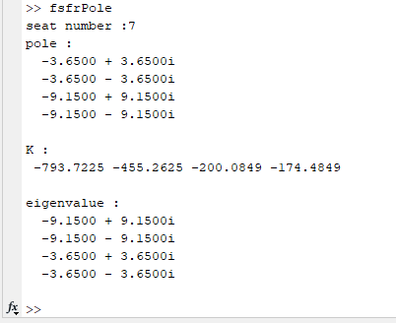

1. Full-order observer

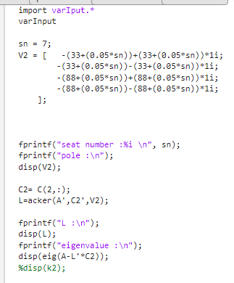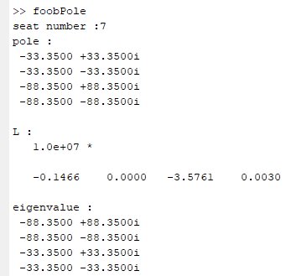

1. Compensator(ACL)

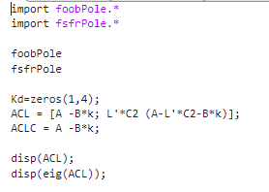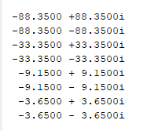

1. Lsim

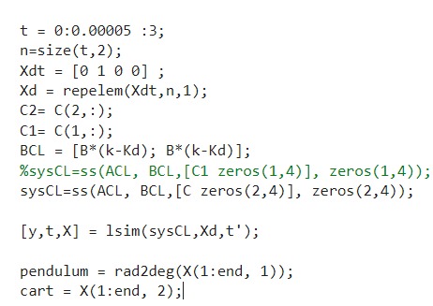

1. ploting

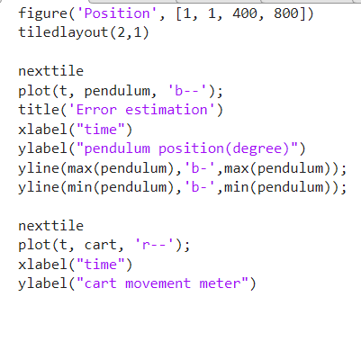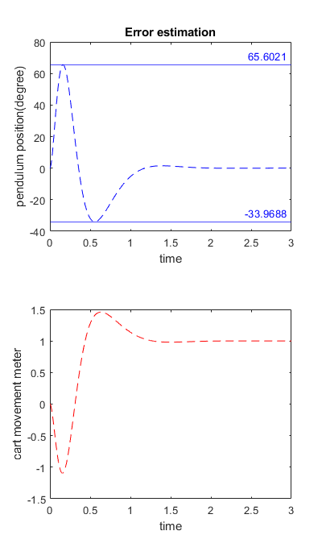

1. Observation

Based on the eigenvalues, The pole placement is correct. And the maximum pendulum swing is 65.6 degrees and cart maximum movement in 1.5 meter. The pendulum swing is quite far but did not exceed 90 degrees. The plant is still inefficient but will not fail and the pendulum eventually stable.