Putu Andika Eka Putra (Pu An Di) F11127807

**Optimal control – Assignment 3**

The state vector are inputted as the following :

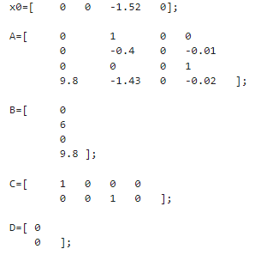

After that, with the initial Q and R, the height and pitch of the helicopter was computed as follows.

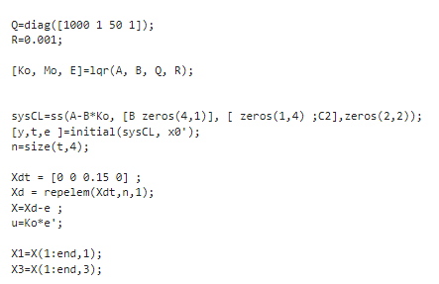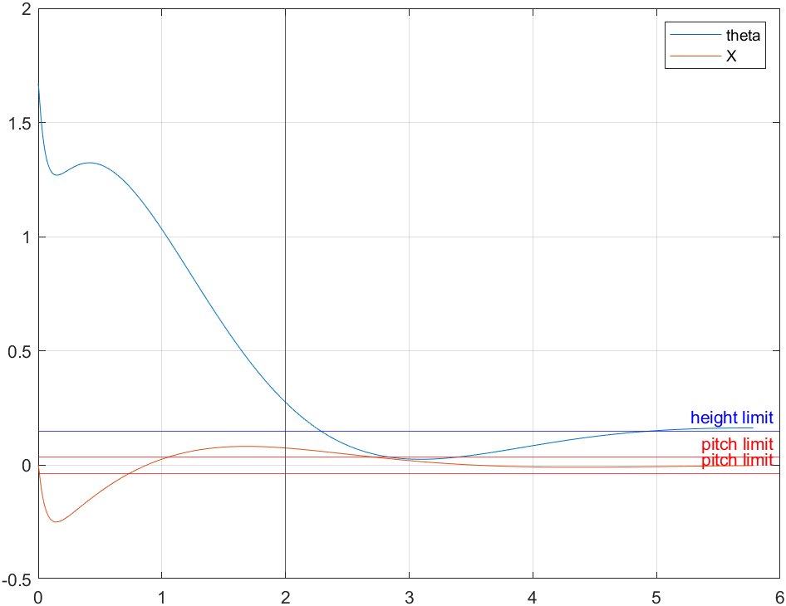

the resulted plot suggested that the helicopter went above height limit just after 2 seconds limit and briefly after 5 second. The pitch also still outside the limit after 2.5 seconds. Therefore, the system still need optimization.

Various solution has been tried to get the optimal value of Q and R. including brute forcing the value using for loop for x1 and x3 in Q resulting in this 3D graph.

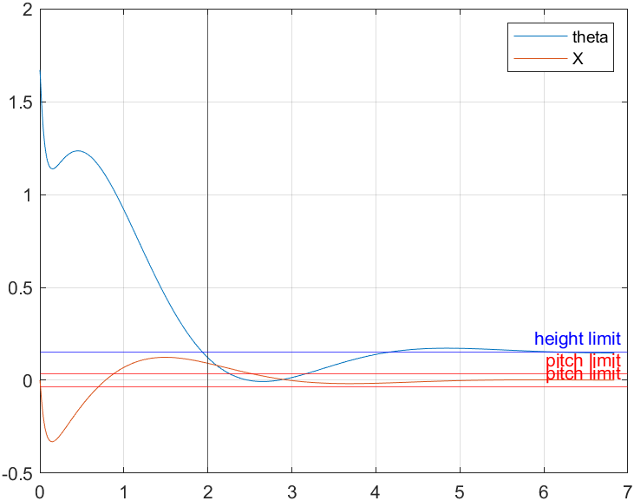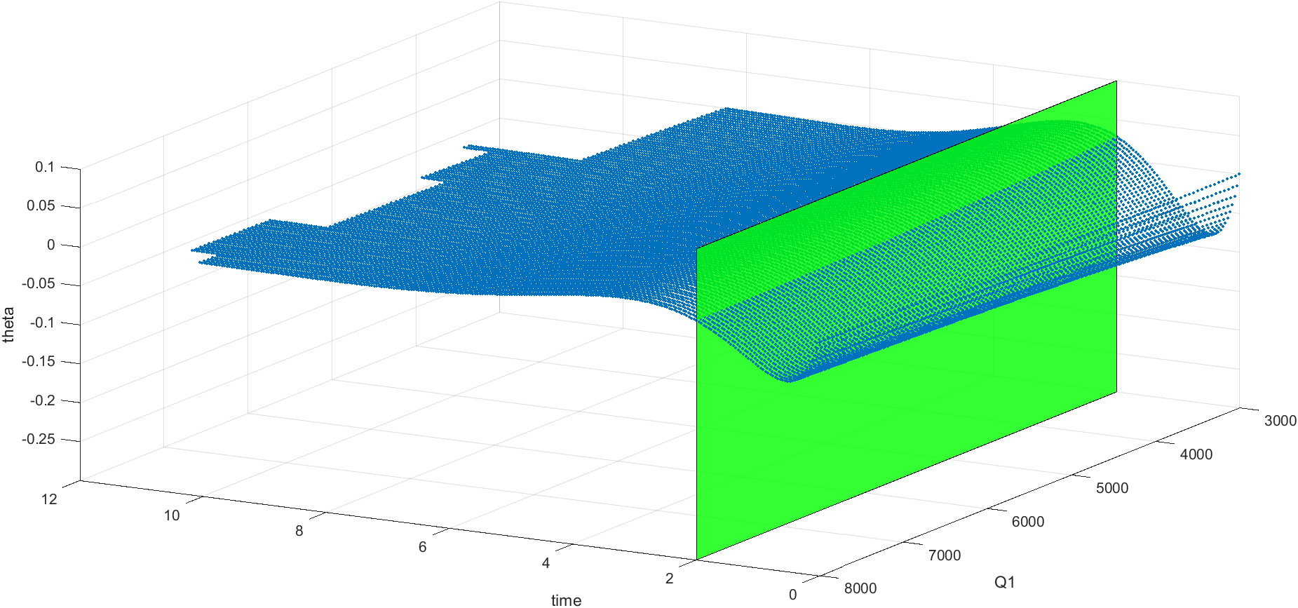R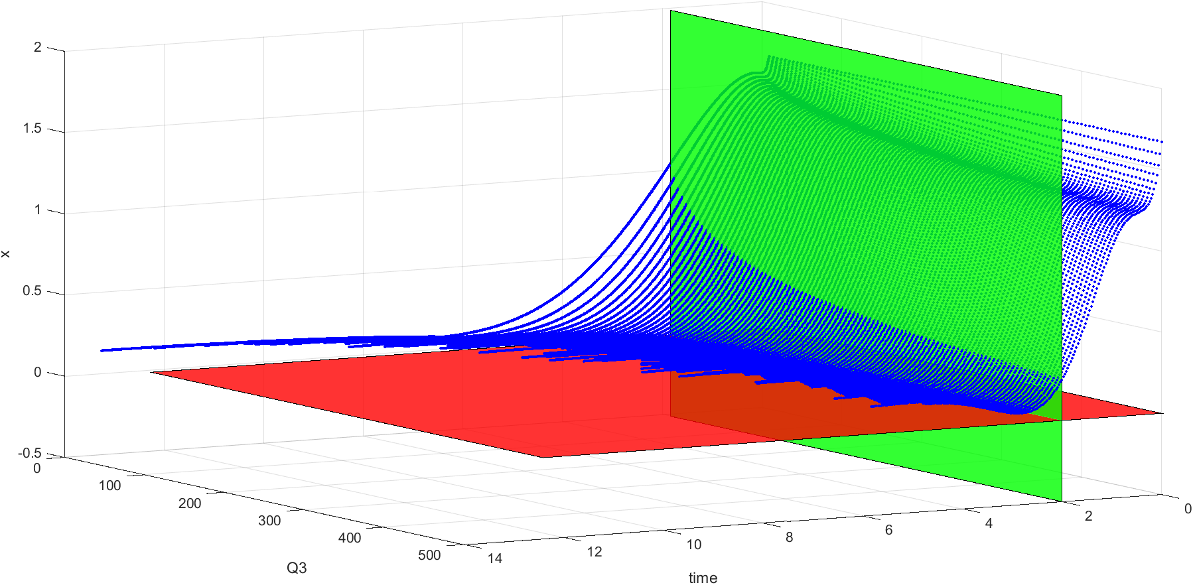

The closest value that has been attempted is

Q = [820 1 85 1]  
R = 0.001

Which resulting in this graph.

The helicopter manage to reach the height target before 2 second but it went above it again after 4 second.

At the end I did not manage to reach the specification. I suspect that I made mistake in the computation of the state space. Otherwise, its simply my lack of understanding and experience.