Putu Andika Eka Putra (Pu An Di) F11127807

**Buck Converter**

* **Topology**



The most basic topology of buck converter consist of a controllable switch in this case a Mosfet, a diode, capacitor, inductor, and controller circuit which control the switch to turn and of periodically.

* **Operating Principle**

The diode will become reverse biased to the applied input whenever the switch is switched ON. All of the input current would therefore flow through the inductor. As a result, the inductor current *Iin* is equal to the DC input current *Idc* flowing in the circuit. The voltage differential between the output voltage Vo and the applied DC voltage Vdc during this time is the inductor voltage *VLon*. Volt second balance indicates that there is no average voltage across the inductor VL. Considering the duty cycle equation, duty cycle D and total time T are combined to create the switch ON time ton. We obtain the value of VL through this process.

When the switch is switched off, the inductor's polarity reverses and it begins to function as a source. The inductor's energy reserves cause the current to flow in. Throughout this time, the DC supply is cut off. As a result, the circuit's current continues to flow until the inductor discharges. The load voltage with negative polarity corresponds to the voltage that appears across the inductor. When the switch is turned off, the inductor's polarity shifts, creating a forward bias in the diode. During this time, the anode voltage shifts from being negative to positive and begins to conduct.

* **Control Block Diagram**



Energy from Vin pass trough the switch in to the buck converter. The converter will adjust the voltage and the current to be send to Load. The operation will produce voltage feedback that will be detected by feedback circuit. The feedback circuit in turn will send PWM signal to control the switch.

* **Simulation Result**
  + **No load**

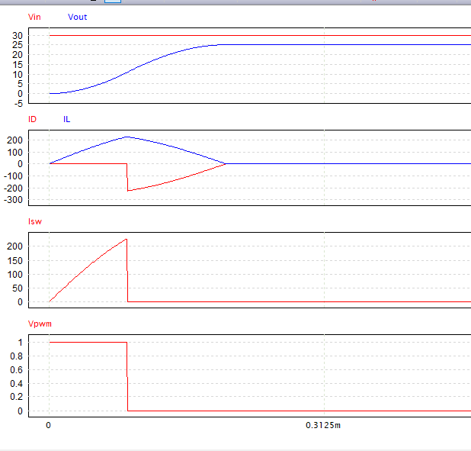In this simulation the circuit given a constant input with no load resulting the vout rising until it almost reached vin but eventually stabilized.

* + 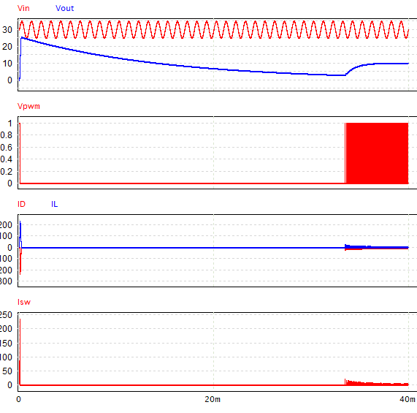**Input varies with fixed load**

In this simulation, a resistor added to the circuit as the load and a sinusoidal voltage source added after the power source to simulate variation of input.

* + **Load varies with fixed Input**

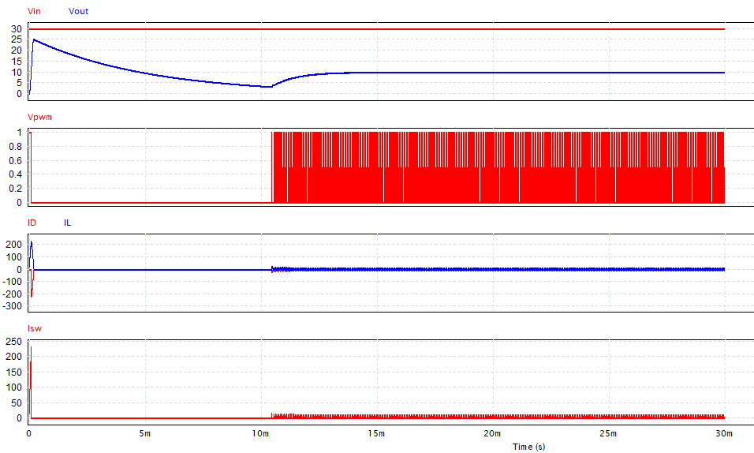

In this simulation, the sinusoidal voltage source has been removed and multiple resistors has been added to the circuit. These resistors connected to bi-directional switches which controlled by step voltage source. As a result this configuration simulate variation in load.