Project #3 Report

**Option 1: Develop a custom heuristic**

Minimax search with iterative deepening is used to test the custom heuristic against the baseline heuristic. The number of rounds used is 50 and the opponent is minimax search.

The custom heuristic is called ‘penalize corner heuristic’. The implementation of the heuristic is shown in Figure 1.

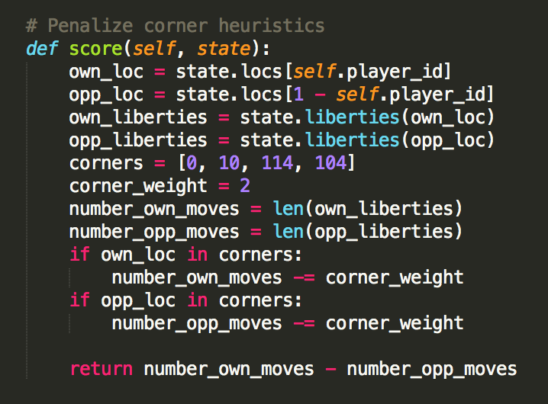

Figure 1 Implementation of custom heuristic

**Result Analysis**

From Table 1 and Figure 2, we can see that the custom heuristic performs better than the baseline heuristic. The baseline heuristic has 70% winning percentage while the custom heuristic has 72.5% winning percentage. The custom heuristic contains a parameter called *corner_weight*, which penalizes the score if a player is located in the corner. In the experiment, this parameter is set as two. Further improvement of the performance can be achieved by adjusting *corner_weight* parameter.

Table 1 Comparison of performance between baseline and custom heuristic

|  |  |
| --- | --- |
|  | **Performance** |
| **Baseline heuristic** | 70.0% |
| **Custom heuristic** | 72.5% |

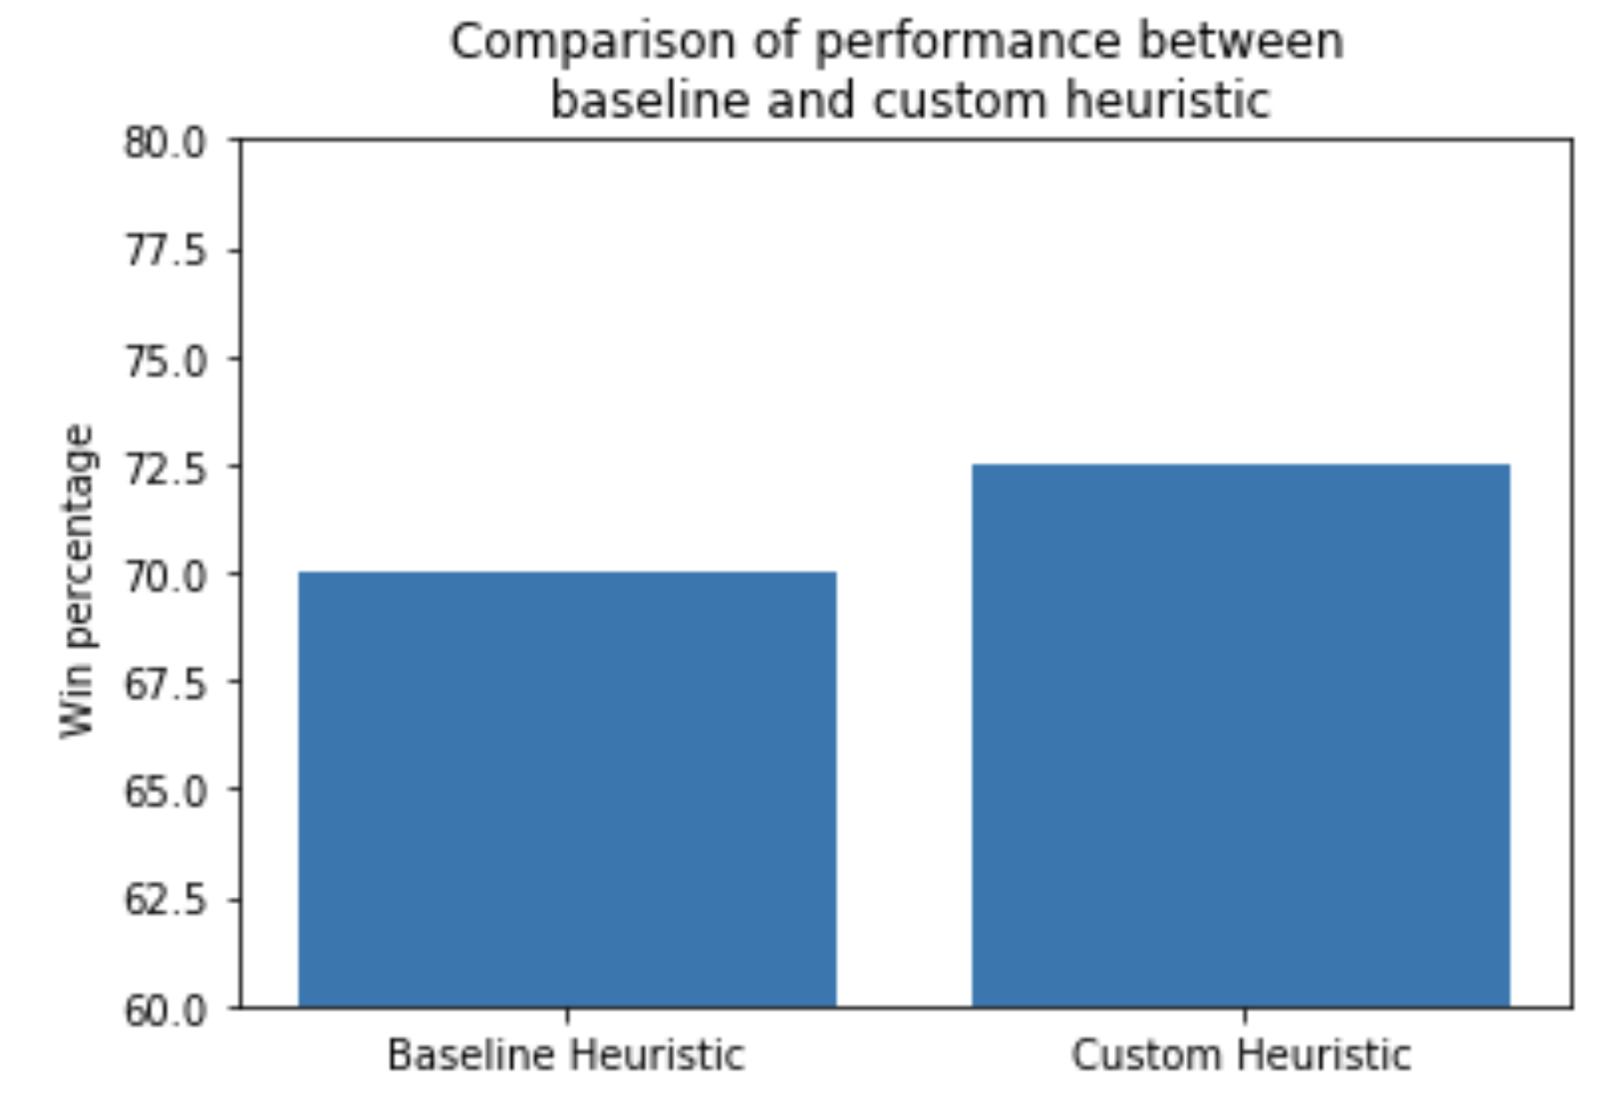

Figure 2 Bar plot showing the performance of baseline and custom heuristic

**Answer to Questions**

* *What features of the game does your heuristic incorporate, and why do you think those features matter in evaluating states during search?*

The intuition behind the custom heuristic is to push the opponent to the corner since that is generally the position where the player has the less movement. The corner also the location where most losses occur. If a player is located in the corner, the score is penalized by two points.

* *Analyze the search depth your agent achieves using your custom heuristic. Does search speed matter more or less than accuracy to the performance of your heuristic?*

In the custom heuristic, search speed matter less than accuracy.