Student details: AG SHBALALA, 222099339
Assignment 1

1. Introduction
This report shows a comprehensive exploratory data analysis (EDA) and missing data handling procedures conducted on the well-known Titanic dataset. The historical records of the passengers on board the RMS Titanic, which sank on April 15, 1912, with a large number of deaths, are the source of the dataset. It offers a useful background for comprehending how socioeconomic and demographic factors affected survival outcomes and is one of the most researched datasets in data science.

Based on a set of explanatory variables, including age, gender, passenger class, and fare, the dataset poses a supervised learning problem, specifically a binary classification task, where the goal is to predict whether a passenger survived (1) or did not survive (0).

Applying significant concepts from learning from data, as presented in Units 1-3, is the main goal of this analysis. This entails methodically converting unstructured data into a dependable, structured format appropriate for modelling and analysis. In order to understand the structure, variable distributions, and underlying patterns of the dataset, the procedure starts with exploratory data analysis. A thorough evaluation of the data quality, in particular the detection and handling of missing values, comes next.

Additionally, suitable pre-processing methods are used, such as multiple imputation procedures and the encoding of categorical data. These procedures are essential because the quality of the input data has a significant impact on the performance and dependability of machine learning models. The dataset should be clear, consistent, and appropriate for use in predictive modelling tasks by the end of this analysis.

2. Materials and Methods
2.1 Data Source
The dataset used in this analysis is Titanic dataset, sourced from the Kaggle data science platform: https://www.kaggle.com/datasets/yasserh/titanic-dataset
This dataset's balanced complexity and practical relevance make it popular in both professional and academic data science settings.

For this task, the dataset is very suitable for a number of reasons. First of all, it is appropriate for illustrating encoding techniques since it combines numerical variables (like Age and Fare) with categorical variables (like Sex and Embarked). Second, it contains naturally occurring missing values, especially in the Age and Cabin variables, which makes it possible to use missing data handling techniques in real-world scenarios.

The dataset also meets the assignment requirements because it is appropriate for a classification task and has more than eight features. It is also perfect for carrying out in-depth exploratory data analysis while preserving computing efficiency due to its reasonable size.

2.2 Data description and exploratory data analysis (EDA)
12 variables (columns) and 891 observations (rows) make up the dataset, each of which represents a distinct characteristic of the Titanic passengers.

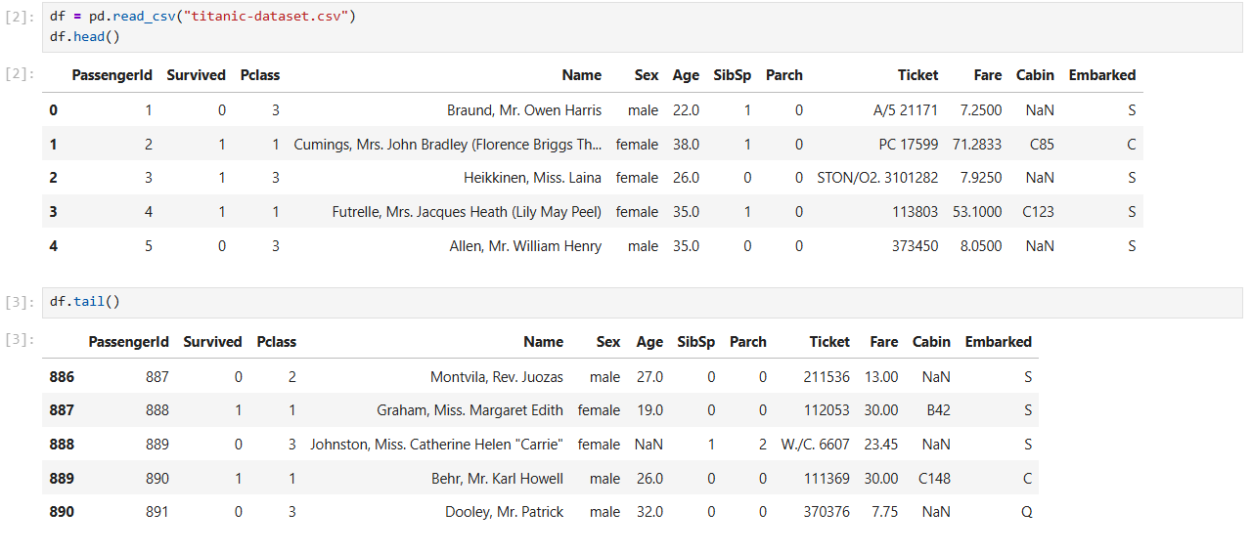
Figure 1: Dataset preview

An overview of the variables and their values is given by this image, which shows the first few rows of the dataset.

Variable Classification
Numerical Variables:
Age, Parch (# of parents/children abroad), Pclass, PassengerId, SibSp (# of siblings/spouses aboard), Fare
Target Variables:
Survived (binary: 0 = Did not survive, 1 = Survived)
Categorical Variables:
Sex, Name, Cabin, Ticket, Embarked (S = Southampton, Q = Queenstown, C = Cherbourg)

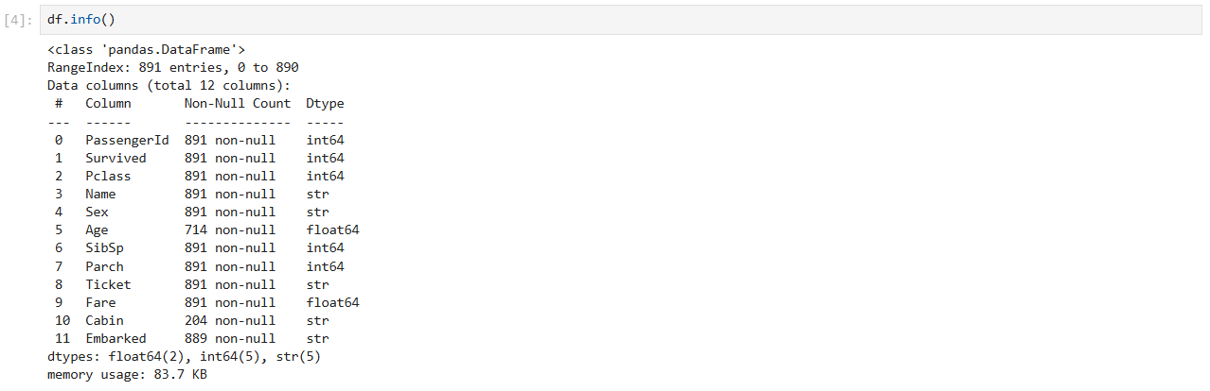
Figure 2: Dataset structure

Summary Statistics
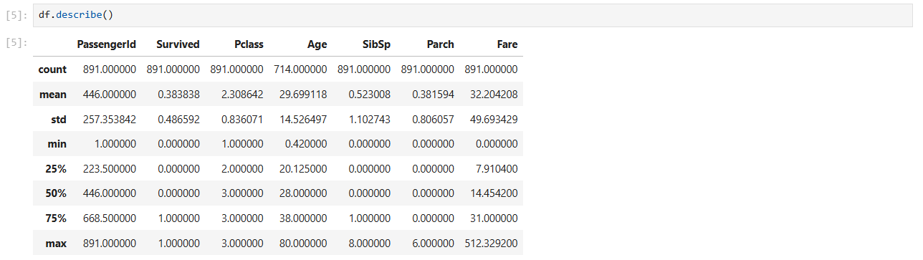
Figure 3: The summary statistics

The dataset's variability is shown by the standard deviation values. The Fare variable, for instance, has a large standard deviation, indicating the existence of notable dispersion and outliers. On the other hand, factors like SibSp and Parch show less variation, indicating that the majority of passengers travelled with less family members.

Important information about the dataset is shown by the summary statistics:
- Only 38% of passengers survived, according to the mean survival rate of about 0.38.
- The passengers range widely in age, from young children to older citizens, with an average age of roughly 29.7 years.
- The Fare variable exhibits notable dispersion, with a maximum value that is significantly higher than the mean, indicating the existence of outliers.
- A significant number of passengers travelled in third class, according to the Pclass variable.

Visualisations and Analysis

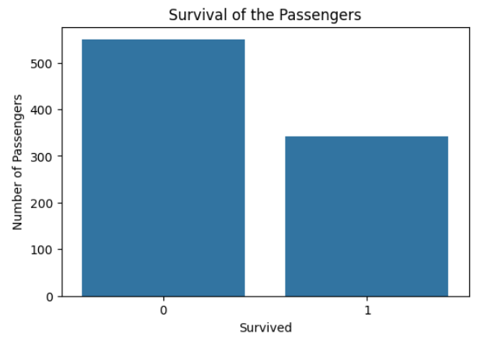
Figure 4: Survival of the Passengers

This figure demonstrates that the number of passengers who did not survive is greater than those who did, indicating evacuation class imbalance.
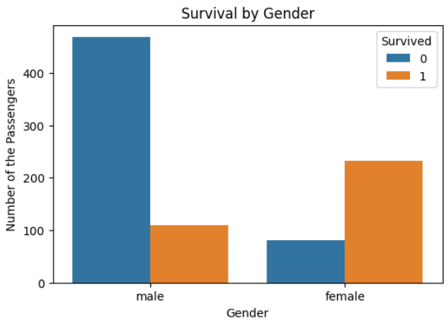
Figure 5: Survival by Gender

Female passengers had a higher survival rate than male passengers, reflecting past evacuation priorities.

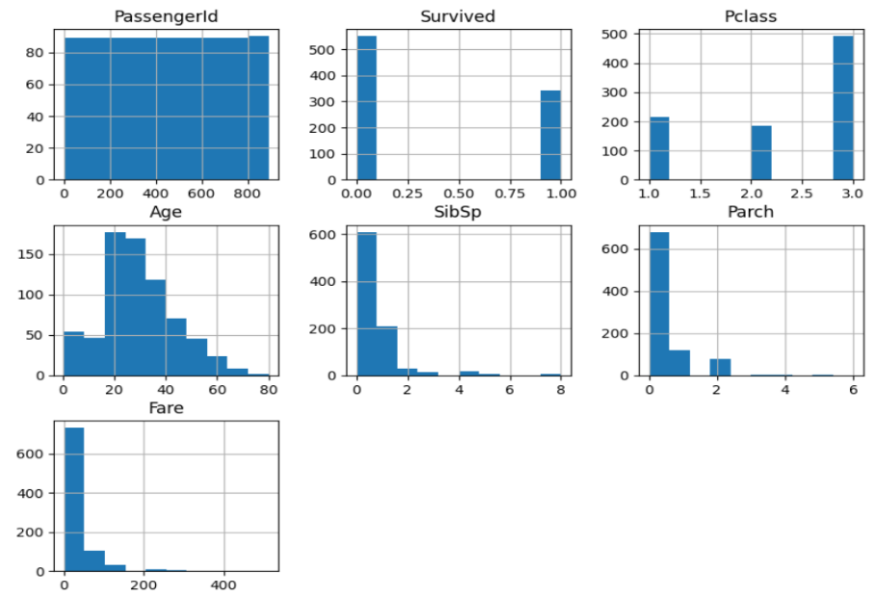
Figure 6: Distribution of the Numerical Variables

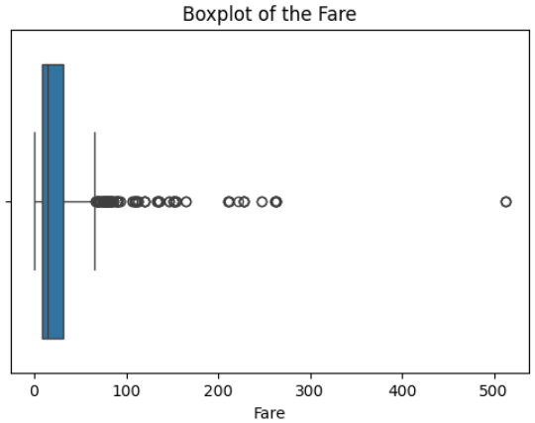
Figure 7: Fare boxplot

This plot shows extreme outliers in Fare, indicating high value ticket prices.

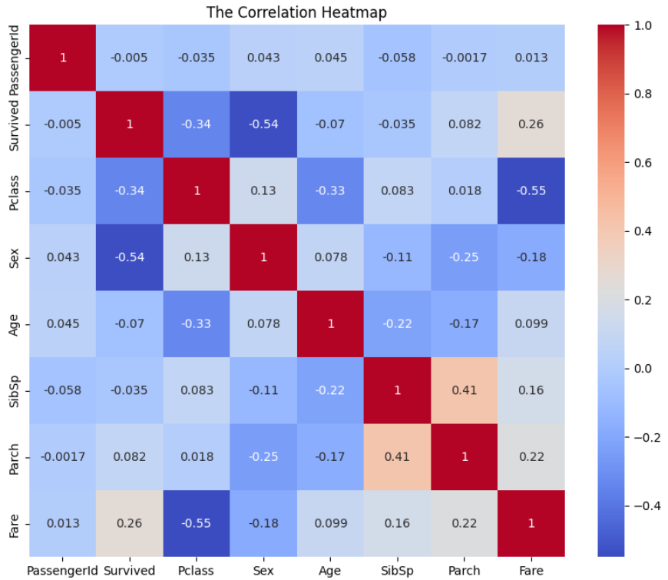
Figure 8: Correlation heatmap

The heatmap demonstrates relationships between variables, with survival being linked with gender and passenger class.

Examining Trends and Patterns
Several significant trends are shown by the exploratory analysis:
- As evidenced by past evacuation priorities, female passengers had a much greater survival percentage than male passengers.
- First-class passengers had a higher chance of surviving than those in lower classes, indicating the impact of socioeconomic level.
- The distribution of the Fare variable is strongly skewed to the right, with several of severe outliers indicating pricey tickets.
- There are more non-survivors than survivors in the dataset, making it unbalanced.

Difficulties with Data Quality
Numerous data quality issues were identified:
- Age, Cabin, and Embarked consist of missing values
- The Cabin variables contains a high percentage of missing values
- Outliers in the fare
- High-cardinality variables like Name and Ticket
- Prior to more analysis or modelling, these issues must be resolved.
Outliers in the Fare variable can have a negative impact on models that are sensitive to extreme values and affect statistical measurements.

2.3 Missing data identification
Quantifying and Visualizing missing data is the first step in handling it.
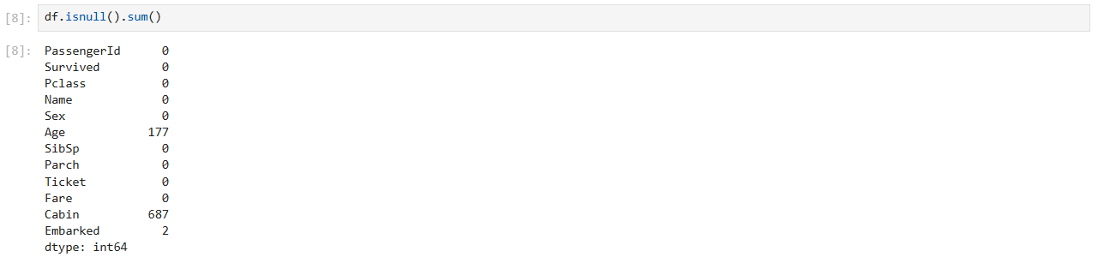
Figure 9: Missing values count

This figure presents the total number of missing values in each column.

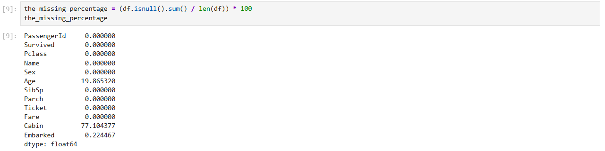
Figure 10: Missing percentage table

This figure shows the parentage of missing values relative to the dataset size.
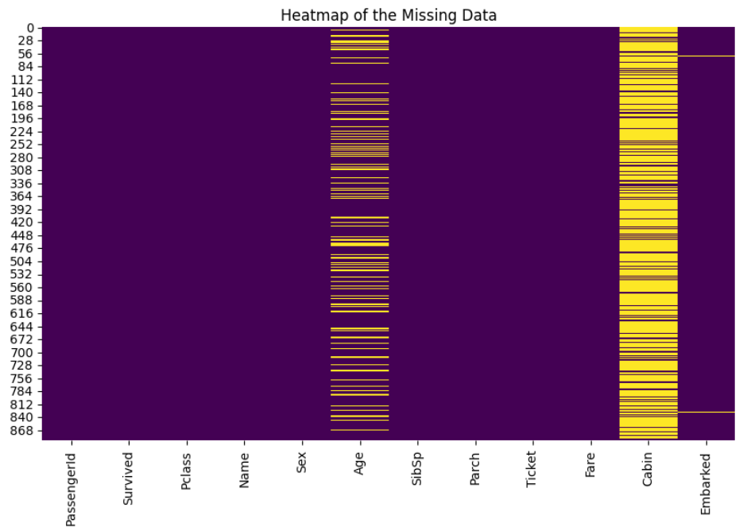
Figure 11: Heatmap of the missing data

This visualisation shows the distribution and pattern of missing data across variables.

Summary of the missing data
- Cabin: 77% missing
- Age: 19.86% missing
- Embarked: 0.22% missing
- All other columns don’t have missing values

Missing data mechanism
- Cabin – MNAR (Missing Not at Random)
The Cabin variable's high missingness rate indicates that it is probably Missing Not at Random (MNAR). The likelihood that a cabin value will be absent is likely correlated with the value. For example, third-class travellers may not have been allocated a cabin or their cabin records may have been misplaced. The lack of data is systematic and non-random since it is directly related to the passenger's class or ticket type.
- Age – MAR (Missing at Random)
The missingness in Age is probably Missing at Random. This indicates that the likelihood of Age being missing depends on other observed variables in the dataset. For instance, it is conceivable that Age was less likely to be recorded for female passengers or those traveling in third class; we can examine this by conditioning on other variables, and the missingness can be fairly estimated from the available data.
- Embarked – MCAR (Missing Completely at Random)
It is quite likely that this data is Missing Completely at Random (MCAR) because there are just two missing values. The few missing records are probably the result of a single recording error and have nothing to do with the value of Embarked or any other variable in the dataset.

2.4 Data encoding
The categorical variables need to be transformed into a numerical format in order to be ready for modelling. Sex and Embarked are the two main categorical variables in the dataset. Because imputing a huge amount of data would create significant bias and is unlikely to generate a valid feature, the Cabin column was dropped because to its high percentage of missing values.

Figure 12: Dropping the Cabin column

The Techniques Applied:
- Label Encoding – Sex
"Male" and "female" make up the binary Sex variable. "Male" and "female" had been transformed to 1 and 0, respectively, using label encoding. This method produces a single number column without adding redundancy, making it appropriate for binary nominal data.
- One-Hot Encoding – Embarked
There are three nominal categories for the Embarked variable ("C", "Q", and "S"). In this case, one-hot encoding is the best approach. In order to avoid the model presuming any ordinal relationship between the ports (e.g., that 'S' is greater than 'C'), it generates new binary columns for each category. In order to avoid the "dummy variable trap," which would introduce perfect multicollinearity in regression models, the first category ("C" in this case) was dropped using the drop_first=True option.
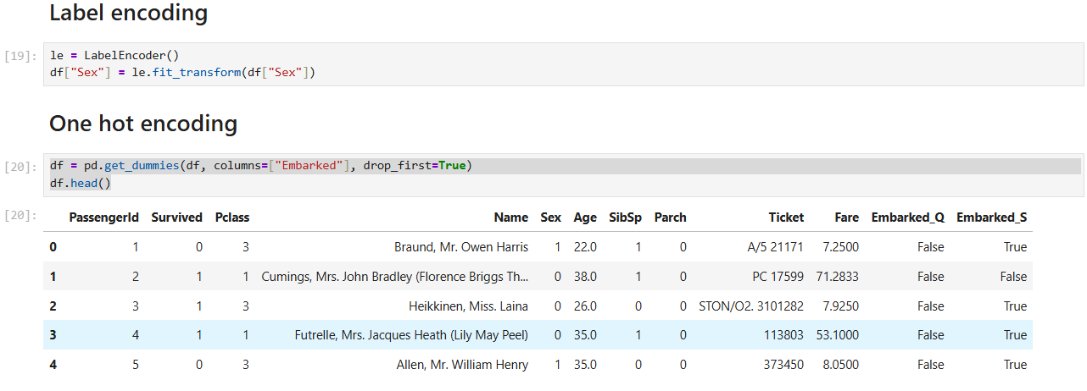
Figure 13: Encoded dataset

This figure shows the dataset after encoding categorical variables.

2.5 Imputation techniques
Four distinct imputation methods were used to deal with the detected missing values. Filling in reasonable values for Age and Embarked is the aim.

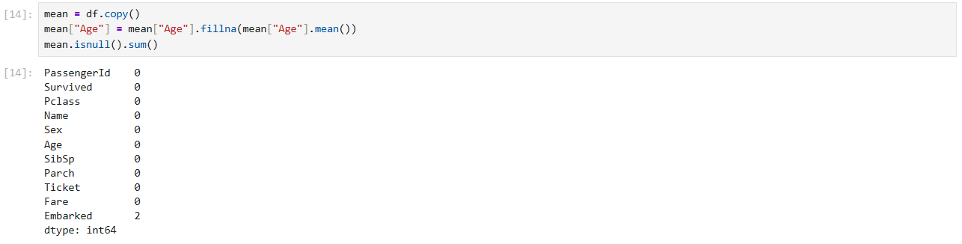
Figure 14: Mean Imputation

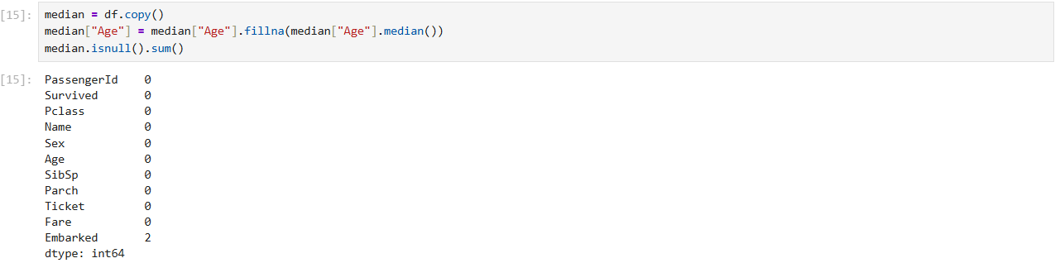
Figure 15: Median Imputation

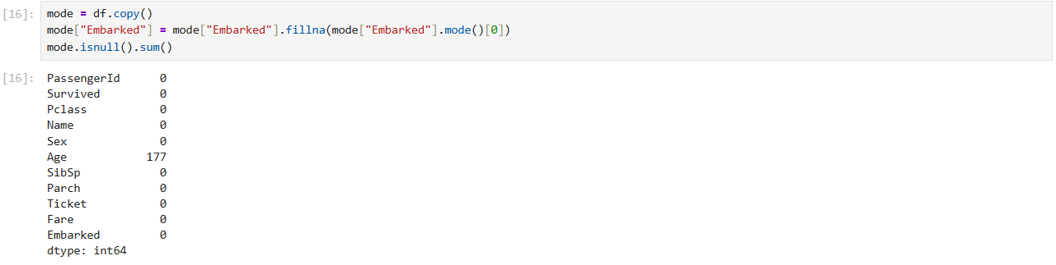
Figure 16: Mode Imputation

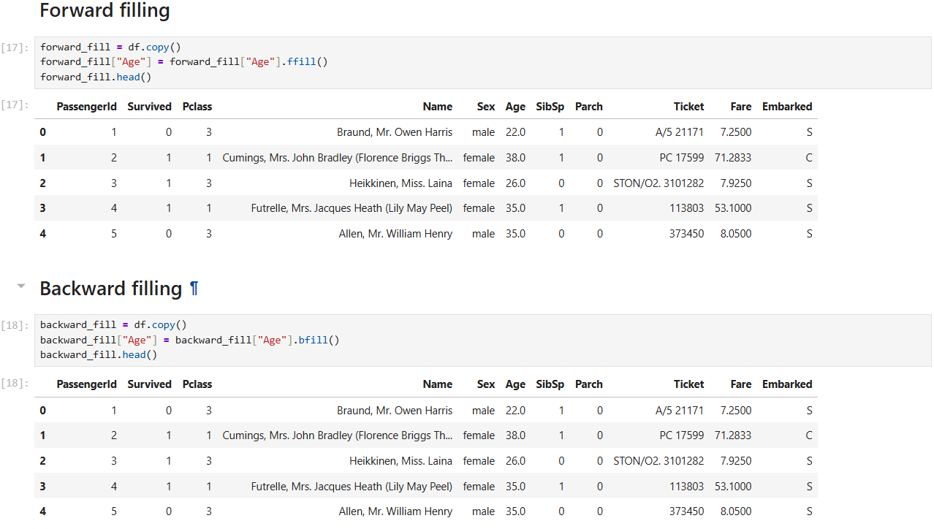
Figure 17: Forward and Backward filling

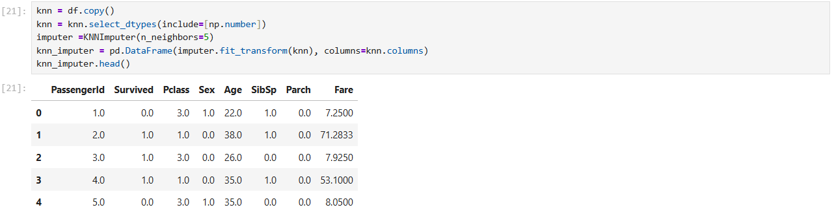
Figure 18: KNN Imputation

The Techniques Applied:
- Mean Imputation
The mean of the observed Age data (about 29.7 years) is used to replace missing age values. It is quick and easy to put into practice. However, it can be significantly impacted by data outliers and changes the original distribution by lowering variance. It was selected as a basic, straightforward approach.
- Median Imputation
The median of the observed Age values (28.0 years) is used to replace missing Age data. It is a superior option for skewed data and is more resilient to outliers than mean imputation. Although it also affects the distribution of the data by lowering variance, for skewed datasets, it is typically favoured above the mean.
- Mode Imputation
The most frequent port of embarkation ('S') was substituted for the two missing entries in the Embarked column using this method. Since it presumes that the missing value is most likely to be the most prevalent category, this is a frequent and sensible method for categorical variables.
- K-Nearest Neighbours (KNN) Imputation:
This is a multivariate, more advanced method. By identifying the five most comparable passengers (neighbours) based on other features like Pclass, Sex, SibSp, Parch, and Fare, it calculates missing Age values. The average Age of its neighbours is then used to impute the missing Age. In general, this approach is better than basic univariate approaches and maintains the links between variables. Its capacity to produce more accurate and data-driven imputations led to its selection.

Implications of imputation on data integrity
Even though it's essential, imputation always adds some degree of uncertainty.
- Mean/Median Imputation
These techniques have the potential to produce understated standard errors and skewed coefficients in downstream models by artificially reducing variance and distorting the data's natural distribution. It does not take into account how the assumed values relate to other attributes.
- Mode Imputation
As seen with Embarked, this is usually safe for a small number of missing categorical data. It adds minimal bias.
- KNN Imputation
This approach preserves the covariance and structure of the data more well. Nevertheless, bias may still be introduced, especially if the neighbours are not really similar. The number of neighbours, or "k," must be carefully chosen, a little "k" could result in overfitting, while a big "k" can blur significant differences. By preserving the links between characteristics, it provides a more accurate and nuanced imputation overall, improving the dataset's integrity for further study.

3. Conclusion
Through the analysis of the Titanic dataset, this report illustrated an organised method for learning from data. The study emphasized how crucial data pre-processing is, especially when addressing missing values and encoding categorical variables.

The results show that passenger class and gender had a significant impact on survival. A major problem was missing data, which necessitated careful analysis and suitable imputation techniques. The dataset was successfully converted into a clean and analysis-ready format by using a variety of preparation procedures. This procedure emphasizes how important data preparation is to guaranteeing the precision, dependability, and efficacy of machine learning models.

References

- Demirtas, H. (2018). Flexible imputation of missing data. Journal of statistical software, 85, 1-5.
- VanderPlas, J. (2016). Python data science handbook: Essential tools for working with data. " O'Reilly Media, Inc.".
- Han, J., Pei, J., & Tong, H. (2022). Data mining: concepts and techniques. Morgan kaufmann.
- Kaggle. (2021). Titanic dataset. Retrieved from https://www.kaggle.com/datasets/yasserh/titanic-dataset

