Supplementary Information
Giant spin-orbit torque induced by spin Hall effect
in amorphous Pt(P) alloys

Utkarsh Shashank^{1, #}, Takafumi Tomoda¹, Arun Jacob Mathew¹, Garima Vashisht¹, Koki Imai¹, Yu Kusaba¹, Chung-Li Dong², Chi-Liang Chen³, Yoichi Horibe^{4, 7}, Manabu Ishimaru⁴, Hiroyuki Awano⁵, Hironori Asada⁶, and Yasuhiro Fukuma^{1, 7}
¹ Department of Physics and Information Technology, Faculty of Computer Science and Systems Engineering, Kyushu Institute of Technology, 680-4 Kawazu, Iizuka 820-8502, Japan
² Department of Physics, Tamkang University, Tamsui 251, Taiwan
³ National Synchrotron Radiation Research Center, Hsinchu 30076, Taiwan
⁴ Department of Materials Science and Engineering, Kyushu Institute of Technology, 1-1 Sensui-cho, Tobata, Kitakyushu 804-8550, Japan
⁵ Memory Engineering Laboratory, Toyota Technological Institute, Nagoya 468-8511, Japan
⁶ Graduate School of Sciences and Technology for Innovation, Yamaguchi University, 2-16-1 Tokiwadai, Ube 755-8611, Japan
⁷ Research Center for Neuromorphic AI hardware, Kyushu Institute of Technology, Kitakyushu 808-0196, Japan
# Present address: Department of Physics, University of Gothenburg, Origovägen 6 B, 41296 Gothenburg, Sweden

S1: Polar Magneto-Optic Kerr Effect (PMOKE) measurements
S2: Comparison of switching energy densities for Pt/GdFeCo and Pt (P)/GdFeCo
S3: Stopping of range of ions in matter (SRIM) simulations
S4: X-ray diffraction (XRD) measurements
S5: High-angle annular dark field scanning transmission electron microscopy (HAADF-STEM) measurements
S6: X-ray absorption (XAS) measurements

S1: Polar Magneto-Optic Kerr Effect (PMOKE) measurements
Perpendicular magnetic anisotropy (PMA) of the Pt/GdFeCo and Pt(P)/GdFeCo samples were evaluated by Polar Magneto-Optic Kerr Effect (PMOKE) measurements under an out-of-plane field sweep. We obtain square hysteresis loops for both Pt/GdFeCo and Pt(P)/GdFeCo, by PMOKE and Hall measurements, as shown in Fig. S1, confirming the PMA of the GdFeCo layer. Both PMOKE and Hall measurements are found to give similar coercivities for the hysteresis, indicating good agreement between them.

Figure S1. Comparison of PMOKE and Hall signals under an out-of-plane field sweep for (a) Pt/GdFeCo and (b) Pt (P)/GdFeCo samples. Similar coercivities are observed using both measurement techniques.

S2: Comparison of switching energy densities for Pt/GdFeCo and Pt (P)/GdFeCo
In this work, we have analyzed the variation in several parameters such as electrical conductivity $σ_{xx}$, spin Hall angle $θ_{SH}$, spin Hall conductivity $σ_{xy}^{SH}$, critical switching current density $J_{sw}$ etc., with P ion implantation. To identify the effect of P ion implantation on the magnetization switching efficiency in terms of a single, specific parameter, we wish to focus on the switching energy density $U_{sw}$, which is derived from the switching energy calculated by Ohm’s law, and is defined as,
$$U_{sw}=\frac{{(J_{sw 0})}^{2}t_{0}}{σ_{xx}} \text{…(}\text{S1}\text{)},$$
where $J_{sw 0}$ is the critical switching current density corresponding to zero thermal fluctuation, $t_{0}$(≈ 1 ns) is the thermal fluctuation time. According to the thermally assisted switching model ^{[A1]}, $J_{sw 0}$ can be estimated by plotting $J_{sw}$ as a function of the current pulse width $t_{pw}$, and fitting it to the equation,
$$J_{sw}=J_{sw 0}[1-\frac{1}{Δ}ln⁡(\frac{t_{pw}}{t_{0}})] \text{…(}\text{S}\text{2)},$$
where $Δ$ is the thermal stability factor. $J_{sw 0}$ is found to be 2.8 × 10¹¹ A/m² and 0.5 × 10¹¹ A/m² for the Pt/GdFeCo and Pt (P)/GdFeCo samples, respectively (Fig. S2). The semi-solid symbols in Fig. S2 correspond to the $J_{sw}$ estimated from Fig. 1 (c) of the main text. These $J_{sw}$ values, for both Pt and Pt(P), being below the fitting line, maybe due to higher Joule heating when using DC currents. As shown in Fig. 4 of the main text, $σ_{xx}$ is found to decrease from approximately 4 × 10⁴ Ω⁻¹ cm⁻¹ to approximately 0.5 × 10⁴ Ω⁻¹ cm⁻¹ after P-ion implantation. For the Pt (P)/GdFeCo films reported in this work, an implantation dose of 5 × 10¹⁶ ions/cm² has been used under an acceleration voltage of 30 keV. Using Eq. (S1), $U_{sw}$ is found to be approximately 4 times higher for Pt as compared to Pt (P) (Table S1), illustrating the higher energy efficiency of Pt (P) in performing magnetization switching.

Figure S2. Critical switching current density $J_{sw}$ as a function of current pulse width $t_{pw}$ for Pt/GdFeCo and Pt (P)/GdFeCo samples. The dotted lines indicate fittings to the experimental data according to Eq. (S2). The semi-solid symbols indicate $J_{sw}$ corresponding to the data given in Fig. 1 (c) of the main text.

Table S1. Various parameters estimated for Pt and Pt (P) heavy metal layers.
Heavy Metal | $J_{sw 0}$ (A/m²) | $σ_{xx}$ (Ω⁻¹ cm⁻¹) | $t_{0}$ (ns) | $U_{sw}$ (J/m³)
Pt | 2.8 × 10¹¹ | 4 × 10⁴ | 1 | 2.0 × 10⁷
Pt (P) | 0.5 × 10¹¹ | 0.5 × 10⁴ | 1 | 0.5 × 10⁷

S3: SRIM simulations
To understand the distribution of the P ions into the Pt layer, stopping of range of ions in matter (SRIM) simulations were performed. Figures S3 a, b, c shows the amount of the P ions in the multilayers as a function of thickness for the acceleration energy of 10, 20, 30 keV, respectively. For 10 keV, the P ions are mainly distributed in the capping layers. As the acceleration energy increases, i.e., for 20 keV and 30 keV, the P ions can enter the Pt layer.
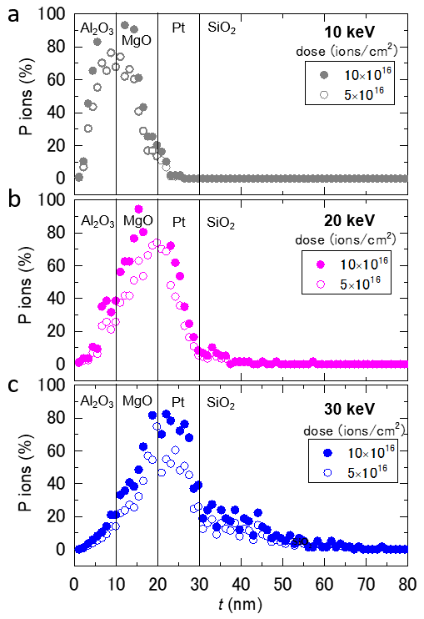

Figure S3. SRIM simulations performed for P ion implantation in Pt (10 nm)/MgO (10 nm)/Al₂O₃ (10 nm) multilayers. Amount of P ions in the multilayers as a function of thickness t for the acceleration energy a) 10 keV, b) 20 keV and c) 30 keV.

S4: XRD measurements
Figure S4a shows the X-ray diffraction (XRD) pattern of the Pt(P) samples implanted with 30 keV P ions at different doses from 2.5 × 10¹⁶ to 9 × 10¹⁶ ions/cm². The intense reflections corresponding to (111), (200), (220) and (311) plane in pure Pt layer with no implantation depicts the formation of polycrystalline fcc phase of Pt with a lattice parameter 3.932 Å. Upon increasing the incident dose of P ions, the crystallinity of the Pt layer decreases as evidenced by the decreasing intensity of the most intense (111) reflections and the peak broadening. The calculated lattice parameter is not affected significantly within the error limits for Pt(P) 2.5×10¹⁶. Such a reduced crystallinity is also followed by the enhancement in I₍₂₂₀₎/I₍₁₁₁₎ to 3.14 for Pt(P) 2.5×10¹⁶ in comparison to 0.33 for Pt. Beyond this incident ion dose, the intensity of XRD peaks decreases and the reflections are drastically shifted towards lower 2$θ$ positions for Pt(P) 4.0 × 10¹⁶ and Pt(P) 9.0 × 10¹⁶, which indicates a distortion in the fcc phase of Pt with increasing P ion dose. Figure S4b gives the X-ray reflectivity (XRR) of the samples. The experimentally observed periodic oscillations (Kiessig fringes) are fitted (solid lines in Figure S4b) using GenX software to estimate the depth integrated profile of fabricated stacks as an impact of the ion implantation. The incident P ions may cause a noticeable mixing between the Pt layer and the capping layer, resulting in an increase in the thickness of the Pt layer that is nearly twofold, i.e., from 8.6 nm for pure Pt to 19.0 nm for Pt(P) 2.5×10¹⁶. The thickness gradually increases to 22.6 nm and 35.4 nm for Pt(P) 4×10¹⁶ and Pt(P) 9×10¹⁶, respectively. The reduction in the critical angle of XRR profile also indicates the reduction in electron density of Pt with the ion-implantation process.

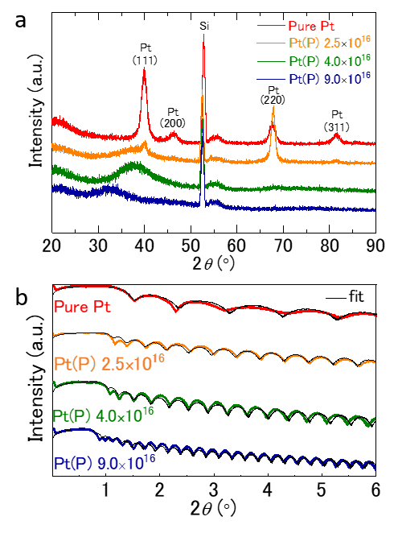

Figure S4. a) X-ray diffraction (XRD) spectra of Pure Pt, Pt(P) 2.5 $×$10¹⁶, Pt(P) 4.0 $×$10¹⁶ and Pt(P) 9.0 $×$10¹⁶. Data is shifted vertically for clarity. b) X-ray reflectivity (XRR) data for Pure Pt, Pt(P) 2.5 $×$10¹⁶, Pt(P) 4.0 $×$10¹⁶ and Pt(P) 9.0 $×$10¹⁶.

S5: HAADF-STEM measurements
Simultaneously, the cross-sectional High-angle annular dark field scanning transmission electron microscopy (HAADF-STEM) images of the Pt(P) samples were recorded by a JEM-F200 at an acceleration voltage of 200 keV. Supporting figure S5 shows the HAADF-STEM image for pure Pt. Here, the Pt layer with the thickness of ~9 nm is observed with the inhomogeneous bright contrasts, indicating the polycrystalline Pt (see Figure S5a). Indeed, the Bragg spots due to polycrystalline nature are observed in the corresponding electron diffraction pattern of Figure S5d. Note that the weak speckles on the top and bottom of the Pt layer could be associated with the roughness of the interfaces, which is consistent with the unclear Kiessig fringes in XRR as shown in Figure S4b. As the doses increases, these inhomogeneous contrasts of the interfaces become less visible for Pt(P) 4.0×10¹⁶ and for Pt(P) 9.0×10¹⁶ in Figure S5b and S5c, with the appearance of halo rings in the corresponding diffraction patterns in Figure S5e and S5f. These results suggest that amorphization occurs for Pt(P) 4.0×10¹⁶ and Pt(P) 9.0×10¹⁶. Note that the thickness of the layer also increases significantly, i.e., ~23 nm for Pt(P) 4.0×10¹⁶ and ~33 nm for Pt(P) 9.0×10¹⁶, consistent with XRR. Furthermore, we noticeably observe bubbles (voids) with dark contrasts, especially in the upper part of the Pt(P) layer. The presence of voids could result in a smaller density of the Pt(P) layer, leading to an increase in its thickness.

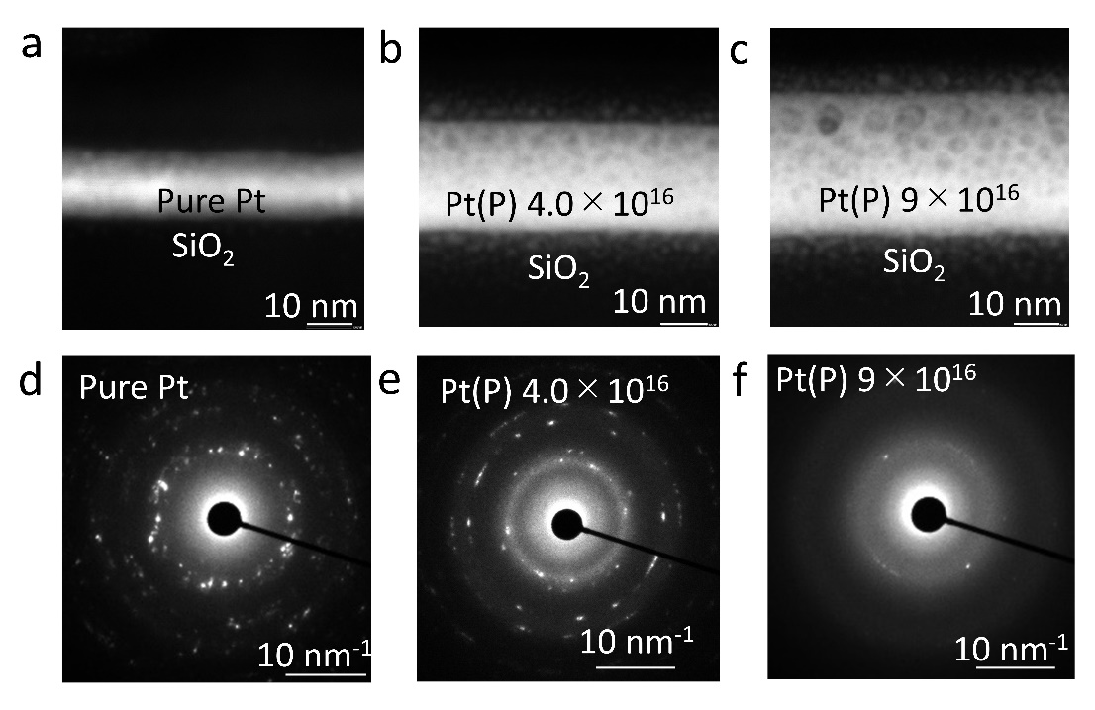

Figure S5. Cross sectional HAADF- STEM images for a) Pure Pt, b) Pt(P) 4.0 $×$10¹⁶ and c) Pt(P) 9.0$×$10¹⁶. Electron diffraction patterns of respective selected area for d) Pure Pt, e) Pt(P) 4.0 $×$10¹⁶ and f) Pt(P) 9.0$×$10¹⁶. Circular array of the spots in d) indicate the polycrystalline structure whereas the halo rings in e) and f) confirms the appearance of the amorphous structure of Pt(P).

S6: XAS measurements
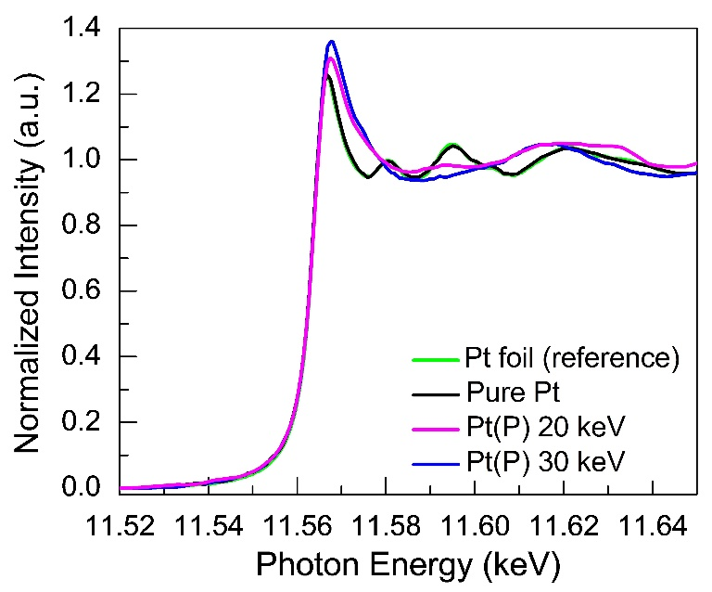
X-ray absorption (XAS) spectra were recorded around the L₃ absorption edge of Pt to study the impact of ion implantation on the electronic structure and local coordination of Pt, as shown in Figure S6. The L₃ edge of Pt signifies the electronic transitions from 2p to the unoccupied 5d_{3/2} and 5d_{5/2} bands. The first insight into the X-ray absorption near edge spectroscopy (XANES) spectrum reveals a blue shift of 1.2 eV and 0.6 eV for Pt(P) samples fabricated by 10×10¹⁶ ions/cm² at 30 keV and 20 keV, respectively, in comparison to the pure Pt. The blue shift is also accompanied by the peak broadening. Similar features of blue shift and peak broadening were also observed in PtAu nanowires due to the charge re-distribution between metallic Pt and Au sites ^{[A2]}. In addition, more intense features of white line (11566 eV) are observed corresponding to the Pt layer implanted at a higher energy of 30 keV in comparison to the implantation energy of 20 keV and the pure Pt layer. The white line intensity corresponding to the absorption edge jump obtained by subtracting the arctan function is 1.24 for pure Pt layer which increases to 1.35 for Pt(P) implanted at 30 keV. These values are in close agreement with those observed for metallic Pt ^{[A3]}. A higher intensity of absorption depicts the generation of unoccupied 5d energy states which provides a sensitive measure to the chemical environment of Pt(P). Therefore, the increase in white line intensity after implantation could be ascribed to the charge re-distribution between the Pt 5d states and the 3p energy states of implanted P ions. These observations substantiate for a charge transfer from Pt to the implanted P ions. Furthermore, the far edge oscillations in the extended X-ray absorption fine structure (EXAFS) wiggles beyond 11581 eV for pure Pt layer. However, the changes in the spectral features of Pt L₃-edge oscillations are appreciable for Pt(P). A relative variation in the oscillations represent distorted fcc phase or reduced local crystallinity of the Pt(P) layer. Hence, the XAS measurements in the near edge and far edge absorption provides a clear indication of metallic nature along with reduction in crystalline order of Pt after implanting with P ions.

Figure S6. Pt L₃ edge XAS for pure Pt and Pt(P) implanted at energy of 20 keV and 30 keV and ion dose of 10$×$10¹⁶ ions/cm².

References to Supplementary Information
- Myers, E. B., Albert, F. J., Sankey, J. C., Bonet, E., Burhman, R. A. and Ralph, D. C., Phys. Rev. Lett. 89, 19 (2002).
- Sham, T. K., Ward, M. J., Murphy, M. W., Liu, L. J. and Han, W. Q. J. Phys.: Conf. Ser. 430, 012018 (2018).
- Geprägs, S., Klewe, C., Meyer, S., Graulich, D., Schade, F., Schneider, M., Francoual, S., Collins, S. P., Ollefs, K., Wilhelm, F., Rogalev, A., Joly, Y., Goennenwein, S. T. B., Opel, M., Kuschel, T., and Gross, R., Phys. Rev. B 102, 214438 (2020).

