Chopper Interlock Module
Specifications Design Document
Implementation in LabVIEW FPGA

Revision: | 1.0
Status: | Draft
Repository: | N/A
Project: | UPM-GMV-LIPAc Support
Last modification: | 29/01/2018
Created: | 18/10/2017
Release Date: | 29/01/2018

Prepared by | Reviewed by | Approved by
Miguel Astrain | Eduardo Barrera | Mariano Ruiz

Table of contents

Introduction 3
CIM Variables: 3
State machine 6
CONFIGURATION: 6
PRE-ARM 6
ARMED 6
GATE OFF 7
GATE ON: RISING 7
GATE ON 7
GATE OFF: DECREASING 7
Chopper interlock Interfaces 9
USE CASES 9
CONFIGURATION 10
PRE-ARM 10
OPERATION:ARMED 10
GATE ON/OFF 11
FBI: VMON late 11
FBI: SPURIOUS ACCT 11
FBI: DUTY CYCLE 12
Requirements 12

Introduction
The CIM module makes sure the following tasks are correctly performed and triggers and interlock action (FBI=”0”) if conditions are not met.
When the system is described as INHIBITED it means no action is taken based on plant signals, maintaining FBI=”1”. To transition into operation the CIM must be manually armed through an EPICS PV “INHIBIT”.
INHIBIT.VAL = 1 to INHIBIT operation.
INHIBIT.VAL = 0 to transition into operation.
**Caution**
All the signal names hereafter refer to the physical signals read by the CIM as depicted on the Chopper interlock Interfaces section.

TASK | DESCRIPTION
T1 | Enable CIM operation only when CHOPPER_ON = “0” and FARADAY_IN =”0”.  *FARADAY_IN=”1” during operation shall transition into an INHIBIT state.
T2 | Monitor the duty cycle and pulse length of SOURCE GATE signal with preset profiles though EPICS PV  (D+ mode PV = SRC:SVL:D2OpenStat (5% duty and 3ms pulse),  H+ mode PV = SRC:SVL:H2OpenStat (10% duty and 6ms pulse)).  Monitor is active with CHOPPER_ON=”0”.
T3 | When CHOPPER_GATE is INACTIVE:  - VMon should be BELOW a set threshold, VMONThr.  - ACCT should be BELOW a set threshold, ACCTThr.  When CHOPPER_GATE is ACTIVE:  - VMon should be ABOVE a set threshold, VMONOff.  - ACCT should be ABOVE the previous threshold, ACCTThr.  To check this conditions some RISE and FALL times are measured, see T4 and T5.
T4 | Check VMON signal correctly transitions to zero within <GATETRise>microseconds of CHOPPER_GATE activation.
T5 | Check VMON signal correctly transitions to negative voltages within <GATETFall>microseconds after CHOPPER_GATE de-activation.

CIM Variables:
Configuration and output variables.
Name | Description | LV type | Range | PV
SRCDuty | Duty cycle threshold. | UInt32 | <5%,10% | --See SRCMode
SRCPulse | Source pulse length. | UInt32 | <3ms,6ms | -- See SRCMode
ACCTThr | ACCT max deviation from the bottom limit. | FXP(24,5)  signed | -[16,16) | LEBT:CHOP_IM:AcctThr  *PV DATATYPE: DOUBLE
VMONThr | VMON max deviation from the bottom limit. | FXP(24,5)  signed | -[16,16) | LEBT:CHOP_IM:VmonThr  *PV DATATYPE: DOUBLE
VMONOff | Threshold where VMON is considered “0”. | FXP(24,5)  signed | -[16,16) | LEBT:CHOP_IM:VmonOff  *PV DATATYPE: DOUBLE
VmonCGoff | Vmon value when the C.Gate signal is OFF “0”. | FXP(24,5)  signed | -[16,16) | LEBT:CHOP_IM:VmonCGoff
StmState | State machine current state. | Enum string | STM states | LEBT:CHOP_IM:StmState
GATETRise | Timing window for VMON to rise after CHOPPER_GATE EDGE. | UInt8 | <15us | Not avaiblable through epicsCA.
GATETFall | Timing window for VMON to fall after CHOPPER_GATE EDGE. | UInt8 | <15us | Not avaiblable through epicsCA.
INHIBIT | Variable to manually arm the CIM.  IF INHIBIT = “1” FBI=1. | Boolean | 0,1 | LEBT:CHOP_IM:Inhibit
FBI | Interlock output variable. | Boolean | 0,1 | LEBT:CHOP_IM:Fbi
SRCMode | Mode reads SRC:SVL PVs and changes CIM Duty Cycle acceptance values. | ENUM | modes | PV = SRC:SVL:D2OpenStat  PV = SRC:SVL:H2OpenStat
Sate machine iteration | Running check. | UInt32 | STM states | LEBT:CHOP_IM:StmRunning
Pulse Diag | Data set which triggered FBI. | Boolean | 0,1 | LEBT:CHOP_IM:FbiDPulse
Duty Diag | Data set which triggered FBI. | Boolean | 0,1 | LEBT:CHOP_IM:FbiDPeriod
C.GATE Diag | Data set which triggered FBI. | Boolean | 0,1 | LEBT:CHOP_IM:FbiCGate
Faraday Diag | Data set which triggered FBI. | Boolean | 0,1 | LEBT:CHOP_IM:FbiFaraday
ACCT Diag | Data set which triggered FBI. | FXP(24,5)  signed | -[16,16) | LEBT:CHOP_IM:FbiAcct
VMon Diag | Data set which triggered FBI. | FXP(24,5)  signed | -[16,16) | LEBT:CHOP_IM:FbiVmon
State Diag | Data set which triggered FBI. | String | STM states | LEBT:CHOP_IM:FbiStmState

Reuqested on-site, the CIM also publishes the following PV’s while in the PRE-ARM state for debugging purposes:
Pulse Debug | PRE-ARM values. | UInt32 | System ticks(25ns) | LEBT:CHOP_IM:DbgDPulse
Duty Debug | PRE-ARM values. | UInt32 | System ticks(25ns) | LEBT:CHOP_IM:DbgDPeriod
ChopperON Debug | PRE-ARM values. | Boolean | 0,1 | LEBT:CHOP_IM:DbgChop
Faraday Debug | PRE-ARM values. | Boolean | 0,1 | LEBT:CHOP_IM:DbgFaraday
ACCT Debug | PRE-ARM values. | FXP(24,5)  signed | -[16,16) | LEBT:CHOP_IM:DbgAcct
VMon Debug | PRE-ARM values. | FXP(24,5)  signed | -[16,16) | LEBT:CHOP_IM:DbgVmon

State machine
To manage the tasks the following state-machine is proposed:
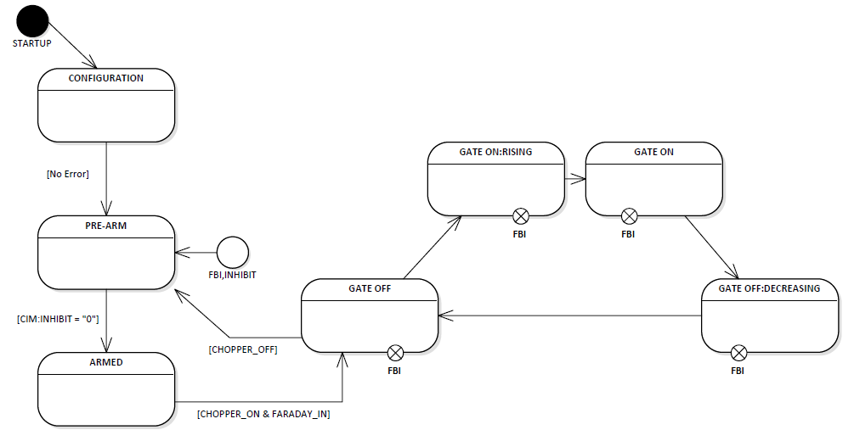

CONFIGURATION:
- In this state correct configuration is checked:
- Module configurations
- Threshold values
- FBI=1

- The system transitions into the next state when the following conditions are met:
- No Errors.

PRE-ARM
- The CIM stays in this state until armed for operation. It will maintain FBI state as it was when entering this state.
- If the system enters PRE-ARM from CONFIGURATION, the FBI =” 1” = ALL OK.
- If the system enters PRE-ARM from an interlock action FBI=”0” it stays there until re-armed.

- The system transitions into the next state when the following conditions are met:
- Arming the chopper is done manually though an EPICS PV: CIM:INHIBIT = 0.
- CIM defaults to INHIBIT=”1” on start up. Needs to be manually armed through EPICS PV.

ARMED
FBI = “1” is set regardless of previous value.
The CIM then waits for CHOPPER_ON = “0” and FARADAY_IN = “0” to transition into the GATE OFF state.

GATE OFF
CIM monitors the following signals in this state:
- SOURCE_GATE: Duty cycle <SRCDuty; Pulse <SRCPulse.
- ACCT: Voltage <ACCTThr
- VMON: Voltage <VMONThr
- CHOPPER_ON
- FARADAY_IN
- CHOPPER_GATE
CIM waits in this state until a rising edge is detected on the CHOPPER_GATE signal.
**Modified on-site operation**
Faraday cup insertion during a GATE_OFF cycle shall force a transition into the PRE-ARM state, in more detail:
- FARADAY_IN=”1” (with the remaining signals on the correct values, meaning:
- CHOPPER_ON=”0” (the physical signal received by the CIM)
- CHOPPER_GATE=”0
- and thresholds as indicated above
this combination shall INHIBIT CIM and transition into a PRE-ARM state. This was requested by the user to be able to “disarm” the CIM without triggering an interlock action.

GATE ON: RISING
CIM stays for (GATETRise) microseconds on this state.
CIM monitors the following signals in this state:
- SOURCE_GATE: Duty cycle <SRCDuty; Pulse <SRCPulse.
- CHOPPER_GATE
- VMON: Voltage
- CHOPPER_ON
- FARADAY_IN

CIM monitors VMON voltage until GATETRise time has passed, if VMON is below (in absolute value) the VMONOff value it shall transition to the next state.

GATE ON
CIM monitors the following signals in this state:
- SOURCE_GATE: Duty cycle <SRCDuty; Pulse <SRCPulse.
- CHOPPER_GATE
- VMON: Voltage
- CHOPPER_ON
- FARADAY_IN

In this state CIM monitors VMON is below (in absolute value) the VMONOff value and waits for a falling edge on CHOPPER_GATE when it transitions onto the next state.

GATE OFF: DECREASING
CIM stays for (GATETFall) microseconds on this state.
CIM monitors the following signals in this state:
- SOURCE_GATE: Duty Cycle <SRCDuty; Pulse <SRCPulse.
- CHOPPER_GATE
- VMON: Voltage
- CHOPPER_ON
- FARADAY_IN

CIM monitors VMON voltage until GATETFall time has passed, if VMON is over (in absolute value) the VMONThr value it shall transition back to GATE_OFF.

Chopper interlock Interfaces
The interfaces are realized as follows:
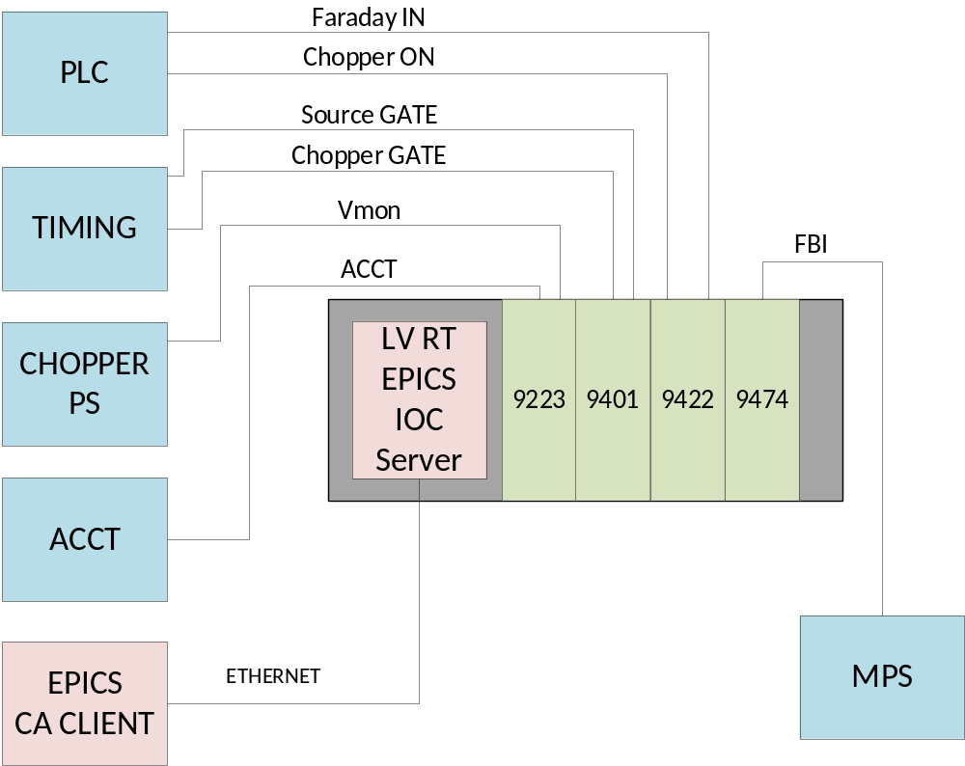

SIGNAL | Type | Range
CHOPPER_ON | DI 24V | 0-24 V
FARADAY_IN | DI 24V | 0-24 V
SOURCE_GATE | DI TTL | 5V TTL
CHOPPER_GATE | DITTL | 5V TTL
VMON | ANALOG | [-4,0] V
ACCT | ANALOG | [-2,2] V *ACCT sensor still uncertain.
FBI | DO 24V | 0-24 V

USE CASES
The following use cases illustrate some of the Interlock behavior:

CONFIGURATION
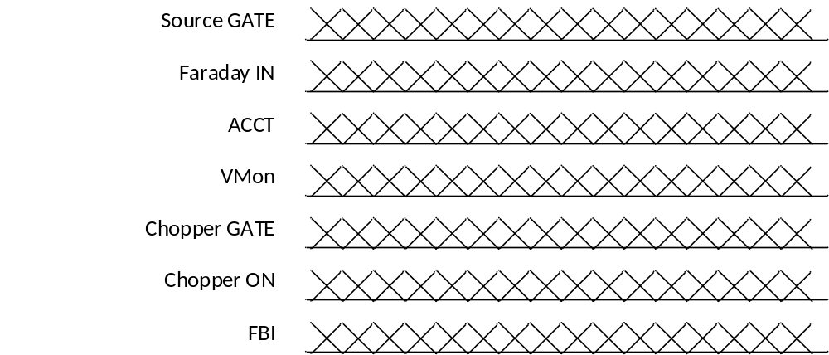

PRE-ARM
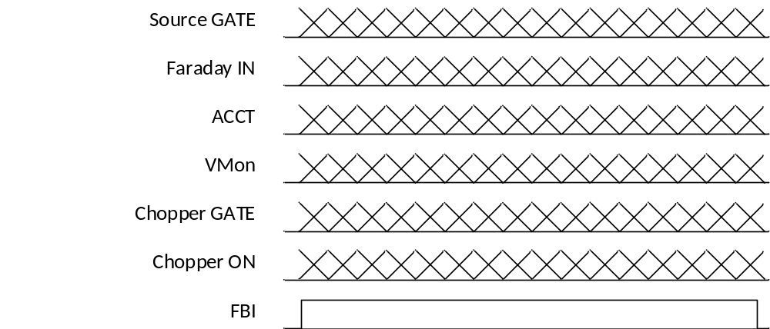

OPERATION:ARMED
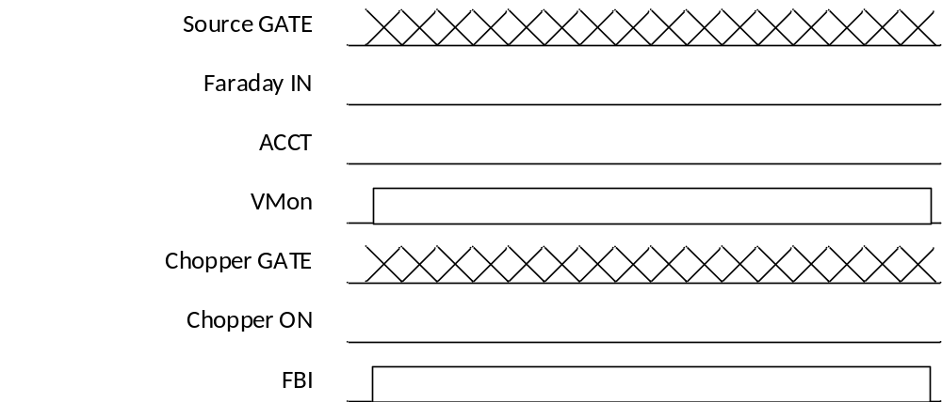

GATE ON/OFF
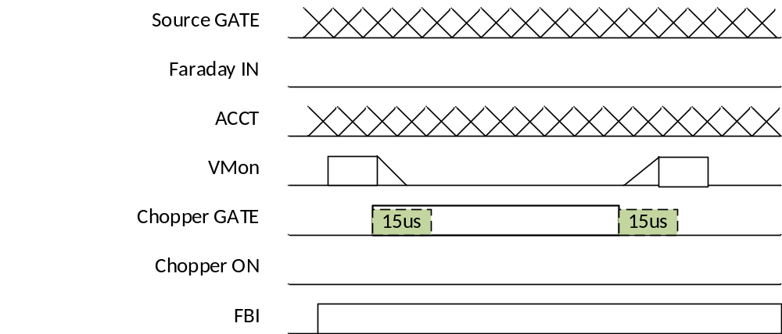

FBI: VMON late
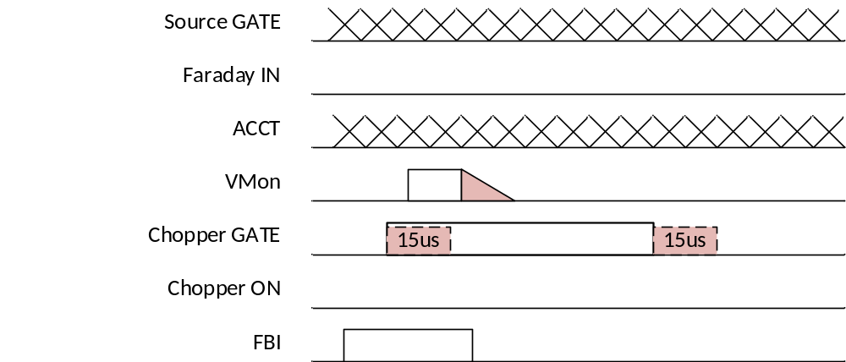

FBI: SPURIOUS ACCT
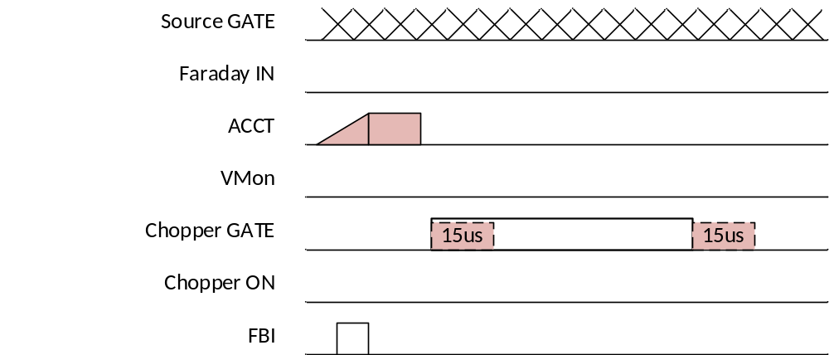

FBI: DUTY CYCLE
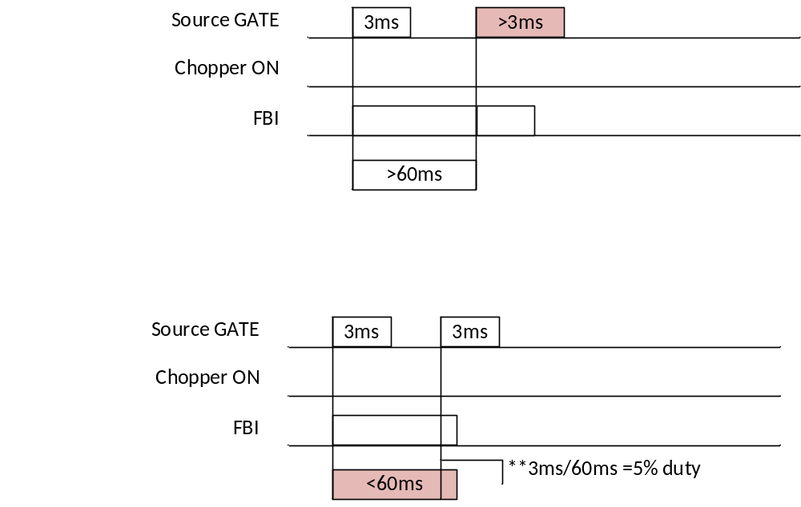

Requirements

CIM-GNRL-000
Chopper Interlock Module (CIM hereafter) shall be implemented using NI-9068 RT chassis. Interfaces shall be implemented using NI-cRIO series Modules and in compliance with their electrical compatibility specifications.
CIM-GNRL-001
CIM shall be developed using:
- LabVIEW 2014 SP1 f10
  - LabVIEW-RT 2014
  - LabVIEW DSC 2014
  - LabVIEW FPGA 2014
- LabVIEW Xilinx vivado tools 13
- NI-RIO 14.0.1

CIM-GNRL-002
CIM shall publish Process Variables (PV) to EPICS using LabVIEW-RT EPICS IOC and Shared Variable PV types.
CIM-FUNC-000
CIM shall be implemented using State Machine design scheme.
CIM-FUNC-001
CIM operation shall be enabled by the actuation of two digital 24V signals. CHOPPER_ON and FARADAY_IN.
CIM-FUNC-002
When enabled, CIM shall monitor a periodic TTL signal SOURCE_GATE.
CIM-FUNC-003
When enabled, CIM shall monitor two analog signals ACCT and VMON.
CIM-FUNC-004
When CHOPPER_GATE is enabled, CIM shall check the correct transition of the VMON signal.
CIM-FUNC-005
When CHOPPER_GATE is disabled, CIM shall check the correct transition of the VMON signal.
CIM-FUNC-006
CIM shall trigger an "interlock action" when some conditions are met.
The "interlock action" is realized with a digital 24V signal on a logic zero and latching onto this state.
CIM shall need to be re-armed from to continue operation.

CIM-TEST-000
CIM Factory Acceptance Tests shall be carried out using real signals generated using NI Multifunction DAQ 6361.

CIM-TEST-001
CIM Site Acceptance tests shall follow the requirements specifications.

