1. Within- and between-subjects similarity

The results in Figures S1 for the covariances FC0 and FC1 are close to those for corrFC in the main text. The distribution for corrFC/SC that only retains the links corresponding to existing connections in EC (as determined by SC) is similar to that for corrFC in Figure 2 in the main text; reducing the dimension of the vector does not affect much the results.

Figure S1. Similarity distributions of FC0, FC1, corrFC/SC and Σ calculated form Dataset A. Distributions of WSS and BSS similarity values for Datasets A1 (blue and red), as well as the BSS values for Dataset A2 (green). The plot is similar to Figure 2B: similarity is calculated using the Pearson correlation coefficient (PCC) between every pair of sessions from the same subjects or from different subjects respectively.

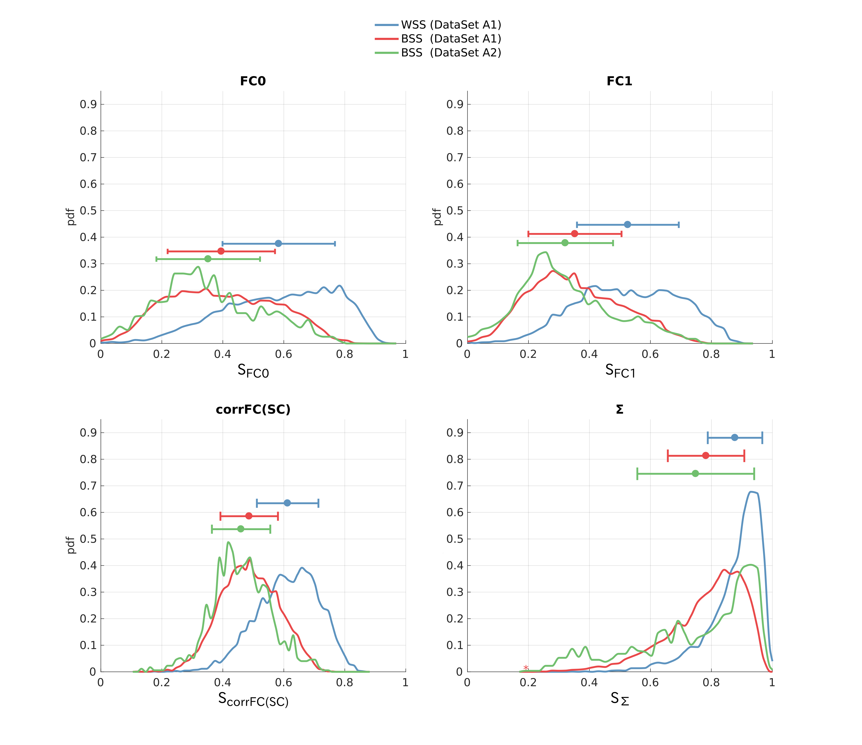

The results for Dataset B are qualitatively similar to those for Dataset A in Figures 2 and S1.

Figure S2. Similarity distributions for Dataset B: comparison of EC, corrFC, FC0, FC1, corrFC/SC, and Σ. Same as Figure 2.B and S1 for Datasets B with WSS and BSS similarity values (blue and red).
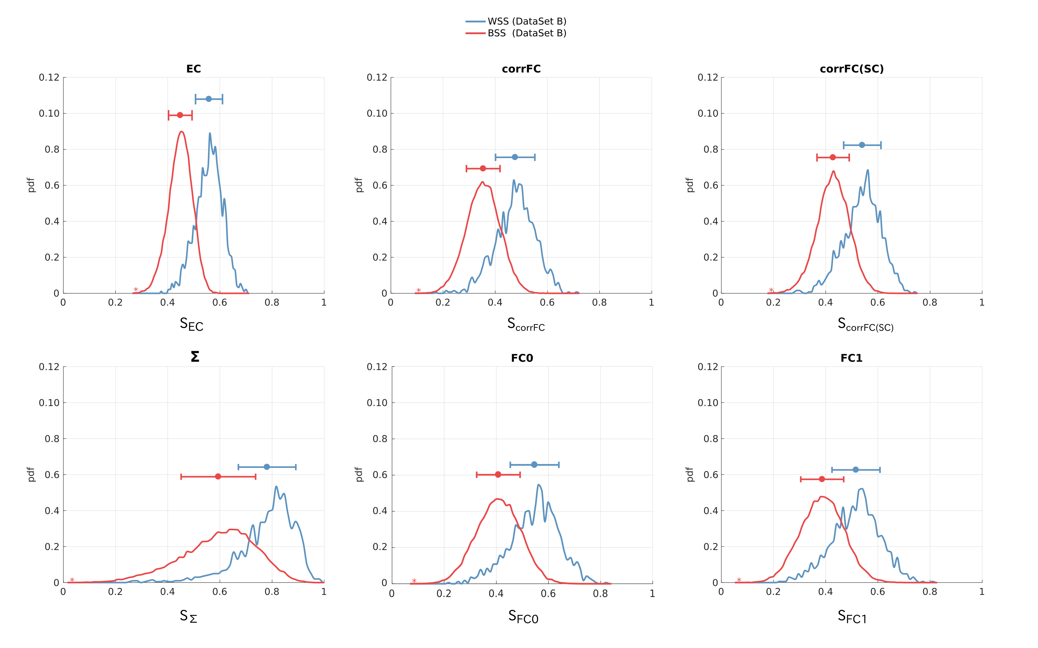

2. Degree of clustering

This indicates that taking as many PCs as subjects is optimal to cluster the subjects. However, adding more PCs reduces the separability, as measured by the PCC-based similarity.

Figure S3. Averaged silhouette coefficient of the first principal components (PCs), taking an increasing number of them as indicated on the x-axis (from 1 to 20 for Dataset A1; from 1 to 50 for Dataset B). PCA was applied on the whole set of subjects for both datasets. The curves correspond to the silhouette for EC (in red) and corrFC (in blue). The silhouette value indicates the quality of clustering the in the directions with largest variance (within the high dimensional space of the data). A maximum is reached around the number of subjects, 6 for the left panel and 30 for the right panel.

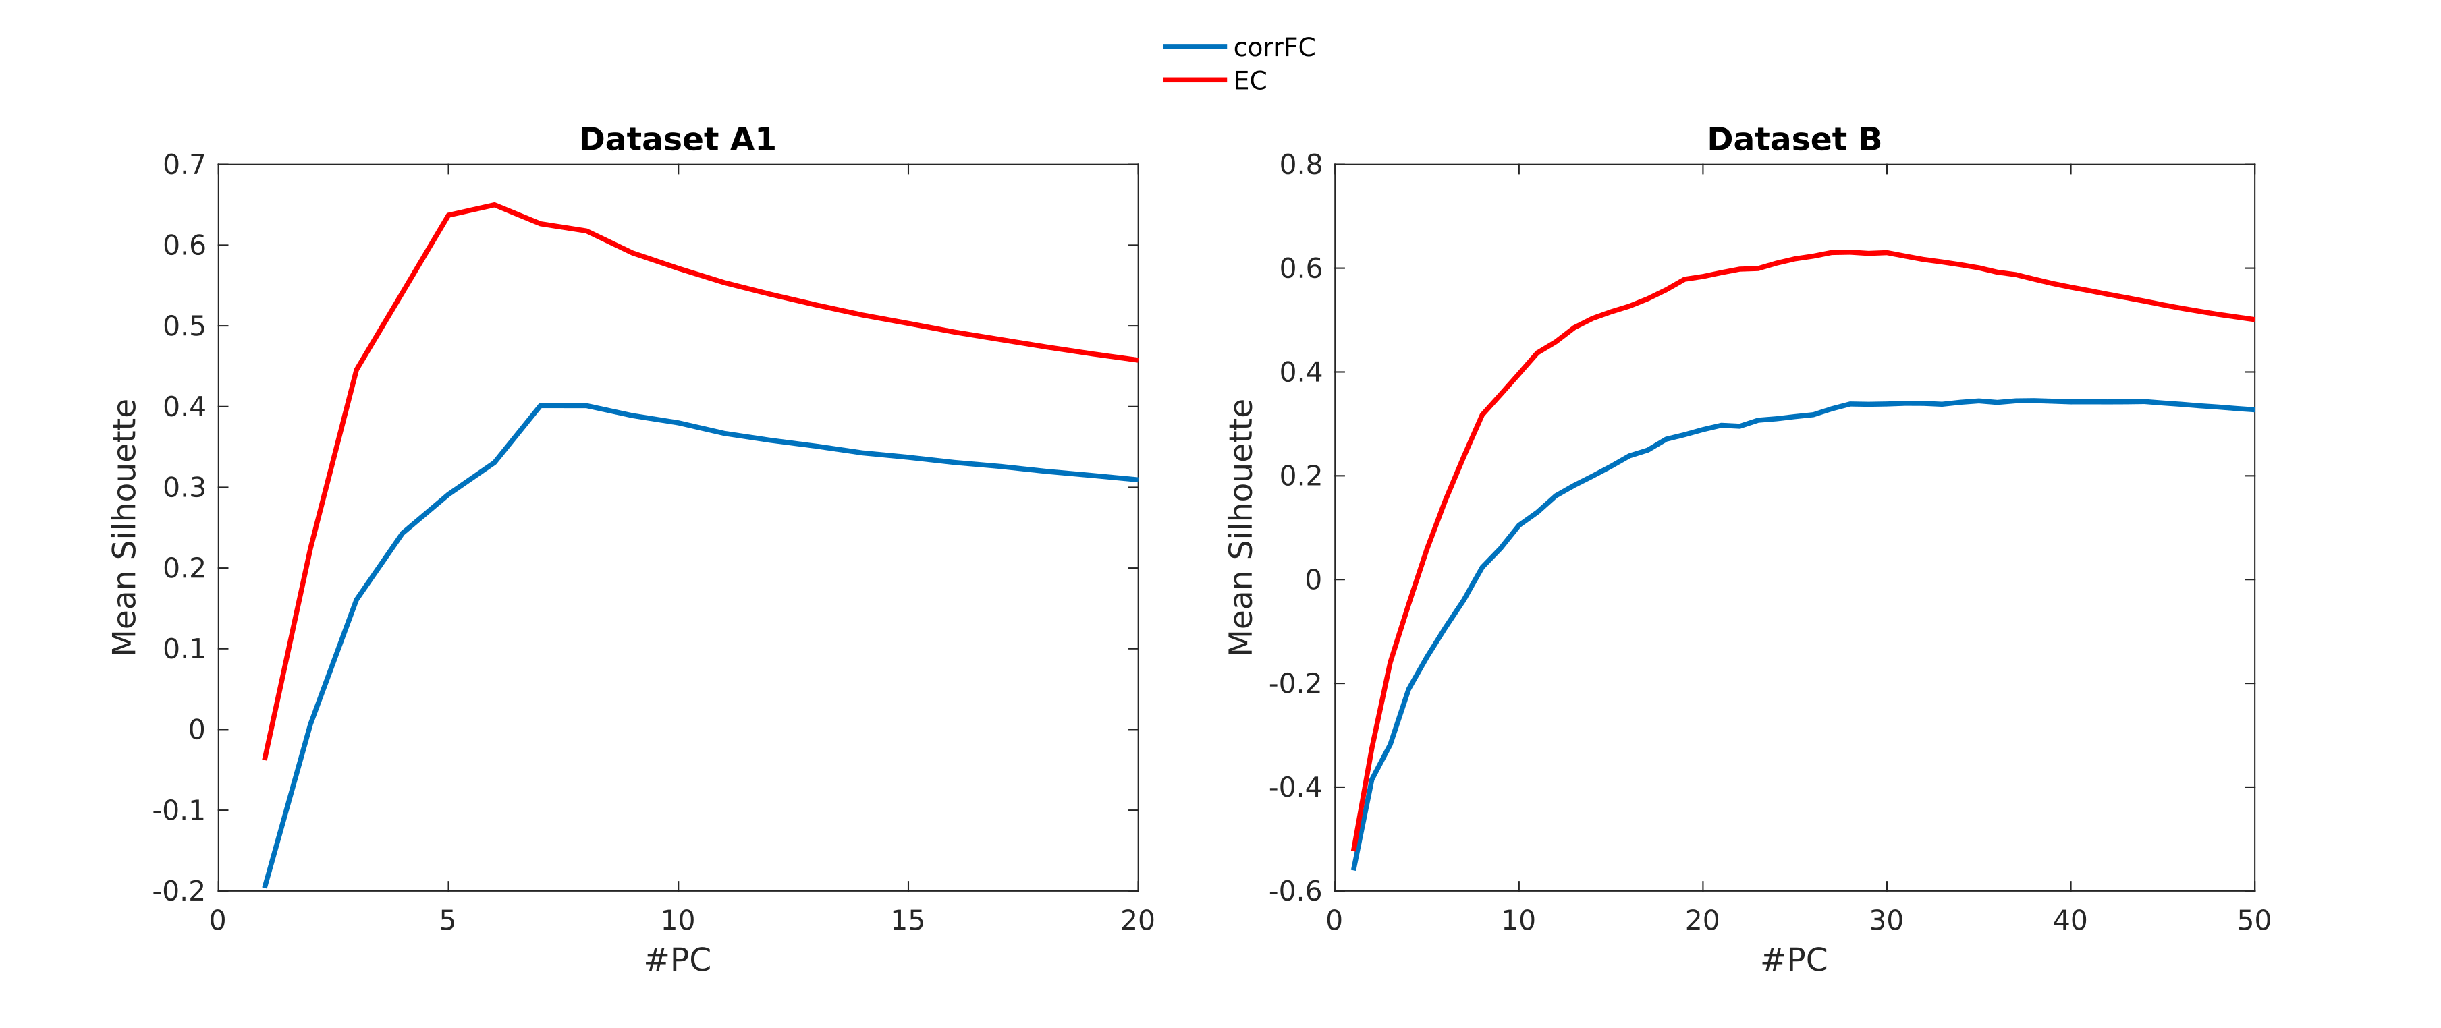

3. Classification of subjects depending on PCA

Figure S4 depicts the method used in previous studies to identify subjects from resting-state sessions (Finn 2015; Kaufman 2017). In particular, the scheme presents the approach applied to Dataset A1 (6 subjects, 40-50 sessions).

Figure S4. Principle of the 1-NN classifier For each target session to classify, we calculate the similarity values (PCC) with each of the sessions in the database. The session is attributed to the subject with largest similarity. For the kNN, the database contains k sessions per subject.

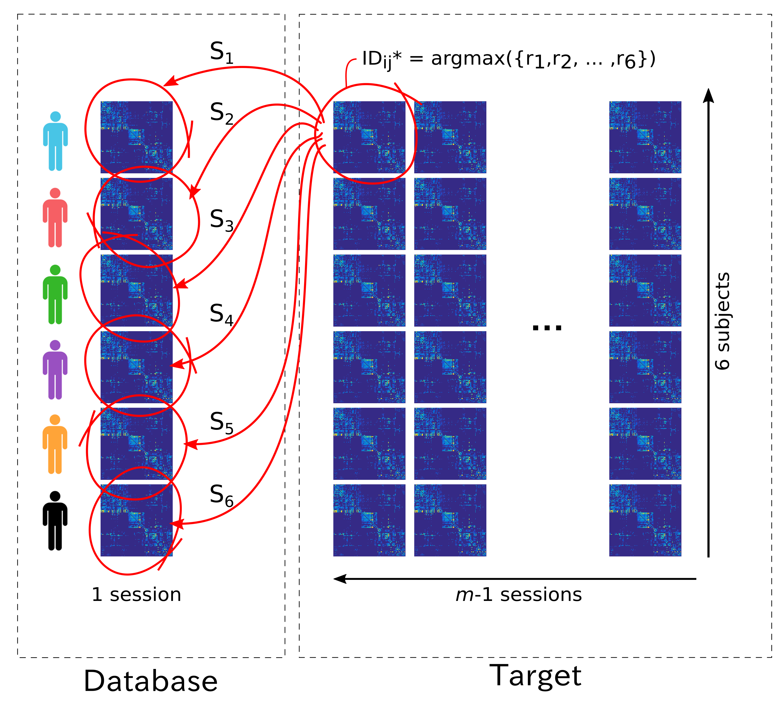

This is the classification performance of subjects after sorting the most discriminant EC links selected by RFE and depicted in Figure 3D.

Figure S9: Test set accuracy of MLR classifier varying number of features.

4. MLR and 1NN in PCA space

Figure S5 shows the classification performance in subject identification of Dataset B for both classifiers, MLR and 1NN, using the data in PCA space. Only for the 1NN the performance is improved after PCA and 1 training session per subject.
Figure S5. Classification of EC and corrFC sessions with 1NN and MLR with and without applying PCA to the data.
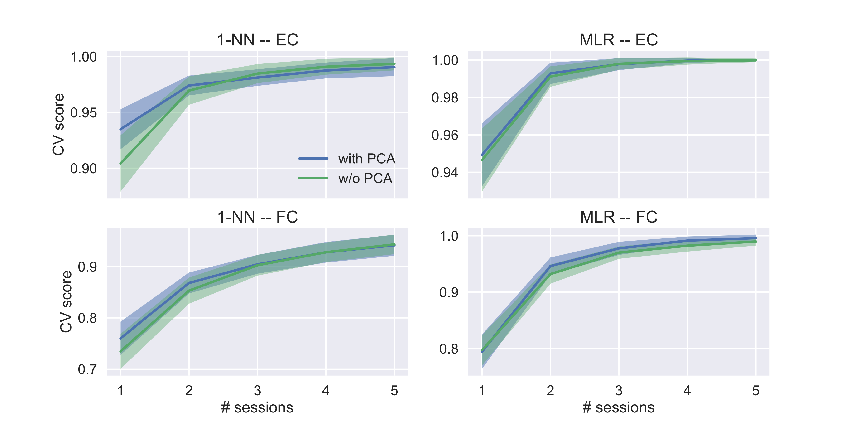
A specific number of PC can be chosen to train the classifier. Figure S6 shows that for a few PC, better performance is achieved with EC. For this particular case of 3 training sessions per subject of Dataset B, after 30 PC the accuracy is 1, meaning that the remaining PC carry redundant information for the identification.

Figure S6. Performance of MLR classifier for EC and corrFC sessions when increasing the number of PC’s. Dataset B with 30 subjects and 3 sessions per subject used for training. The information relevant for the classification is distributed across the first 20-30 PCs, especially for EC.
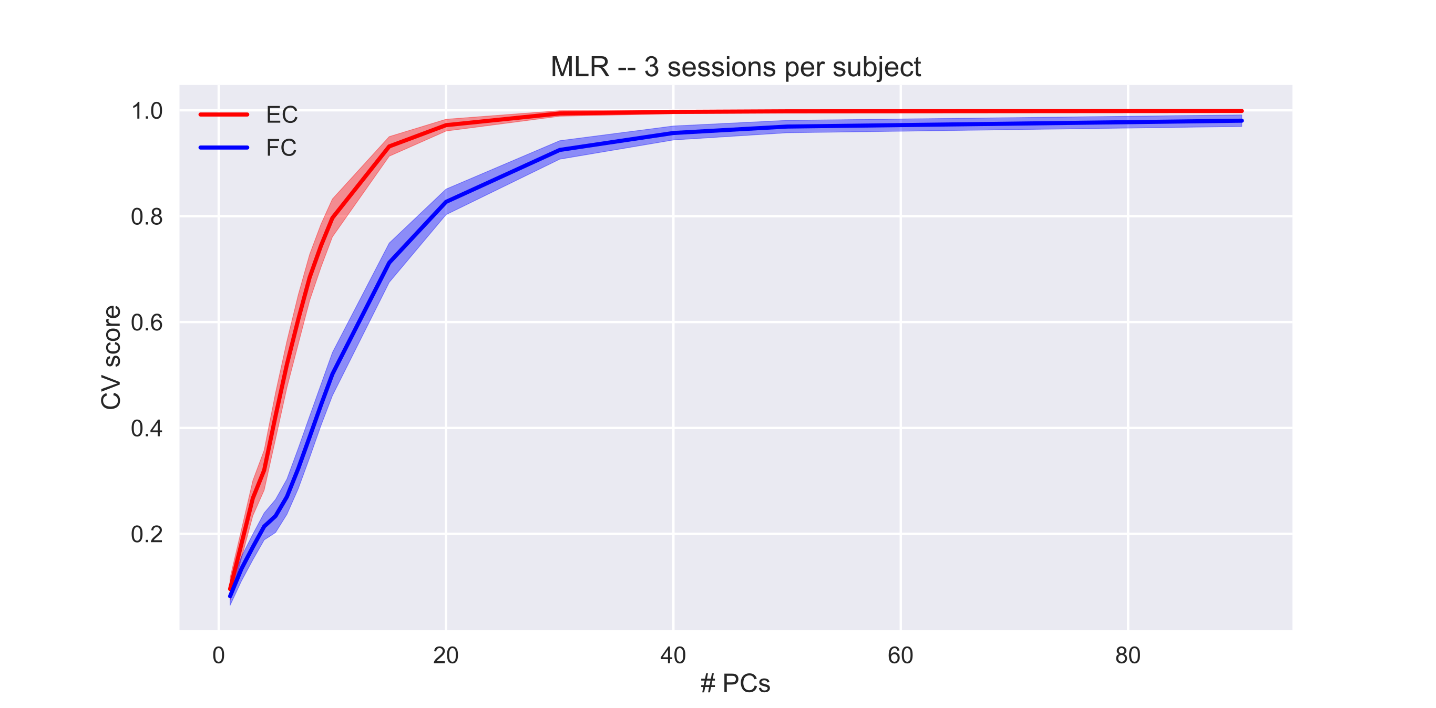

This illustrates that PCA with sufficiently many sessions achieves perfect clustering. The left panel shows that all PCs up to 6 convey relevant information for subject identification, especially PC3 to 6. This confirms the results Figure S4, where the silhouette curve is steeper for those PCs.

Figure S7. Decomposition of the contributions along each principal component (PC) of the MLR+PCA regressors. The MLR was trained using EC from Dataset A1 with 20 sessions per subject. The left plot shows for subjects 1 to 5 (in color, corresponding each to a regressor against the 6th subject) the weight for each PC (beta 1 to 6). Large values indicate that PC strongly contributes to the discrimination of the subject. The middle and right panels display a visualization of many averages of 20 sessions (distinct from the training ones, represented each by a colored dot) in the PC space; PC2 is omitted.

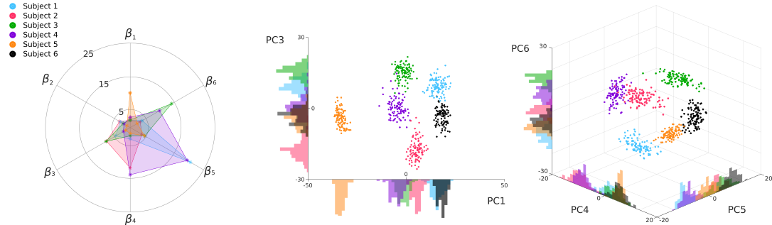

For Both Dataset A1 and B, the first PCs are less informative than the ones following. This indicates that the main variability (first PCs) of EC is common to all subjects; subsequent PCs with lower variability are actually more informative about the subjects' identity, which supports the use of proper machine learning tools to make the best use this distributed information.

Fig S8. Comparison of the contributions of all MLR+PCA regressors along the PCs for Datasets A1 and B. After training the MLR with PCA on EC, we calculate for each PC a single value that measures the importance of that PC in the global classification; it simply collapses the values in the left panel of Figure S6 by summing them for each PC.

