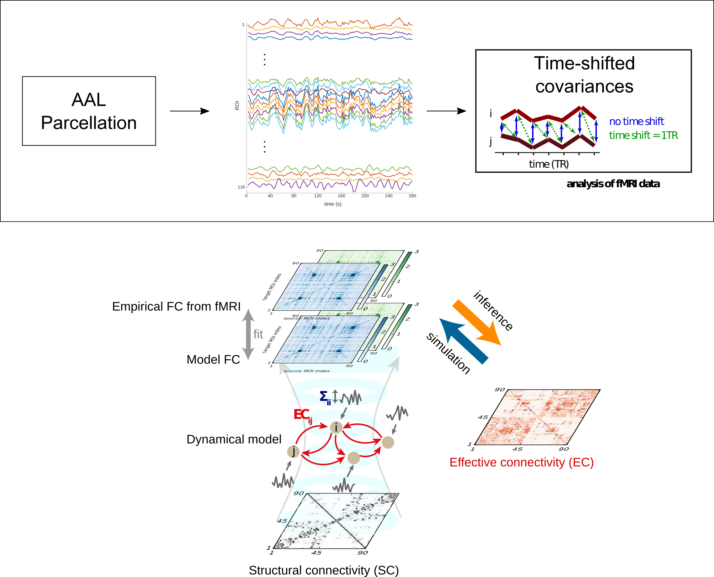
Figure 1. Workflow for the calculation of the connectivity measures from fMRI resting-state data. A) After a standard pre-processing pipeline, a parcellation covering the whole-brain is applied (AAL) to extract BOLD time series for 116 ROIs. Here we consider two versions of functional connectivity: the classical corrFC corresponding to the Pearson correlation coefficient (PCC) for pairs of time series; spatiotemporal FC (stFC) where FC0 and FC1 are the covariances without (blue arrows) and with (blue) time shift, respectively; see Methods for the detail of the calculation. B) Whole-brain network model to interpret fMRI data. The local fluctuating activity (with variances Σ_{ii} for region i) propagates via the recurrent EC to generate the correlation patterns (stFC) at the network level. Structural connectivity (SC, bottom) obtained using diffusion-weight imaging (DWI) determines the skeleton of EC. The estimation procedure iteratively tunes EC and Σ such that the model best reproduces the empirical stFC. C) Xxx NEW SUBFIG TO PUT THERE The corrFC matrices have 116*116 elements, but it is symmetric and has diagonal elements all equal to 1, so only the 3335 independent links in the lower triangle are retained for identification/classification. Likewise, the EC matrix has 4056 non-zero elements (density of 30%).

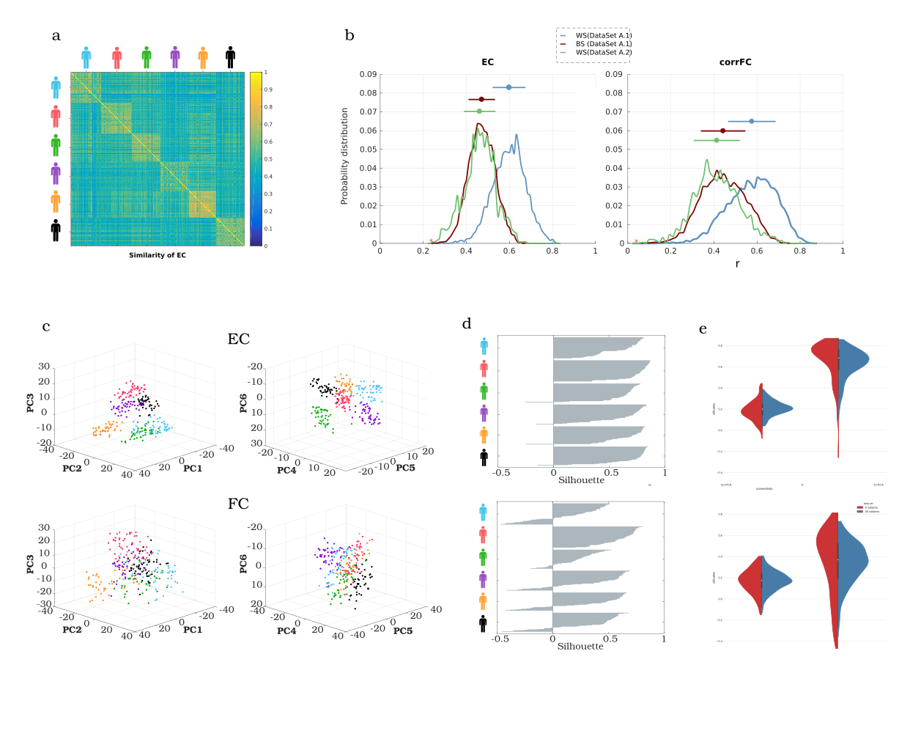
Figure 2. Within- and between-subject similarity (WSS and BSS, respectively) for EC and corrFC. A) Matrix of Pearson correlation coefficient (PCC) values for EC xxx RECHECK for all pairs of sessions of Dataset A1. ECs from two sessions are transformed into two vectors, from which PCC is calculated; the sessions are grouped by subjects, as indicated by the colored symbols. B) Distributions of WSS and BSS PCC values for Datasets A1 – corresponding to diagonal and off-diagonal in A, respectively – and of BSS for Dataset A2. WS similarity (in blue) has been calculated from the dataset A1. Xxx repeating for 1000 times xxxWHAT IS THIS? C) Visualization of the sessions of Dataset A1 in the space of the first 6 principal components (PCs) obtained from PCA applied to all the vectorized EC (top panels) and corrFC (bottom panels). Each point corresponds to a scan session and the colors correspond to the subjects in A. D) Silhouette coefficients of each session dot in C, combining the intra-cluster cohesion and separation between clusters xxx RECHECK in the 6-PC space. The silhouette values range from -1 to 1 and more positive values indicate a better degree of clustering; see Eq. xxx in Methods for details. E) Distribution of the silhouette coefficients for EC (top panel) and FC (bottom panel), without (left) and with (right) PCA applied to the sessions. Both Datasets A1 (6 subjects, in red) and B (30 subjects, in blue) are represented by the violin plots.

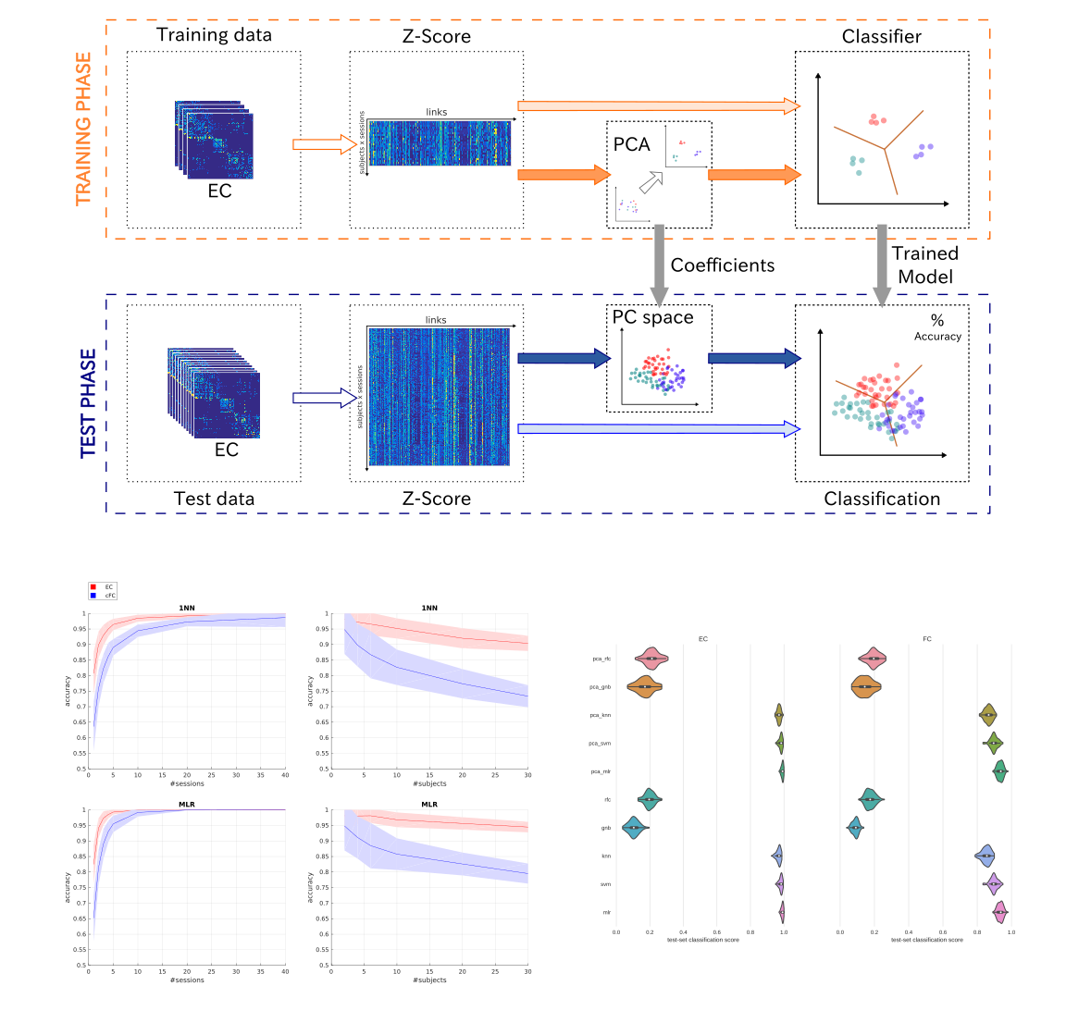
Figure 3. Classification performance of EC and corrFC depending on sessions and subjects. A) Classification pipeline for the multinomial linear rergessor (MLR) used to assess the performance on subject identification. The full set of connectivity measures (here EC) over all fMRI sessions was split into two groups: a train set and a test set. We applied a z-score standardization for the elements of each session matrix. We trained the classifier – with or without applying PCA – and evaluated the classification accuracy on the test set. B) Performance of 1NN and MLR INVERT ORDER, MLR FIRST classifiers varying the number of sessions per subject used on the train set with Dataset A1 (6 subjects with about 50 sessions each). The mean (solid curve) and standard deviation (colored area) were calculated for 100 repetitions with different training and test sessions randomly chosen. XXX PCA? #PCs? C) Same as B when varying the number of subjects using a single xxx RECHECK training session per subject with dataset B (30 subjects with 10 sessions each). D) TO CHANGE FOR CONTRIBUTING LINKS?

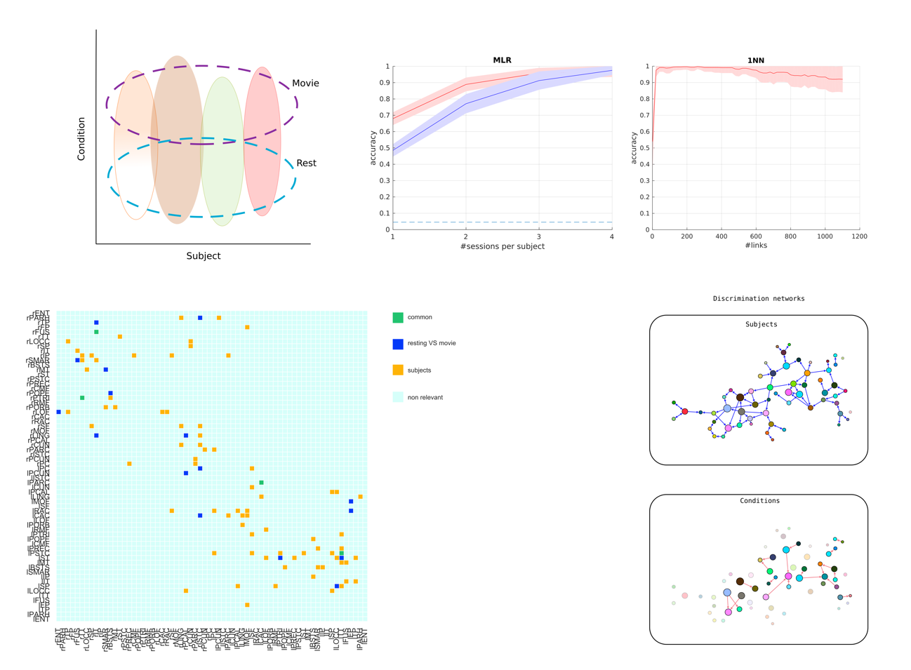

Figure 4. Two-fold discrimination between subjects and conditions using EC. A) Scheme of the bi-dimensional approach used for identifying both the signature of each condition and the fingerprint of the subjects. B) Classification accuracy on subjects and conditions (resting vs. free viewing) COLORS??? on dataset C using a MLR classifier and X train sessions (signal length) per subject. C) Performance when selecting the most informative links SUBJECT? CONDITION? BOTH?. D) Extraction of the links that significantly contribute to the classification. Links are grouped by subsystems here, but unlike Figure 3D we keep individual information.

Figure S4: Test set accuracy of MLR classifier varying number of features.

