**Fade Software Design**

***SteerTurnIllum***



|  |  |  |
| --- | --- | --- |
| Author: |  | Nicolae-Bogdan Bacrău |
| Version: |  | 1.0 |

Index

1 Glossary 3

2 Introduction 4

2.1 Purpose of the Document 4

2.2 Overview 4

3 Design Requirements 5

4 Information about this Document 7

4.1 Copyright 7

4.2 Version Index 7

# Glossary

This section contains a glossary of all the important terms and acronyms used inside the document.

|  |  |
| --- | --- |
| **Term / Acronym** | **Description** |
| AUTOSAR | AUTomotive Open System ARchitecture |
| VFB | Virtual Functional Bus |
| SWC | Software Component |
| RTE | Runtime Environment |
| BSW | Basic Software |
| OS | Operating System |
| S/R | Sender / Receiver |
| C/S | Client / Server |
| ECU | Electronic Control Unit |
| uC | Microcontroller |
| ADC | Analog Digital Converter |
| DIO | Digital Input / Output |
| PWM | Pulse Width Modulation |

Table 1 - Glossary.

# Introduction

## Purpose of the Document

The purpose of the document is to define the software design of the ***Fade*** SWC for the ***SteerTurnIllum*** embedded academy project.

## Overview

The ***Fade*** SWC implements a mechanism for performing a transition between a start value and a target value in a given amount of time by following a function that is defined through linear equations.

# Design Requirements

1. The Fade SWC shall adhere to the structure illustrated in the composite structure diagram from **Figure 1**.

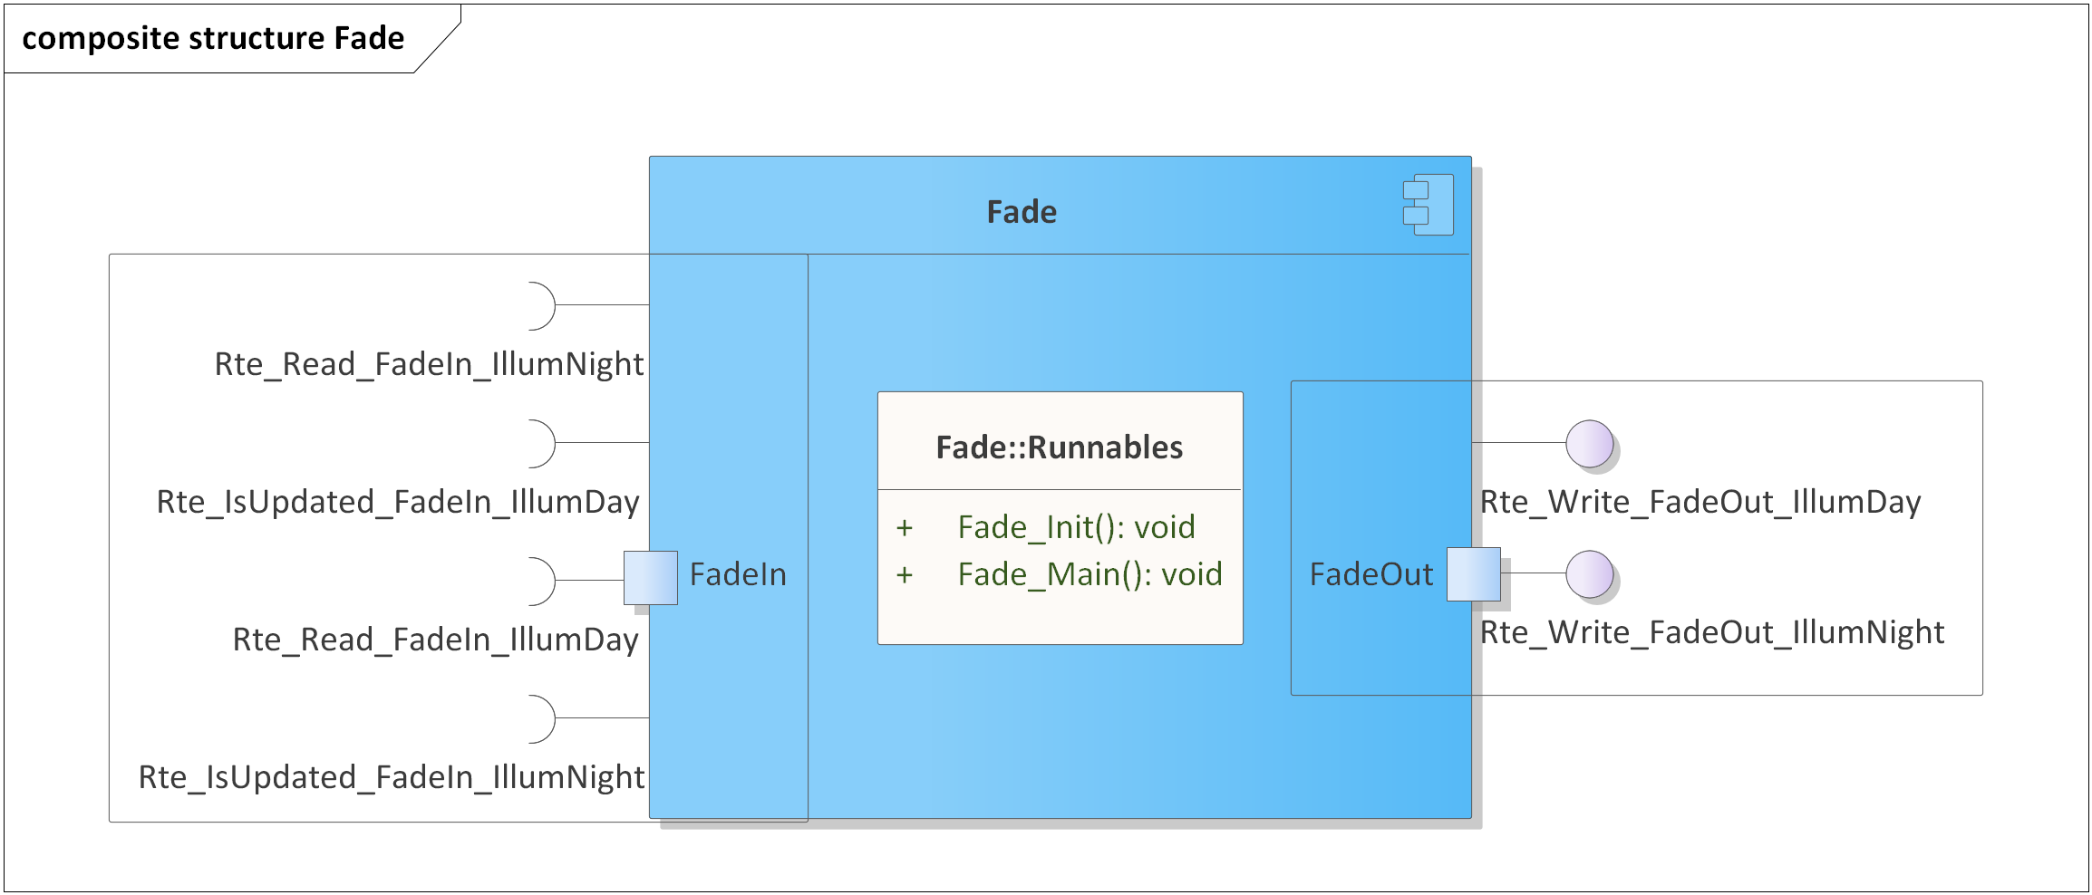

Figure 1 - Fade composite structure diagram.

1. The Fade SWC shall implement the fading mechanism as described in chapter 3.4 from the System Requirements.
2. The Fade SWC shall adhere to the SWC file structure template from 4_Engineering\1_Software\2_Development\1_Sources\8_Templates\Swc\Code.
3. The Fade SWC shall contain the following configuration parameters:

* In *Fade_Cfg.h*:
  + *FADE_MAIN_PERIODICITY_US*: macro defining the periodicity of the main function in microseconds.
  + *FADE_NUMBER_OF_INSTANCES*: macro defining the number of fading instances to be processed in the main function.
  + *FADE_*_INSTANCE*: zero based macros defining unique IDs of all the fading instances, needed for the interaction between the core and RTE.
* In *Fade_Cfg.c*:
  + *Fade_gkat_Config*[FADE_NUMBER_OF_INSTANCES]: internal global constant array defining the IFX interpolation curve configurations for all the instances.

1. The Fade SWC shall configure the IFX interpolation points, needed for *Fade_gkat_Config[]*,defined on columns F and G in .\Resources\SwDe_Fade_Config.xlsx.
2. The Fade SWC shall implement the *void Fade_Init(void)* runnable for initializing all the internal static and global variables.
3. The Fade SWC shall implement the *void Fade_Main(void)* runnable for implementing the processing of all the fading jobs as follows:

* Checks if the fading input control data elements have been updated, through *Rte_IsUpdated_FadeIn_*(),* and, if true, reads the input control data through *Rte_Read_FadeIn_*()* and starts a new fading job.
* If a fading job is ongoing, updates the output fading status data and writes it to RTE through *Rte_Write_FadeOut_*()*.
* If a fading job is ongoing and the fading input control data has been updated, the current job shall be aborted and a new one shall be started with the new data.
* Once the elapsed time reaches 0, and implicitly the target value has been reached, the fading job shall enter the idle state.
* While in the idle state, the output fading status data shall remain unchanged.
* If the input control data contains the input fading time equal to 0 or if the start value equals the target value, the output level shall be set to the target level and the fading job shall immediately enter the idle state.

1. The Fade SWC shall include *Ifx.h* and directly use the *Ifx_IntIpoCur_u16_u16()* functionfor calculating the current output level through linear interpolation.

# Information about this Document

## Copyright

All rights, including translation rights, are reserved. Under no circumstances shall any fragment of this document be reproduced without written authorization from NTT DATA Romania S.A, including copying, photographing or replicating through other methods.

Copyright (c) NTT DATA Romania S.A.

## Version Index

|  |  |  |  |  |
| --- | --- | --- | --- | --- |
| **Version** | **Date** | **Author** | **Chapter** | **Modification description** |
| 1.0 | 10.07.2021 | Nicolae-Bogdan Bacrău | All | Created. |

Table 2 - Version Index.