**Illum Software Design**

***SteerTurnIllum***



|  |  |  |
| --- | --- | --- |
| Author: |  | Nicolae-Bogdan Bacrău |
| Version: |  | 1.0 |

Index

1 Glossary 3

2 Introduction 4

2.1 Purpose of the Document 4

2.2 Overview 4

3 Design Requirements 5

4 Information about this Document 7

4.1 Copyright 7

4.2 Version Index 7

# Glossary

This section contains a glossary of all the important terms and acronyms used inside the document.

|  |  |
| --- | --- |
| **Term / Acronym** | **Description** |
| AUTOSAR | AUTomotive Open System ARchitecture |
| VFB | Virtual Functional Bus |
| SWC | Software Component |
| RTE | Runtime Environment |
| BSW | Basic Software |
| OS | Operating System |
| S/R | Sender / Receiver |
| C/S | Client / Server |
| ECU | Electronic Control Unit |
| uC | Microcontroller |
| ADC | Analog Digital Converter |
| DIO | Digital Input / Output |
| PWM | Pulse Width Modulation |

Table 1 - Glossary.

# Introduction

## Purpose of the Document

The purpose of the document is to define the software design of the ***Illum*** SWC for the ***SteerTurnIllum*** embedded academy project.

## Overview

The ***Illum*** SWC implements the control of the day and night illumination LEDs through fading jobs based on the modifications in the ambient luminance.

# Design Requirements

1. The Illum SWC shall adhere to the structure illustrated in the composite structure diagram from **Figure 1**.

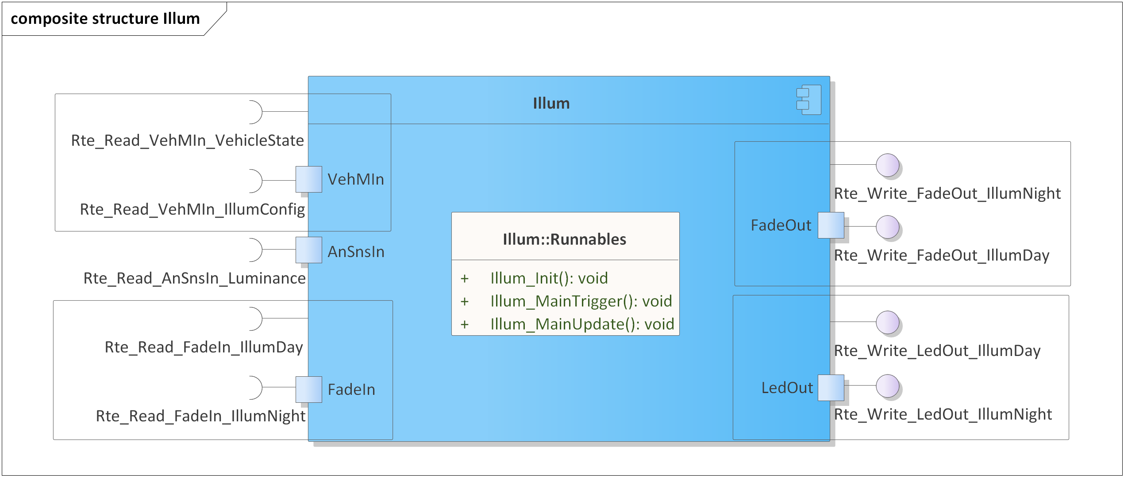

Figure 1 - Illum composite structure diagram.

1. The Illum SWC shall implement the illumination requirements as described in chapter 4.5 from the System Requirements.
2. The Illum SWC shall be implemented in two C files: *Illum.h* for exporting all the runnables, and *Illum.c* for implementing the runnables.
3. The Illum SWC shall implement the *void Illum_Init(void)* runnable for initializing all the internal static and global variables.
4. The Illum SWC shall implement the *void Illum_MainTrigger(void)* runnable for:

* Reading the ambient luminance through *Rte_Read_AnSnsIn_Luminance()*.
* Averaging the read ambient luminance.
* Reading the current illumination configuration through *Rte_Read_VehMIn_IllumConfig()*.
* Identifying fading triggers based on the modifications in the ambient luminance and starting fading jobs through *Rte_Write_FadeOut_*()* with fading times depending on the read illumination configuration.

1. The Illum SWC shall implement the *void Illum_MainUpdate(void)* runnable for reading the current status of the fading jobs, through *Rte_Read_FadeIn_*()* and updating the duty cycles of the illumination LEDs, through *Rte_Write_LedOut_*()*, with the read fading levels*.*
2. The *Rte_Write_FadeOut_*()* start and target values and the *Rte_Write_LedOut_*()* duty cycle values shall be in the [0, 10000] interval, representing PWM duty cycle percentages with two decimals.
3. The Illum SWC shall include *Efx.h* and directly use the *Efx_MovingAverage_u16_u16()* functionfor averaging the ambient luminance.
4. The Illum SWC shall include *Ifx.h* and directly use the *Ifx_IntIpoCur_u16_u16()* function for calculating duty cycles based on the average luminance.
5. *Illum_MainUpdate()* and *Illum_MainTrigger()* shall execute only if the current vehicle state, read through *Rte_Read_VehMIn_VehicleState()*, is RTE_VEHICLE_STATE_NORMAL.

# Information about this Document

## Copyright

All rights, including translation rights, are reserved. Under no circumstances shall any fragment of this document be reproduced without written authorization from NTT DATA Romania S.A, including copying, photographing or replicating through other methods.

Copyright (c) NTT DATA Romania S.A.

## Version Index

|  |  |  |  |  |
| --- | --- | --- | --- | --- |
| **Version** | **Date** | **Author** | **Chapter** | **Modification description** |
| 1.0 | 10.07.2021 | Nicolae-Bogdan Bacrău | All | Created. |

Table 2 - Version Index.