**Steer Software Design**

***SteerTurnIllum***



|  |  |  |
| --- | --- | --- |
| Author: |  | Nicolae-Bogdan Bacrău |
| Version: |  | 1.0 |

Index

1 Glossary 3

2 Introduction 4

2.1 Purpose of the Document 4

2.2 Overview 4

3 Design Requirements 5

4 Information about this Document 7

4.1 Copyright 7

4.2 Version Index 7

# Glossary

This section contains a glossary of all the important terms and acronyms used inside the document.

|  |  |
| --- | --- |
| **Term / Acronym** | **Description** |
| AUTOSAR | AUTomotive Open System ARchitecture |
| VFB | Virtual Functional Bus |
| SWC | Software Component |
| RTE | Runtime Environment |
| BSW | Basic Software |
| OS | Operating System |
| S/R | Sender / Receiver |
| C/S | Client / Server |
| ECU | Electronic Control Unit |
| uC | Microcontroller |
| ADC | Analog Digital Converter |
| DIO | Digital Input / Output |
| PWM | Pulse Width Modulation |

Table 1 - Glossary.

# Introduction

## Purpose of the Document

The purpose of the document is to define the software design of the ***Steer*** SWC for the ***SteerTurnIllum*** embedded academy project.

## Overview

The ***Steer*** SWC implements the control of the steering servomotors based on the movements of the steering joystick and the control of the steering horn based on the presses of the horn button.

# Design Requirements

1. The Steer SWC shall adhere to the structure illustrated in the composite structure diagram from **Figure 1**.

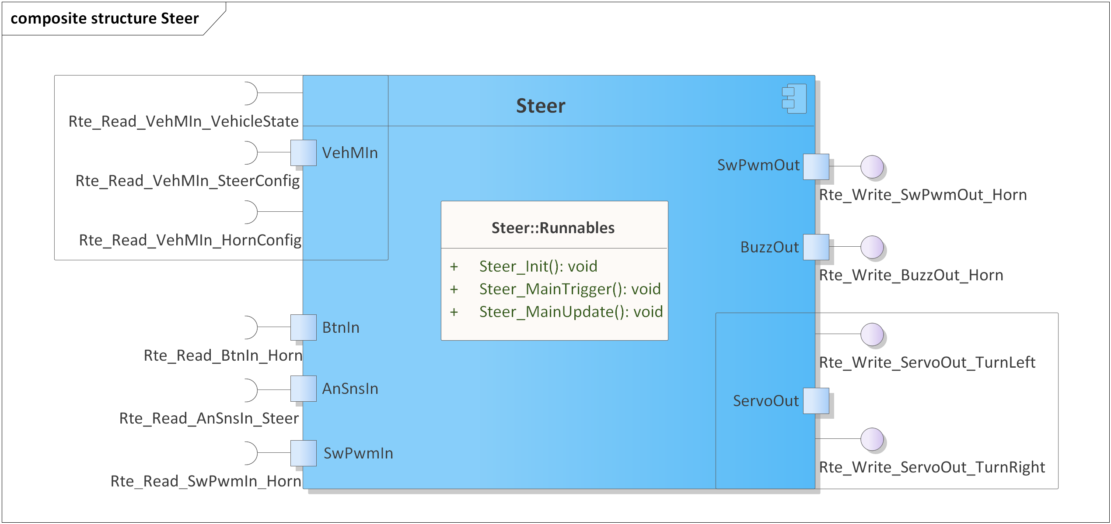

Figure 1 - Steer composite structure diagram.

1. The Steer SWC shall implement the steering requirements as described in chapter 4.3 from the System Requirements.
2. The Steer SWC shall be implemented in two C files: *Steer.h* for exporting all the runnables, and *Steer.c* for implementing the runnables.
3. The Steer SWC shall implement the *void Steer_Init(void)* runnable for initializing all the internal static and global variables.
4. The Steer SWC shall implement the *void Steer_MainTrigger(void)* runnable for:

* Reading the press state of the horn button through *Rte_Read_BtnIn_Horn()*.
* Reading the current horn configuration through *Rte_Read_VehMIn_HornConfig()*.
* If the horn button is pressed, process horn activation based on the read horn configuration:
  + RTE_HORN_MODE_CONTINUOUS: set horn state to STEER_HORN_CONTROL_CONTINUOUS.
  + RTE_HORN_MODE_BEEPING: set horn state to STEER_HORN_CONTROL_BEEPING and trigger continuous SwPwm job through *Rte_Write_SwPwmOut_Horn().*
* If the horn button is not pressed, set horn state to STEER_HORN_CONTROL_MUTE.

1. The Steer SWC shall implement the *void Steer_MainUpdate(void)* runnable for:

* Controlling the buzzer activation, through *Rte_Write_BuzzOut_Horn()*, based on the current horn state:
  + STEER_HORN_CONTROL_MUTE: apply RTE_BUZZ_OFF.
  + STEER_HORN_CONTROL_CONTINUOUS: apply RTE_BUZZ_ON.
  + STEER_HORN_CONTROL_BEEPING: read and apply current value from the SwPwm job, through *Rte_Read_SwPwmIn_Horn()*.
* Reading the current steering configuration through *Rte_Read_VehMIn_SteerConfig()*.
* Reading the current steering joystick position through *Rte_Read_AnSnsIn_Steer()*.
* Calculate the inner and outer angles of the servomotors based on the current steering configuration and current position of the steering joystick.
* Transform the calculated inner and outer angles in absolute angles and set them through *Rte_Write_ServoOut_*().*

1. The *Rte_Write_ServoOut_*()* absolute angle values shall be in the [0 ... 18000] interval, representing desired angles with two decimals (0 meaning pointing right, 9000 meaning pointing forward and 18000 meaning pointing left).
2. *Steer_MainUpdate()* and *Steer_MainTrigger()* shall execute only if the current vehicle state, read through *Rte_Read_VehMIn_VehicleState()*, is RTE_VEHICLE_STATE_NORMAL.

# Information about this Document

## Copyright

All rights, including translation rights, are reserved. Under no circumstances shall any fragment of this document be reproduced without written authorization from NTT DATA Romania S.A, including copying, photographing or replicating through other methods.

Copyright (c) NTT DATA Romania S.A.

## Version Index

|  |  |  |  |  |
| --- | --- | --- | --- | --- |
| **Version** | **Date** | **Author** | **Chapter** | **Modification description** |
| 1.0 | 10.07.2021 | Nicolae-Bogdan Bacrău | All | Created. |

Table 2 - Version Index.