**SwPwm Software Design**

***SteerTurnIllum***



|  |  |  |
| --- | --- | --- |
| Author: |  | Nicolae-Bogdan Bacrău |
| Version: |  | 1.0 |

Index

1 Glossary 3

2 Introduction 4

2.1 Purpose of the Document 4

2.2 Overview 4

3 Design Requirements 5

4 Information about this Document 7

4.1 Copyright 7

4.2 Version Index 7

# Glossary

This section contains a glossary of all the important terms and acronyms used inside the document.

|  |  |
| --- | --- |
| **Term / Acronym** | **Description** |
| AUTOSAR | AUTomotive Open System ARchitecture |
| VFB | Virtual Functional Bus |
| SWC | Software Component |
| RTE | Runtime Environment |
| BSW | Basic Software |
| OS | Operating System |
| S/R | Sender / Receiver |
| C/S | Client / Server |
| ECU | Electronic Control Unit |
| uC | Microcontroller |
| ADC | Analog Digital Converter |
| DIO | Digital Input / Output |
| PWM | Pulse Width Modulation |

Table 1 - Glossary.

# Introduction

## Purpose of the Document

The purpose of the document is to define the software design of the ***SwPwm*** SWC for the ***SteerTurnIllum*** embedded academy project.

## Overview

The ***SwPwm*** SWC generates software PWMs by keeping track of the elapsed time through a cyclic task. It is able to generate continuous software PWMs (generated until specifically stopped) and finite software PWMs (automatic stop after a given number of periods).

SwPwm is an application SWC, so it has no access to MCAL resources for writing actual signals. It just provides digital software output values to be used for generating actual signals.

# Design Requirements

1. The SwPwm SWC shall adhere to the structure illustrated in the composite structure diagram from **Figure 1**.

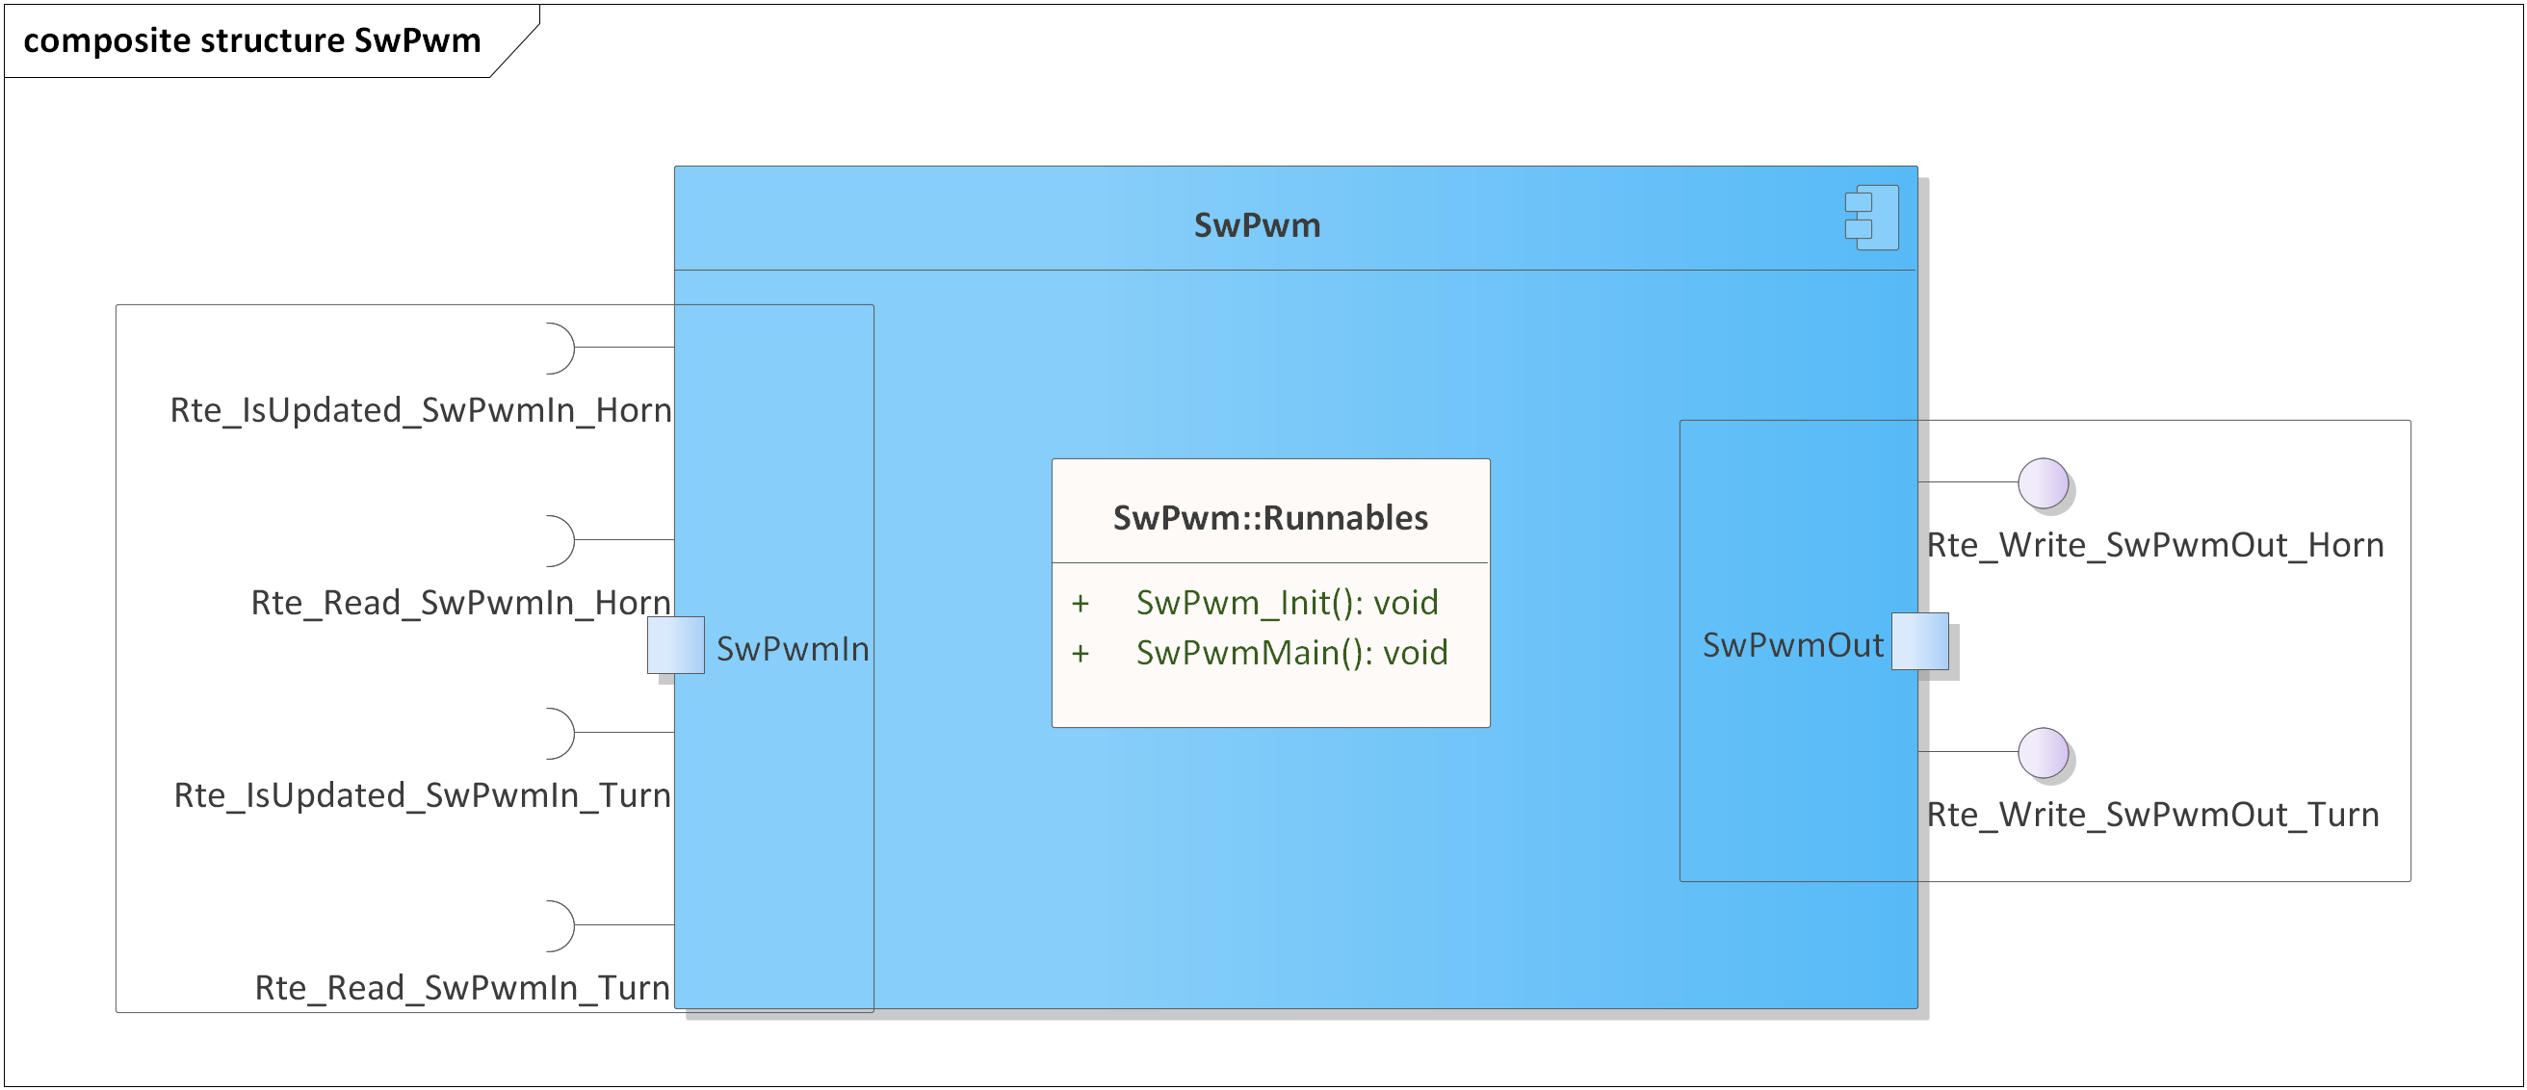

Figure 1 - SwPwm composite structure diagram.

1. The SwPwm SWC shall adhere to the SWC file structure template from 4_Engineering\1_Software\2_Development\1_Sources\8_Templates\Swc\Code.
2. The SwPwm SWC shall contain the following configuration parameters:

* In *SwPwm_Cfg.h*:
  + *SWPWM_MAIN_PERIODICITY_US*: macro defining the periodicity of the main function in microseconds.
  + *SWPWM_NUMBER_OF_INSTANCES*: macro defining the number of software PWM instances to be processed in the main function.
  + *SWPWM_*_INSTANCE*: zero based macros defining unique IDs of all the software PWM instances, needed for the interaction between the core and RTE.
* In *SwPwm_Cfg.c*:
  + *Rte_SwPwmLevelType SwPwm_gkat_Config*[SWPWM_NUMBER_OF_INSTANCES]: internal global constant array defining the active values to be used at the start of each period (*STD_HIGH* or *STD_LOW*) for all the software PWM instances.

1. The SwPwm SWC shall implement the *void SwPwm_Init(void)* runnable for initializing all the internal static and global variables.
2. The SwPwm SWC shall implement the *void SwPwm_Main(void)* runnable for implementing the processing of all the software PWM jobs as follows:

* Checks if the software PWM input control data elements have been updated, through *Rte_IsUpdated_SwPwmIn_*(),* and, if true, reads the input control data through *Rte_Read_SwPwmIn_*()* and starts a new job for that channel.
* If a job is ongoing, updates the output status data and writes it to RTE through *Rte_Write_PwmOut_*()*.
* If a job is ongoing and the input control data has been updated, the current job shall be aborted and a new one shall be started with the new data.
* Depending on the input control data, the behavior shall be as follows:
  + *RTE_SWPWM_OFF*: continuously reporting the output level as the inverse of the configured active level and the number of periods left always set to 0.
  + *RTE_SWPWM_ON_CONTINUOUS*: keeping track of the elapsed time and continuously generating the output level according to the configured active level, the input control period and the active time, while the number of periods left is always set to 0.
  + *RTE_SWPWM_FINITE*: keeping track of the elapsed time, generating the output according to the configured active level, the input control period and the active time, and automatically switching to RTE_SWPWM_OFF after the number of periods left reaches 0.

# Information about this Document

## Copyright

All rights, including translation rights, are reserved. Under no circumstances shall any fragment of this document be reproduced without written authorization from NTT DATA Romania S.A, including copying, photographing or replicating through other methods.

Copyright (c) NTT DATA Romania S.A.

## Version Index

|  |  |  |  |  |
| --- | --- | --- | --- | --- |
| **Version** | **Date** | **Author** | **Chapter** | **Modification description** |
| 1.0 | 10.07.2021 | Nicolae-Bogdan Bacrău | All | Created. |

Table 2 - Version Index.