**AnSns Software Design**

***SteerTurnIllum***



|  |  |  |
| --- | --- | --- |
| Author: |  | Nicolae-Bogdan Bacrău |
| Version: |  | 1.0 |

Index

1 Glossary 3

2 Introduction 4

2.1 Purpose of the Document 4

2.2 Overview 4

3 Design Requirements 5

4 Information about this Document 7

4.1 Copyright 7

4.2 Version Index 7

# Glossary

This section contains a glossary of all the important terms and acronyms used inside the document.

|  |  |
| --- | --- |
| **Term / Acronym** | **Description** |
| AUTOSAR | AUTomotive Open System ARchitecture |
| VFB | Virtual Functional Bus |
| SWC | Software Component |
| RTE | Runtime Environment |
| BSW | Basic Software |
| OS | Operating System |
| S/R | Sender / Receiver |
| C/S | Client / Server |
| ECU | Electronic Control Unit |
| uC | Microcontroller |
| ADC | Analog Digital Converter |
| DIO | Digital Input / Output |
| PWM | Pulse Width Modulation |

Table 1 - Glossary.

# Introduction

## Purpose of the Document

The purpose of the document is to define the software design of the ***AnSns*** SWC for the ***SteerTurnIllum*** embedded academy project.

## Overview

The ***AnSns*** SWC implements the reading, filtering and conversion to units of measurement of all the analog input sensors.

# Design Requirements

1. The AnSns SWC shall adhere to the structure illustrated in the composite structure diagram from **Figure 1**.

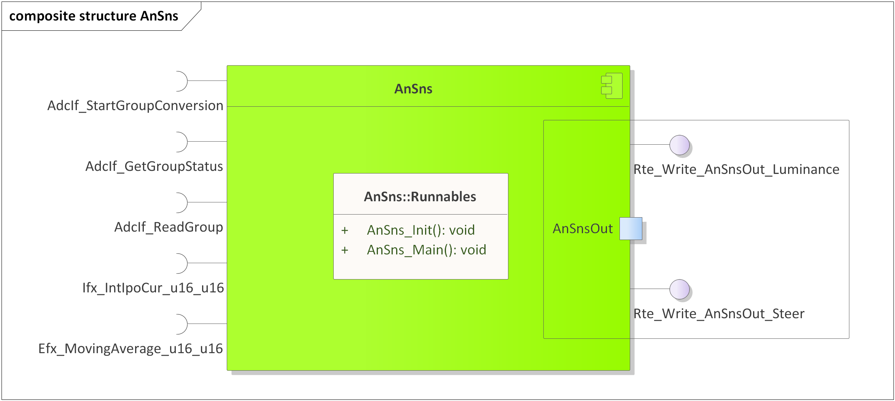

Figure 1 - AnSns composite structure diagram.

1. The AnSns SWC shall assure a moving average filtering according to [SYRE_GEN_12] from the System Requirements.
2. The AnSns SWC shall adhere to the SWC file structure template from 4_Engineering\1_Software\2_Development\1_Sources\8_Templates\Swc\Code.
3. The AnSns SWC shall contain the following configuration parameters:

* In *AnSns_Cfg.h*:
  + *ANSNS_NUMBER_OF_INSTANCES*: macro defining the number of sensor instances to be processed in the main function.
  + *ANSNS_*_INSTANCE*: zero based macros defining unique IDs of all the sensor instances, needed for the interaction between the core and RTE.
* In *AnSns_Cfg.c*:
  + *AnSns_gkat_Config*[ANSNS_NUMBER_OF_INSTANCES]: internal global constant array defining the EFX configuration, IFX configuration and the AdcIf channel for all the sensor instances.

1. The AnSns SWC shall implement the *void AnSns_Init(void)* runnable for initializing all the internal static and global variables and performing sequential ADC readings for filling in all the Efx moving average buffers.
2. The AnSns SWC shall implement the *void AnSns_Main(void)* runnable for implementing the processing of all the sensor instances as follows:
   * Reads the ADCs for all sensor instances.
   * Filters the read ADC values through an EFX moving average.
   * Converts from ADC ticks units of measurements through IFX interpolations.
   * Writes the filtered sensors status to the RTE through *Rte_Write_AnSnsOut_*()*.
3. All ADC readings of the analog channels shall be synchronous, using the following sequence:

AdcIf_StartGroupConversion(t_AdcGroup);

while (ADCIF_BUSY == AdcIf_GetGroupStatus(t_AdcGroup))

{

/* Wait for the conversion to finish. */

}

(void) AdcIf_ReadGroup(t_AdcGroup, &t_AdcValue);

1. The AnSns SWC shall include *AdcIf.h* and directly use the *AdcIf_SetupResultBuffer(), AdcIf_StartGroupConversion()* and *AdcIf_GetGroupStatus()* functionsfor reading the ADCs.
2. The AnSns SWC shall include *Efx.h* and directly use the *Efx_MovingAverage_u16_u16()* functionfor averaging the sensors data.
3. The AnSns SWC shall include *Ifx.h* and directly use the *Ifx_IntIpoCur_u16_u16()* function for transforming from ADC values to units of measurement.
4. The *Rte_Write_AnSnsOut_Steer()* data shall be in the [0, 10000] interval, representing steering stick position in percentages with two decimals. The position values shall adhere to [SYRE_GEN_3] from the System Requirements.
5. The *Rte_Write_AnSnsOut_Luminance()* data shall be in the [0, 10000] interval, representing luminance percentages with two decimals, the most counter-clockwise position of the potentiometer representing 0% luminance and the most clockwise position of the potentiometer representing 100% luminance.

# Information about this Document

## Copyright

All rights, including translation rights, are reserved. Under no circumstances shall any fragment of this document be reproduced without written authorization from NTT DATA Romania S.A, including copying, photographing or replicating through other methods.

Copyright (c) NTT DATA Romania S.A.

## Version Index

|  |  |  |  |  |
| --- | --- | --- | --- | --- |
| **Version** | **Date** | **Author** | **Chapter** | **Modification description** |
| 1.0 | 10.07.2021 | Nicolae-Bogdan Bacrău | All | Created. |

Table 2 - Version Index.