**Disp7Seg Software Design**

***SteerTurnIllum***



|  |  |  |
| --- | --- | --- |
| Author: |  | Nicolae-Bogdan Bacrău |
| Version: |  | 1.0 |

Index

1 Glossary 3

2 Introduction 4

2.1 Purpose of the Document 4

2.2 Overview 4

3 Design Requirements 5

4 Information about this Document 7

4.1 Copyright 7

4.2 Version Index 7

# Glossary

This section contains a glossary of all the important terms and acronyms used inside the document.

|  |  |
| --- | --- |
| **Term / Acronym** | **Description** |
| AUTOSAR | AUTomotive Open System ARchitecture |
| VFB | Virtual Functional Bus |
| SWC | Software Component |
| RTE | Runtime Environment |
| BSW | Basic Software |
| OS | Operating System |
| S/R | Sender / Receiver |
| C/S | Client / Server |
| ECU | Electronic Control Unit |
| uC | Microcontroller |
| ADC | Analog Digital Converter |
| DIO | Digital Input / Output |
| PWM | Pulse Width Modulation |

Table 1 - Glossary.

# Introduction

## Purpose of the Document

The purpose of the document is to define the software design of the ***Disp7Seg*** SWC for the ***SteerTurnIllum*** embedded academy project.

## Overview

The ***Disp7Seg*** SWC implements the control of dual 7 segments displays, providing a simple interface for displaying numerical digits.

# Design Requirements

1. The Disp7Seg SWC shall adhere to the structure illustrated in the composite structure diagram from **Figure 1**.

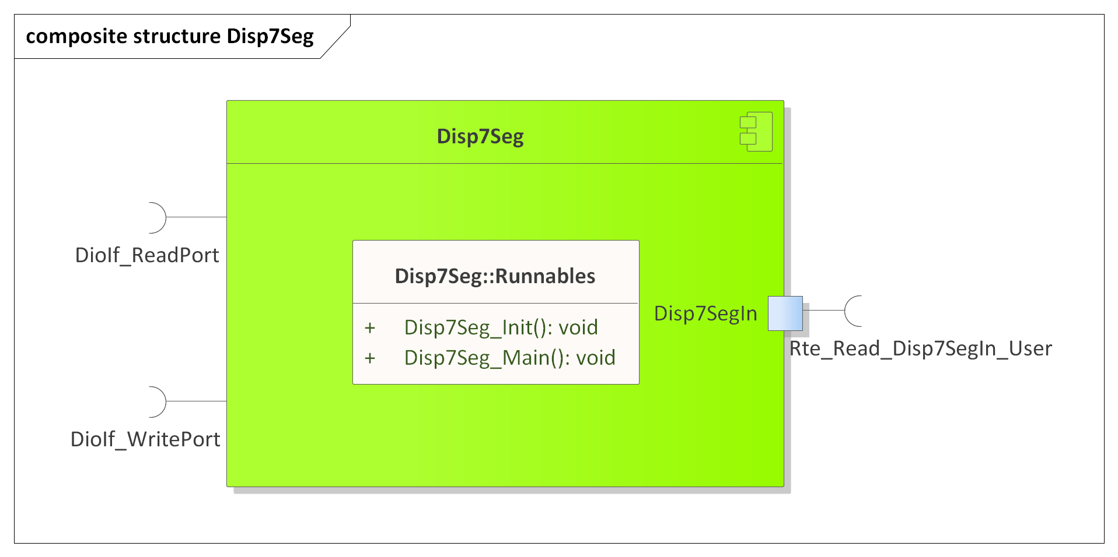

Figure 1 - Disp7Seg composite structure diagram.

1. The Disp7Seg SWC shall adhere to the SWC file structure template from 4_Engineering\1_Software\2_Development\1_Sources\8_Templates\Swc\Code.
2. The Disp7Seg SWC shall contain the following configuration parameters:

* In *Disp7Seg_Cfg.h*:
  + *DISP7SEG_NUMBER_OF_INSTANCES*: macro defining the number of 7 segments display instances to be processed in the main function.
  + *DISP7SEG_*_INSTANCE*: zero based macros defining unique IDs of all the 7 segments display instances, needed for the interaction between the core and RTE.
* In *Disp7Seg_Cfg.c*:
  + *Disp7Seg_gkat_Config*[DISP7SEG_NUMBER_OF_INSTANCES]: internal global constant array defining masks for displaying the left and right digits and the DioIf port channels for the two digits.

1. The Disp7Seg SWC shall implement the *void Disp7Seg_Init(void)* runnable for initializing all the internal static and global variables and setting all the display segments off through *DioIf_WritePort()*.
2. The Disp7Seg SWC shall implement the *void Disp7Seg_Main(void)* runnable for implementing the processing of all the 7 segments display instances as follows:
   * Reads the 7 segments display input control data, the number to be displayed (values in the [0, 100] interval) and the state of the dots, through *Rte_Read_Disp7SegIn_*()*.
   * Reads the current port values of the left and right digits through *DioIf_ReadPort()*.
   * Calculates the value of each display digit based on the read input control data number to be displayed, and, also depending on the read input control data dots state, uses the configured masks for each digit for writing the digits DioIf ports through *DioIf_WritePort()*. Writing back to the ports shall modify only the pins that are configured for the displays (all the other pins from the impacted ports shall remain unchanged).
3. The Disp7Seg SWC shall include *DioIf.h* and directly use the *DioIf_ReadPort()* and *DioIf_WritePort()* functionsfor updating the display DioIf ports.

# Information about this Document

## Copyright

All rights, including translation rights, are reserved. Under no circumstances shall any fragment of this document be reproduced without written authorization from NTT DATA Romania S.A, including copying, photographing or replicating through other methods.

Copyright (c) NTT DATA Romania S.A.

## Version Index

|  |  |  |  |  |
| --- | --- | --- | --- | --- |
| **Version** | **Date** | **Author** | **Chapter** | **Modification description** |
| 1.0 | 10.07.2021 | Nicolae-Bogdan Bacrău | All | Created. |

Table 2 - Version Index.