**Led Software Design**

***SteerTurnIllum***



|  |  |  |
| --- | --- | --- |
| Author: |  | Nicolae-Bogdan Bacrău |
| Version: |  | 1.0 |

Index

1 Glossary 3

2 Introduction 4

2.1 Purpose of the Document 4

2.2 Overview 4

3 Design Requirements 5

4 Information about this Document 7

4.1 Copyright 7

4.2 Version Index 7

# Glossary

This section contains a glossary of all the important terms and acronyms used inside the document.

|  |  |
| --- | --- |
| **Term / Acronym** | **Description** |
| AUTOSAR | AUTomotive Open System ARchitecture |
| VFB | Virtual Functional Bus |
| SWC | Software Component |
| RTE | Runtime Environment |
| BSW | Basic Software |
| OS | Operating System |
| S/R | Sender / Receiver |
| C/S | Client / Server |
| ECU | Electronic Control Unit |
| uC | Microcontroller |
| ADC | Analog Digital Converter |
| DIO | Digital Input / Output |
| PWM | Pulse Width Modulation |

Table 1 - Glossary.

# Introduction

## Purpose of the Document

The purpose of the document is to define the software design of the ***Led*** SWC for the ***SteerTurnIllum*** embedded academy project.

## Overview

The ***Led*** SWC implements an unitary control interface for LEDs that are connected to DIO and PWM channels.

# Design Requirements

1. The Led SWC shall adhere to the structure illustrated in the composite structure diagram from **Figure 1**.

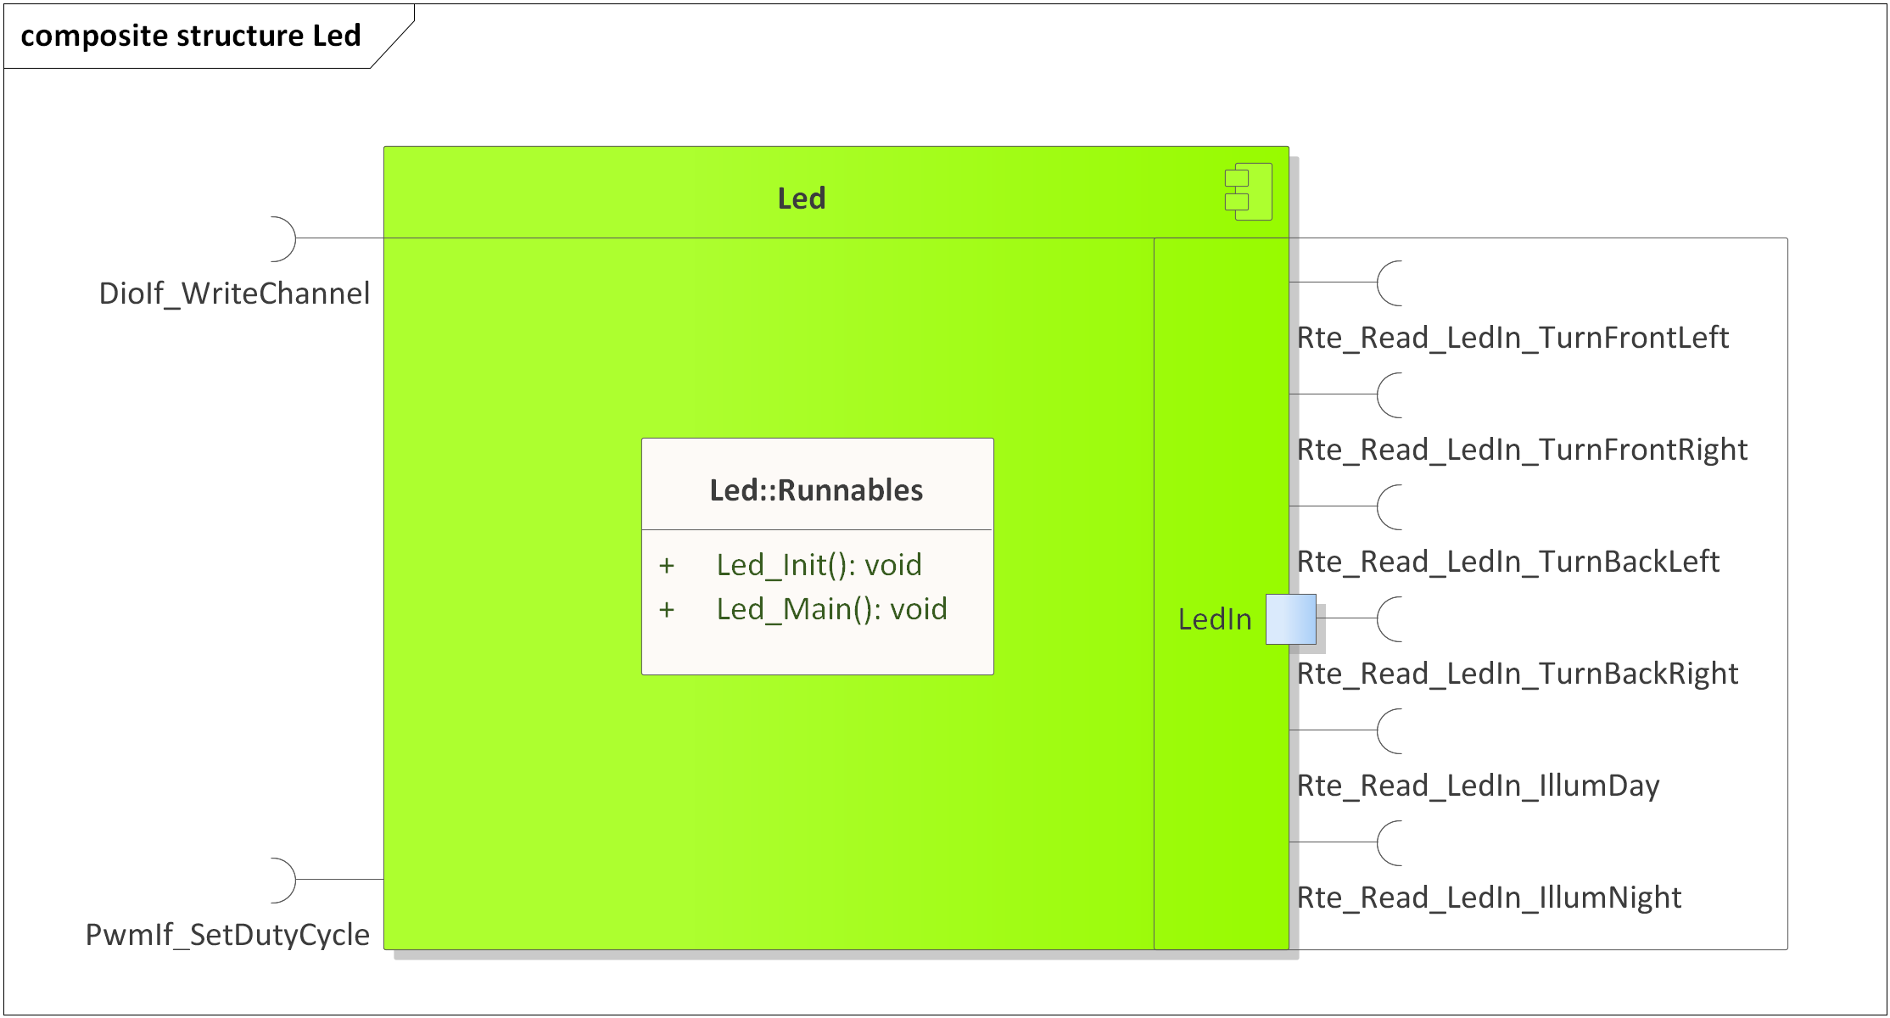

Figure 1 - Led composite structure diagram.

1. The Led SWC shall adhere to the SWC file structure template from 4_Engineering\1_Software\2_Development\1_Sources\8_Templates\Swc\Code.
2. The Led SWC shall contain the following configuration parameters:

* In *Led_Cfg.h*:
  + *LED_DIO_NUMBER_OF_INSTANCES*: macro defining the number of DIO LED instances to be processed in the main function.
  + *LED_DIO_*_INSTANCE*: zero based macros defining unique IDs of all the DIO LED instances, needed for the interaction between the core and RTE.
  + *LED_PWM_NUMBER_OF_INSTANCES*: macro defining the number of PWM LED instances to be processed in the main function.
  + *LED_PWM_*_INSTANCE*: zero based macros defining unique IDs of all the PWM LED instances, needed for the interaction between the core and RTE.
* In *Led_Cfg.c*:
  + *Led_gkat_DioConfig*[LED_DIO_NUMBER_OF_INSTANCES]: internal global constant array defining the DioIf channels and active levels (STD_HIGH or STD_LOW) for all DIO LED instances.
  + *Led_gkat_PwmConfig*[LED_PWM_NUMBER_OF_INSTANCES]: internal global constant array defining the PwmIf channels and active levels (PWMIF_HIGH or PWMIF_LOW) for all PWM LED instances.

1. The Led SWC shall implement the *void Led_Init(void)* runnable for initializing all the internal static and global variables and turning off all the LEDs through *DioIf_WriteChannel()* and *PwmIf_SetDutyCycle()*.
2. The Led SWC shall implement the *void Led_Main(void)* runnable for implementing the processing of all the LED instances as follows:
   * Reads the LED input control data through *Rte_Read_LedIn_*()*.
   * For DIO LEDs, depending on the LED state input state control data and on the configured active levels turns the LEDs ON if the state is RTE_LED_ON or OFF if the state RTE_LED_OFF, through *DioIf_WriteChannel()*. Any other input states shall be ignored. The duty cycle from the input control data shall be ignored.

* For PWM LEDs:
  + Transforms the duty cycle input control data from the [0, 10000] interval to the AUTOSAR duty cycle format in the [0, 0x8000] interval.
  + If the LED state input control data is RTE_LED_ON applies the calculated duty cycle or 0x8000 minus the calculated duty cycle, depending on the configured active level, through *PwmIf_SetDutyCycle().*
  + If the LED state input control data is RTE_LED_OFF applies 0 or 0x8000 duty cycle, depending on the configured active level, through *PwmIf_SetDutyCycle().*
  + Duty cycle inputs > 10000 and state inputs different than RTE_LED_ON and RTE_LED_OFF shall be ignored.

1. The Led SWC shall include *DioIf.h* and directly use the *DioIf_WriteChannel()* functionfor writing the DioIf channels of the DIO LEDs.
2. The Led SWC shall include *PwmIf.h* and directly use the *PwmIf_SetDutyCycle()* functionfor writing the PwmIf channels of the PWM LEDs.

# Information about this Document

## Copyright

All rights, including translation rights, are reserved. Under no circumstances shall any fragment of this document be reproduced without written authorization from NTT DATA Romania S.A, including copying, photographing or replicating through other methods.

Copyright (c) NTT DATA Romania S.A.

## Version Index

|  |  |  |  |  |
| --- | --- | --- | --- | --- |
| **Version** | **Date** | **Author** | **Chapter** | **Modification description** |
| 1.0 | 10.07.2021 | Nicolae-Bogdan Bacrău | All | Created. |

Table 2 - Version Index.