**Servo Software Design**

***SteerTurnIllum***



|  |  |  |
| --- | --- | --- |
| Author: |  | Nicolae-Bogdan Bacrău |
| Version: |  | 1.0 |

Index

1 Glossary 3

2 Introduction 4

2.1 Purpose of the Document 4

2.2 Overview 4

3 Design Requirements 5

4 Information about this Document 7

4.1 Copyright 7

4.2 Version Index 7

# Glossary

This section contains a glossary of all the important terms and acronyms used inside the document.

|  |  |
| --- | --- |
| **Term / Acronym** | **Description** |
| AUTOSAR | AUTomotive Open System ARchitecture |
| VFB | Virtual Functional Bus |
| SWC | Software Component |
| RTE | Runtime Environment |
| BSW | Basic Software |
| OS | Operating System |
| S/R | Sender / Receiver |
| C/S | Client / Server |
| ECU | Electronic Control Unit |
| uC | Microcontroller |
| ADC | Analog Digital Converter |
| DIO | Digital Input / Output |
| PWM | Pulse Width Modulation |

Table 1 - Glossary.

# Introduction

## Purpose of the Document

The purpose of the document is to define the software design of the ***Servo*** SWC for the ***SteerTurnIllum*** embedded academy project.

## Overview

The ***Servo*** SWC implements a simple control interface, through transforming from degrees into PWM duty cycles, for positioning servomotors.

# Design Requirements

1. The Servo SWC shall adhere to the structure illustrated in the composite structure diagram from **Figure 1**.

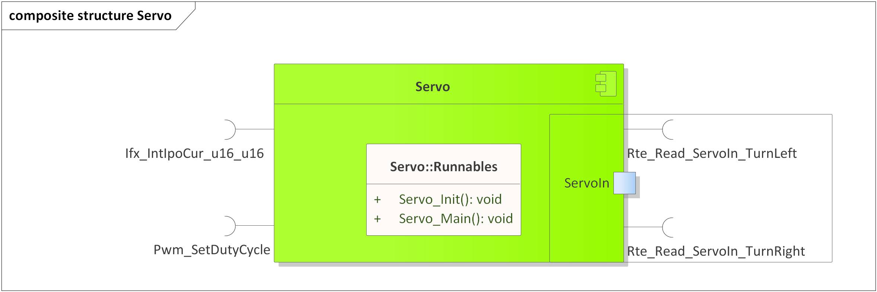

Figure 1 - Servo composite structure diagram.

1. The Servo SWC shall adhere to the SWC file structure template from 4_Engineering\1_Software\2_Development\1_Sources\8_Templates\Swc\Code.
2. The Servo SWC shall contain the following configuration parameters:

* In *Servo_Cfg.h*:
  + *SERVO_NUMBER_OF_INSTANCES*: macro defining the number of servomotor instances to be processed in the main function.
  + *SERVO_*_INSTANCE*: zero based macros defining unique IDs of all the servomotor instances, needed for the interaction between the core and RTE.
* In *Servo_Cfg.c*:
  + *Servo_gkat_Config*[SERVO_NUMBER_OF_INSTANCES]: internal global constant array defining the configuration of Ifx degrees to PWM duty cycles interpolation curves and PwmIf channels for all servomotor instances. The Ifx configuration shall contain at least 3 points: 0 degrees, 90 degrees and 180 degrees.

1. The Servo SWC shall implement the *void Servo_Init(void)* runnable for initializing all the internal static and global variables and setting the servomotors to point forwards through *Pwm_SetDutyCycle()*.
2. The Servo SWC shall implement the *void Servo_Main(void)* runnable for implementing the processing of all the servomotor instances as follows:
   * Reads the servomotor degrees input control data through *Rte_Read_ServoIn_*()*.

* Converts from degrees input in the [0, 18000] interval (0 - pointing right, 9000 - pointing forward, 18000 - pointing left), to [3 ... 12] % PWM duty cycles, through Ifx interpolations, and applies them to the servomotor PwmIf channels through *PwmIf_SetDutyCycle().* Degrees inputs > 18000 shall be ignored.

*Note*: in the servomotor datasheet the [5 ... 10] % PWM duty cycle control interval is specified, but this interval is not enough for reaching 180 degrees.

1. The Servo SWC shall include *PwmIf.h* and directly use the *PwmIf_SetDutyCycle()* functionfor writing the PwmIf channels of the servomotors.
2. The Servo SWC shall include *Ifx.h* and directly use the *Ifx_IntIpoCur_u16_u16()* function for transforming from degrees to PWM duty cycles.

# Information about this Document

## Copyright

All rights, including translation rights, are reserved. Under no circumstances shall any fragment of this document be reproduced without written authorization from NTT DATA Romania S.A, including copying, photographing or replicating through other methods.

Copyright (c) NTT DATA Romania S.A.

## Version Index

|  |  |  |  |  |
| --- | --- | --- | --- | --- |
| **Version** | **Date** | **Author** | **Chapter** | **Modification description** |
| 1.0 | 10.07.2021 | Nicolae-Bogdan Bacrău | All | Created. |

Table 2 - Version Index.