**Mcu Software Design**

***SteerTurnIllum***

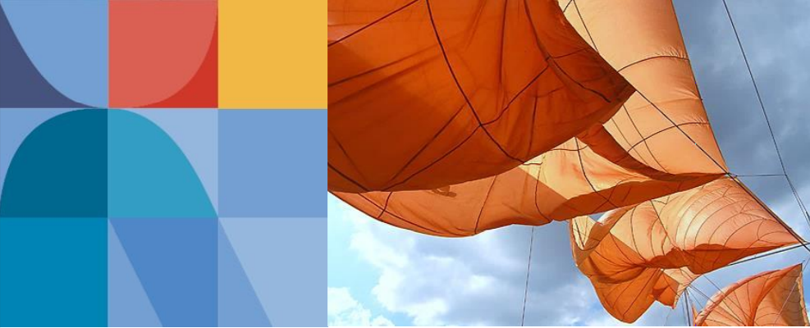

|  |  |  |
| --- | --- | --- |
| Author: |  | Nicolae-Bogdan Bacrău |
| Version: |  | 1.0 |

Index

1 Glossary 3

2 Introduction 4

2.1 Purpose of the Document 4

2.2 Overview 4

3 Design Requirements 5

4 Information about this Document 6

4.1 Copyright 6

4.2 Version Index 6

# Glossary

This section contains a glossary of all the important terms and acronyms used inside the document.

|  |  |
| --- | --- |
| **Term / Acronym** | **Description** |
| AUTOSAR | AUTomotive Open System ARchitecture |
| VFB | Virtual Functional Bus |
| SWC | Software Component |
| RTE | Runtime Environment |
| BSW | Basic Software |
| OS | Operating System |
| S/R | Sender / Receiver |
| C/S | Client / Server |
| ECU | Electronic Control Unit |
| uC | Microcontroller |
| ADC | Analog Digital Converter |
| DIO | Digital Input / Output |
| PWM | Pulse Width Modulation |

Table 1 - Glossary.

# Introduction

## Purpose of the Document

The purpose of the document is to define the software design of the ***Mcu*** driver for the ***SteerTurnIllum*** embedded academy project.

## Overview

While the AUTOSAR ***Mcu*** module is complex and is usually configured via generators, in this project its purpose is limited to:

* Sets up system clock.
* Distributes clocks to peripherals (for enabling them).
* Initializes the stack.

# Design Requirements

1. The Mcu driver shall assure clocks to all the hardware peripherals that are configured in the other MCAL drivers (ADCs, GPIOs and TIMERs) through *Mcu_gkt_Config* from *Mcu_PBcfg.c*.The *Mcu_PBcfg.c.start* file shall be used as a starting point. The .start extension shall be removed for adding the file to the build process.

Note: This update should take place in parallel to the implementation of the Adc, Dio, Port and Pwm drivers.

# Information about this Document

## Copyright

All rights, including translation rights, are reserved. Under no circumstances shall any fragment of this document be reproduced without written authorization from NTT DATA Romania S.A, including copying, photographing or replicating through other methods.

Copyright (c) NTT DATA Romania S.A.

## Version Index

|  |  |  |  |  |
| --- | --- | --- | --- | --- |
| **Version** | **Date** | **Author** | **Chapter** | **Modification description** |
| 1.0 | 10.07.2021 | Nicolae-Bogdan Bacrău | All | Created. |

Table 2 - Version Index.