**Ifx Software Design**

***SteerTurnIllum***

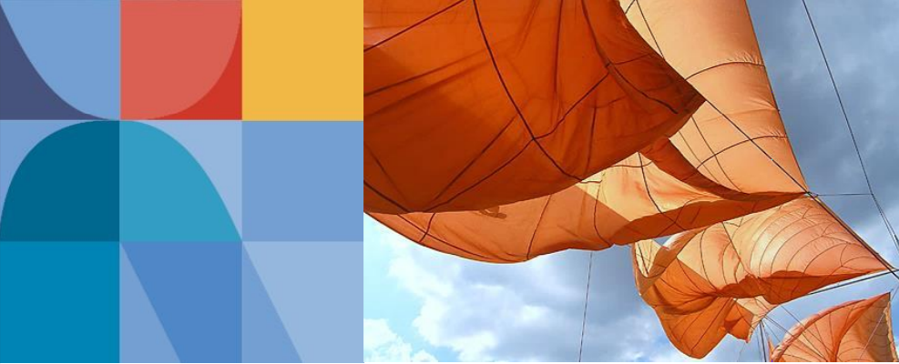

|  |  |  |
| --- | --- | --- |
| Author: |  | Nicolae-Bogdan Bacrău |
| Version: |  | 1.0 |

Index

1 Glossary 3

2 Introduction 4

2.1 Purpose of the Document 4

2.2 Overview 4

3 Design Requirements 5

4 Information about this Document 6

4.1 Copyright 6

4.2 Version Index 6

# Glossary

This section contains a glossary of all the important terms and acronyms used inside the document.

|  |  |
| --- | --- |
| **Term / Acronym** | **Description** |
| AUTOSAR | AUTomotive Open System ARchitecture |
| VFB | Virtual Functional Bus |
| SWC | Software Component |
| RTE | Runtime Environment |
| BSW | Basic Software |
| OS | Operating System |
| S/R | Sender / Receiver |
| C/S | Client / Server |
| ECU | Electronic Control Unit |
| uC | Microcontroller |
| ADC | Analog Digital Converter |
| DIO | Digital Input / Output |
| PWM | Pulse Width Modulation |

Table 1 - Glossary.

# Introduction

## Purpose of the Document

The purpose of the document is to define the software design of the ***Ifx*** library for the ***SteerTurnIllum*** embedded academy project.

## Overview

While the AUTOSAR ***Ifx*** library contains more methods, in this project it implements a single interface for performing linear interpolations on uint16 inputs and outputs.

# Design Requirements

1. The Ifx library shall be implemented according to AUTOSAR 4.3.1 specifications.
2. The Ifx library shall implement the following interfaces and all their required data types for performing linear interpolations on uint16 inputs and outputs (see “8.5.2.1 Integrated curve interpolation” on page 30):

* *Ifx_IntIpoCur_u16_u16();*

1. The Ifx library shall consist of the following files:

* *Ifx.c*: Implements all the required interfaces in a generic way.
* *Ifx*.*h*: Exports all the required interfaces and data types.

# Information about this Document

## Copyright

All rights, including translation rights, are reserved. Under no circumstances shall any fragment of this document be reproduced without written authorization from NTT DATA Romania S.A, including copying, photographing or replicating through other methods.

Copyright (c) NTT DATA Romania S.A.

## Version Index

|  |  |  |  |  |
| --- | --- | --- | --- | --- |
| **Version** | **Date** | **Author** | **Chapter** | **Modification description** |
| 1.0 | 10.07.2021 | Nicolae-Bogdan Bacrău | All | Created. |

Table 2 - Version Index.