**Hardware Architecture**

***SteerTurnIllum***



|  |  |  |
| --- | --- | --- |
| Author: |  | Nicolae-Bogdan Bacrău |
| Version: |  | 1.0 |

Index

1 Glossary 3

2 Introduction 4

2.1 Purpose of the Document 4

2.2 Overview 4

3 Schematic 5

4 Pin Configurations 7

5 Information about this Document 9

5.1 Copyright 9

5.2 Version index 9

# Glossary

This section contains a glossary of all the important terms and acronyms used inside the document.

|  |  |
| --- | --- |
| **Term / Acronym** | **Description** |
| ECU | Electronic Control Unit |
| uC | Microcontroller |
| PWM | Pulse Width Modulation |

Table - Glossary.

# Introduction

## Purpose of the Document

The purpose of the document is to define the hardware architecture of the ***SteerTurnIllum*** embedded academy project.

## Overview

The hardware architecture of ***SteerTurnIllum*** consists of the ECU schematic, which describes all the needed connections between the hardware components, and the microcontroller pin configurations which describes the pin modes and directions.

# Schematic

The ***SteerTurnIllum*** ECU shall contain the following general hardware components:

* 1 x STM32F4DISCOVERY development board based on a STM32F407VG uC: STM32F407G-DISC1.
* 1 x pair of STM32F4DISCOVERY development board to breadboard adapters (not visible in the schematic since they are just connectors).
* resistors for pull-up, pull-down topologies and for current limitation.
* breadboards and wires for connecting all the hardware components.

The ***SteerTurnIllum*** ECU shall contain the following input hardware components:

* 3 x buttons for controlling the turn signals: BTN_LEFT, BTN_RIGHT, BTN_HAZARD.
* 1 x joystick with incorporated button for controlling the servomotors and the horn: JOY_STEER. The incorporated button represents BTN_HORN.
* 1 x potentiometer for controlling the luminance: POT_LUMINANCE.

The ***SteerTurnIllum*** ECU shall contain the following output hardware components:

* 1 x buzzer for indicating the activation of the horn: BUZZ_HORN.
* 4 x yellow LEDs for indicating the turn signals: LED_TURN_FRONT_LEFT, LED_TURN_FRONT_RIGHT, LED_TURN_BACK_LEFT, LED_TURN_BACK_RIGHT.
* 2 x red LEDs for indicating the board illumination: LED_ILLUM_NIGHT, LED_ILLUM_DAY.
* 1 x dual 7 segments display for indicating the configuration states: DISP7SEG.
* 1 x CD4050B buffer for amplifying the servomotor PWM signals: CD4050B.
* 2 x servomotors for indicating the steering of the wheels: SERVO_TURN_LEFT, SERVO_TURN_RIGHT.

The schematic of the ECU is presented in **Figure 1**. The schematic is also available as a .pdf in the ./../2_Schematic folder.

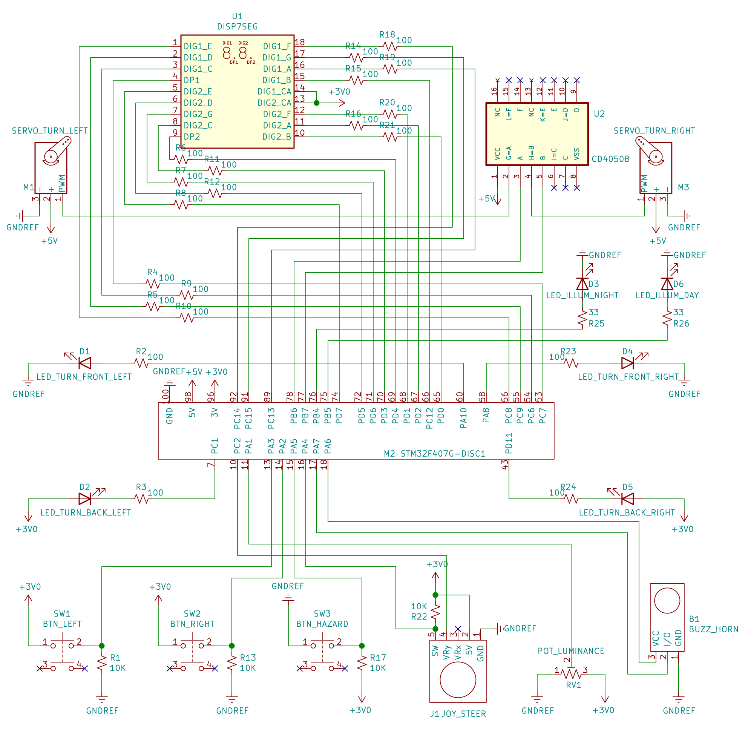Figure 1 – ECU schematic.

# Pin Configurations

The uC pin configurations that shall be used are presented in **Table 2**.

|  |  |  |  |
| --- | --- | --- | --- |
| Pin Name | Pin Mode | Pin Direction | Peripheral |
| PA3 | Digital | In | BTN_LEFT |
| PA2 | Digital | In | BTN_RIGHT |
| PA5 | Digital | In | BTN_HAZARD |
| PA4 | Digital | In | JOY_STEER |
| PA7 | Digital | Out | BUZZ_HORN |
| PA6 | Digital | Out | BUZZ_HORN |
| PA10 | Digital | Out | LED_TURN_FRONT_LEFT |
| PA8 | Digital | Out | LED_TURN_FRONT_RIGHT |
| PC1 | Digital | Out | LED_TURN_BACK_LEFT |
| PD11 | Digital | Out | LED_TURN_BACK_RIGHT |
| PD0 | Digital | Out | DISP7SEG |
| PD2 | Digital | Out | DISP7SEG |
| PD1 | Digital | Out | DISP7SEG |
| PC12 | Digital | Out | DISP7SEG |
| PC13 | Digital | Out | DISP7SEG |
| PC15 | Digital | Out | DISP7SEG |
| PC14 | Digital | Out | DISP7SEG |
| PD4 | Digital | Out | DISP7SEG |
| PD3 | Digital | Out | DISP7SEG |
| PD6 | Digital | Out | DISP7SEG |
| PD5 | Digital | Out | DISP7SEG |
| PD7 | Digital | Out | DISP7SEG |
| PC7 | Digital | Out | DISP7SEG |
| PC6 | Digital | Out | DISP7SEG |
| PC9 | Digital | Out | DISP7SEG |
| PC8 | Digital | Out | DISP7SEG |
| PA1 | Analog | In | POT_LUMINANCE |
| PC2 | Analog | In | POT_LUMINANCE |
| PB4 | PWM | Out | LED_ILLUM_NIGHT |
| PB5 | PWM | Out | LED_ILLUM_DAY |
| PB6 | PWM | Out | SERVO_TURN_LEFT |
| PB7 | PWM | Out | SERVO_TURN_RIGHT |

Table - Pin configurations.

# Information about this Document

## Copyright

All rights, including translation rights, are reserved. Under no circumstances shall any fragment of this document be reproduced without written authorization from NTT DATA Romania S.A, including copying, photographing or replicating through other methods.

Copyright (c) NTT DATA Romania S.A.

## Version Index

|  |  |  |  |  |
| --- | --- | --- | --- | --- |
| **Vers.** | **Date** | **Author** | **Chapter** | **Modification description** |
| 1.0 | 10.07.2021 | Nicolae-Bogdan Bacrău | All | Created. |

Table - Version Index.