Insert

1. INSERT INTO `table_mobil`(`id_mobil`, `warna_mobil`, `merk_mobil`, `plat_mobil`) VALUES ('','merah','brio','dd1405aw');
2. INSERT INTO `table_mobil`(`id_mobil`, `warna_mobil`, `merk_mobil`, `plat_mobil`) VALUES ('','biru','civic','dd 51 aw');
3. INSERT INTO `table_mobil`(`id_mobil`, `warna_mobil`, `merk_mobil`, `plat_mobil`) VALUES ('','hitam','civic','dd 78 aw');
4. INSERT INTO `table_mobil`(`id_mobil`, `warna_mobil`, `merk_mobil`, `plat_mobil`) VALUES ('','putih','civic','dd50aw');
5. INSERT INTO `table_mobil`(`id_mobil`, `warna_mobil`, `merk_mobil`, `plat_mobil`) VALUES ('','putih','brio','dd 80 aw');

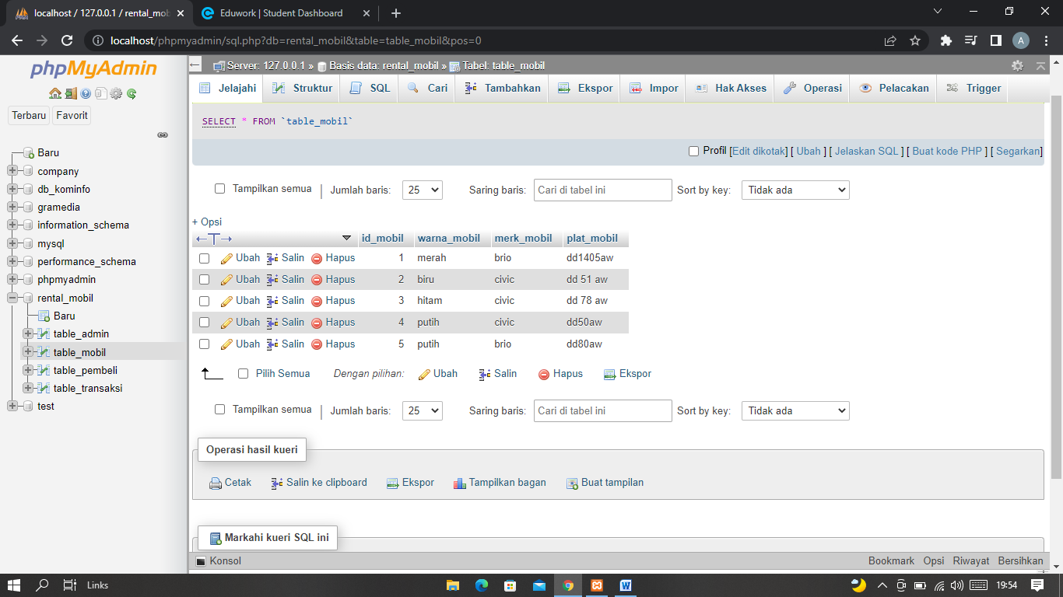

Update

1. UPDATE `table_mobil` SET `merk_mobil`='brio RS' WHERE id_mobil = '1' ;
2. UPDATE `table_mobil` SET `merk_mobil`='civic turbo' WHERE id_mobil = '2' ;
3. UPDATE `table_mobil` SET `merk_mobil`=' civic turbo ' WHERE id_mobil = '3' ;
4. UPDATE `table_mobil` SET `merk_mobil`=' civic turbo ' WHERE id_mobil = '4' ;
5. UPDATE `table_mobil` SET `merk_mobil`='brio RS' WHERE id_mobil = '5' ;

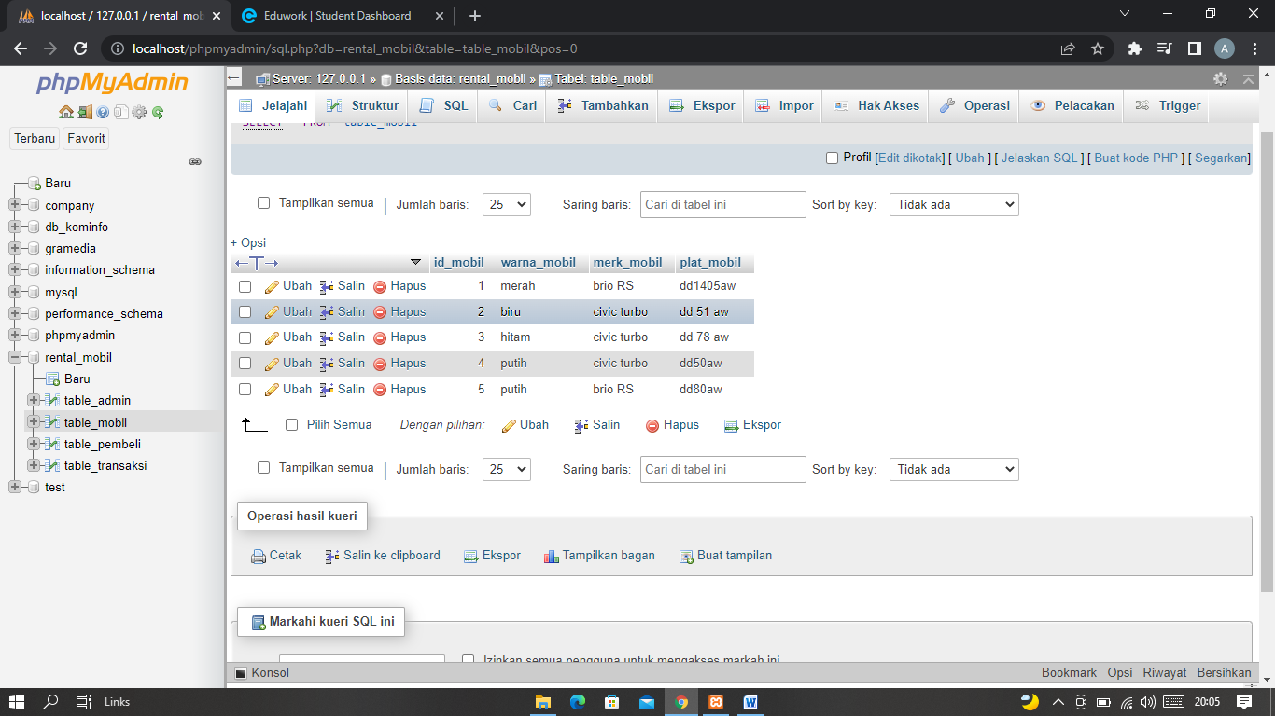

Delete

1. DELETE FROM `table_mobil` WHERE id_mobil='1';
2. DELETE FROM `table_mobil` WHERE id_mobil='2';
3. DELETE FROM `table_mobil` WHERE id_mobil='3';
4. DELETE FROM `table_mobil` WHERE id_mobil='4';
5. DELETE FROM `table_mobil` WHERE id_mobil='5';