Odsek Visoka ICT škola,

Akademija tehničko-umetničkih strukovnih studija,

Beograd

 Eshopper

<https://andjela-kostic.github.io/-eshopper-wp2/>

Smer: Internet tehnologije Student: Anđela Kostić 51/19

Modul: Web programiranje

Predmet: Web programiranje 2

**Sadržaj**

1. **Uvod1**

1.1Korišćeni programski jezici/tehnologije3

1.2.Opis funkcionalnosti3

1.3.Template4

**2. Organizacija4**

2.1 Organizaiona šema4

2.2 Mapa sajta…5

2.3 Slike stranica I opis funkcionalnosti…6

2.3.1 index.html…6

2.3.2 shop.html…8

2.3.3 detail.shop…9

2.3.4 cart.shop…10

2.3.5 contact.shop…12

**3. Kodovi**1**4**

3.1 HTML14

3.1.1 index.html…14

3.1.2 shop.html…20

3.1.3 contact.html…26

3.1.4 detail.html…31

3.1.5 cart.html…36

3.2 CSS44

3.3 JavaScript44

3.3.1 myjs.js44

3.4 Data56

3.4.1 products.json56

3.4.2 categories.json65

3.4.3 sizes.json66

3.4.4 menu.json66

3.4.5 featured.json67

3.4.6 socialLinks.json57

1. **Uvod**
   1. Korišćeni programski jezici/tehnologije

Za potrebe sajta korišćene su sledeće tehnologije:

* HTML
* CSS
* Bootstrap
* Font Awesome
* JavaScript + JSON + jQuery
* XML (sitemap)
* Visual Studio Code
  1. Opis funkcionalnosti

Funkcionalnosti sajta se mogu svrstati u sledeće kategorije:

* Upotreba AJAXA za čitanje JSON fajlova
* Dinamičko učitavanje linkova ka socijalnim mrežama iz JSON fajla
* Dinamički ispis menija is JSON fajla na svakoj stranici
* Dinamički ispis kategorija iz JSON fajla kao lista linkova u sklopu linkova, I kao sadržaj stranice index.html sa fotografijom karakterističnom za taj proizvod sa dinamičkim ispisom broja proizvoda za tu kategoriju
* Dinamički ispis nekoliko specifikacija prodavnice iz JSON fajla
* Dinamički ispis po 4 proizvoda iz JSON fajla na stranici index.html u dve grupe, razlika je što su u jednoj grupi random proizvodi, a u drugoj novi random proizvodi.
* Ispis svih proizvoda iz JSON fajla u shop.html sa mogućnošću filtriranja po kategoriji, ceni I veličini, pretragu proizvoda po imenu, kao i sortiranje po ceni I nazivu rastuće I opadajuće.
* Ispis svih veličina iz JSON fajla
* Mogućnosti prikaza detalja odabranog proizvoda
* Mogućnost dodavanja proizvoda u korpu. Proces je onemogućen ako nije odabrana veličina. Nemoguće je označiti veličinu koje nema za dati proizvod.
* Ispis broja proizvoda u korpi pored linka sa ikonicom korpe u meniju, pri učitavanju stranice I svakoj promeni
* Prikaz proizvoda koji se nalaze u korpi.
* Mogućnost menjanja količine proizvoda i automatsko menjanje totalne cene za taj proizvod, kao I totalne cene za sve proizvode ukupno. Ukoliko je količina proizvoda jednaka nuli, tada se proizvod briše iz korpe, kao I kada se klikne na “X” dugme.
* Klikom na “Proceed to Checkout” prikazuje se forma koja je inicijalno sakrivena I služi za popunjavanje podataka zarad kupovine. Ukoliko forma nije ispravno popunjena, polja se uokviruju crvenom I ispisuje se primer ispravno popunjenog polja.
* Ukoliko je korpa prazna na stranici cart.html ne možemo videte ništa osim rečenice “Your cart is empty.”
* Obrada forme za kontakt I vraćanje odgovora
  1. Template

Za izradu ovog sajta korišćen je gotovi bootstrap template:

<https://themewagon.com/themes/eshopper-free-responsive-bootstrap-4-e-commerce-website-template/>

1. **Organizacija**

2.1 Organizaciona šema

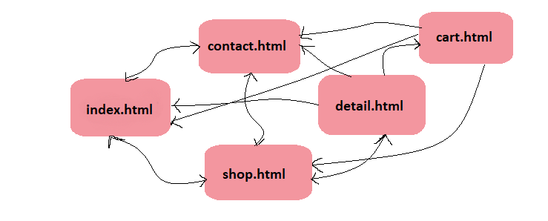

2.2 Mapa sajta

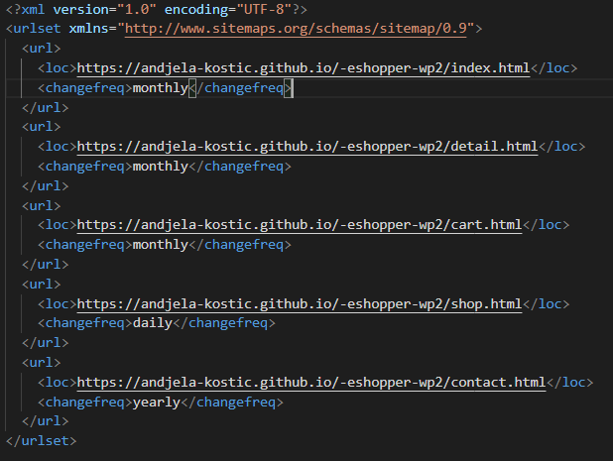

2.3 Slike stranica I opisi funkcionalnosti

2.3.1 index.html

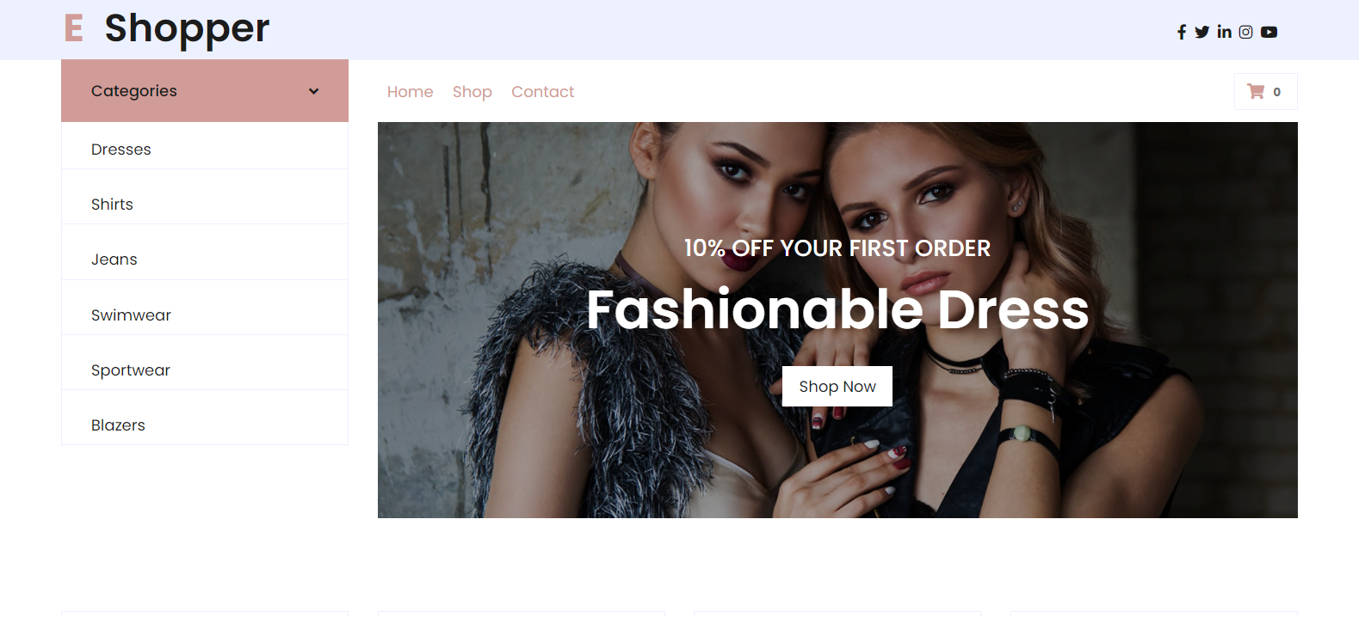

Navigacija se učitava dinamički AJAX-om iz JSON fajla, takođe prisutan je i meni za mobilne uređaje. Lista kategorija se takođe učitava na isti način kao I niz linkova za društvene mreže. Klikom na neku kategoriju, kategorija se smešta u localstorage I redirektuje se na shop.html, gde se prikazuju proizvodi za zadatu kategoriju. Klikom na link Shop, u slučaju da postoji u localstorage-u podaci o izabranoj kategoriji, brišu se I na shop.html se prikazuju svi proizvodi.

Pri učitavanju stranice, kao I dodavanju ili brisanju proizvoda iz korpe, menja se brojka pored ikonice korpe.

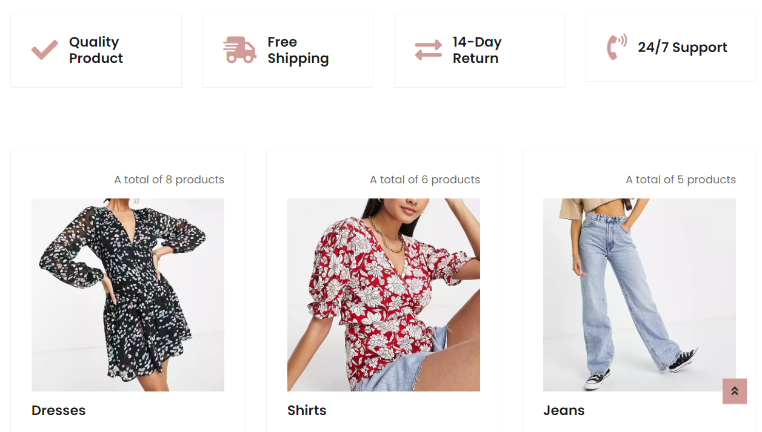Prikaz nekoliko specifikacija prodavnice dinamički AJAX-om iz JSON fajla. Učitavanje kategorija dinamički I štampanje sa fotografijom karakterističnom za taj proizvod sa dinamičkim ispisom broja proizvoda za tu kategoriju.

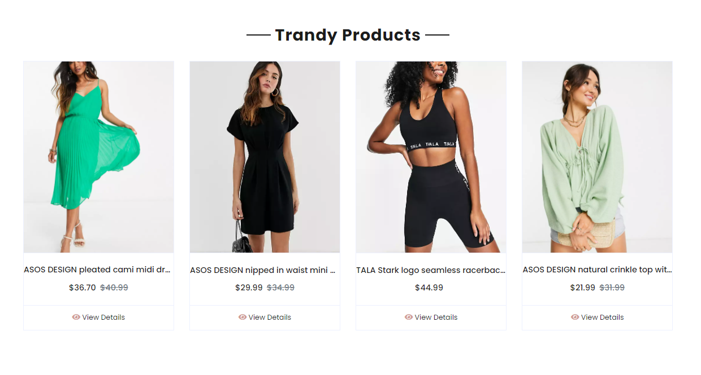

Ispis 4 random proizvoda.

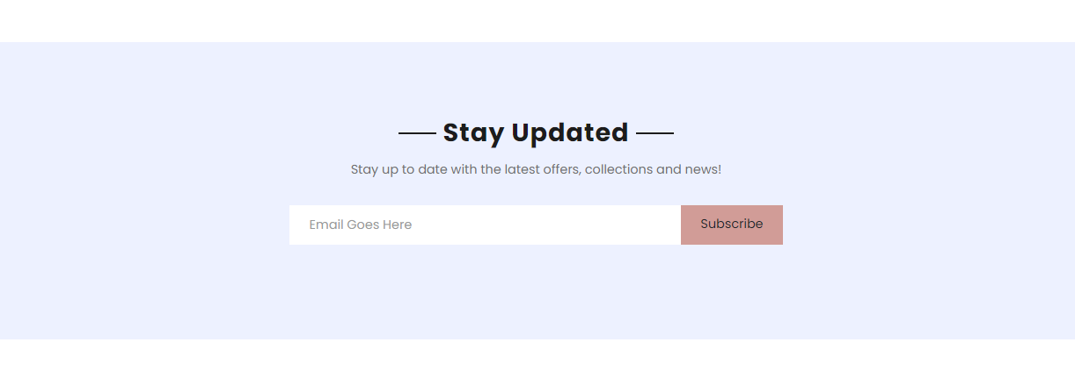

Forma za subcribe. Ako nije unet mejl u ispravnom formatu, ispisuje se poruka.

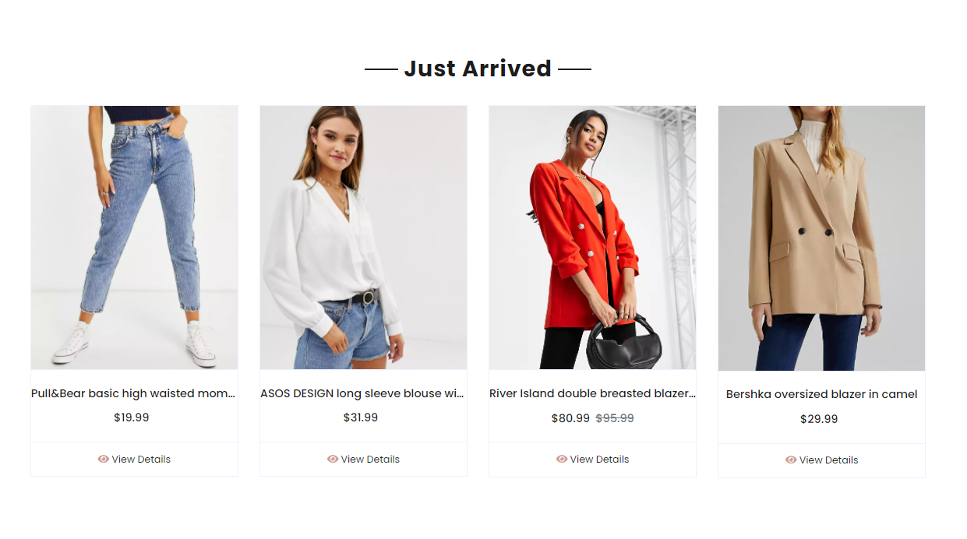

Ispis 4 random proizvoda koji su novi. Klikom na View Details, prikazuje se proizvod u detail.html.

2.3.2 shop.html

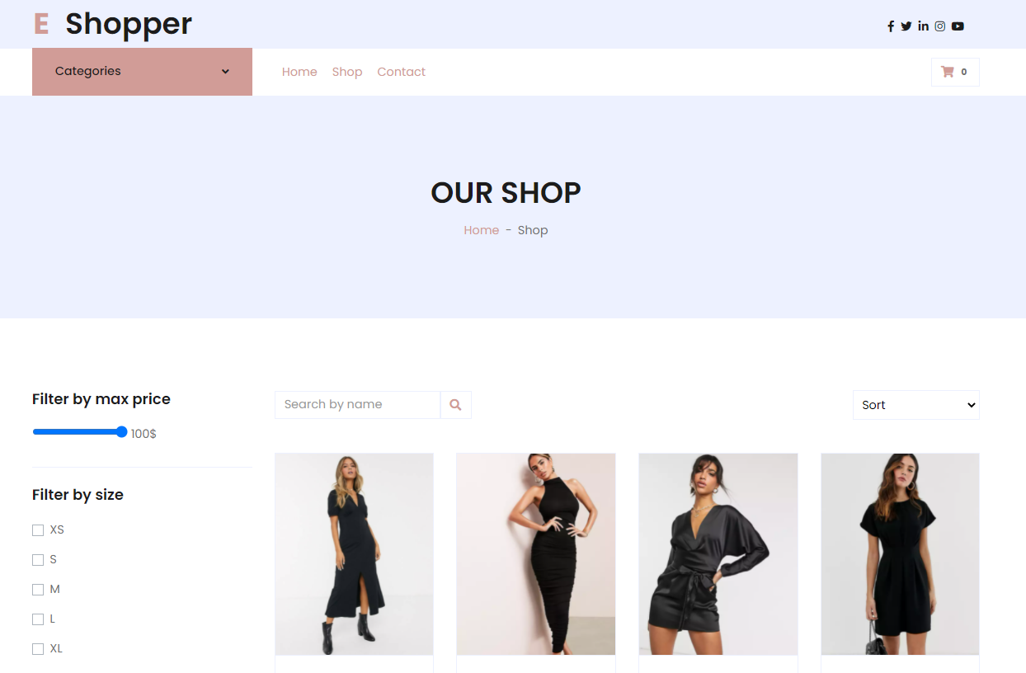

Ispis svih proizvoda iz JSON fajla u shop.html sa mogućnošću filtriranja po kategoriji, ceni I veličini, pretragu proizvoda po imenu, kao i sortiranje po ceni I nazivu rastuće I opadajuće. Ispis svih veličina iz JSON fajla. Mogućnosti prikaza detalja odabranog proizvoda

2.3.3 detail.html

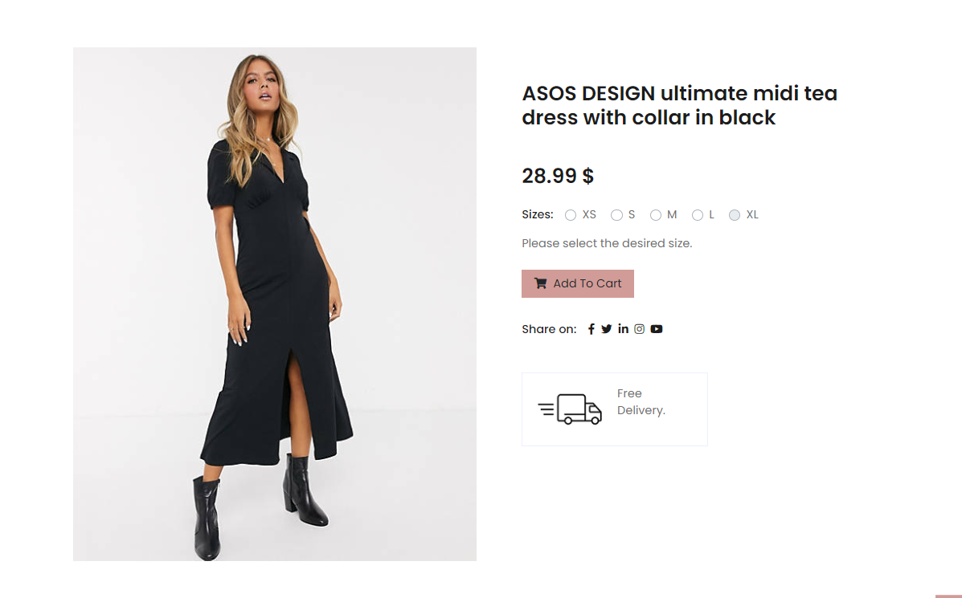

Prikaz detalja o odabranom proizvodu.

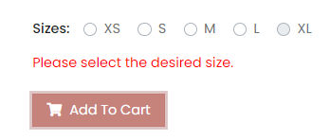

Ukoliko nije odabrana veličina, proizvod se ne dodaje u korpu.

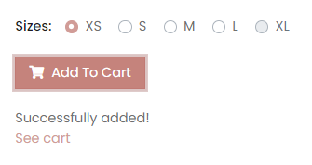

Ukoliko je odabrana veličina, proizvod se dodaje u korpu.

2.3.4. cart.html

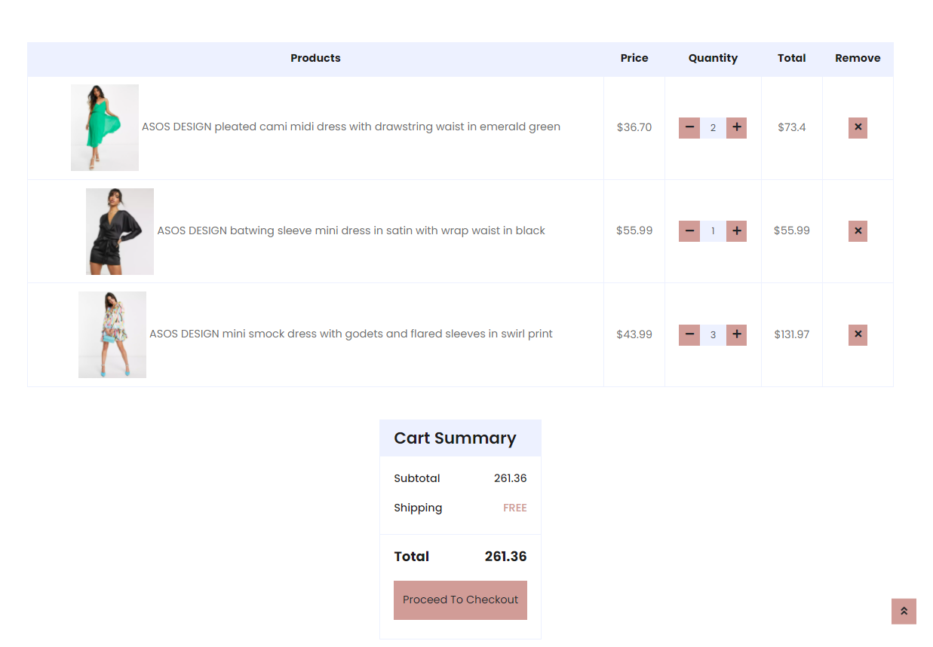

Mogućnost menjanja količine proizvoda i automatsko menjanje totalne cene za taj proizvod, kao I totalne cene za sve proizvode ukupno. Ukoliko je količina proizvoda jednaka nuli, tada se proizvod briše iz korpe, kao I kada se klikne na “X” dugme.

Klikom na “Proceed to Checkout” prikazuje se forma koja je inicijalno sakrivena I služi za popunjavanje podataka zarad kupovine.

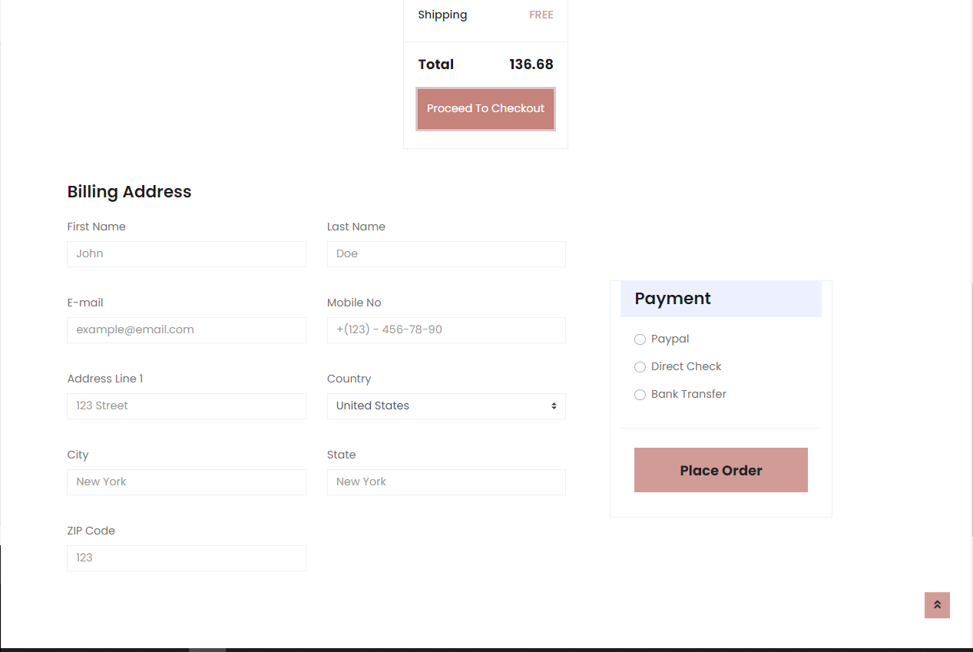

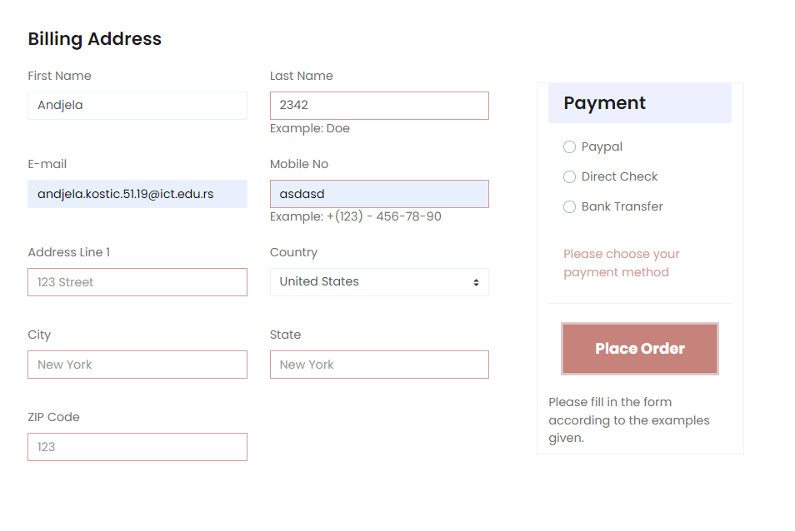

Ukoliko forma nije ispravno popunjena, polja se uokviruju crvenom I ispisuje se primer ispravno popunjenog polja.

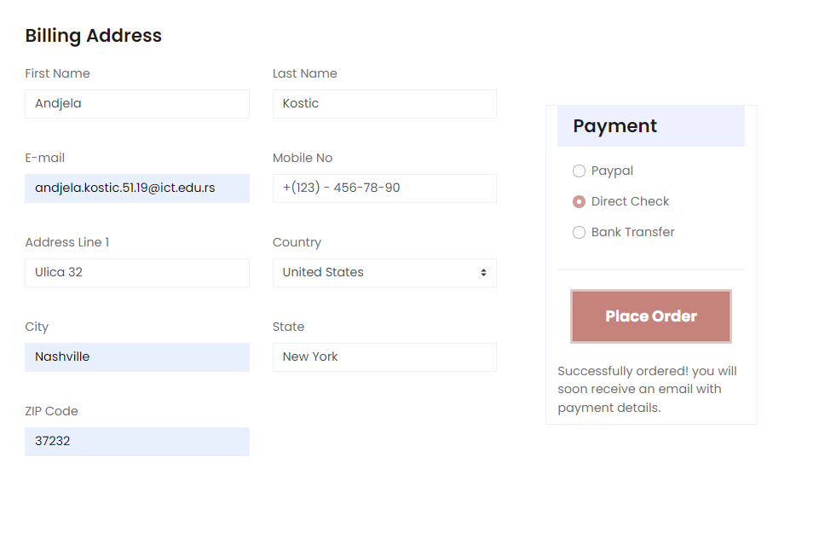

Kada su podaci uneti ispravno, ispisuje se poruka kojom se dobija potvrda o tome.

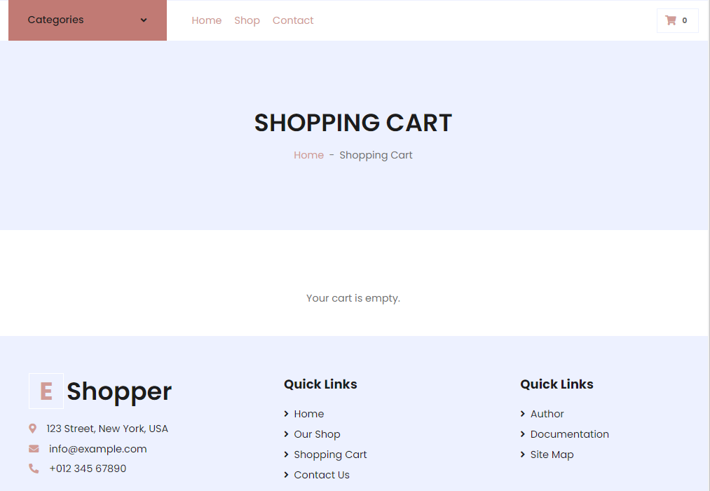

Ukoliko je korpa prazna na stranici cart.html ispisuje se rečenica “Your cart is empty.”

2.3.5 contact.html

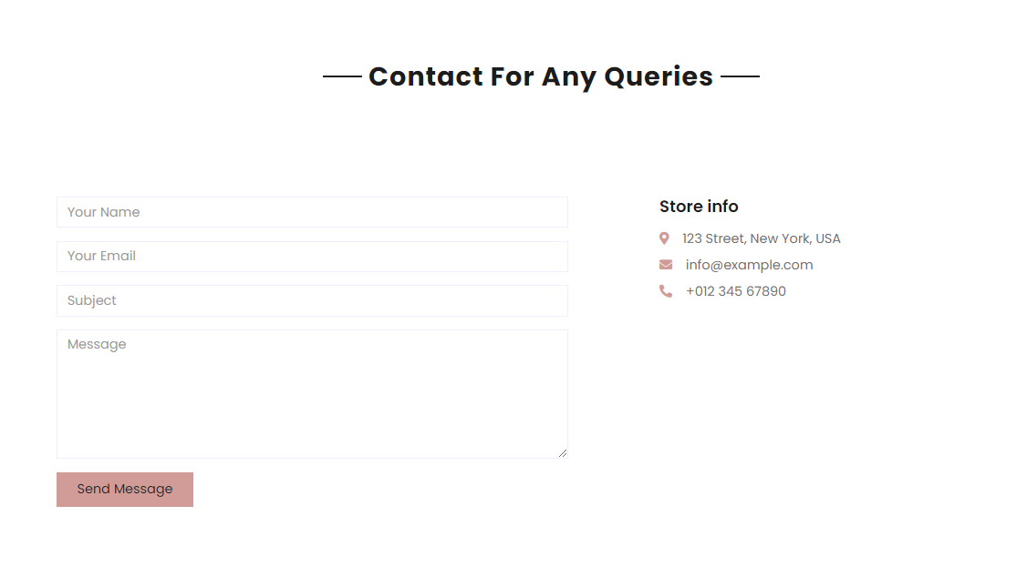

Na contact stranici je od ključnog značaja klasična forma za slanje poruke administratoru.

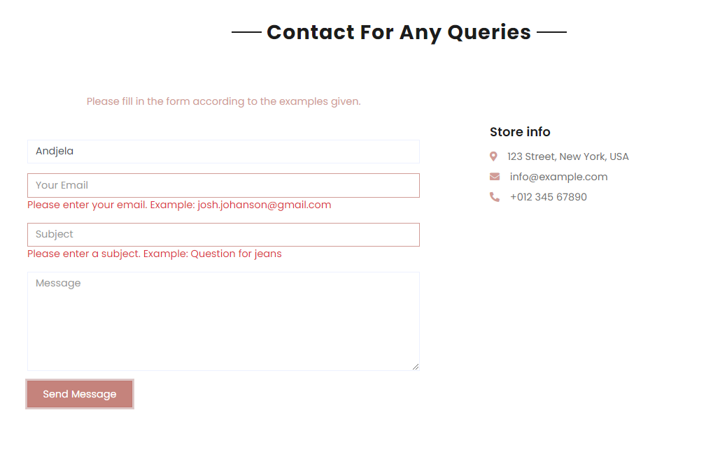

Ukoliko polja nisu ispravno popunjena, ispisuju se komentari.

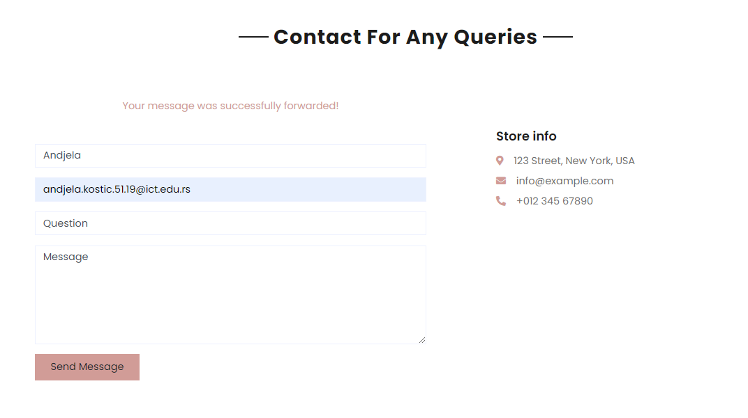

Kada je sve ispravno popunjeno, ispisuje se poruka da je poruka uspešno prosleđena.

1. **KODOVI**
   1. HTML
      1. index.html

<!DOCTYPE html>

<html lang="en">

<head>

    <meta charset="utf-8">

    <title>EShopper - Home page</title>

    <meta content="width=device-width, initial-scale=1.0" name="viewport">

    <meta content="Shop. Dresses. Jeans. Shirt. Swimwear. Sportwear. Blazers" name="keywords">

    <meta content="Eshoper, the shop for women. " name="description">

    <!-- Favicon -->

    <link href="assets/img/favico.png" rel="icon">

    <!-- Google Web Fonts -->

    <link rel="preconnect" href="https://fonts.gstatic.com">

    <link href="https://fonts.googleapis.com/css2?family=Poppins:wght@100;200;300;400;500;600;700;800;900&display=swap" rel="stylesheet">

    <!-- Font Awesome -->

    <link href="https://cdnjs.cloudflare.com/ajax/libs/font-awesome/5.10.0/css/all.min.css" rel="stylesheet">

    <!-- Libraries Stylesheet -->

    <link href="assets/lib/owlcarousel/assets/owl.carousel.min.css" rel="stylesheet">

    <!-- Customized Bootstrap Stylesheet -->

    <link href="assets/css/style.css" rel="stylesheet">

</head>

<body>

    <!-- Topbar Start -->

    <div class="container-fluid">

        <div class="row bg-secondary py-2">

            <div class="col-lg-4 d-none d-lg-block px-5">

                <a href="" class="text-decoration-none">

                    <h1 class="m-0 display-5 font-weight-semi-bold"><span class="text-primary font-weight-bold border px-3 mr-1">E</span>Shopper</h1>

                </a>

            </div>

            <div class="col-lg-7 pt-3 mx-5 text-right">

                <div class="social d-inline-flex align-items-center">

                </div>

            </div>

        </div>

    </div>

    <!-- Topbar End -->

    <!-- Navbar Start -->

    <div class="container-fluid mb-5">

        <div class="row border-top px-xl-5">

            <div class="col-lg-3 d-none d-lg-block">

                <a class="btn shadow-none d-flex align-items-center justify-content-between bg-primary text-white w-100" data-toggle="collapse" href="#navbar-vertical" style="height: 65px; margin-top: -1px; padding: 0 30px;">

                    <h6 class="m-0">Categories</h6>

                    <i class="fa fa-angle-down text-dark"></i>

                </a>

                <nav class="collapse show navbar navbar-vertical navbar-light align-items-start p-0 border border-top-0 border-bottom-0" id="navbar-vertical">

                    <div class="navCatMenu navbar-nav w-100 overflow-hidden" style="height: 335px">

                    </div>

                </nav>

            </div>

            <div class="col-lg-9">

                <nav class="navbar navbar-expand-lg bg-light navbar-light py-3 py-lg-0 px-0">

                    <a href="index.html" class="text-decoration-none d-block d-lg-none">

                        <h1 class="m-0 display-5 font-weight-semi-bold"><span class="text-primary font-weight-bold border px-3 mr-1">E</span>Shopper</h1>

                    </a>

                    <button type="button" class="navbar-toggler" data-toggle="collapse" data-target="#navbarCollapse">

                        <span class="navbar-toggler-icon"></span>

                    </button>

                    <div class="collapse navbar-collapse justify-content-between" id="navbarCollapse">

                        <div class="menu navbar-nav mr-auto py-0">

                        </div>

                        <a href="cart.html" class="btn border">

                            <i class="fas fa-shopping-cart text-primary"></i>

                            <span class="badge">0</span>

                        </a>

                    </div>

                </nav>

                <div id="header-carousel" class="carousel slide" data-ride="carousel">

                    <div id="carousel" class="carousel-inner">

                        <div class="carousel-item active" style="height: 410px;">

                            <img class="img-fluid" src="assets/img/carousel-1.jpg" alt="Image for header. Two women.">

                            <div class="carousel-caption d-flex flex-column align-items-center justify-content-center">

                                <div class="p-3" style="max-width: 700px;">

                                    <h4 class="text-light text-uppercase font-weight-medium mb-3">10% Off Your First Order</h4>

                                    <h3 class="display-4 text-white font-weight-semi-bold mb-4">Fashionable Dress</h3>

                                    <a href="shop.html" class="btn btn-light py-2 px-3">Shop Now</a>

                                </div>

                            </div>

                        </div>

                    </div>

                </div>

            </div>

        </div>

    </div>

    <!-- Navbar End -->

    <!-- Featured Start -->

    <div class="container-fluid pt-5">

        <div id="featured" class="row px-xl-5 pb-3">

        </div>

    </div>

    <!-- Featured End -->

    <!-- Categories Start -->

    <div class="container-fluid pt-5">

        <div id="catCover" class="row px-xl-5 pb-3">

        </div>

    </div>

    <!-- Categories End -->

    <!-- Offer Start -->

    <div class="container-fluid offer pt-5">

        <div class="row px-xl-5">

            <div class="col-md-6 pb-4">

                <div class="position-relative bg-secondary text-center text-md-right text-white mb-2 py-5 px-5">

                    <img src="assets/img/offer-1.png" alt="poster offers">

                    <div class="position-relative" style="z-index: 1;">

                        <h5 class="text-uppercase text-primary mb-3"></h5>

                        <h1 class="mb-4 font-weight-semi-bold">Spring Collection</h1>

                        <a href="shop.html" class="btn btn-outline-primary py-md-2 px-md-3">Shop Now</a>

                    </div>

                </div>

            </div>

            <div class="col-md-6 pb-4">

                <div class="position-relative bg-secondary text-center text-md-left text-white mb-2 py-5 px-5">

                    <img src="assets/img/offer-2.png" alt="poster offers">

                    <div class="position-relative" style="z-index: 1;">

                        <h5 class="text-uppercase text-primary mb-3"></h5>

                        <h1 class="mb-4 font-weight-semi-bold">Winter Collection</h1>

                        <a href="shop.html" class="btn btn-outline-primary py-md-2 px-md-3">Shop Now</a>

                    </div>

                </div>

            </div>

        </div>

    </div>

    <!-- Offer End -->

    <!-- Products Start -->

    <div class="container-fluid pt-5">

        <div class="text-center mb-4">

            <h2 class="section-title px-5"><span class="px-2">Trandy Products</span></h2>

        </div>

        <div id="trendyProducts" class="row px-xl-5 pb-3">

        </div>

    </div>

    <!-- Products End -->

    <!-- Subscribe Start -->

    <div class="container-fluid bg-secondary my-5">

        <div class="row justify-content-md-center py-5 px-xl-5">

            <div class="col-md-6 col-12 py-5">

                <div class="text-center mb-2 pb-2">

                    <h2 class="section-title px-5 mb-3"><span class="bg-secondary px-2">Stay Updated</span></h2>

                    <p>Stay up to date with the latest offers, collections and news!</p>

                </div>

                <form>

                    <div class="input-group">

                        <input id="emailSub" type="text" class="form-control border-white p-4" placeholder="Email Goes Here">

                        <div class="input-group-append">

                            <input type="button" id="subscribe" class="btn btn-primary px-4"value="Subscribe"/>

                        </div>

                    </div>

                </form>

                <div class="text-center">

                    <label class="m-2" id="result"></label>

                </div>

            </div>

        </div>

    </div>

    <!-- Subscribe End -->

    <!-- Products Start -->

    <div class="container-fluid pt-5">

        <div class="text-center mb-4">

            <h2 class="section-title px-5"><span class="px-2">Just Arrived</span></h2>

        </div>

        <div id="justArrivedProducts" class="row px-xl-5 pb-3">

        </div>

    </div>

    <!-- Products End -->

    <!-- Footer Start -->

    <div class="container-fluid bg-secondary text-dark mt-5 pt-3">

        <div class="row px-xl-5 pt-5">

            <div class="col-lg-4 col-md-12 mb-3 pl-5">

                <a href="" class="text-decoration-none">

                    <h1 class="mb-4 display-5 font-weight-semi-bold"><span class="text-primary font-weight-bold border border-white px-3 mr-1">E</span>Shopper</h1>

                </a>

                <p class="mb-2"><i class="fa fa-map-marker-alt text-primary mr-3"></i>123 Street, New York, USA</p>

                <p class="mb-2"><i class="fa fa-envelope text-primary mr-3"></i>info@example.com</p>

                <p class="mb-0"><i class="fa fa-phone-alt text-primary mr-3"></i>+012 345 67890</p>

            </div>

            <div class="col-lg-8 col-md-12">

                <div class="row">

                    <div class="col-md-4 mx-auto mb-5">

                        <h5 class="font-weight-bold text-dark mb-4">Quick Links</h5>

                        <div class="d-flex flex-column justify-content-start">

                            <a class="text-dark mb-2" href="index.html"><i class="fa fa-angle-right mr-2"></i>Home</a>

                            <a class="text-dark mb-2" href="shop.html"><i class="fa fa-angle-right mr-2"></i>Our Shop</a>

                            <a class="text-dark mb-2" href="cart.html"><i class="fa fa-angle-right mr-2"></i>Shopping Cart</a>

                            <a class="text-dark" href="contact.html"><i class="fa fa-angle-right mr-2"></i>Contact Us</a>

                        </div>

                    </div>

                    <div class="col-md-4 mx-auto mb-5">

                        <h5 class="font-weight-bold text-dark mb-4">Quick Links</h5>

                        <div class="d-flex flex-column justify-content-start">

                            <a class="text-dark mb-2" href="https://andjela-kostic.github.io/portfolio2021/"><i class="fa fa-angle-right mr-2"></i>Author</a>

                            <a class="text-dark mb-2" href="shop.html"><i class="fa fa-angle-right mr-2"></i>Documentation</a>

                            <a class="text-dark mb-2" href="detail.html"><i class="fa fa-angle-right mr-2"></i>Site Map</a>

                        </div>

                    </div>

                </div>

            </div>

        </div>

        <div class="row border-top border-light mx-xl-5 py-4">

            <div class="col-md-6 px-xl-0">

                <p class="mb-md-0 text-center text-md-left text-dark">

                    &copy; <a class="text-dark font-weight-semi-bold" href="index.html">Eshopper</a>. All Rights Reserved. Designed

                    by

                    <a class="text-dark font-weight-semi-bold" href="https://htmlcodex.com">HTML Codex</a><br>

                    Distributed By <a href="https://themewagon.com" target="_blank">ThemeWagon</a>

                </p>

            </div>

            <div class="col-md-6 px-xl-0 text-center text-md-right">

                <img class="img-fluid" src="assets/img/payments.png" alt="payments">

            </div>

        </div>

    </div>

    <!-- Footer End -->

    <!-- Back to Top -->

    <a href="#" class="btn btn-primary back-to-top"><i class="fa fa-angle-double-up"></i></a>

    <!-- JavaScript Libraries -->

    <script src="https://code.jquery.com/jquery-3.4.1.min.js"></script>

    <script src="https://stackpath.bootstrapcdn.com/bootstrap/4.4.1/js/bootstrap.bundle.min.js"></script>

    <script src="assets/lib/easing/easing.min.js"></script>

    <script src="assets/lib/owlcarousel/owl.carousel.min.js"></script>

    <!-- Contact Javascript File -->

    <script src="assets/mail/jqBootstrapValidation.min.js"></script>

    <script src="assets/mail/contact.js"></script>

    <!-- Template Javascript -->

    <script src="assets/js/main.js"></script>

    <script src="assets/js/myjs.js"></script>

</body>

</html>

* + 1. shop.html

<!DOCTYPE html>

<html lang="en">

<head>

    <meta charset="utf-8">

    <title>EShopper - Home page</title>

    <meta content="width=device-width, initial-scale=1.0" name="viewport">

    <meta content="Shop. Dresses. Jeans. Shirt. Swimwear. Sportwear. Blazers. Size. Search. Price." name="keywords">

    <meta content="Eshoper, the shop for women. Pages for search products." name="description">

    <!-- Favicon -->

    <link href="assets/img/favico.png" rel="icon">

    <!-- Google Web Fonts -->

    <link rel="preconnect" href="https://fonts.gstatic.com">

    <link href="https://fonts.googleapis.com/css2?family=Poppins:wght@100;200;300;400;500;600;700;800;900&display=swap" rel="stylesheet">

    <!-- Font Awesome -->

    <link href="https://cdnjs.cloudflare.com/ajax/libs/font-awesome/5.10.0/css/all.min.css" rel="stylesheet">

    <!-- Libraries Stylesheet -->

    <link href="assets/lib/owlcarousel/assets/owl.carousel.min.css" rel="stylesheet">

    <!-- Customized Bootstrap Stylesheet -->

    <link href="assets/css/style.css" rel="stylesheet">

</head>

<body>

     <!-- Topbar Start -->

    <div class="container-fluid">

        <div class="row bg-secondary py-2">

            <div class="col-lg-4 d-none d-lg-block px-5">

                <a href="index.html" class="text-decoration-none">

                    <h1 class="m-0 display-5 font-weight-semi-bold"><span class="text-primary font-weight-bold border px-3 mr-1">E</span>Shopper</h1>

                </a>

            </div>

            <div class="col-lg-7 pt-3 mx-5 text-right">

                <div class="social d-inline-flex align-items-center">

                </div>

            </div>

        </div>

    </div>

    <!-- Topbar End -->

    <!-- Navbar Start -->

    <div class="container-fluid">

        <div class="row border-top px-xl-5">

            <div class="col-lg-3 d-none d-lg-block">

                <a class="btn shadow-none d-flex align-items-center justify-content-between bg-primary text-white w-100" data-toggle="collapse" href="#navbar-vertical" style="height: 65px; margin-top: -1px; padding: 0 30px;">

                    <h6 class="m-0">Categories</h6>

                    <i class="fa fa-angle-down text-dark"></i>

                </a>

                <nav class="collapse position-absolute navbar navbar-vertical navbar-light align-items-start p-0 border border-top-0 border-bottom-0 bg-light" id="navbar-vertical" style="width: calc(100% - 30px); z-index: 1;">

                    <div  class="navCatMenu navbar-nav w-100 overflow-hidden" style="height: 335px">

                    </div>

                </nav>

            </div>

            <div class="col-lg-9">

                <nav class="navbar navbar-expand-lg bg-light navbar-light py-3 py-lg-0 px-0">

                    <a href="" class="text-decoration-none d-block d-lg-none">

                        <h1 class="m-0 display-5 font-weight-semi-bold"><span class="text-primary font-weight-bold border px-3 mr-1">E</span>Shopper</h1>

                    </a>

                    <button type="button" class="navbar-toggler" data-toggle="collapse" data-target="#navbarCollapse">

                        <span class="navbar-toggler-icon"></span>

                    </button>

                    <div class="collapse navbar-collapse justify-content-between" id="navbarCollapse">

                        <div class="menu navbar-nav mr-auto py-0">

                        </div>

                        <a href="cart.html" class="btn border">

                            <i class="fas fa-shopping-cart text-primary"></i>

                            <span class="badge">0</span>

                        </a>

                    </div>

                </nav>

            </div>

        </div>

    </div>

    <!-- Navbar End -->

    <!-- Page Header Start -->

    <div class="container-fluid bg-secondary mb-5">

        <div class="d-flex flex-column align-items-center justify-content-center" style="min-height: 300px">

            <h1 class="font-weight-semi-bold text-uppercase mb-3">Our Shop</h1>

            <div class="d-inline-flex">

                <p class="m-0"><a href="index.html">Home</a></p>

                <p class="m-0 px-2">-</p>

                <p class="m-0">Shop</p>

            </div>

        </div>

    </div>

    <!-- Page Header End -->

    <!-- Shop Start -->

    <div class="container-fluid pt-5">

        <div class="row px-xl-5">

            <!-- Shop Sidebar Start -->

            <div class="col-lg-3 col-md-12">

                <!-- Price Start -->

                <div class="border-bottom mb-4 pb-4">

                    <h5 class="font-weight-semi-bold mb-4">Filter by max price</h5>

                    <form>

                        <div>

                        <input type="range" id="range" name="range" min="0" max="100" value="100" step="10">

                        <label id="rangeValue" for="range">100$</label>

                        </div>

                    </form>

                </div>

                <!-- Price End -->

                <!-- Size Start -->

                <div class="mb-5">

                    <h5 class="font-weight-semi-bold mb-4">Filter by size</h5>

                    <form id="sizesForm">

                    </form>

                </div>

                <!-- Size End -->

            </div>

            <!-- Shop Sidebar End -->

            <!-- Shop Product Start -->

            <div class="col-lg-9 col-md-12">

                <div class="row pb-3">

                    <div class="col-12 pb-1">

                        <div class="d-flex align-items-center justify-content-between mb-4">

                            <form action="">

                                <div class="input-group">

                                    <input type="text" class="form-control" id="searchName" placeholder="Search by name">

                                    <div class="input-group-append">

                                        <span class="input-group-text bg-transparent text-primary">

                                            <i class="fa fa-search"></i>

                                        </span>

                                    </div>

                                </div>

                            </form>

                            <!--<div class="dropdown ml-4">

                                <button class="btn border dropdown-toggle" type="button" id="triggerId" data-toggle="dropdown" aria-haspopup="true"

                                        aria-expanded="false">

                                            Sort by

                                        </button>

                                <div class="dropdown-menu dropdown-menu-right" aria-labelledby="triggerId">

                                    <a class="dropdown-item" id="priceAsc" href="#">Price low to high</a>

                                    <a class="dropdown-item" id="priceDesc" href="#">Price high to low</a>

                                    <a class="dropdown-item" id="namesDesc" href="#">Names A-Z</a>

                                    <a class="dropdown-item" id="namesAsc" href="#">Names Z-A</a>

                                </div>

                            </div>-->

                            <div class="dropdown ml-4">

                                <select id="sort" class="border dropdown-toggle p-2">

                                    <option class="dropdown-item" hidden value="default">Sort</option>

                                    <option class="dropdown-item" value="priceAsc">Price low to high</option>

                                    <option class="dropdown-item" value="priceDesc">Price high to low</option>

                                    <option class="dropdown-item" value="namesAsc">Names A-Z</option>

                                    <option class="dropdown-item" value="namesDesc">Names Z-A</option>

                                </select>

                                </div>

                            </div>

                        </div>

                    </div>

                    <div id="products" class="row"></div>

                </div>

            </div>

            <!-- Shop Product End -->

        </div>

    </div>

    <!-- Shop End -->

    <!-- Footer Start -->

    <div class="container-fluid bg-secondary text-dark mt-5 pt-3">

        <div class="row px-xl-5 pt-5">

            <div class="col-lg-4 col-md-12 mb-3 pl-5">

                <a href="index.html" class="text-decoration-none">

                    <h1 class="mb-4 display-5 font-weight-semi-bold"><span class="text-primary font-weight-bold border border-white px-3 mr-1">E</span>Shopper</h1>

                </a>

                <p class="mb-2"><i class="fa fa-map-marker-alt text-primary mr-3"></i>123 Street, New York, USA</p>

                <p class="mb-2"><i class="fa fa-envelope text-primary mr-3"></i>info@example.com</p>

                <p class="mb-0"><i class="fa fa-phone-alt text-primary mr-3"></i>+012 345 67890</p>

            </div>

            <div class="col-lg-8 col-md-12">

                <div class="row">

                    <div class="col-md-4 mx-auto mb-5">

                        <h5 class="font-weight-bold text-dark mb-4">Quick Links</h5>

                        <div class="d-flex flex-column justify-content-start">

                            <a class="text-dark mb-2" href="index.html"><i class="fa fa-angle-right mr-2"></i>Home</a>

                            <a class="text-dark mb-2" href="shop.html"><i class="fa fa-angle-right mr-2"></i>Our Shop</a>

                            <a class="text-dark mb-2" href="cart.html"><i class="fa fa-angle-right mr-2"></i>Shopping Cart</a>

                            <a class="text-dark" href="contact.html"><i class="fa fa-angle-right mr-2"></i>Contact Us</a>

                        </div>

                    </div>

                    <div class="col-md-4 mx-auto mb-5">

                        <h5 class="font-weight-bold text-dark mb-4">Quick Links</h5>

                        <div class="d-flex flex-column justify-content-start">

                            <a class="text-dark mb-2" href="https://andjela-kostic.github.io/portfolio2021/"><i class="fa fa-angle-right mr-2"></i>Author</a>

                            <a class="text-dark mb-2" href="shop.html"><i class="fa fa-angle-right mr-2"></i>Documentation</a>

                            <a class="text-dark mb-2" href="detail.html"><i class="fa fa-angle-right mr-2"></i>Site Map</a>

                        </div>

                    </div>

                </div>

            </div>

        </div>

        <div class="row border-top border-light mx-xl-5 py-4">

            <div class="col-md-6 px-xl-0">

                <p class="mb-md-0 text-center text-md-left text-dark">

                    &copy; <a class="text-dark font-weight-semi-bold" href="#">Eshopper</a>. All Rights Reserved. Designed

                    by

                    <a class="text-dark font-weight-semi-bold" href="https://htmlcodex.com">HTML Codex</a><br>

                    Distributed By <a href="https://themewagon.com" target="_blank">ThemeWagon</a>

                </p>

            </div>

            <div class="col-md-6 px-xl-0 text-center text-md-right">

                <img class="img-fluid" src="assets/img/payments.png" alt="payments">

            </div>

        </div>

    </div>

    <!-- Footer End -->

    <!-- Back to Top -->

    <a href="#" class="btn btn-primary back-to-top"><i class="fa fa-angle-double-up"></i></a>

    <!-- JavaScript Libraries -->

    <script src="https://code.jquery.com/jquery-3.4.1.min.js"></script>

    <script src="https://stackpath.bootstrapcdn.com/bootstrap/4.4.1/js/bootstrap.bundle.min.js"></script>

    <script src="assets/lib/easing/easing.min.js"></script>

    <script src="assets/lib/owlcarousel/owl.carousel.min.js"></script>

    <!-- Contact Javascript File -->

    <script src="assets/mail/jqBootstrapValidation.min.js"></script>

    <script src="assets/mail/contact.js"></script>

    <!-- Template Javascript -->

    <script src="assets/js/main.js"></script>

    <script src="assets/js/myjs.js"></script>

</body>

</html>

* + 1. contact.html

<!DOCTYPE html>

<html lang="en">

<head>

    <meta charset="utf-8">

    <title>EShopper - Contact page</title>

    <meta content="width=device-width, initial-scale=1.0" name="viewport">

    <meta content="Shop. Dresses. Jeans. Shirt. Swimwear. Sportwear. Blazers. Contact." name="keywords">

    <meta content="Eshoper, the shop for women. Page for contant." name="description">

    <!-- Favicon -->

    <link href="assets/img/favico.png" rel="icon">

    <!-- Google Web Fonts -->

    <link rel="preconnect" href="https://fonts.gstatic.com">

    <link href="https://fonts.googleapis.com/css2?family=Poppins:wght@100;200;300;400;500;600;700;800;900&display=swap" rel="stylesheet">

    <!-- Font Awesome -->

    <link href="https://cdnjs.cloudflare.com/ajax/libs/font-awesome/5.10.0/css/all.min.css" rel="stylesheet">

    <!-- Libraries Stylesheet -->

    <link href="assets/lib/owlcarousel/assets/owl.carousel.min.css" rel="stylesheet">

    <!-- Customized Bootstrap Stylesheet -->

    <link href="assets/css/style.css" rel="stylesheet">

</head>

<body>

      <!-- Topbar Start -->

      <div class="container-fluid">

        <div class="row bg-secondary py-2">

            <div class="col-lg-4 d-none d-lg-block px-5">

                <a href="index.html" class="text-decoration-none">

                    <h1 class="m-0 display-5 font-weight-semi-bold"><span class="text-primary font-weight-bold border px-3 mr-1">E</span>Shopper</h1>

                </a>

            </div>

            <div class="col-lg-7 pt-3 mx-5 text-right">

                <div class="social d-inline-flex align-items-center">

                </div>

            </div>

        </div>

    </div>

    <!-- Topbar End -->

   <!-- Navbar Start -->

   <div class="container-fluid">

    <div class="row border-top px-xl-5">

        <div class="col-lg-3 d-none d-lg-block">

            <a class="btn shadow-none d-flex align-items-center justify-content-between bg-primary text-white w-100" data-toggle="collapse" href="#navbar-vertical" style="height: 65px; margin-top: -1px; padding: 0 30px;">

                <h6 class="m-0">Categories</h6>

                <i class="fa fa-angle-down text-dark"></i>

            </a>

            <nav class="collapse position-absolute navbar navbar-vertical navbar-light align-items-start p-0 border border-top-0 border-bottom-0 bg-light" id="navbar-vertical" style="width: calc(100% - 30px); z-index: 1;">

                <div  class="navCatMenu navbar-nav w-100 overflow-hidden" style="height: 335px">

                </div>

            </nav>

        </div>

        <div class="col-lg-9">

            <nav class="navbar navbar-expand-lg bg-light navbar-light py-3 py-lg-0 px-0">

                <a href="" class="text-decoration-none d-block d-lg-none">

                    <h1 class="m-0 display-5 font-weight-semi-bold"><span class="text-primary font-weight-bold border px-3 mr-1">E</span>Shopper</h1>

                </a>

                <button type="button" class="navbar-toggler" data-toggle="collapse" data-target="#navbarCollapse">

                    <span class="navbar-toggler-icon"></span>

                </button>

                <div class="collapse navbar-collapse justify-content-between" id="navbarCollapse">

                    <div class="menu navbar-nav mr-auto py-0">

                    </div>

                    <a href="cart.html" class="btn border">

                        <i class="fas fa-shopping-cart text-primary"></i>

                        <span class="badge">0</span>

                    </a>

                </div>

            </nav>

        </div>

    </div>

</div>

<!-- Navbar End -->

    <!-- Page Header Start -->

    <div class="container-fluid bg-secondary mb-5">

        <div class="d-flex flex-column align-items-center justify-content-center" style="min-height: 300px">

            <h1 class="font-weight-semi-bold text-uppercase mb-3">Contact Us</h1>

            <div class="d-inline-flex">

                <p class="m-0"><a href="index.html">Home</a></p>

                <p class="m-0 px-2">-</p>

                <p class="m-0">Contact</p>

            </div>

        </div>

    </div>

    <!-- Page Header End -->

    <!-- Contact Start -->

    <div class="container-fluid pt-5">

        <div class="text-center mb-4">

            <h2 class="section-title px-5"><span class="px-2">Contact For Any Queries</span></h2>

        </div>

        <div class="row px-xl-5 pt-5">

            <div class="col-lg-6 mb-5  mx-5">

                <div class="contact-form">

                    <div id="success" class="text-center mb-5 text-primary"></div>

                    <form name="sentMessage" id="contactForm" novalidate="novalidate">

                        <div class="control-group">

                            <input type="text" class="form-control" id="name" placeholder="Your Name"

                                required="required" data-validation-required-message="Please enter your name. Example: Josh" />

                            <p class="help-block text-danger"></p>

                        </div>

                        <div class="control-group">

                            <input type="email" class="form-control" id="email" placeholder="Your Email"

                                required="required" data-validation-required-message="Please enter your email. Example: josh.johanson@gmail.com" />

                            <p class="help-block text-danger"></p>

                        </div>

                        <div class="control-group">

                            <input type="text" class="form-control" id="subject" placeholder="Subject"

                                required="required" data-validation-required-message="Please enter a subject. Example: Question for jeans" />

                            <p class="help-block text-danger"></p>

                        </div>

                        <div class="control-group">

                            <textarea class="form-control" rows="6" id="message" placeholder="Message"

                                required="required"

                                data-validation-required-message="Please enter your message"></textarea>

                            <p class="help-block text-danger"></p>

                        </div>

                        <div>

                            <input class="btn btn-primary py-2 px-4" type="button" id="sendMessageButton" value="Send Message"/>

                        </div>

                    </form>

                </div>

            </div>

            <div class="col-lg-5 mt-5 mt-5 pl-5">

                <div class="d-flex flex-column">

                    <h5 class="font-weight-semi-bold mb-3">Store info</h5>

                    <p class="mb-2"><i class="fa fa-map-marker-alt text-primary mr-3"></i>123 Street, New York, USA</p>

                    <p class="mb-2"><i class="fa fa-envelope text-primary mr-3"></i>info@example.com</p>

                    <p class="mb-0"><i class="fa fa-phone-alt text-primary mr-3"></i>+012 345 67890</p>

                </div>

            </div>

        </div>

    </div>

    <!-- Contact End -->

   <!-- Footer Start -->

   <div class="container-fluid bg-secondary text-dark mt-5 pt-3">

    <div class="row px-xl-5 pt-5">

        <div class="col-lg-4 col-md-12 mb-3 pl-5">

            <a href="index.html" class="text-decoration-none">

                <h1 class="mb-4 display-5 font-weight-semi-bold"><span class="text-primary font-weight-bold border border-white px-3 mr-1">E</span>Shopper</h1>

            </a>

            <p class="mb-2"><i class="fa fa-map-marker-alt text-primary mr-3"></i>123 Street, New York, USA</p>

            <p class="mb-2"><i class="fa fa-envelope text-primary mr-3"></i>info@example.com</p>

            <p class="mb-0"><i class="fa fa-phone-alt text-primary mr-3"></i>+012 345 67890</p>

        </div>

        <div class="col-lg-8 col-md-12">

            <div class="row">

                <div class="col-md-4 mx-auto mb-5">

                    <h5 class="font-weight-bold text-dark mb-4">Quick Links</h5>

                    <div class="d-flex flex-column justify-content-start">

                        <a class="text-dark mb-2" href="index.html"><i class="fa fa-angle-right mr-2"></i>Home</a>

                        <a class="text-dark mb-2" href="shop.html"><i class="fa fa-angle-right mr-2"></i>Our Shop</a>

                        <a class="text-dark mb-2" href="cart.html"><i class="fa fa-angle-right mr-2"></i>Shopping Cart</a>

                        <a class="text-dark" href="contact.html"><i class="fa fa-angle-right mr-2"></i>Contact Us</a>

                    </div>

                </div>

                <div class="col-md-4 mx-auto mb-5">

                    <h5 class="font-weight-bold text-dark mb-4">Quick Links</h5>

                    <div class="d-flex flex-column justify-content-start">

                        <a class="text-dark mb-2" href="https://andjela-kostic.github.io/portfolio2021/"><i class="fa fa-angle-right mr-2"></i>Author</a>

                        <a class="text-dark mb-2" href="shop.html"><i class="fa fa-angle-right mr-2"></i>Documentation</a>

                        <a class="text-dark mb-2" href="detail.html"><i class="fa fa-angle-right mr-2"></i>Site Map</a>

                    </div>

                </div>

            </div>

        </div>

    </div>

    <div class="row border-top border-light mx-xl-5 py-4">

        <div class="col-md-6 px-xl-0">

            <p class="mb-md-0 text-center text-md-left text-dark">

                &copy; <a class="text-dark font-weight-semi-bold" href="index.html">Eshopper</a>. All Rights Reserved. Designed

                by

                <a class="text-dark font-weight-semi-bold" href="https://htmlcodex.com">HTML Codex</a><br>

                Distributed By <a href="https://themewagon.com" target="_blank">ThemeWagon</a>

            </p>

        </div>

        <div class="col-md-6 px-xl-0 text-center text-md-right">

            <img class="img-fluid" src="assets/img/payments.png" alt="payments">

        </div>

    </div>

</div>

<!-- Footer End -->

    <!-- Back to Top -->

    <a href="#" class="btn btn-primary back-to-top"><i class="fa fa-angle-double-up"></i></a>

    <!-- JavaScript Libraries -->

    <script src="https://code.jquery.com/jquery-3.4.1.min.js"></script>

    <script src="https://stackpath.bootstrapcdn.com/bootstrap/4.4.1/js/bootstrap.bundle.min.js"></script>

    <script src="lib/easing/easing.min.js"></script>

    <script src="lib/owlcarousel/owl.carousel.min.js"></script>

    <!-- Contact Javascript File -->

    <script src="mail/jqBootstrapValidation.min.js"></script>

    <script src="mail/contact.js"></script>

    <!-- Template Javascript -->

    <script src="assets/js/main.js"></script>

    <script src="assets/js/myjs.js"></script>

</body>

</html>

* + 1. detail.html

<!DOCTYPE html>

<html lang="en">

<head>

    <meta charset="utf-8">

    <title>EShopper - Home page</title>

    <meta content="width=device-width, initial-scale=1.0" name="viewport">

    <meta content="Shop. Dresses. Jeans. Shirt. Swimwear. Sportwear. Blazers. Details of product. " name="keywords">

    <meta content="Eshoper, the shop for women. Details about products." name="description">

    <!-- Favicon -->

    <link href="assets/img/favico.png" rel="icon">

    <!-- Google Web Fonts -->

    <link rel="preconnect" href="https://fonts.gstatic.com">

    <link href="https://fonts.googleapis.com/css2?family=Poppins:wght@100;200;300;400;500;600;700;800;900&display=swap" rel="stylesheet">

    <!-- Font Awesome -->

    <link href="https://cdnjs.cloudflare.com/ajax/libs/font-awesome/5.10.0/css/all.min.css" rel="stylesheet">

    <!-- Libraries Stylesheet -->

    <link href="assets/lib/owlcarousel/assets/owl.carousel.min.css" rel="stylesheet">

    <!-- Customized Bootstrap Stylesheet -->

    <link href="assets/css/style.css" rel="stylesheet">

</head>

<body>

     <!-- Topbar Start -->

     <div class="container-fluid">

        <div class="row bg-secondary py-2">

            <div class="col-lg-4 d-none d-lg-block px-5">

                <a href="index.html" class="text-decoration-none">

                    <h1 class="m-0 display-5 font-weight-semi-bold"><span class="text-primary font-weight-bold border px-3 mr-1">E</span>Shopper</h1>

                </a>

            </div>

            <div class="col-lg-7 pt-3 mx-5 text-right">

                <div class="social d-inline-flex align-items-center">

                </div>

            </div>

        </div>

    </div>

    <!-- Topbar End -->

   <!-- Navbar Start -->

   <div class="container-fluid">

    <div class="row border-top px-xl-5">

        <div class="col-lg-3 d-none d-lg-block">

            <a class="btn shadow-none d-flex align-items-center justify-content-between bg-primary text-white w-100" data-toggle="collapse" href="#navbar-vertical" style="height: 65px; margin-top: -1px; padding: 0 30px;">

                <h6 class="m-0">Categories</h6>

                <i class="fa fa-angle-down text-dark"></i>

            </a>

            <nav class="collapse position-absolute navbar navbar-vertical navbar-light align-items-start p-0 border border-top-0 border-bottom-0 bg-light" id="navbar-vertical" style="width: calc(100% - 30px); z-index: 1;">

                <div  class="navCatMenu navbar-nav w-100 overflow-hidden" style="height: 335px">

                </div>

            </nav>

        </div>

        <div class="col-lg-9">

            <nav class="navbar navbar-expand-lg bg-light navbar-light py-3 py-lg-0 px-0">

                <a href="" class="text-decoration-none d-block d-lg-none">

                    <h1 class="m-0 display-5 font-weight-semi-bold"><span class="text-primary font-weight-bold border px-3 mr-1">E</span>Shopper</h1>

                </a>

                <button type="button" class="navbar-toggler" data-toggle="collapse" data-target="#navbarCollapse">

                    <span class="navbar-toggler-icon"></span>

                </button>

                <div class="collapse navbar-collapse justify-content-between" id="navbarCollapse">

                    <div class="menu navbar-nav mr-auto py-0">

                    </div>

                    <a href="cart.html" class="btn border">

                        <i class="fas fa-shopping-cart text-primary"></i>

                        <span class="badge">0</span>

                    </a>

                </div>

            </nav>

        </div>

    </div>

</div>

<!-- Navbar End -->

    <!-- Page Header Start -->

    <div class="container-fluid bg-secondary mb-5">

        <div class="d-flex flex-column align-items-center justify-content-center" style="min-height: 300px">

            <h1 class="font-weight-semi-bold text-uppercase mb-3">Shop Detail</h1>

            <div class="d-inline-flex">

                <p class="m-0"><a href="">Home</a></p>

                <p class="m-0 px-2">-</p>

                <p class="m-0">Shop Detail</p>

            </div>

        </div>

    </div>

    <!-- Page Header End -->

    <!-- Shop Detail Start -->

    <div id="detailsDiv" class="container-fluid py-5">

        <div class="row px-xl-5">

            <div class="col-lg-6 px-5 ml-5">

                <img id="detailImg" style="width:100%" src="" alt=""/>

            </div>

            <div class="col-lg-5 py-5">

                <h3 id="detailName" class="font-weight-semi-bold mb-5"></h3>

                <h3 id="detailPrice" class="font-weight-semi-bold mb-4"></h3>

                <div class="d-flex mb-3">

                    <p class="text-dark font-weight-medium mb-0 mr-3">Sizes:</p>

                    <form>

                        <div class="custom-control custom-radio custom-control-inline">

                            <input type="radio" class="custom-control-input" id="size-1" name="size" value="1">

                            <label class="custom-control-label" for="size-1">XS</label>

                        </div>

                        <div class="custom-control custom-radio custom-control-inline">

                            <input type="radio" class="custom-control-input" id="size-2" name="size" value="2">

                            <label class="custom-control-label" for="size-2">S</label>

                        </div>

                        <div class="custom-control custom-radio custom-control-inline">

                            <input type="radio" class="custom-control-input" id="size-3" name="size" value="3">

                            <label class="custom-control-label" for="size-3">M</label>

                        </div>

                        <div class="custom-control custom-radio custom-control-inline">

                            <input type="radio" class="custom-control-input" id="size-4" name="size" value="4">

                            <label class="custom-control-label" for="size-4">L</label>

                        </div>

                        <div class="custom-control custom-radio custom-control-inline">

                            <input type="radio" class="custom-control-input" id="size-5" name="size" value="5">

                            <label class="custom-control-label" for="size-5">XL</label>

                        </div>

                    </form>

                </div>

                <p id="chooseSize">Please select the desired size.</p>

                <div class="d-flex align-items-center mb-4 pt-2">

                    <button id="addToCart" class="btn btn-primary px-3"><i class="fa fa-shopping-cart mr-1"></i> Add To Cart</button>

                </div>

                <p id="added"></p>

                <div class="d-flex pt-2">

                    <p class="text-dark font-weight-medium mb-0 mr-2">Share on:</p>

                    <div class="social d-inline-flex">

                    </div>

                </div>

                <div class="d-flex col-6 border mt-5">

                    <img src="assets/img/truck.png" alt="truck ico for free sheeping"/>

                    <p  class="m-3">Free Delivery.</p>

                </div>

            </div>

        </div>

    </div>

    <!-- Shop Detail End -->

    <!-- Products Start -->

     <div class="container-fluid py-5">

    </div>

    <!-- Products End -->

    <!-- Footer Start -->

    <div class="container-fluid bg-secondary text-dark mt-5 pt-3">

        <div class="row px-xl-5 pt-5">

            <div class="col-lg-4 col-md-12 mb-3 pl-5">

                <a href="index.html" class="text-decoration-none">

                    <h1 class="mb-4 display-5 font-weight-semi-bold"><span class="text-primary font-weight-bold border border-white px-3 mr-1">E</span>Shopper</h1>

                </a>

                <p class="mb-2"><i class="fa fa-map-marker-alt text-primary mr-3"></i>123 Street, New York, USA</p>

                <p class="mb-2"><i class="fa fa-envelope text-primary mr-3"></i>info@example.com</p>

                <p class="mb-0"><i class="fa fa-phone-alt text-primary mr-3"></i>+012 345 67890</p>

            </div>

            <div class="col-lg-8 col-md-12">

                <div class="row">

                    <div class="col-md-4 mx-auto mb-5">

                        <h5 class="font-weight-bold text-dark mb-4">Quick Links</h5>

                        <div class="d-flex flex-column justify-content-start">

                            <a class="text-dark mb-2" href="index.html"><i class="fa fa-angle-right mr-2"></i>Home</a>

                            <a class="text-dark mb-2" href="shop.html"><i class="fa fa-angle-right mr-2"></i>Our Shop</a>

                            <a class="text-dark mb-2" href="cart.html"><i class="fa fa-angle-right mr-2"></i>Shopping Cart</a>

                            <a class="text-dark" href="contact.html"><i class="fa fa-angle-right mr-2"></i>Contact Us</a>

                        </div>

                    </div>

                    <div class="col-md-4 mx-auto mb-5">

                        <h5 class="font-weight-bold text-dark mb-4">Quick Links</h5>

                        <div class="d-flex flex-column justify-content-start">

                            <a class="text-dark mb-2" href="https://andjela-kostic.github.io/portfolio2021/"><i class="fa fa-angle-right mr-2"></i>Author</a>

                            <a class="text-dark mb-2" href="shop.html"><i class="fa fa-angle-right mr-2"></i>Documentation</a>

                            <a class="text-dark mb-2" href="detail.html"><i class="fa fa-angle-right mr-2"></i>Site Map</a>

                        </div>

                    </div>

                </div>

            </div>

        </div>

        <div class="row border-top border-light mx-xl-5 py-4">

            <div class="col-md-6 px-xl-0">

                <p class="mb-md-0 text-center text-md-left text-dark">

                    &copy; <a class="text-dark font-weight-semi-bold" href="index.html">Eshopper</a>. All Rights Reserved. Designed

                    by

                    <a class="text-dark font-weight-semi-bold" href="https://htmlcodex.com">HTML Codex</a><br>

                    Distributed By <a href="https://themewagon.com" target="_blank">ThemeWagon</a>

                </p>

            </div>

            <div class="col-md-6 px-xl-0 text-center text-md-right">

                <img class="img-fluid" src="assets/img/payments.png" alt="">

            </div>

        </div>

    </div>

    <!-- Footer End -->

    <!-- Back to Top -->

    <a href="#" class="btn btn-primary back-to-top"><i class="fa fa-angle-double-up"></i></a>

    <!-- JavaScript Libraries -->

    <script src="https://code.jquery.com/jquery-3.4.1.min.js"></script>

    <script src="https://stackpath.bootstrapcdn.com/bootstrap/4.4.1/js/bootstrap.bundle.min.js"></script>

    <script src="assets/lib/easing/easing.min.js"></script>

    <script src="assets/lib/owlcarousel/owl.carousel.min.js"></script>

    <!-- Contact Javascript File -->

    <script src="assets/mail/jqBootstrapValidation.min.js"></script>

    <script src="assets/mail/contact.js"></script>

    <!-- Template Javascript -->

    <script src="assets/js/main.js"></script>

    <script src="assets/js/myjs.js"></script>

</body>

</html>

* + 1. cart.html

1. <!DOCTYPE html>
2. <html lang="en">
3. <head>
4. <meta charset="utf-8">
5. <title>EShopper - Home page</title>
6. <meta content="width=device-width, initial-scale=1.0" name="viewport">
7. <meta content="Shop. Dresses. Jeans. Shirt. Swimwear. Sportwear. Blazers. Cart" name="keywords">
8. <meta content="Eshoper, the shop for women. Cart." name="description">
9. <!-- Favicon -->
10. <link href="assets/img/favico.png" rel="icon">
11. <!-- Google Web Fonts -->
12. <link rel="preconnect" href="https://fonts.gstatic.com">
13. <link href="https://fonts.googleapis.com/css2?family=Poppins:wght@100;200;300;400;500;600;700;800;900&display=swap" rel="stylesheet">
14. <!-- Font Awesome -->
15. <link href="https://cdnjs.cloudflare.com/ajax/libs/font-awesome/5.10.0/css/all.min.css" rel="stylesheet">
16. <!-- Libraries Stylesheet -->
17. <link href="assets/lib/owlcarousel/assets/owl.carousel.min.css" rel="stylesheet">
18. <!-- Customized Bootstrap Stylesheet -->
19. <link href="assets/css/style.css" rel="stylesheet">
20. </head>
21. <body>
22. <!-- Topbar Start -->
23. <div class="container-fluid">
24. <div class="row bg-secondary py-2">
25. <div class="col-lg-4 d-none d-lg-block px-5">
26. <a href="" class="text-decoration-none">
27. <h1 class="m-0 display-5 font-weight-semi-bold"><span class="text-primary font-weight-bold border px-3 mr-1">E</span>Shopper</h1>
28. </a>
29. </div>
30. <div class="col-lg-7 pt-3 mx-5 text-right">
31. <div class="social d-inline-flex align-items-center">
33. </div>
34. </div>
35. </div>
36. </div>
37. <!-- Topbar End -->
38. <!-- Navbar Start -->
39. <div class="container-fluid">
40. <div class="row border-top px-xl-5">
41. <div class="col-lg-3 d-none d-lg-block">
42. <a class="btn shadow-none d-flex align-items-center justify-content-between bg-primary text-white w-100" data-toggle="collapse" href="#navbar-vertical" style="height: 65px; margin-top: -1px; padding: 0 30px;">
43. <h6 class="m-0">Categories</h6>
44. <i class="fa fa-angle-down text-dark"></i>
45. </a>
46. <nav class="collapse position-absolute navbar navbar-vertical navbar-light align-items-start p-0 border border-top-0 border-bottom-0 bg-light" id="navbar-vertical" style="width: calc(100% - 30px); z-index: 1;">
47. <div  class="navCatMenu navbar-nav w-100 overflow-hidden" style="height: 335px">
48. </div>
49. </nav>
50. </div>
51. <div class="col-lg-9">
52. <nav class="navbar navbar-expand-lg bg-light navbar-light py-3 py-lg-0 px-0">
53. <a href="index.html" class="text-decoration-none d-block d-lg-none">
54. <h1 class="m-0 display-5 font-weight-semi-bold"><span class="text-primary font-weight-bold border px-3 mr-1">E</span>Shopper</h1>
55. </a>
56. <button type="button" class="navbar-toggler" data-toggle="collapse" data-target="#navbarCollapse">
57. <span class="navbar-toggler-icon"></span>
58. </button>
59. <div class="collapse navbar-collapse justify-content-between" id="navbarCollapse">
60. <div class="menu navbar-nav mr-auto py-0">
62. </div>
63. <a href="cart.html" class="btn border">
64. <i class="fas fa-shopping-cart text-primary"></i>
65. <span class="badge">0</span>
66. </a>
67. </div>
68. </nav>
69. </div>
70. </div>
71. </div>
72. <!-- Navbar End -->
73. <!-- Page Header Start -->
74. <div class="container-fluid bg-secondary mb-5">
75. <div class="d-flex flex-column align-items-center justify-content-center" style="min-height: 300px">
76. <h1 class="font-weight-semi-bold text-uppercase mb-3">Shopping Cart</h1>
77. <div class="d-inline-flex">
78. <p class="m-0"><a href="index.html">Home</a></p>
79. <p class="m-0 px-2">-</p>
80. <p class="m-0">Shopping Cart</p>
81. </div>
82. </div>
83. </div>
84. <!-- Page Header End -->
85. <!-- Cart Start -->
86. <div id="cartDiv" class="container-fluid pt-5">
87. <div  class="row px-xl-5">
88. <div class="col-lg-12 table-responsive mb-5">
89. <table class="table table-bordered text-center mb-0">
90. <thead class="bg-secondary text-dark">
91. <tr  class=" text-center">
92. <th>Products</th>
93. <th>Price</th>
94. <th>Quantity</th>
95. <th>Total</th>
96. <th>Remove</th>
97. </tr>
98. </thead>
99. <tbody id="cartTable" class="align-middle">
101. </tbody>
102. </table>
103. </div>
104. <div class="col-12 d-flex justify-content-center">
105. <div class="card border-secondary mb-5">
106. <div class="card-header bg-secondary border-0">
107. <h4 class="font-weight-semi-bold m-0">Cart Summary</h4>
108. </div>
109. <div class="card-body">
110. <div class="d-flex justify-content-between mb-3 pt-1">
111. <h6 class="font-weight-medium">Subtotal</h6>
112. <h6 id="subtotal" class="font-weight-medium">$150</h6>
113. </div>
114. <div class="d-flex justify-content-between">
115. <h6 class="font-weight-medium">Shipping</h6>
116. <h6 id="shipping" class="font-weight-medium text-primary">FREE</h6>
117. </div>
118. </div>
119. <div class="card-footer border-secondary bg-transparent">
120. <div class="d-flex justify-content-between mt-2">
121. <h5 class="font-weight-bold">Total</h5>
122. <h5 id="total" class="font-weight-bold"></h5>
123. </div>
124. <button id="checkout" class="btn btn-block btn-primary my-3 py-3">Proceed To Checkout</button>
125. </div>
126. </div>
127. </div>
128. <div id="checkoutForm" class="row pl-5" style="display: none;">
129. <div class="col-md-7 mb-4">
130. <h4 class="font-weight-semi-bold mb-4">Billing Address</h4>
131. <div class="row">
132. <div class="col-md-6 form-group">
133. <label>First Name</label>
134. <input class="form-control" type="text" id="firstname" placeholder="John">
135. <label class="example"></label>
136. </div>
137. <div class="col-md-6 form-group">
138. <label>Last Name</label>
139. <input class="form-control" type="text" id="lastname"placeholder="Doe">
140. <label class="example"></label>
141. </div>
142. <div class="col-md-6 form-group">
143. <label>E-mail</label>
144. <input class="form-control" type="text" id="email" placeholder="example@email.com">
145. <label class="example"></label>
146. </div>
147. <div class="col-md-6 form-group">
148. <label>Mobile No</label>
149. <input class="form-control" type="text" id="phone" placeholder="+(123) - 456-78-90">
150. <label class="example"></label>
151. </div>
152. <div class="col-md-6 form-group">
153. <label>Address Line 1</label>
154. <input class="form-control" type="text" id="address" placeholder="123 Street">
155. <label class="example"></label>
156. </div>
158. <div class="col-md-6 form-group">
159. <label>Country</label>
160. <select id="country" class="custom-select">
161. <option value="usa" selected="">United States</option>
162. </select>
163. </div>
164. <div class="col-md-6 form-group">
165. <label>City</label>
166. <input class="form-control" type="text" id="city" placeholder="New York">
167. <label class="example"></label>
168. </div>
169. <div class="col-md-6 form-group">
170. <label>State</label>
171. <input class="form-control" type="text" id="state" placeholder="New York">
172. <label class="example"></label>
173. </div>
174. <div class="col-md-6 form-group">
175. <label>ZIP Code</label>
176. <input class="form-control" type="text" id="zip" placeholder="123">
177. <label class="example"></label>
178. </div>
179. </div>
180. </div>
181. <div class="col-md-3 card border-secondary my-auto m-5">
182. <div class="card-header bg-secondary border-0">
183. <h4 class="font-weight-semi-bold m-0">Payment</h4>
184. </div>
185. <div class="card-body">
186. <div class="form-group">
187. <div class="custom-control custom-radio">
188. <input type="radio" class="custom-control-input" name="payment" id="paypal">
189. <label class="custom-control-label" for="paypal">Paypal</label>
190. </div>
191. </div>
192. <div class="form-group">
193. <div class="custom-control custom-radio">
194. <input type="radio" class="custom-control-input" name="payment" id="directcheck">
195. <label class="custom-control-label" for="directcheck">Direct Check</label>
196. </div>
197. </div>
198. <div class="form-group">
199. <div class="custom-control custom-radio">
200. <input type="radio" class="custom-control-input" name="payment" id="banktransfer">
201. <label class="custom-control-label" for="banktransfer">Bank Transfer</label>
202. </div>
203. </div>
204. <label class="mt-4 text-primary" id="please"  style="display:none;">Please choose your payment method</label>
205. </div>
206. <div class="card-footer border-secondary bg-transparent">
207. <button id="order" class="btn btn-lg btn-block btn-primary font-weight-bold my-3 py-3" >Place Order</button>
208. </div>
209. <label id="successOrder"></label>
210. </div>
211. </div>
212. </div>
213. </div>
214. <!-- Cart End -->
215. <!-- Footer Start -->
216. <div class="container-fluid bg-secondary text-dark mt-5 pt-3">
217. <div class="row px-xl-5 pt-5">
218. <div class="col-lg-4 col-md-12 mb-3 pl-5">
219. <a href="" class="text-decoration-none">
220. <h1 class="mb-4 display-5 font-weight-semi-bold"><span class="text-primary font-weight-bold border border-white px-3 mr-1">E</span>Shopper</h1>
221. </a>
222. <p class="mb-2"><i class="fa fa-map-marker-alt text-primary mr-3"></i>123 Street, New York, USA</p>
223. <p class="mb-2"><i class="fa fa-envelope text-primary mr-3"></i>info@example.com</p>
224. <p class="mb-0"><i class="fa fa-phone-alt text-primary mr-3"></i>+012 345 67890</p>
225. </div>
226. <div class="col-lg-8 col-md-12">
227. <div class="row">
228. <div class="col-md-4 mx-auto mb-5">
229. <h5 class="font-weight-bold text-dark mb-4">Quick Links</h5>
230. <div class="d-flex flex-column justify-content-start">
231. <a class="text-dark mb-2" href="index.html"><i class="fa fa-angle-right mr-2"></i>Home</a>
232. <a class="text-dark mb-2" href="shop.html"><i class="fa fa-angle-right mr-2"></i>Our Shop</a>
233. <a class="text-dark mb-2" href="cart.html"><i class="fa fa-angle-right mr-2"></i>Shopping Cart</a>
234. <a class="text-dark" href="contact.html"><i class="fa fa-angle-right mr-2"></i>Contact Us</a>
235. </div>
236. </div>
237. <div class="col-md-4 mx-auto mb-5">
238. <h5 class="font-weight-bold text-dark mb-4">Quick Links</h5>
239. <div class="d-flex flex-column justify-content-start">
240. <a class="text-dark mb-2" href="https://andjela-kostic.github.io/portfolio2021/"><i class="fa fa-angle-right mr-2"></i>Author</a>
241. <a class="text-dark mb-2" href="shop.html"><i class="fa fa-angle-right mr-2"></i>Documentation</a>
242. <a class="text-dark mb-2" href="detail.html"><i class="fa fa-angle-right mr-2"></i>Site Map</a>
243. </div>
244. </div>
245. </div>
246. </div>
247. </div>
248. <div class="row border-top border-light mx-xl-5 py-4">
249. <div class="col-md-6 px-xl-0">
250. <p class="mb-md-0 text-center text-md-left text-dark">
251. &copy; <a class="text-dark font-weight-semi-bold" href="index.html">Eshopper</a>. All Rights Reserved. Designed
252. by
253. <a class="text-dark font-weight-semi-bold" href="https://htmlcodex.com">HTML Codex</a><br>
254. Distributed By <a href="https://themewagon.com" target="_blank">ThemeWagon</a>
255. </p>
256. </div>
257. <div class="col-md-6 px-xl-0 text-center text-md-right">
258. <img class="img-fluid" src="assets/img/payments.png" alt="payment">
259. </div>
260. </div>
261. </div>
262. <!-- Footer End -->
263. <!-- Back to Top -->
264. <a href="#" class="btn btn-primary back-to-top"><i class="fa fa-angle-double-up"></i></a>
265. <!-- JavaScript Libraries -->
266. <script src="https://code.jquery.com/jquery-3.4.1.min.js"></script>
267. <script src="https://stackpath.bootstrapcdn.com/bootstrap/4.4.1/js/bootstrap.bundle.min.js"></script>
268. <script src="assets/lib/easing/easing.min.js"></script>
269. <script src="assets/lib/owlcarousel/owl.carousel.min.js"></script>
270. <!-- Contact Javascript File -->
271. <script src="assets/mail/jqBootstrapValidation.min.js"></script>
272. <script src="assets/mail/contact.js"></script>
273. <!-- Template Javascript -->
274. <script src="assets/js/main.js"></script>
275. <script src="assets/js/myjs.js"></script>
276. </body>
277. </html>

3.2 CSS

Css fajlove neću kopirati jer su preuzeti i ja tu ništa nisam menjala.

3.3 JavaScript

3.3.1 myjs.js

$(document).ready(function(){

    getData("categories.json",printCategories);

    getData("categories.json",printCoverCat);

    getData("menu.json",printMenu)

    getData("products.json",printTrendyProducts);

    getData("products.json",printJustArrivedProducts);

    getData("featuredStart.json",printFeatured)

    getData("socialLinks.json",printSocial)

    getData("products.json",printProductsShop)

    getData("sizes.json",printSizes)

    printDetails()

    productInBasket()

    $("#range").on('change', filterChange)

    $("#searchName").keyup(filterChange)

    $('#sizesForm').on('change', '.sizes', filterChange)

    $("#sort").change(filterChange)

    $("#addToCart").click(addToCart)

    //If the basket is not empty

    if(JSON.parse(localStorage.getItem("cart"))!=null){

        fillBasket()

        cartSumary()

    }//In case the basket is empty but there is

    else if(JSON.parse(localStorage.getItem("cart"))){

        localStorage.removeItem("cart")

        $('#cartDiv').html('<p class="text-center col-12">Your cart is empty.</p>')

    }//In case the basket does not exist

    else{

        $('#cartDiv').html('<p class="text-center col-12">Your cart is empty.</p>')

    }

    //the form is hidden until the purchase processing button is clicked

    $("#checkoutForm").hide()

    $("#checkout").click(function(){

        $("#checkoutForm").show('slow')

    })

    //subscribe check function

    $("#subscribe").click(function(){

        let regEmail=/\b[\w\.-]+@[\w\.-]+\.\w{2,4}\b/;

        let email=$("#emailSub").val()

        if(email.match(regEmail)){

            $("#result").html("Successfully!")

        }else{

            $("#result").html("Please enter your email in the correct format.")

        }

    })

})

//retrieving json files

function getData(url,callback){

    $.ajax({

        url:"https://andjela-kostic.github.io/-eshopper-wp2/assets/data/"+url,

        //url:"../eshopper-1.0.0/assets/data/"+url,

        method: "get",

        dataType: "json",

        success: function(response){

            callback(response);

        },

        error: function(err){

            console.log(err);

        }

    })

}

//Print categories

function printCategories(data){

    let html='';

    data.forEach(c => {

        html+=`<a href="shop.html" id="${c.id}" class="catLink nav-item nav-link my-2" onclick="getCatId(this.id)">${c.name}</a>`

    });

    $('.navCatMenu').each(function(){

        $(this).html(html)

    })

    localStorage.setItem("cat",JSON.stringify(data))

}

//storing id from the selected category to perform filtering

var id;

function getCatId(elem){

    id=elem

    localStorage.setItem("idCat",id)

    filterChange();

}

//Print menu

function printMenu(data){

    let html=``;

    data.forEach(a=>{

            html+=`<a href="${a.href}" id="${a.name}" class="nav-item nav-link active" onclick="restartStorage()">${a.name}</a>`

    });

    $('.menu').each(function(){

        $(this).html(html)

    })

}

//View all products when you click on shop.html, in case the category was previously selected so that only that category would not be displayed again

function restartStorage(){

    if(localStorage.getItem("idCat")){

        localStorage.removeItem("idCat")

    }

    filterChange()

}

//printing 4 random products on the home page

function printTrendyProducts(data){

    let randomArray=getRandomElements(data, 4);

    printProducts(randomArray, "#trendyProducts");

}

//printing 4 random products that are new on the home page

function printJustArrivedProducts(data){

    let randomArray=getRandomElements(data, 4, true);

    printProducts(randomArray,"#justArrivedProducts")

}

//random product return function

function getRandomElements(array,limit, newProduct=false){

    let result = [];

    while(1){

        let e=array[Math.floor(Math.random()*array.length)];

        if(newProduct && result.indexOf(e)==-1 && e.new){

                result.push(e)

        }

        else if(!newProduct && result.indexOf(e)==-1){

            result.push(e)

    }

        if(result.length==limit) break;

    }

    return result;

}

//universal product printing function

function printProducts(data, id="#products"){

    let html=``;

    data.forEach(p => {

        html+=`<div class="col-lg-3 col-md-6 col-sm-12 pb-1">

        <div id="${p.id}"class="card product-item border-0 mb-4">

            <div class="card-header product-img position-relative overflow-hidden bg-transparent border p-0">

                <img class="img-fluid w-100" src="assets/img/${p.image.img}" alt="">

            </div>

            <div class="card-body border-left border-right text-center p-0 pt-4 pb-3">

                <h6 class="text-truncate mb-3">${p.name}</h6>

                <div class="d-flex justify-content-center">

                    <h6>$${p.price.new}</h6><h6 class="text-muted ml-2">${p.price.old ? `<del>$${p.price.old}</del>`:""}</h6>

                </div>

            </div>

            <div class="card-footer bg-light border text-center">

                <a href="detail.html" id="viewDetail" class="btn btn-sm text-dark p-0" onclick="viewDetail(this)"><i class="fas fa-eye text-primary mr-1"></i>View Details</a>

            </div>

        </div>

    </div>`

    });

    if(data.length){

        $(id).html(html);

    }

    else{

        $(id).html("<p class='col-8 mx-auto py-5'>We currently do not have products for the specified conditions</p>")

    }

}

//printing products on shop.html with all conditions

function printProductsShop(data){

    data=filterSearch(data)

    data=filterCategory(data)

    data=filterPrice(data)

    data=filterSize(data)

    data=sort(data)

    printProducts(data)

}

//filtering by category

function filterCategory(data){

    let id=localStorage.getItem("idCat");

    if(id){

        return data.filter(x=>x.cat==id);

    }

    return data;

}

//filtering by price

function filterPrice(data){

    let value=$("#range").val();

    if(value==100) return data

    $("#rangeValue").text(value + "$");

    return data.filter(x=>parseInt(x.price.new)<value);

}

//a function that is called up at each change to display the product

function filterChange(){

    getData("products.json",printProductsShop);

}

//Print sizes

function printSizes(data){

    let html=``;

    data.forEach(d => {

        html+=` <div class="custom-control custom-checkbox d-flex align-items-center justify-content-between mb-3">

        <input type="checkbox" name="sizes" class="sizes custom-control-input" id="size-${d.id}" value="${d.id}"/>

        <label class="custom-control-label" for="size-${d.id}">${d.value}</label>

    </div> `

    });

    $('#sizesForm').html(html)

    localStorage.setItem("allSizes",JSON.stringify(data))

}

//filtering by size

function filterSize(data){

    let checked=[]

    $(".sizes:checked").each(function(el){

        checked.push(parseInt($(this).val()))

    })

    if(checked!=0){

        return data.filter(x => x.size.some(z=>checked.includes(z)))

    }

    return data

}

//printing section

function printFeatured(data){

    let html=``;

    data.forEach(d => {

        html+=` <div class="col-lg-3 col-md-6 col-sm-12 pb-1">

        <div class="d-flex align-items-center border mb-4" style="padding: 30px;">

            <h1 class="${d.ico} text-primary m-0 mr-3"></h1>

            <h5 class="font-weight-semi-bold m-0">${d.text}</h5>

        </div>

    </div>`

    });

    $('#featured').html(html)

}

//printing categories with images and numbers of products for that category

function printCoverCat(data){

    let html=``;

    data.forEach(d => {

        html+=`<div class="col-lg-4 col-md-6 pb-1">

        <div class="cat-item d-flex flex-column border mb-4" style="padding: 30px;">

            <p class="text-right">A total of ${returnNumberProducts(d.id)} products</p>

            <a href="shop.html" id="${d.id}" class="cat-img position-relative overflow-hidden mb-3" onclick="getCatId(this.id)">

                <img class="img-fluid" src="assets/img/${d.cover}" alt="">

            </a>

            <h5 class="font-weight-semi-bold m-0">${d.name}</h5>

        </div>

    </div>`

    });

    $('#catCover').html(html)

}

//a function that returns the number of products for a given category

function returnNumberProducts(id){

    let cats=JSON.parse(localStorage.getItem("allProducts"))

    let sameCat= cats.filter(x=>x.cat==id);

    return sameCat.length

}

//printing links for social networks

function printSocial(data){

    let html=``;

    data.forEach(d => {

        html+=`<a class="text-dark pl-2" href="${d.href}">

                 <i class="${d.ico}"></i>

            </a>`

    });

    $('.social').each(function(){

        $(this).html(html)

    })

}

//filtering by name

function filterSearch(data){

    let value=$('#searchName').val()

    if(value){

        valueLower=value.toLowerCase();

        return data.filter(function(el){

            return el.name.toLowerCase().indexOf(valueLower) !== -1;

        })

    }

    return data

}

//sorting by price and name

function sort(data){

    let value=$("#sort").val()

    if(value=="priceAsc"){

        return data.sort((a,b)=>a.price.new-b.price.new)

    }

    else if(value=="priceDesc"){

        return data.sort((a,b)=>b.price.new-a.price.new)

    }

    else if(value=="namesAsc"){

        return data.sort((a,b) => a.name > b.name ? 1 : -1);

    }

    else if(value=="namesDesc"){

        return data.sort((a,b) => a.name < b.name ? 1 : -1)

    }

    return data

}

/*it is activated when you click on see details below the product, retrieve its id and all

 product data is stored in local storage and a display function is called.*/

function viewDetail(el){

    let selected=$(el).parent().parent().attr('id');

    getData("products.json", getProducts);

    function getProducts(data){

        localStorage.setItem("allProducts",JSON.stringify(data))

        let product=data.filter(x=>x.id==selected)

        localStorage.setItem("product", JSON.stringify(product))

    }

    printDetails();

}

//the data on the selected product is printed. Radio buttons of unavailable sizes are disabled

function printDetails(){

    let product=JSON.parse(localStorage.getItem("product"))

    if(!product){

        $("#detailsDiv").html("<p class='bold text-center'>Choose which product you want to see.</p>")

    }

    else{

        let id=product[0].id

        let name=product[0].name

        let cat=product[0].cat

        let size=product[0].size

        let price=product[0].price

        let image=product[0].image

        $("#detailName").html(name)

        $("#detailPrice").html(price.new+" $")

        $("#detailImg").attr('src',`assets/img/${image.img}`)

        $("#detailImg").attr('alt',image.alt)

        let allSizes=$('input[name=size]')

        for(let i=0; i<allSizes.length;i++){

            let id=allSizes[i].id

            let sizeNumber=id.match(/\d/)[0]

            if(size.indexOf(parseInt(sizeNumber))==-1){

                $('[id="size-'+sizeNumber+'"][name="size"]').prop("disabled", true)

                $('[id="size-'+sizeNumber+'"][name="size"]').parent().prop("title","Size not available")

            }

        }

    }

}

//function for adding product to cart

function addToCart(){

    let size=$('input[name="size"]:checked').val();

    if(!size){

        $("#chooseSize").show()

        $("#chooseSize").css('color','red')

    }

    else{

        $("#chooseSize").hide()

        let cart=[];

        let sizes=[]

        let getProduct=JSON.parse(localStorage.getItem("product"))

        if(JSON.parse(localStorage.getItem("cart")) && JSON.parse(localStorage.getItem("sizes"))){

            let cartStorage=JSON.parse(localStorage.getItem("cart"))

            cartStorage.forEach(element => {

                cart.push(element)

            });

            let sizesStorage=JSON.parse(localStorage.getItem("sizes"))

            sizesStorage.forEach(element => {

                sizes.push(element)

            });

            if(getProduct){

                cart.push(getProduct)

                sizes.push(size)

            }

        }

        else{

            if(getProduct!=null){

                cart.push(getProduct)

                sizes.push(size)

            }

        }

        localStorage.setItem("cart",JSON.stringify(cart))

        localStorage.setItem("sizes",JSON.stringify(sizes))

        productInBasket()

        $("#added").html("Successfully added!</br><a href='cart.html'>See cart</a>")

        fillBasket()

    }

}

//enters the current product number in the basket

function productInBasket(){

    $('.badge').each(function(){

        let cart=JSON.parse(localStorage.getItem("cart"))

        if(cart)  {

            $(this).html(cart.length)

        }

        else{

            $(this).html("0")

        }

    })

}

//basket filling function

function fillBasket(){

    let cart=JSON.parse(localStorage.getItem("cart"))

    //let sizes=JSON.parse(localStorage.getItem("sizes"))

    let html=``;

    for(let i=0; i<cart.length;i++){

        html+=`<tr id="${cart[i][0].id}">

        <td class="align-left"><img src="assets/img/${cart[i][0].image.img}" alt=" ${cart[i][0].image.alt}" style="width: 100px;"> ${cart[i][0].image.alt}</td>

        <td class="price align-middle">$${cart[i][0].price.new}</td>

        <td class="align-middle">

            <div class="input-group quantity mx-auto" style="width: 100px;">

                <div class="changeQuantity input-group-btn">

                    <button class="btn btn-sm btn-primary btn-minus" >

                    <i class="fa fa-minus"></i>

                    </button>

                </div>

                <input type="text" id="quantity" class="form-control form-control-sm bg-secondary text-center" value="1">

                <div class="changeQuantity input-group-btn">

                    <button class="btn btn-sm btn-primary btn-plus">

                        <i class="fa fa-plus"></i>

                    </button>

                </div>

            </div>

        </td>

        <td class="total align-middle">$${cart[i][0].price.new}</td>

        <td class="align-middle"><div><button class="remove btn btn-sm btn-primary" onclick="remove(this)"><i class="fa fa-times"></i></button><div></td>

        </tr>`

    }

    $("#cartTable").html(html)

    $(".changeQuantity").click(changeQuantity)

}

//to change the quantity of the product. If the number is reduced to 0 then the product is thrown out of the basket

//returns the total price for one product depending on the quantity of that product

function changeQuantity(){

    let currentlyInt=parseInt(($(this).parent().find("input[type=text]")).val())

    if($(this).find('.btn').hasClass('btn-plus')){

        let next=currentlyInt+1

        $(this).parent().find("input[type=text]").val(next)

    }

    else if($(this).find('.btn').hasClass('btn-minus')){

        var next=currentlyInt-1

        $(this).parent().find("input[type=text]").val(next)

        if(next==0){

            remove(this)

        }

    }

    let currently=parseInt(($(this).parent().find("input[type=text]")).val())

    let findPrice=$(this).parent().parent().parent().find('.price').text()

    let price=parseFloat(findPrice.substr(1))

    let total=price*currently

    $(this).parent().parent().parent().find('.total').text("$"+total)

    cartSumary()

    productInBasket()

}

//throwing the product out of the basket. is called when the product number is 0 or click remove

function remove(el){

    let idOfProduct= $(el).parent().parent().parent().attr('id')

    let itemsProducs = JSON.parse(localStorage.getItem('cart'));

    let itemForDelete = itemsProducs.filter(item => item[0].id == parseInt(idOfProduct));

    let indexItem=itemsProducs.indexOf(itemForDelete[0])

    let filteredProducts = itemsProducs.filter(item =>(itemsProducs.indexOf(item)) != indexItem);

    localStorage.setItem('cart', JSON.stringify(filteredProducts));

    $(el).parent().parent().parent().fadeOut(300, function(){ $(this).remove();});

    if(!JSON.parse(localStorage.getItem('cart')).length){

        $('#cartDiv').html('<p class="text-center col-12">Your cart is empty.</p>')

        localStorage.removeItem("cart")

    }

}

//returns the total sum of the prices of all products in the basket

function cartSumary(){

    var count=0;

    $("#cartTable tr").each( function() {

        var text = $('.total',this).text();

        var crop=parseFloat(text.substr(1))

        count+=crop

    })

    $("#subtotal").html(count.toFixed(2))

    $("#total").html(count.toFixed(2))

}

var universalReg=/^([A-Z][a-z]+([ ]?[a-z]?["-]?[A-Z][a-z]+)*)$/;

var regEmail=/\b[\w\.-]+@[\w\.-]+\.\w{2,4}\b/;

//check contact form

$("#order").click(function(){

    let regPhone=/^[+]*[(]{0,1}[0-9]{1,4}[)]{0,1}[-\s\./0-9]*$/;

    let regAddress=/[A-Za-z0-9'\.\-\s\,]{2,20}/;

    let regZip=/^([0-9]+)$/

    let errors=0;

    check("#firstname",universalReg)

    check("#lastname",universalReg)

    check("#email",regEmail)

    check("#address",regAddress)

    check("#phone",regPhone)

    check("#city",universalReg)

    check("#state",universalReg)

    check("#zip",regZip)

    if($("#country").val().length){

        errors++

        $("#country").addClass('border border-danger')

    }

    else{

        $("#country").removeClass('border border-danger')

    }

    function check(id,regex){

        let val=$(id).val()

        if(!val.match(regex)){

            errors++

            $(id).addClass('border border-primary')

           let example=$(id).attr('placeholder');

           if(val){

            $(id).parent().find('.example').text("Example: "+example);

           }

        }

        else{

            $(id).attr('class','form-control')

            $(id).parent().find('.example').text('')

        }

    }

    if($('input[name=payment]:checked').val()){

        $("#please").hide()

    }

    else{

        $("#please").show()

        errors++

    }

    if(!errors){

        $("#successOrder").html("Successfully ordered! you will soon receive an email with payment details. ")

    }

    else{

        $("#successOrder").html("Please fill in the form according to the examples given.")

    }

})

//check contact form

$("#sendMessageButton").click(function(){

    var errors=0;

    check("#name",universalReg)

    check("#email",regEmail)

    check("#subject",universalReg)

    if($("#messsage").text()==null){

        errors++

        $("#messsage").addClass('border border-danger')

    }

    else{

        $("#messsage").removeClass('border border-danger')

    }

    function check(id,regex){

        let val=$(id).val()

        if(!val.match(regex)){

            errors++

            $(id).addClass('border border-primary')

            let message=$(id).attr('data-validation-required-message')

            $(id).parent().find('.help-block').text(message);

        }

        else{

            $(id).attr('class','form-control')

            $(id).parent().find('.help-block').text('')

        }

    }

    if(errors==0){

        $("#success").html("Your message was successfully forwarded!")

    }

    else{

        $("#success").html("Please fill in the form according to the examples given.")

    }

})

3.4 DATA

3.4.1 products.json

[

    {

        "id":1,

        "name":"ASOS DESIGN ultimate midi tea dress with collar in black",

        "cat":1,

        "size":[1,2,3,4],

        "price":{

            "old":"",

            "new":"28.99"

        },

        "image":{

            "img":"dress1-black.jpg",

            "alt":"ASOS DESIGN ultimate midi tea dress with collar in black"

        },

        "available":true,

        "new":false

    },

    {

        "id":2,

        "name":"ASOS DESIGN ruched racer front neck midi dress in black",

        "cat":1,

        "size":[2,3,5],

        "price":{

            "old":"24.99",

            "new":"20.99"

        },

        "image":{

            "img":"dress2-black.jpg",

            "alt":"ASOS DESIGN ruched racer front neck midi dress in black"

        },

        "available":true,

        "new":false

    },

    {

        "id":3,

        "name":"ASOS DESIGN batwing sleeve mini dress in satin with wrap waist in black",

        "cat":1,

        "size":[1,2,3,4,5],

        "price":{

            "old":"",

            "new":"55.99"

        },

        "image":{

            "img":"dress3-black.jpg",

            "alt":"ASOS DESIGN batwing sleeve mini dress in satin with wrap waist in black"

        },

        "available":true,

        "new":true

    },

    {

        "id":4,

        "name":"ASOS DESIGN nipped in waist mini dress in black",

        "cat":1,

        "size":[4,5],

        "price":{

            "old":"34.99",

            "new":"29.99"

        },

        "image":{

            "img":"dress4-black.jpg",

            "alt":"ASOS DESIGN nipped in waist mini dress in black"

        },

        "available":true,

        "new":false

    },

    {

        "id":5,

        "name":"ASOS DESIGN pleated cami midi dress with drawstring waist in emerald green",

        "cat":1,

        "size":[2,4],

        "price":{

            "old":"40.99",

            "new":"36.70"

        },

        "image":{

            "img":"dress5-emeraldgreen.jpg",

            "alt":"ASOS DESIGN pleated cami midi dress with drawstring waist in emerald green"

        },

        "available":true,

        "new":false

    },

    {

        "id":6,

        "name":"River Island tie front midi dress in pink",

        "cat":1,

        "size":[1,2,3,5],

        "price":{

            "old":"",

            "new":"76.99"

        },

        "image":{

            "img":"dress6-pinkmedium.jpg",

            "alt":"River Island tie front midi dress in pink"

        },

        "available":true,

        "new":true

    },

    {

        "id":7,

        "name":"ASOS DESIGN drape detail midi dress with cut out detail",

        "cat":1,

        "size":[1,2,3,4,5],

        "price":{

            "old":"",

            "new":"56.99"

        },

        "image":{

            "img":"dress7-brightgreen.jpg",

            "alt":"ASOS DESIGN drape detail midi dress with cut out detail"

        },

        "available":true,

        "new":true

    },

    {

        "id":8,

        "name":"ASOS DESIGN mini smock dress with godets and flared sleeves in swirl print",

        "cat":1,

        "size":[2,3,5],

        "price":{

            "old":"48.99",

            "new":"43.99"

        },

        "image":{

            "img":"dress8-swirlprint.jpg",

            "alt":"ASOS DESIGN mini smock dress with godets and flared sleeves in swirl print"

        },

        "available":true,

        "new":false

    },

    {

        "id":9,

        "name":"ASOS DESIGN long sleeve blouse with pocket detail in ivory",

        "cat":2,

        "size":[1,2,3,4,5],

        "price":{

            "old":"",

            "new":"31.99"

        },

        "image":{

            "img":"shirt1.jpg",

            "alt":"ASOS DESIGN long sleeve blouse with pocket detail in ivory"

        },

        "available":true,

        "new":true

    },

    {

        "id":10,

        "name":"ASOS DESIGN natural crinkle top with side ties in sage",

        "cat":2,

        "size":[2,5],

        "price":{

            "old":"31.99",

            "new":"21.99"

        },

        "image":{

            "img":"shirt2.jpg",

            "alt":"ASOS DESIGN natural crinkle top with side ties in sage"

        },

        "available":true,

        "new":false

    },

    {

        "id":11,

        "name":"Urban Revivo shirt in pink",

        "cat":2,

        "size":[1,2,4,5],

        "price":{

            "old":"",

            "new":"39.95"

        },

        "image":{

            "img":"shirt3.jpg",

            "alt":"Urban Revivo shirt in pink"

        },

        "available":true,

        "new":true

    },

    {

        "id":12,

        "name":"Pimkie poplin shirt in blue pinstripe",

        "cat":2,

        "size":[1,5],

        "price":{

            "old":"24.99",

            "new":"19.99"

        },

        "image":{

            "img":"shirt4.jpg",

            "alt":"Pimkie poplin shirt in blue pinstripe"

        },

        "available":true,

        "new":false

    },

    {

        "id":13,

        "name":"River Island Maternity floral wrap blouse in black",

        "cat":2,

        "size":[1,3,5],

        "price":{

            "old":"30.99",

            "new":"27.99"

        },

        "image":{

            "img":"shirt6.jpg",

            "alt":"ASOS DESIGN textured frill"

        },

        "available":true,

        "new":false

    },

    {

        "id":14,

        "name":"ASOS DESIGN textured frill sleeve tee in orange",

        "cat":2,

        "size":[1,2,5],

        "price":{

            "old":"36.99",

            "new":"30.99"

        },

        "image":{

            "img":"shirt5.jpg",

            "alt":"ASOS DESIGN textured frill sleeve tee in orange"

        },

        "available":true,

        "new":false

    },

    {

        "id":15,

        "name":"Pull&Bear basic high waisted mom jean in medium blue",

        "cat":3,

        "size":[1,2,3,4,5],

        "price":{

            "old":"",

            "new":"19.99"

        },

        "image":{

            "img":"jeans-cover.jpg",

            "alt":"Pull&Bear basic high waisted mom jean in medium blue"

        },

        "available":true,

        "new":false

    },

    {

        "id":16,

        "name":"Pull&Bear basic mom jean in washed grey",

        "cat":3,

        "size":[1,2,3,4,5],

        "price":{

            "old":"22.99",

            "new":"19.99"

        },

        "image":{

            "img":"jeans3.jpg",

            "alt":"Pull&Bear basic mom jean in washed grey"

        },

        "available":true,

        "new":false

    },

    {

        "id":17,

        "name":"Pull&Bear basic high waisted mom jean in medium blue",

        "cat":3,

        "size":[1,2,4,5],

        "price":{

            "old":"",

            "new":"19.99"

        },

        "image":{

            "img":"jeans2.jpg",

            "alt":"Pull&Bear basic high waisted mom jean in medium blue"

        },

        "available":true,

        "new":true

    },

    {

        "id":18,

        "name":"Stradivarius slim mom jean with stretch and rip in authentic blue",

        "cat":3,

        "size":[1,3,5],

        "price":{

            "old":"24.99",

            "new":"19.99"

        },

        "image":{

            "img":"jeans4.jpg",

            "alt":"Stradivarius slim mom jean with stretch and rip in authentic blue"

        },

        "available":true,

        "new":false

    },

    {

        "id":19,

        "name":"Topshop active co-ord sports bra in yellow",

        "cat":5,

        "size":[1,3,4,5],

        "price":{

            "old":"23.99",

            "new":"15.05"

        },

        "image":{

            "img":"sport1.jpg",

            "alt":"Topshop active co-ord sports bra in yellow"

        },

        "available":true,

        "new":false

    },

    {

        "id":20,

        "name":"TALA Stark logo seamless racerback mid support sports bra in black",

        "cat":5,

        "size":[1,3,5],

        "price":{

            "old":"",

            "new":"44.99"

        },

        "image":{

            "img":"sport2.jpg",

            "alt":"TALA Stark logo seamless racerback mid support sports bra in black"

        },

        "available":true,

        "new":false

    },

    {

        "id":21,

        "name":"Bershka oversized blazer in camel",

        "cat":6,

        "size":[1,2,3,5],

        "price":{

            "old":"",

            "new":"29.99"

        },

        "image":{

            "img":"blazer1.jpg",

            "alt":"Bershka oversized blazer in camel"

        },

        "available":true,

        "new":true

    },

    {

        "id":22,

        "name":"Miss Selfridge military blazer in pink",

        "cat":6,

        "size":[1,2,3,4],

        "price":{

            "old":"50.99",

            "new":"41.99"

        },

        "image":{

            "img":"blazer2.jpg",

            "alt":"Miss Selfridge military blazer in pink"

        },

        "available":true,

        "new":false

    },

    {

        "id":23,

        "name":"Stradivarius faux leather blazer in ecru",

        "cat":6,

        "size":[1,2,3,4],

        "price":{

            "old":"",

            "new":"35.99"

        },

        "image":{

            "img":"blazer3.jpg",

            "alt":"Stradivarius faux leather blazer in ecru"

        },

        "available":true,

        "new":false

    },

    {

        "id":24,

        "name":"& Other Stories co-ord waist detail blazer in beige",

        "cat":6,

        "size":[1,2,3,4,5],

        "price":{

            "old":"98.99",

            "new":"88.99"

        },

        "image":{

            "img":"blazer4.jpg",

            "alt":"& Other Stories co-ord waist detail blazer in beige"

        },

        "available":true,

        "new":false

    },

    {

        "id":25,

        "name":"River Island double breasted blazer co-ord in red",

        "cat":6,

        "size":[1,4,5],

        "price":{

            "old":"95.99",

            "new":"80.99"

        },

        "image":{

            "img":"blazer5.jpg",

            "alt":"River Island double breasted blazer co-ord in red"

        },

        "available":true,

        "new":true

    },

    {

        "id":26,

        "name":"Stradivarius contrast two tone slim mom jean in ecru",

        "cat":3,

        "size":[1,4,5],

        "price":{

            "old":"25.99",

            "new":"16.99"

        },

        "image":{

            "img":"jeans5.jpg",

            "alt":"Stradivarius contrast two tone slim mom jean in ecru"

        },

        "available":true,

        "new":false

    }

]

3.4.2 categories.json

[

    {

        "id":1,

        "name":"Dresses",

        "cover":"dress-cover1.jpg"

    },

    {

        "id":2,

        "name":"Shirts",

        "cover":"shirt-cover1.jpg"

    },

    {

        "id":3,

        "name":"Jeans",

        "cover":"jeans-cover1.jpg"

    },

    {

        "id":4,

        "name":"Swimwear",

        "cover":"swimsuit-cover1.jpg"

    },

    {

        "id":5,

        "name":"Sportwear",

        "cover":"sportwear-cover1.jpg"

    },

    {

        "id":6,

        "name":"Blazers",

        "cover":"blazer-cover1.jpg"

    }

]

3.4.3 sizes.json

[

    {

        "id":1,

        "value":"XS"

    },

    {

        "id":2,

        "value":"S"

    },

    {

        "id":3,

        "value":"M"

    },

    {

        "id":4,

        "value":"L"

    },

    {

        "id":5,

        "value":"XL"

    }

]

3.4.4 menu.json

[

    {

        "id":1,

        "name":"Home",

        "href":"index.html"

    },

    {

        "id":2,

        "name":"Shop",

        "href":"shop.html"

    },

    {

        "id":3,

        "name":"Contact",

        "href":"contact.html"

    }

]

3.4.5 featured.json

[

    {

        "id":1,

        "text":"Quality Product",

        "ico":"fa fa-check"

    },

    {

        "id":2,

        "text":"Free Shipping",

        "ico":"fa fa-shipping-fast"

    },

    {

        "id":3,

        "text":"14-Day Return",

        "ico":"fas fa-exchange-alt"

    },

    {

        "id":4,

        "text":"24/7 Support",

        "ico":"fa fa-phone-volume"

    }

]

3.4.6 socialLinks.json

[

    {

        "id":1,

        "href":"https://www.facebook.com/",

        "name":"facebook",

        "ico":"fab fa-facebook-f"

    },

    {

        "id":2,

        "href":"https://twitter.com/",

        "name":"twiter",

        "ico":"fab fa-twitter"

    },

    {

        "id":3,

        "href":"https://www.linkedin.com/",

        "name":"linkedin",

        "ico":"fab fa-linkedin-in"

    },

    {

        "id":4,

        "href":"https://www.instagram.com/",

        "name":"instagram",

        "ico":"fab fa-instagram"

    },

    {

        "id":5,

        "href":"https://www.youtube.com/",

        "name":"youtube",

        "ico":"fab fa-youtube"

    }

]