*Project 2:*

*More Buckets*

*Overview*

For Project 2, I aim to transform my ETL project into a dashboard interface, allowing users to visualize combined data from NBA games and their corresponding game threads.

*r/nba Game Thread Dashboard*

[*More Buckets*](https://github.com/andjmorrison/mo_buckets)—named for [a fan favorite player](https://www.google.com/search?client=firefox-b-1-d&q=mo+buckets)—will be powered by a remote mongoDB, containing data from every NBA game from the 2018-19 season and its corresponding game thread on Reddit. Data points include the traditional NBA statistics, data from each shot taken by a player, and data from Reddit itself, such as upvote count, comment text, and number of expletives per comment. The Dashboard will visualize radar plots and shot charts for selected players, as well as comparison of thread activity and team/player performance.

Dataset(s) gathered from: multiple APIs from NBA ([stats.nba.com](https://stats.nba.com/stats/shotchartdetail?CFID=33&AheadBehind=&CFPARAMS=2018-19&ClutchTime=&Conference=&ContextFilter=&ContextMeasure=FGA&DateFrom=&DateTo=&Division=&EndPeriod=10&EndRange=28800&GROUP_ID=&GameEventID=&GameID=&GameSegment=&GroupID=&GroupMode=&GroupQuantity=5&LastNGames=0&LeagueID=00&Location=&Month=0&OnOff=&OpponentTeamID=0&Outcome=&PORound=0&Period=0&PlayerID=201939&PlayerID1=&PlayerID2=&PlayerID3=&PlayerID4=&PlayerID5=&PlayerPosition=&PointDiff=&Position=&RangeType=0&RookieYear=&Season=2018-19&SeasonSegment=&SeasonType=Regular+Season&ShotClockRange=&StartPeriod=1&StartRange=0&&StarterBench=&TeamID=0&VsConference=&VsDivision=&VsPlayerID1=&VsPlayerID2=&VsPlayerID3=&VsPlayerID4=&VsPlayerID5=&VsTeamID=), [data.nba.net](http://data.nba.net/10s/prod/v2/2019/teams.json)) and PRAW to access [r/nba Game Threads](https://www.reddit.com/r/nba/comments/c0ffg2/post_game_thread_the_toronto_raptors_defeat_the/).

I am primarily inspired by the work of media professionals in the industry, specifically the work of [Kirk Goldsberry](https://twitter.com/kirkgoldsberry?ref_src=twsrc%5Egoogle%7Ctwcamp%5Eserp%7Ctwgr%5Eauthor), noted NBA analyst/writer, *actual* cartographer, and creator of the famous FiveThirtyEight shot chart.[1] Shot charts with a heatmap are a highly effective way to visualize the efficiency or lack thereof of players on the offensive end of the court. Radar plots are another great way to visualize seemingly “disparate” or unrelated attributes. In this project I will animate these plots to show change over time for players/teams, which is something I have not seen done before.

*Figures*

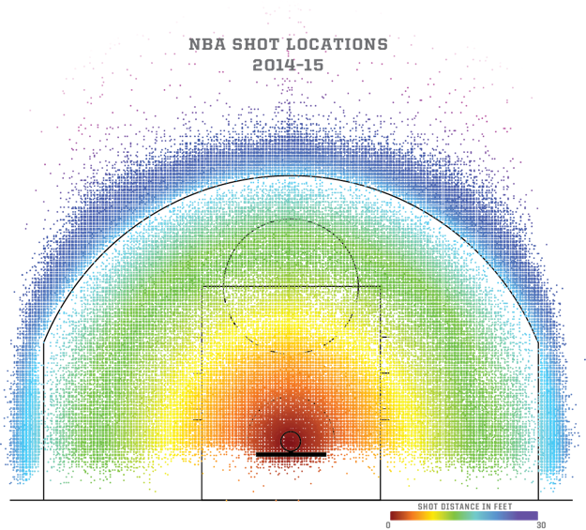

Figure : Every shot from the 2014-15 season w/ heatmap

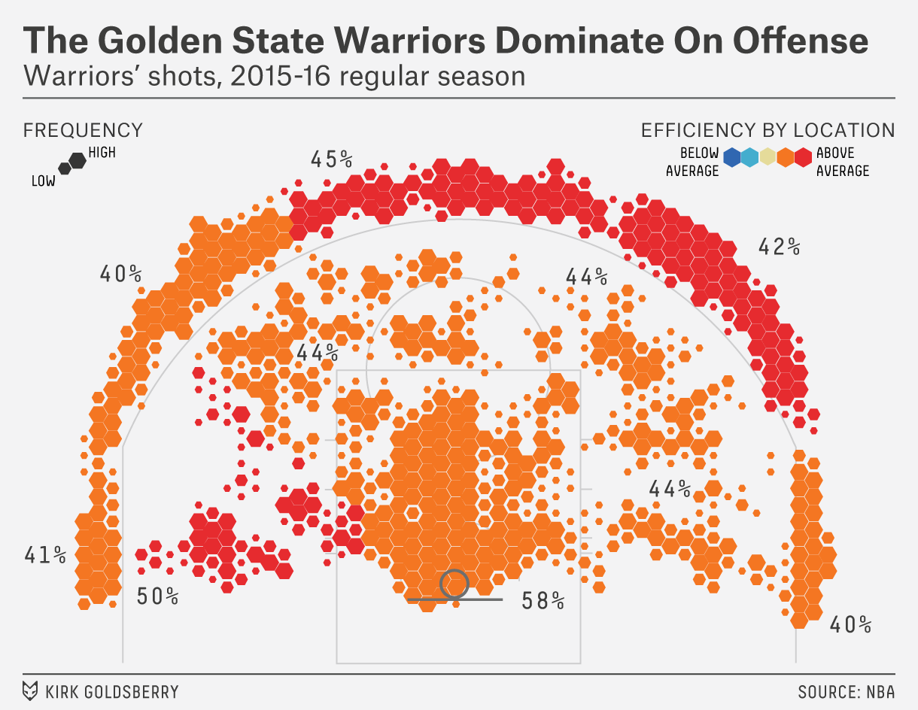

Figure : hex shot chart w/ efficiency % and heatmap

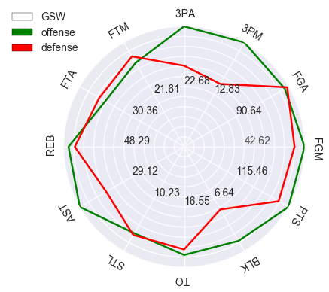

Figure : radar plot containing many statistical categories

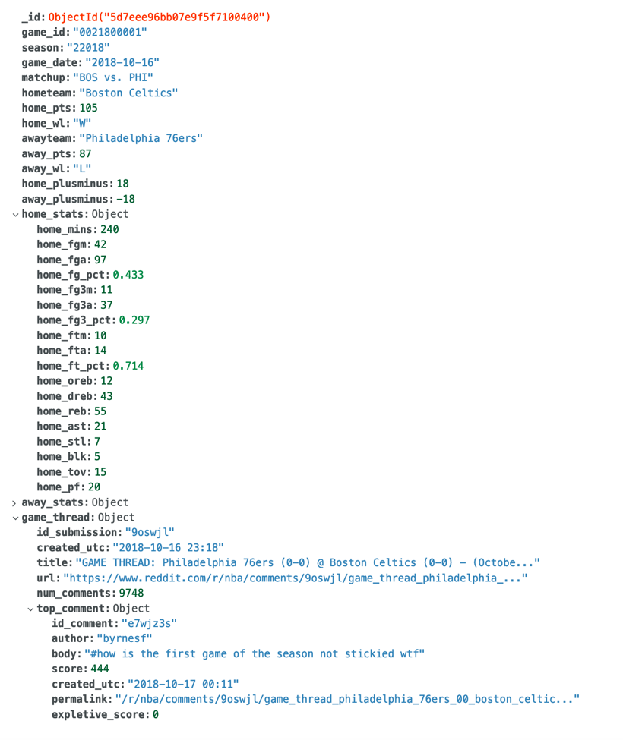

Figure : sample document from remoted mongoDB

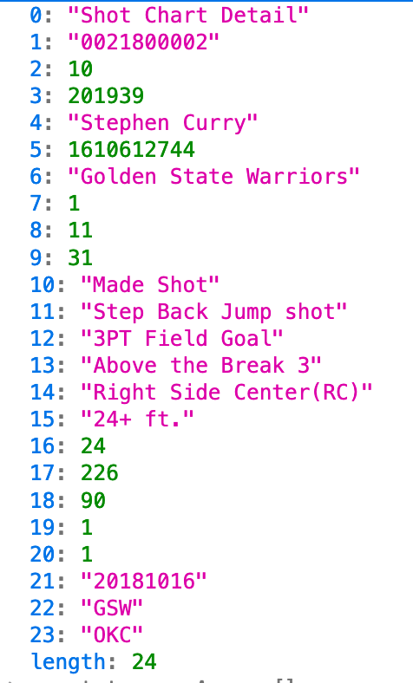

Figure : sample document from shot chart db/API request

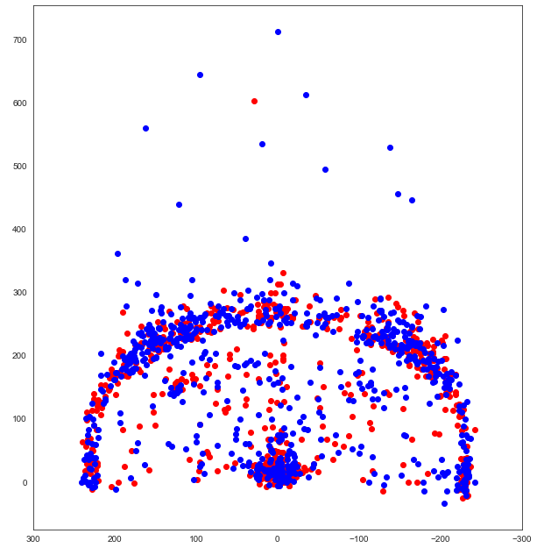

Figure : first attempt at a shot chart for Stephen Curry

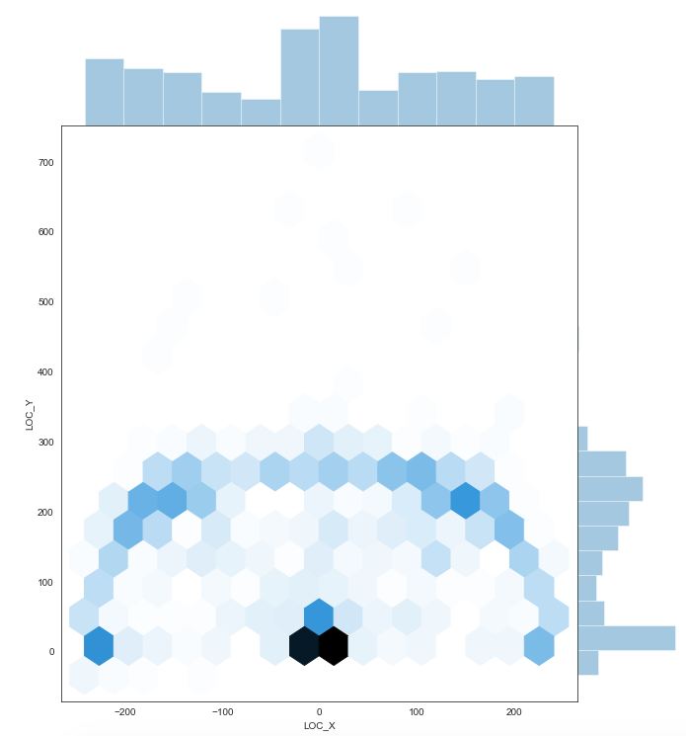

Figure : first attempt at hex shot chart

1. Goldsberry’s paper on spatial analytics for the *Sloan Conference* was foundational for the modern NBA. <https://pdfs.semanticscholar.org/46e4/a7271de62e9118625dec935c4aef1bc0ea74.pdf>