Attendance

Mapping church attendance in time

## Cross-Sectional View

The focal variable of interest is **attend**, the item measuring church attendance for the year that preceded the interview date. The questionnaire recorded the responses on the ordinal scale.

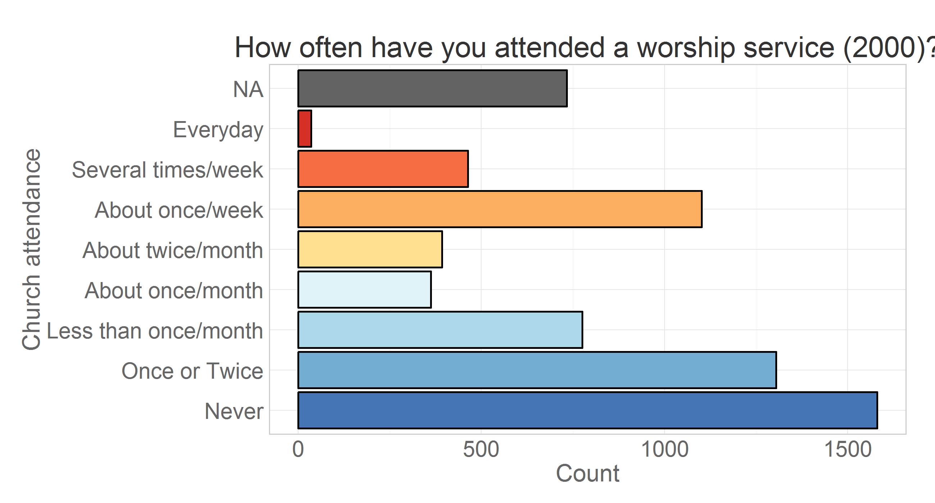

Creating frequency distributions for each of the measurement wave we have:

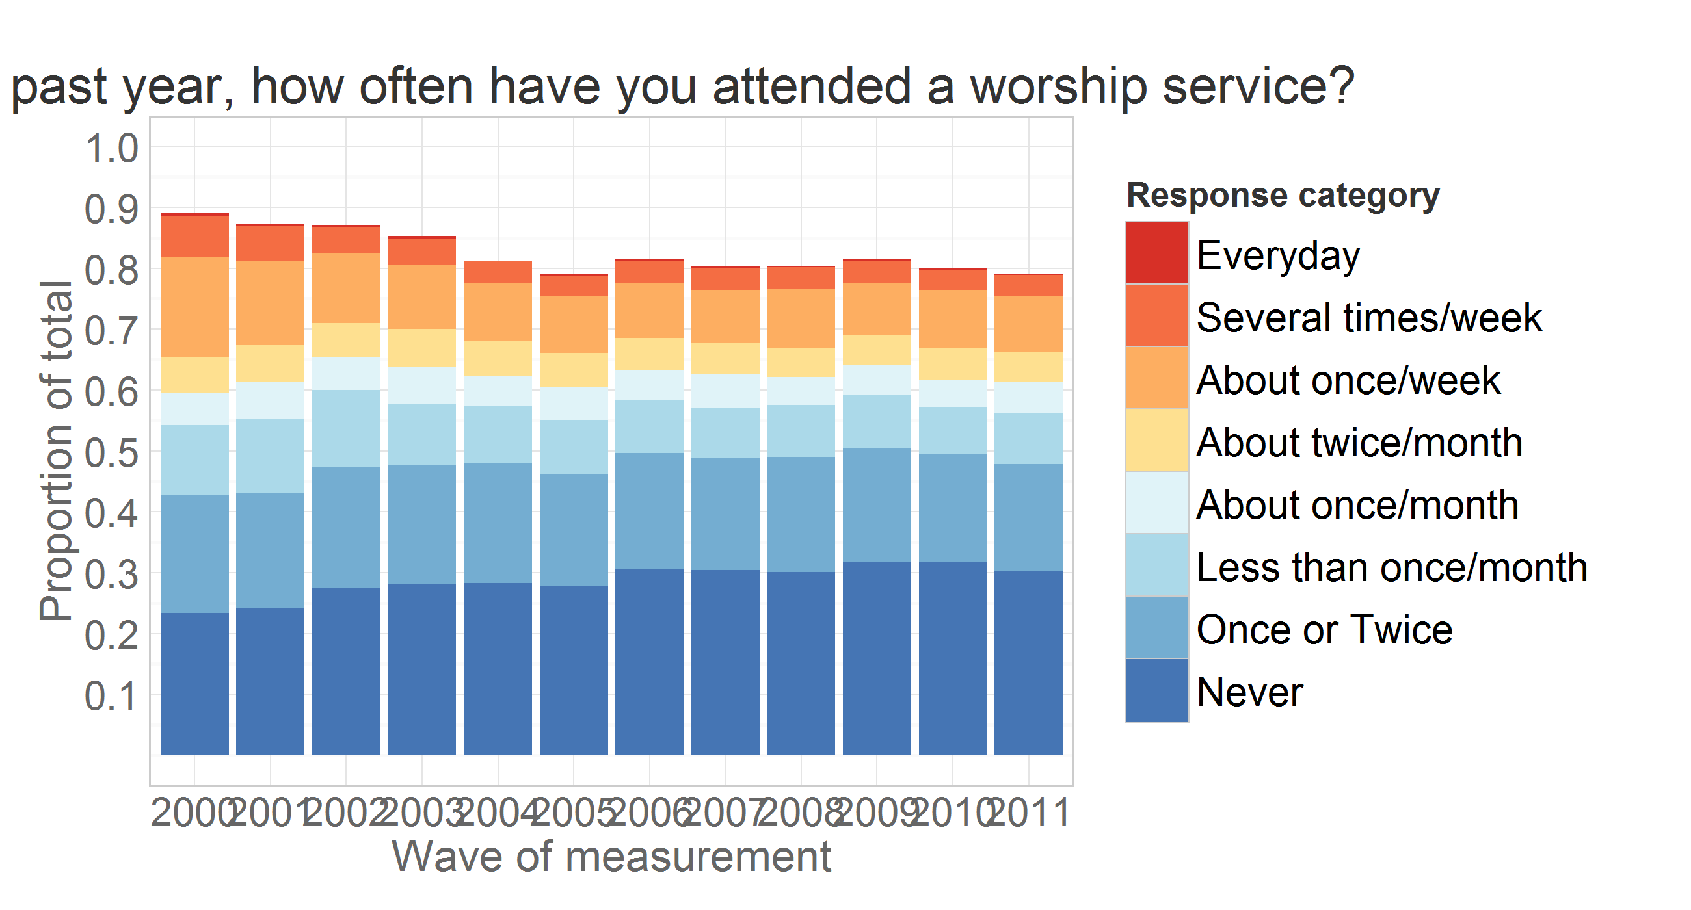

Here, missing values are used in the calculation of total responses to show the natural attrition in the study. Assuming that attrition is not significantly associated with the outcome measure, we can remove missing values from the calculation of the total and look at prevalence of response endorsements over time.

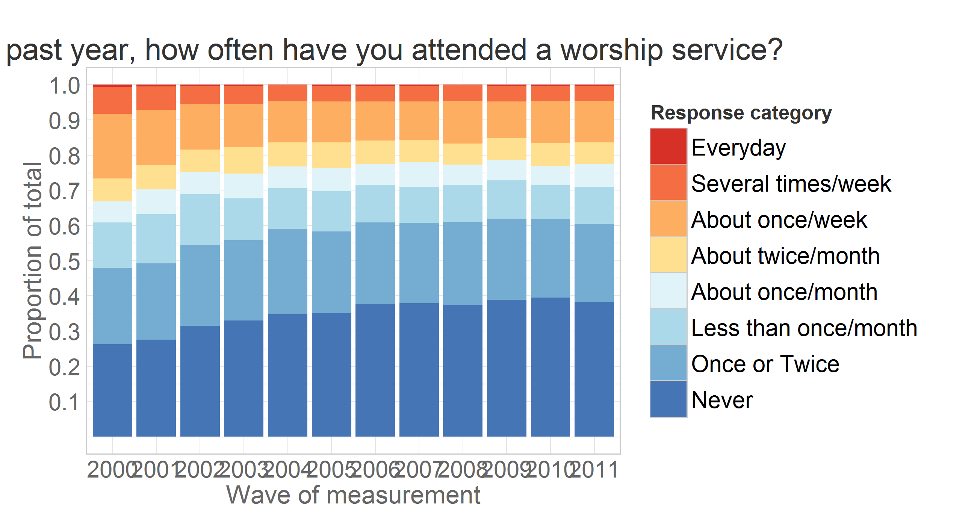

### Change in prevalences

Tracing the rate of change of prevalence in a line graph, we see more clearly which categores increase over time (e.g. "Never"), which decline (e.g. ""About once/week), and which stay relatively stable (e.g. "About twice/month").

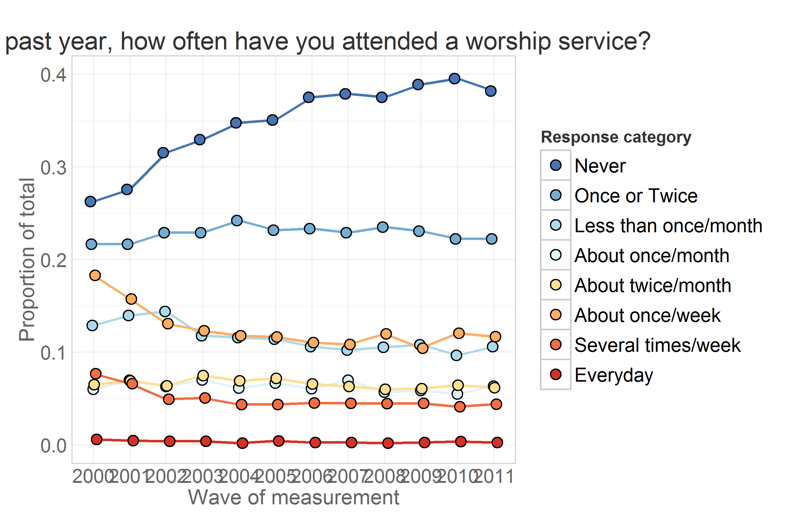

### Prevalence change and race

Inspecting the prevalence trajectories across races.

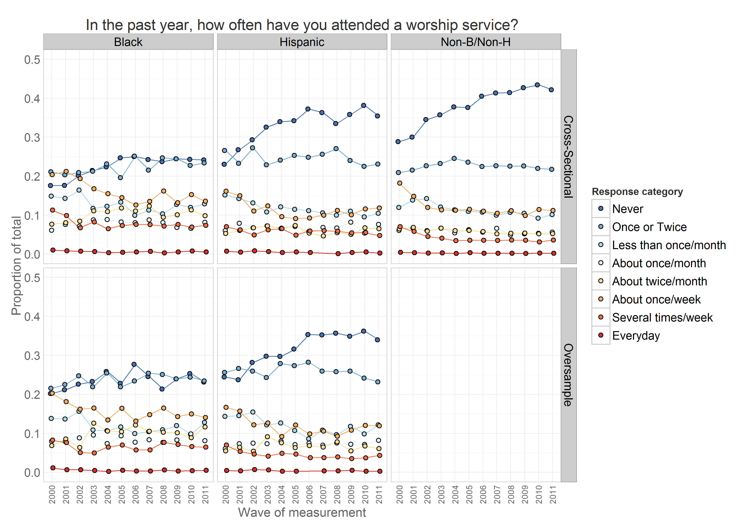

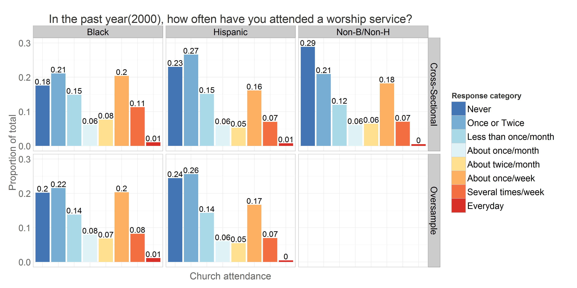

## Longitudinal View

Graphs above shows change in the cross-sectional distribution of responses over the years. Modeling the change in these response frequencies is handled well by Markov models. LCM, however, works with longitudinal data, modeling the trajectory of each individual and treating attendance as a continuous outcome.

To demonstrate mapping of individual trajectories to time, let's select a dataset that would include personal identifyer (**id**), cohort indicator (**byear**), wave of measurement (**year**) and the focal variable of interest - worship attendance (**attend**).

ds<- dsL %>% dplyr::filter(year %in% c(2000:2011), id==47) %>%  
 dplyr:: select(id, byear, year, attend, attendF)  
print(ds)

id byear year attend attendF  
1 47 1982 2000 5 About twice/month  
2 47 1982 2001 2 Once or Twice  
3 47 1982 2002 4 About once/month  
4 47 1982 2003 2 Once or Twice  
5 47 1982 2004 3 Less than once/month  
6 47 1982 2005 2 Once or Twice  
7 47 1982 2006 2 Once or Twice  
8 47 1982 2007 3 Less than once/month  
9 47 1982 2008 2 Once or Twice  
10 47 1982 2009 1 Never  
11 47 1982 2010 1 Never  
12 47 1982 2011 1 Never

The view above lists attendance data for subjust with id = 47. Mapping his attendance to time we have .

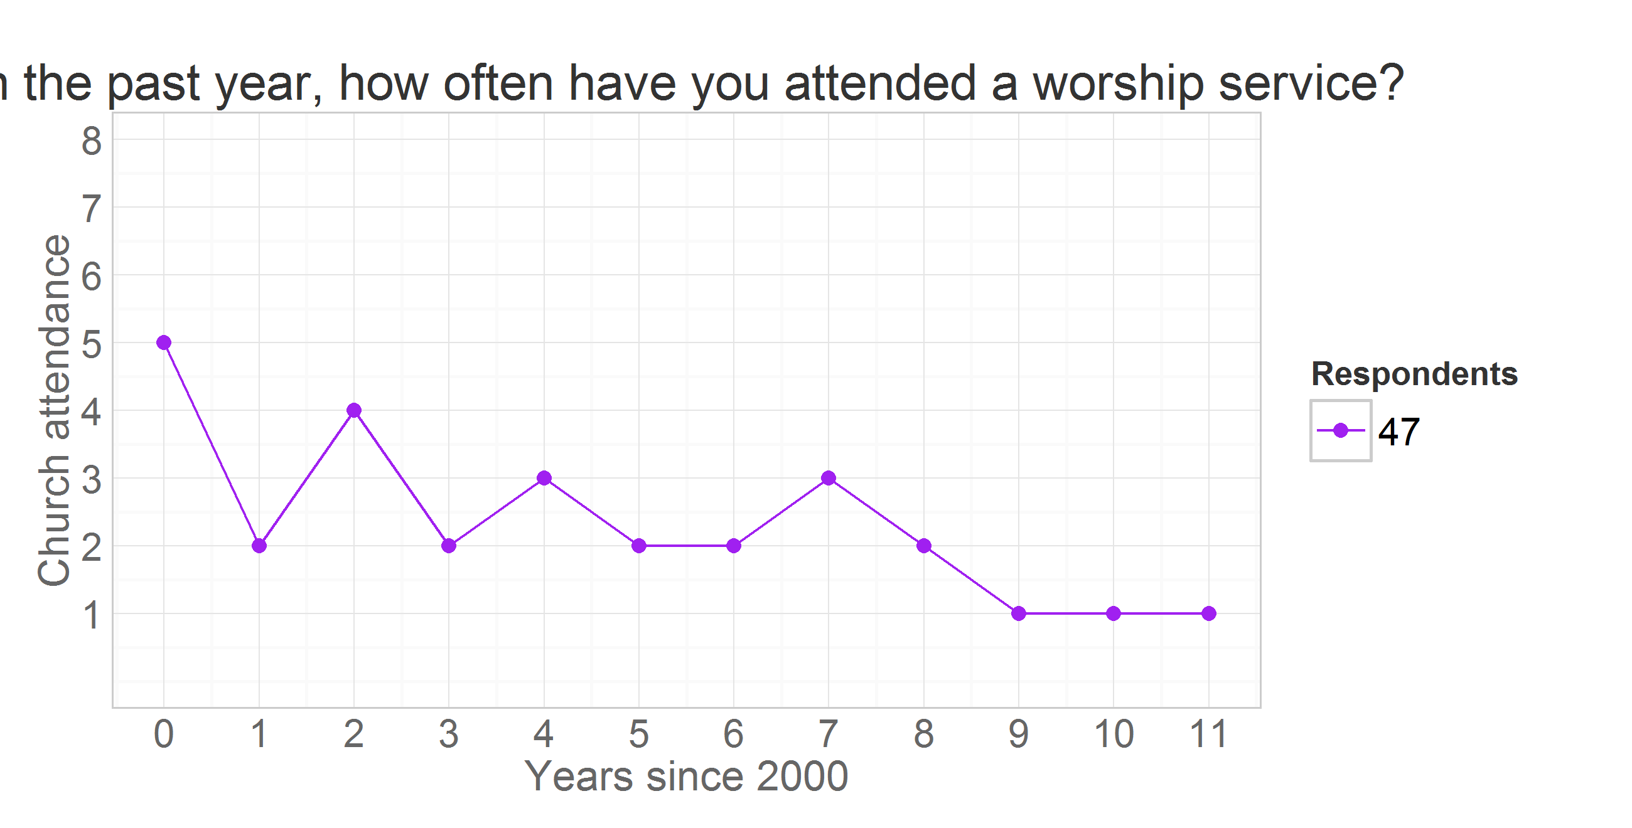

where vertical dimension maps the outcome value and the horizontal maps the time. There will be a trajecory for each of the respondents. Each of such trajectories imply a story, a life scenario. Why one person grows in his religious involvement, while other declines, or never develops an interest in the first place? To demostrate how interpretations of trajectories can vary among individuals consider the following example.

### Attendance over waves

Attendance trajectories of subjects with **id**s 4, 25, 35, and 47 are plotted in the next graph

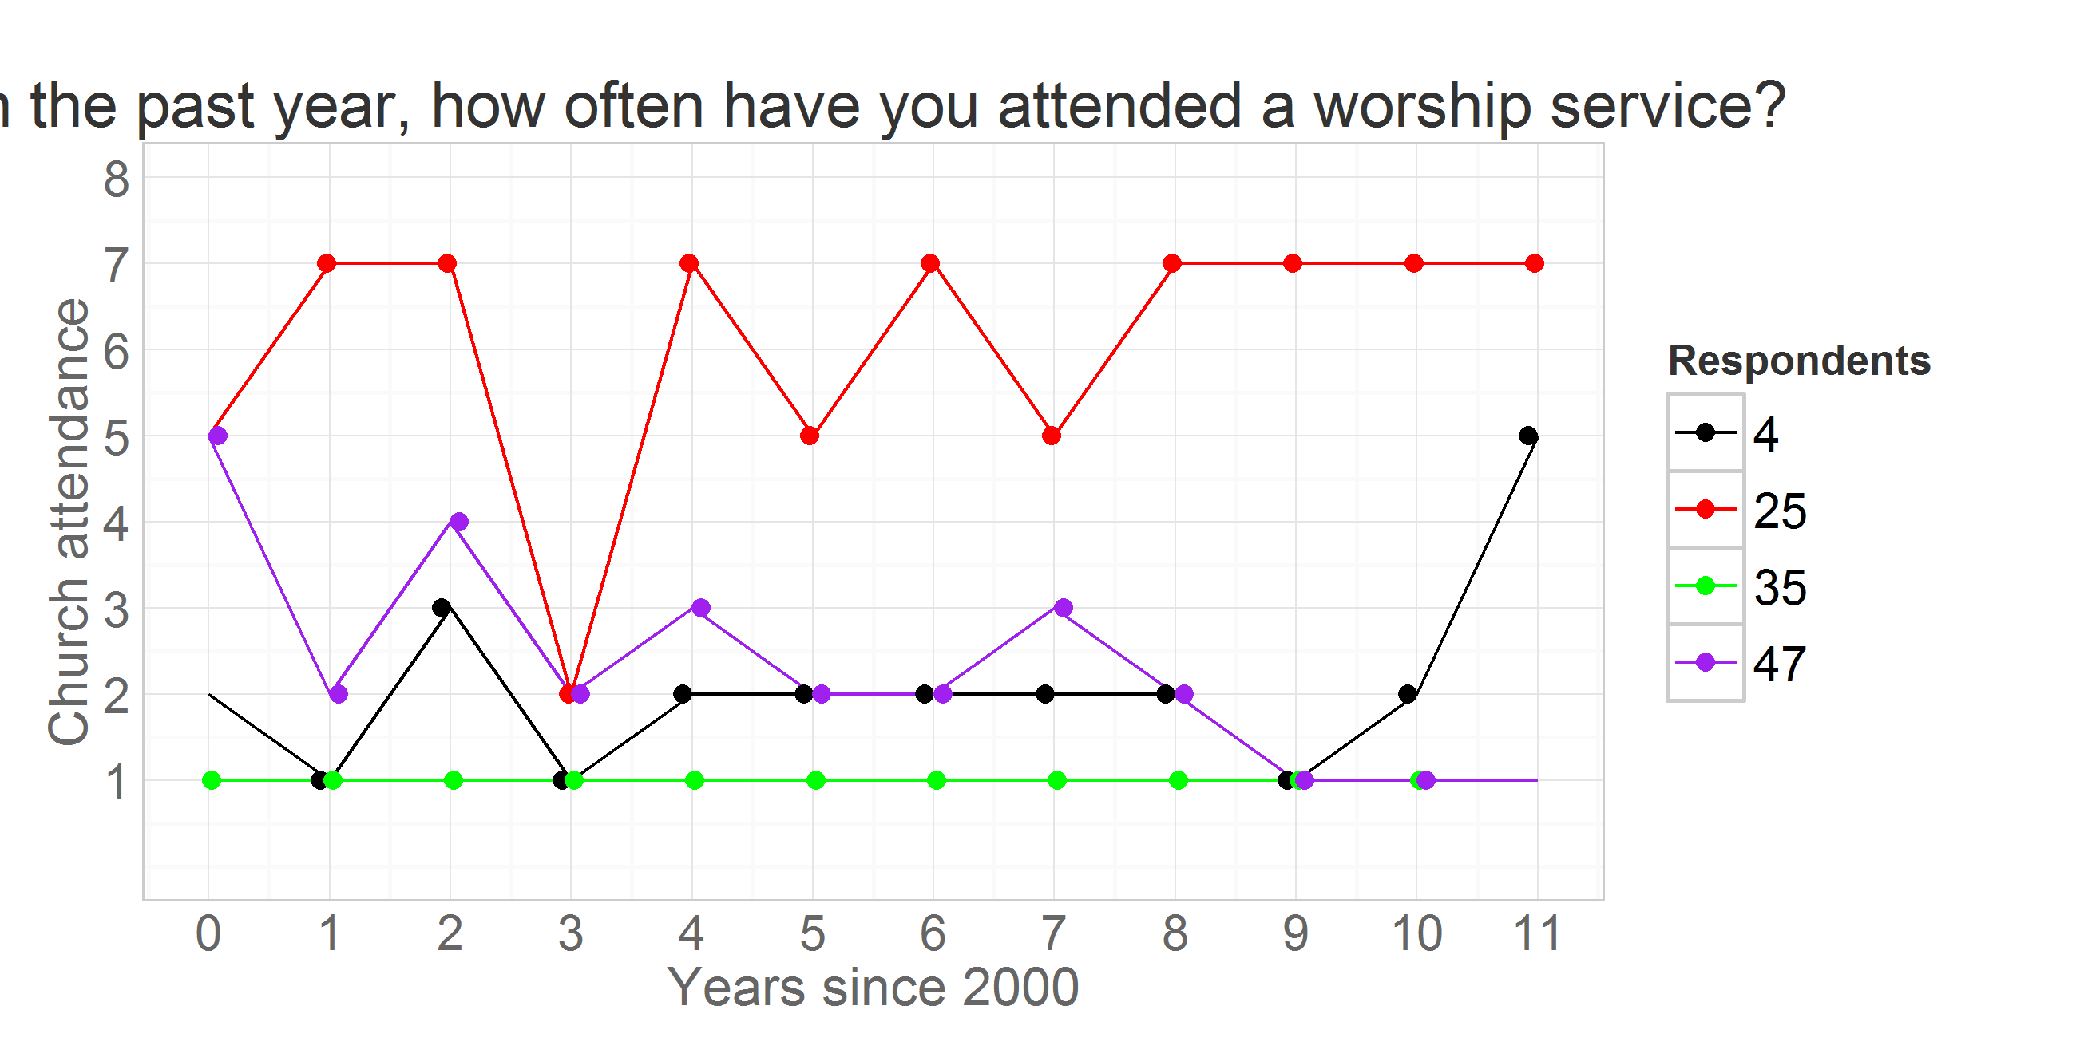

The respondent **id** = 35 reported attending no worship services in any of the years, while respodent **id** = 25 seemed to frequent it, indicating weekly attendance in 8 out of the 12 years. Individual **id** = 47 started as a fairly regular attendee of religious services in 2000 (5 = "about twice a month"), then gradually declined his involvement to nill in 2009 and on. Respondent **id** = 4, on the other hand started off with a rather passive involvement, reporting attended church only "Once or twice" in 2000, maintained a low level of participation throughout the years, only to surge his attendance in 2011. Latent curve models will describe intraindividual trajectories of change, while summarizinig the interindividual similarities and trends.

### Changing the metric of time

Previous research in religiousity indicated that age might be one of the primary factors explaining interindividual differences in church attendance. To examine the role of age, we change the metric of time from waves of measurement, as in the previous graph, to biological age. Consult [Metrics](https://github.com/andkov/Longitudinal_Models_of_Religiosity_NLSY97/blob/master/Models/Descriptives/Metrics.md) report for details on measurement of age.

ds<- dsL %>% dplyr::filter(id %in% c(4,25,35,47),year %in% c(2000:2011)) %>%   
 dplyr::select(idF,byear,bmonth,year,ageyear,agemon) %.%  
 dplyr::mutate(time=year-2000, age=agemon/12)  
print(ds[ds$idF==25,])

idF byear bmonth year ageyear agemon time age  
13 25 1983 3 2000 17 214 0 17.83  
14 25 1983 3 2001 18 226 1 18.83  
15 25 1983 3 2002 19 236 2 19.67  
16 25 1983 3 2003 21 254 3 21.17  
17 25 1983 3 2004 21 261 4 21.75  
18 25 1983 3 2005 22 272 5 22.67  
19 25 1983 3 2006 23 284 6 23.67  
20 25 1983 3 2007 24 295 7 24.58  
21 25 1983 3 2008 25 307 8 25.58  
22 25 1983 3 2009 26 319 9 26.58  
23 25 1983 3 2010 27 332 10 27.67  
24 25 1983 3 2011 28 342 11 28.50

### Attendance over ages

Plotting individual trajectories, with age as the metric of time.

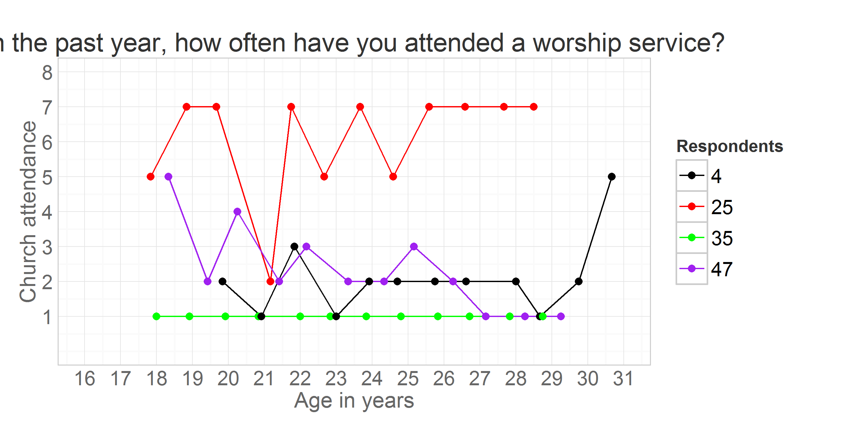

## Read more

in ./Models/Descriptives:

* [Metrics](https://github.com/andkov/Longitudinal_Models_of_Religiosity_NLSY97/blob/master/Models/Descriptives/Metrics.md) - how values of items are labeled
* [Descriptives](https://github.com/andkov/Longitudinal_Models_of_Religiosity_NLSY97/blob/master/Models/Descriptives/Descriptives.md) - basic stats of various items
* [Attendance](https://github.com/andkov/Longitudinal_Models_of_Religiosity_NLSY97/blob/master/Models/Descriptives/Attendance.md) - focus on church attendence over time
* [Databox](https://github.com/andkov/Longitudinal_Models_of_Religiosity_NLSY97/blob/master/Models/Descriptives/Databox.Rmd)

See also

* [Deriving Data from NLYS97 extract](https://github.com/andkov/Longitudinal_Models_of_Religiosity_NLSY97/blob/master/Data/Derive_dsL_from_Extract.md)
* [Data Manipulation Guide](https://github.com/andkov/Longitudinal_Models_of_Religiosity_NLSY97/blob/master/Vignettes/dplyr/Data_Manipulation_Guide.md)