Descriptives

Andriy Koval

Tuesday, June 24, 2014

There are total of

cat(length(unique(dsL$id)))

8983

respondents.

ds<- dsL %>% group_by(sampleF) %>% summarize (count=n_distinct(id))  
ds

Source: local data frame [2 x 2]  
  
 sampleF count  
1 Cross-Sectional 6747  
2 Oversample 2236

Basic demographics is given in Figure 4.#

ymax not defined: adjusting position using y instead  
ymax not defined: adjusting position using y instead

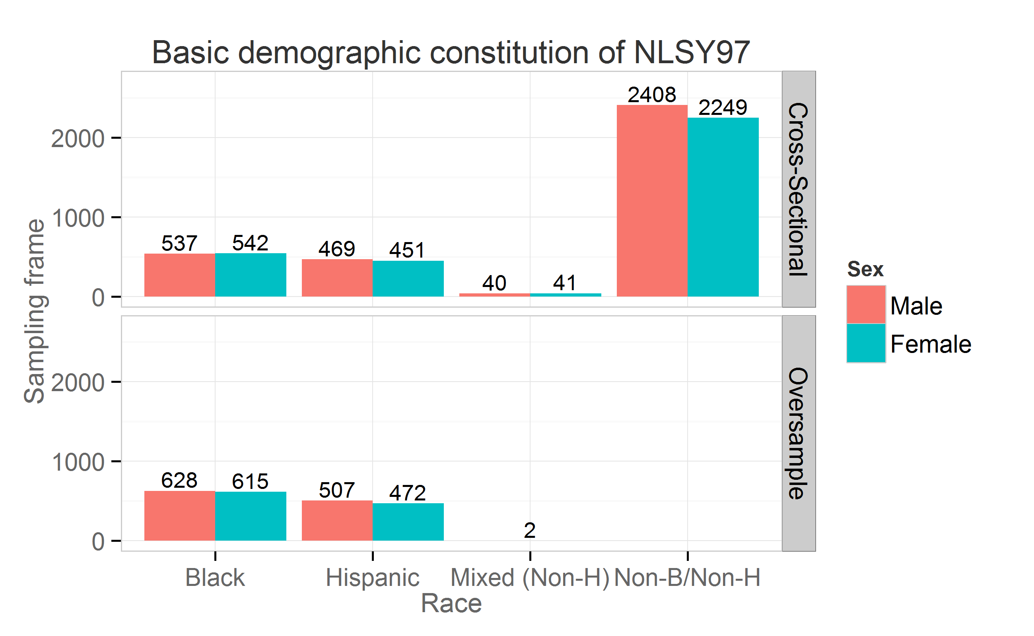

Respondentsâ€™ age was of particular interest and was entered as a predictor of church attendance. NSLY97 contains static and dynamic indicators of age age. Variables byear and bmonth were recorded once in 1997 (static) and contain respondentsâ€™ birth year and birth month respectively. Two age variables were recorded continuously at each interview (dynamic): age at the time of the interview in months agemon and in years ageyear. Figure 4.2 shows how births in the NLSY97 sample (static age) was distributed over calendric months from 1980 to 1984:

Source: local data frame [13 x 4]  
Groups: bmonth  
  
 bmonth byearF count born  
1 1 1980 159 80-1  
2 2 1980 136 80-2  
3 3 1980 139 80-3  
4 4 1980 125 80-4  
5 5 1980 128 80-5  
6 6 1980 137 80-6  
7 7 1980 136 80-7  
8 8 1980 141 80-8  
9 9 1980 144 80-9  
10 10 1980 146 80-10  
11 11 1980 146 80-11  
12 12 1980 154 80-12  
13 1 1981 160 81-1

