Metrics

Andriy Koval

Tuesday, June 24, 2014

# Metrics: labeling factors and exploring scales

Report explains how the response categories from NLSY97 questionnaire are labeled and demonstrates application of labeled factors in data operations and graphing.

## Data preliminaries

This section introduces data space.  
### Data In Initial point of departure - the [databox](http://statcanvas.net/thesis/databox/) of the selected variables, described in the [Methods](http://statcanvas.net/thesis/III_methods/03_Methods.htm) chapter. 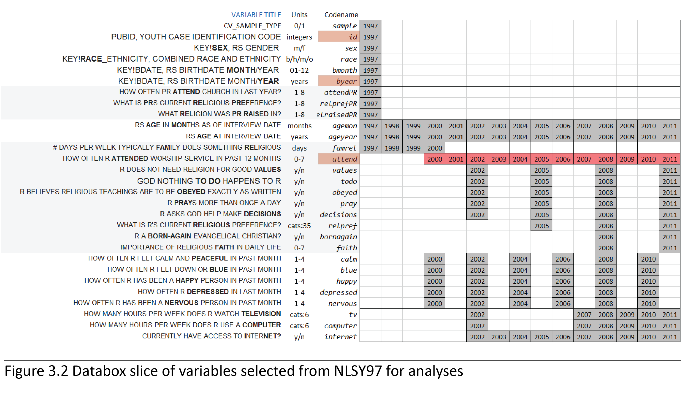 This [databox](http://statcanvas.net/thesis/databox/) corresponds to the dataset **dsL** produced by [Derive_dsL_from_Extract](https://github.com/andkov/Longitudinal_Models_of_Religiosity_NLSY97/blob/master/Data/Derive_dsL_from_Extract.md) report, given in the Appendix.

dsL<-readRDS("./Data/Derived/dsL.rds")

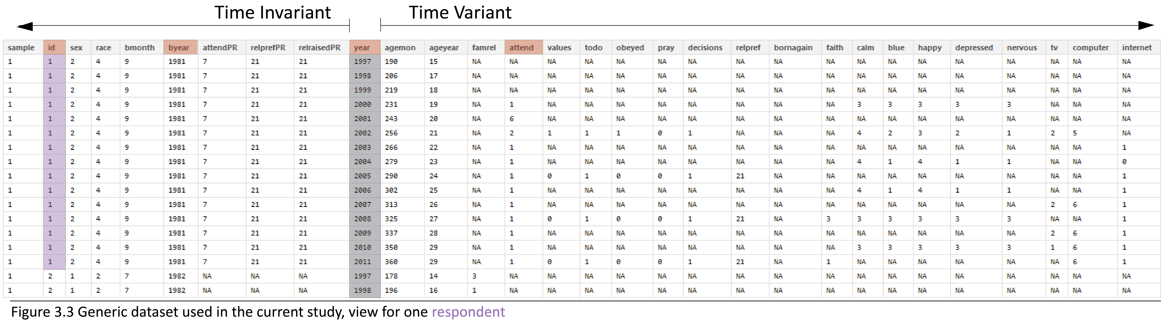

## Labeling Factor Levels

Review of the item reference [cards](http://statcanvas.net/thesis/databox/) shows that initially, all items were recorded on some discrete scale, either counting occasions or assigning an intiger to a category of response. However, data were saved as numerical values or intigers

ds<- dsL[,1:(ncol(dsL)/2)]# selects the first half of variables  
str(ds)

'data.frame': 134760 obs. of 30 variables:  
 $ sample : int 1 1 1 1 1 1 1 1 1 1 ...  
 $ id : int 1 1 1 1 1 1 1 1 1 1 ...  
 $ sex : int 2 2 2 2 2 2 2 2 2 2 ...  
 $ race : int 4 4 4 4 4 4 4 4 4 4 ...  
 $ bmonth : int 9 9 9 9 9 9 9 9 9 9 ...  
 $ byear : int 1981 1981 1981 1981 1981 1981 1981 1981 1981 1981 ...  
 $ attendPR : int 7 7 7 7 7 7 7 7 7 7 ...  
 $ relprefPR : int 21 21 21 21 21 21 21 21 21 21 ...  
 $ relraisedPR: int 21 21 21 21 21 21 21 21 21 21 ...  
 $ year : int 1997 1998 1999 2000 2001 2002 2003 2004 2005 2006 ...  
 $ agemon : num 190 206 219 231 243 256 266 279 290 302 ...  
 $ ageyear : num 15 17 18 19 20 21 22 23 24 25 ...  
 $ famrel : num NA NA NA NA NA NA NA NA NA NA ...  
 $ attend : num NA NA NA 1 6 2 1 1 1 1 ...  
 $ values : num NA NA NA NA NA 1 NA NA 0 NA ...  
 $ todo : num NA NA NA NA NA 1 NA NA 1 NA ...  
 $ obeyed : num NA NA NA NA NA 1 NA NA 0 NA ...  
 $ pray : num NA NA NA NA NA 0 NA NA 0 NA ...  
 $ decisions : num NA NA NA NA NA 1 NA NA 1 NA ...  
 $ relpref : num NA NA NA NA NA NA NA NA 21 NA ...  
 $ bornagain : num NA NA NA NA NA NA NA NA NA NA ...  
 $ faith : num NA NA NA NA NA NA NA NA NA NA ...  
 $ calm : num NA NA NA 3 NA 4 NA 4 NA 4 ...  
 $ blue : num NA NA NA 3 NA 2 NA 1 NA 1 ...  
 $ happy : num NA NA NA 3 NA 3 NA 4 NA 4 ...  
 $ depressed : num NA NA NA 3 NA 2 NA 1 NA 1 ...  
 $ nervous : num NA NA NA 3 NA 1 NA 1 NA 1 ...  
 $ tv : num NA NA NA NA NA 2 NA NA NA NA ...  
 $ computer : num NA NA NA NA NA 5 NA NA NA NA ...  
 $ internet : num NA NA NA NA NA NA 1 0 1 1 ...

[LabelingFactorLevels.R](https://github.com/andkov/Longitudinal_Models_of_Religiosity_NLSY97/blob/master/Scripts/Data/LabelingFactorLevels.R) sourced at the end of [Derive_dsL_from_Extract](https://github.com/andkov/Longitudinal_Models_of_Religiosity_NLSY97/blob/master/Data/Derive_dsL_from_Extract.md) matches numeric values with response labels from the questionnaire and adds to **dsL** copies of the variables, saved as labeled factors. For estimations routines such as lm4 or graphing functions such as ggplot, the data type (string,numeric, factor) is a meaningful input, so a quick access to both formats frequently proves useful. It is convenient to think that **dsL** contains only

ncol(dsL)/2

[1] 30

variables, but each of them has a double, a labeled factor.

str(dsL)

'data.frame': 134760 obs. of 60 variables:  
 $ sample : int 1 1 1 1 1 1 1 1 1 1 ...  
 $ id : int 1 1 1 1 1 1 1 1 1 1 ...  
 $ sex : int 2 2 2 2 2 2 2 2 2 2 ...  
 $ race : int 4 4 4 4 4 4 4 4 4 4 ...  
 $ bmonth : int 9 9 9 9 9 9 9 9 9 9 ...  
 $ byear : int 1981 1981 1981 1981 1981 1981 1981 1981 1981 1981 ...  
 $ attendPR : int 7 7 7 7 7 7 7 7 7 7 ...  
 $ relprefPR : int 21 21 21 21 21 21 21 21 21 21 ...  
 $ relraisedPR : int 21 21 21 21 21 21 21 21 21 21 ...  
 $ year : int 1997 1998 1999 2000 2001 2002 2003 2004 2005 2006 ...  
 $ agemon : num 190 206 219 231 243 256 266 279 290 302 ...  
 $ ageyear : num 15 17 18 19 20 21 22 23 24 25 ...  
 $ famrel : num NA NA NA NA NA NA NA NA NA NA ...  
 $ attend : num NA NA NA 1 6 2 1 1 1 1 ...  
 $ values : num NA NA NA NA NA 1 NA NA 0 NA ...  
 $ todo : num NA NA NA NA NA 1 NA NA 1 NA ...  
 $ obeyed : num NA NA NA NA NA 1 NA NA 0 NA ...  
 $ pray : num NA NA NA NA NA 0 NA NA 0 NA ...  
 $ decisions : num NA NA NA NA NA 1 NA NA 1 NA ...  
 $ relpref : num NA NA NA NA NA NA NA NA 21 NA ...  
 $ bornagain : num NA NA NA NA NA NA NA NA NA NA ...  
 $ faith : num NA NA NA NA NA NA NA NA NA NA ...  
 $ calm : num NA NA NA 3 NA 4 NA 4 NA 4 ...  
 $ blue : num NA NA NA 3 NA 2 NA 1 NA 1 ...  
 $ happy : num NA NA NA 3 NA 3 NA 4 NA 4 ...  
 $ depressed : num NA NA NA 3 NA 2 NA 1 NA 1 ...  
 $ nervous : num NA NA NA 3 NA 1 NA 1 NA 1 ...  
 $ tv : num NA NA NA NA NA 2 NA NA NA NA ...  
 $ computer : num NA NA NA NA NA 5 NA NA NA NA ...  
 $ internet : num NA NA NA NA NA NA 1 0 1 1 ...  
 $ sampleF : Ord.factor w/ 2 levels "Cross-Sectional"<..: 1 1 1 1 1 1 1 1 1 1 ...  
 $ idF : Factor w/ 8984 levels "1","2","3","4",..: 1 1 1 1 1 1 1 1 1 1 ...  
 $ sexF : Ord.factor w/ 3 levels "Male"<"Female"<..: 2 2 2 2 2 2 2 2 2 2 ...  
 $ raceF : Ord.factor w/ 4 levels "Black"<"Hispanic"<..: NA NA NA NA NA NA NA NA NA NA ...  
 $ bmonthF : Ord.factor w/ 12 levels "Jan"<"Feb"<"Mar"<..: 9 9 9 9 9 9 9 9 9 9 ...  
 $ byearF : Factor w/ 5 levels "1980","1981",..: 2 2 2 2 2 2 2 2 2 2 ...  
 $ attendPRF : Ord.factor w/ 8 levels "Never"<"Once or Twice"<..: 7 7 7 7 7 7 7 7 7 7 ...  
 $ relprefPRF : Ord.factor w/ 33 levels "Catholic"<"Baptist"<..: 21 21 21 21 21 21 21 21 21 21 ...  
 $ relraisedPRF: Ord.factor w/ 33 levels "Catholic"<"Baptist"<..: 21 21 21 21 21 21 21 21 21 21 ...  
 $ yearF : Factor w/ 15 levels "1997","1998",..: 1 2 3 4 5 6 7 8 9 10 ...  
 $ agemonF : Factor w/ 244 levels "146","147","148",..: 45 61 74 86 98 111 121 134 145 157 ...  
 $ ageyearF : Factor w/ 21 levels "12","13","14",..: 4 6 7 8 9 10 11 12 13 14 ...  
 $ famrelF : Factor w/ 8 levels "0","1","2","3",..: NA NA NA NA NA NA NA NA NA NA ...  
 $ attendF : Ord.factor w/ 8 levels "Never"<"Once or Twice"<..: NA NA NA 1 6 2 1 1 1 1 ...  
 $ valuesF : Ord.factor w/ 2 levels "FALSE/less Religious"<..: NA NA NA NA NA 2 NA NA 1 NA ...  
 $ todoF : Ord.factor w/ 2 levels "FALSE/less Religious"<..: NA NA NA NA NA 2 NA NA 2 NA ...  
 $ obeyedF : Ord.factor w/ 2 levels "FALSE/less Religious"<..: NA NA NA NA NA 2 NA NA 1 NA ...  
 $ prayF : Ord.factor w/ 2 levels "FALSE/less Religious"<..: NA NA NA NA NA 1 NA NA 1 NA ...  
 $ decisionsF : Ord.factor w/ 2 levels "FALSE/less Religious"<..: NA NA NA NA NA 2 NA NA 2 NA ...  
 $ relprefF : Ord.factor w/ 33 levels "Catholic"<"Baptist"<..: NA NA NA NA NA NA NA NA 21 NA ...  
 $ bornagainF : Ord.factor w/ 2 levels "NO"<"YES": NA NA NA NA NA NA NA NA NA NA ...  
 $ faithF : Ord.factor w/ 5 levels "Exrtemely"<"Very"<..: NA NA NA NA NA NA NA NA NA NA ...  
 $ calmF : Ord.factor w/ 4 levels "All of the time"<..: NA NA NA NA NA NA NA NA NA NA ...  
 $ blueF : Ord.factor w/ 4 levels "All of the time"<..: NA NA NA NA NA NA NA NA NA NA ...  
 $ happyF : Ord.factor w/ 4 levels "All of the time"<..: NA NA NA NA NA NA NA NA NA NA ...  
 $ depressedF : Ord.factor w/ 4 levels "All of the time"<..: NA NA NA NA NA NA NA NA NA NA ...  
 $ nervousF : Ord.factor w/ 4 levels "All of the time"<..: NA NA NA NA NA NA NA NA NA NA ...  
 $ tvF : Ord.factor w/ 6 levels "less than 2"<..: NA NA NA NA NA 2 NA NA NA NA ...  
 $ computerF : Ord.factor w/ 6 levels "None"<"less than 1"<..: NA NA NA NA NA 5 NA NA NA NA ...  
 $ internetF : Ord.factor w/ 2 levels "No"<"Yes": NA NA NA NA NA NA 2 1 2 2 ...

This give a certain flexibity to assemble needed dataset quickly and have access to factor labels. One can alternate between the raw metric and labeled factor by adding "F" suffix to the end of the variable name:

selectCols<-c("year","id","byear","attend","attendF") # select the columns with these names  
ds<-dsL[,selectCols] # select all rows for the columns listed selectCols  
print(ds[ds$id==1,]) # print all availible data for respondent with ID 1

year id byear attend attendF  
1 1997 1 1981 NA <NA>  
2 1998 1 1981 NA <NA>  
3 1999 1 1981 NA <NA>  
4 2000 1 1981 1 Never  
5 2001 1 1981 6 About once/week  
6 2002 1 1981 2 Once or Twice  
7 2003 1 1981 1 Never  
8 2004 1 1981 1 Never  
9 2005 1 1981 1 Never  
10 2006 1 1981 1 Never  
11 2007 1 1981 1 Never  
12 2008 1 1981 1 Never  
13 2009 1 1981 1 Never  
14 2010 1 1981 1 Never  
15 2011 1 1981 1 Never

Having quick access to factor labels will be especially useful during graph production. For the grammer rules of operations with relevant data see [Data Manipulation Guide](https://github.com/andkov/Longitudinal_Models_of_Religiosity_NLSY97/blob/master/Vignettes/dplyr/Data_Manipulation_Guide.md).

## Time metrics : Age, Period, Cohort

NLSY97 sample includes individuals from five cohorts, born between 1980 and 1984.The following graphics shows how birth cohort, age of respondents, and round of observation are related in NSLY97.  
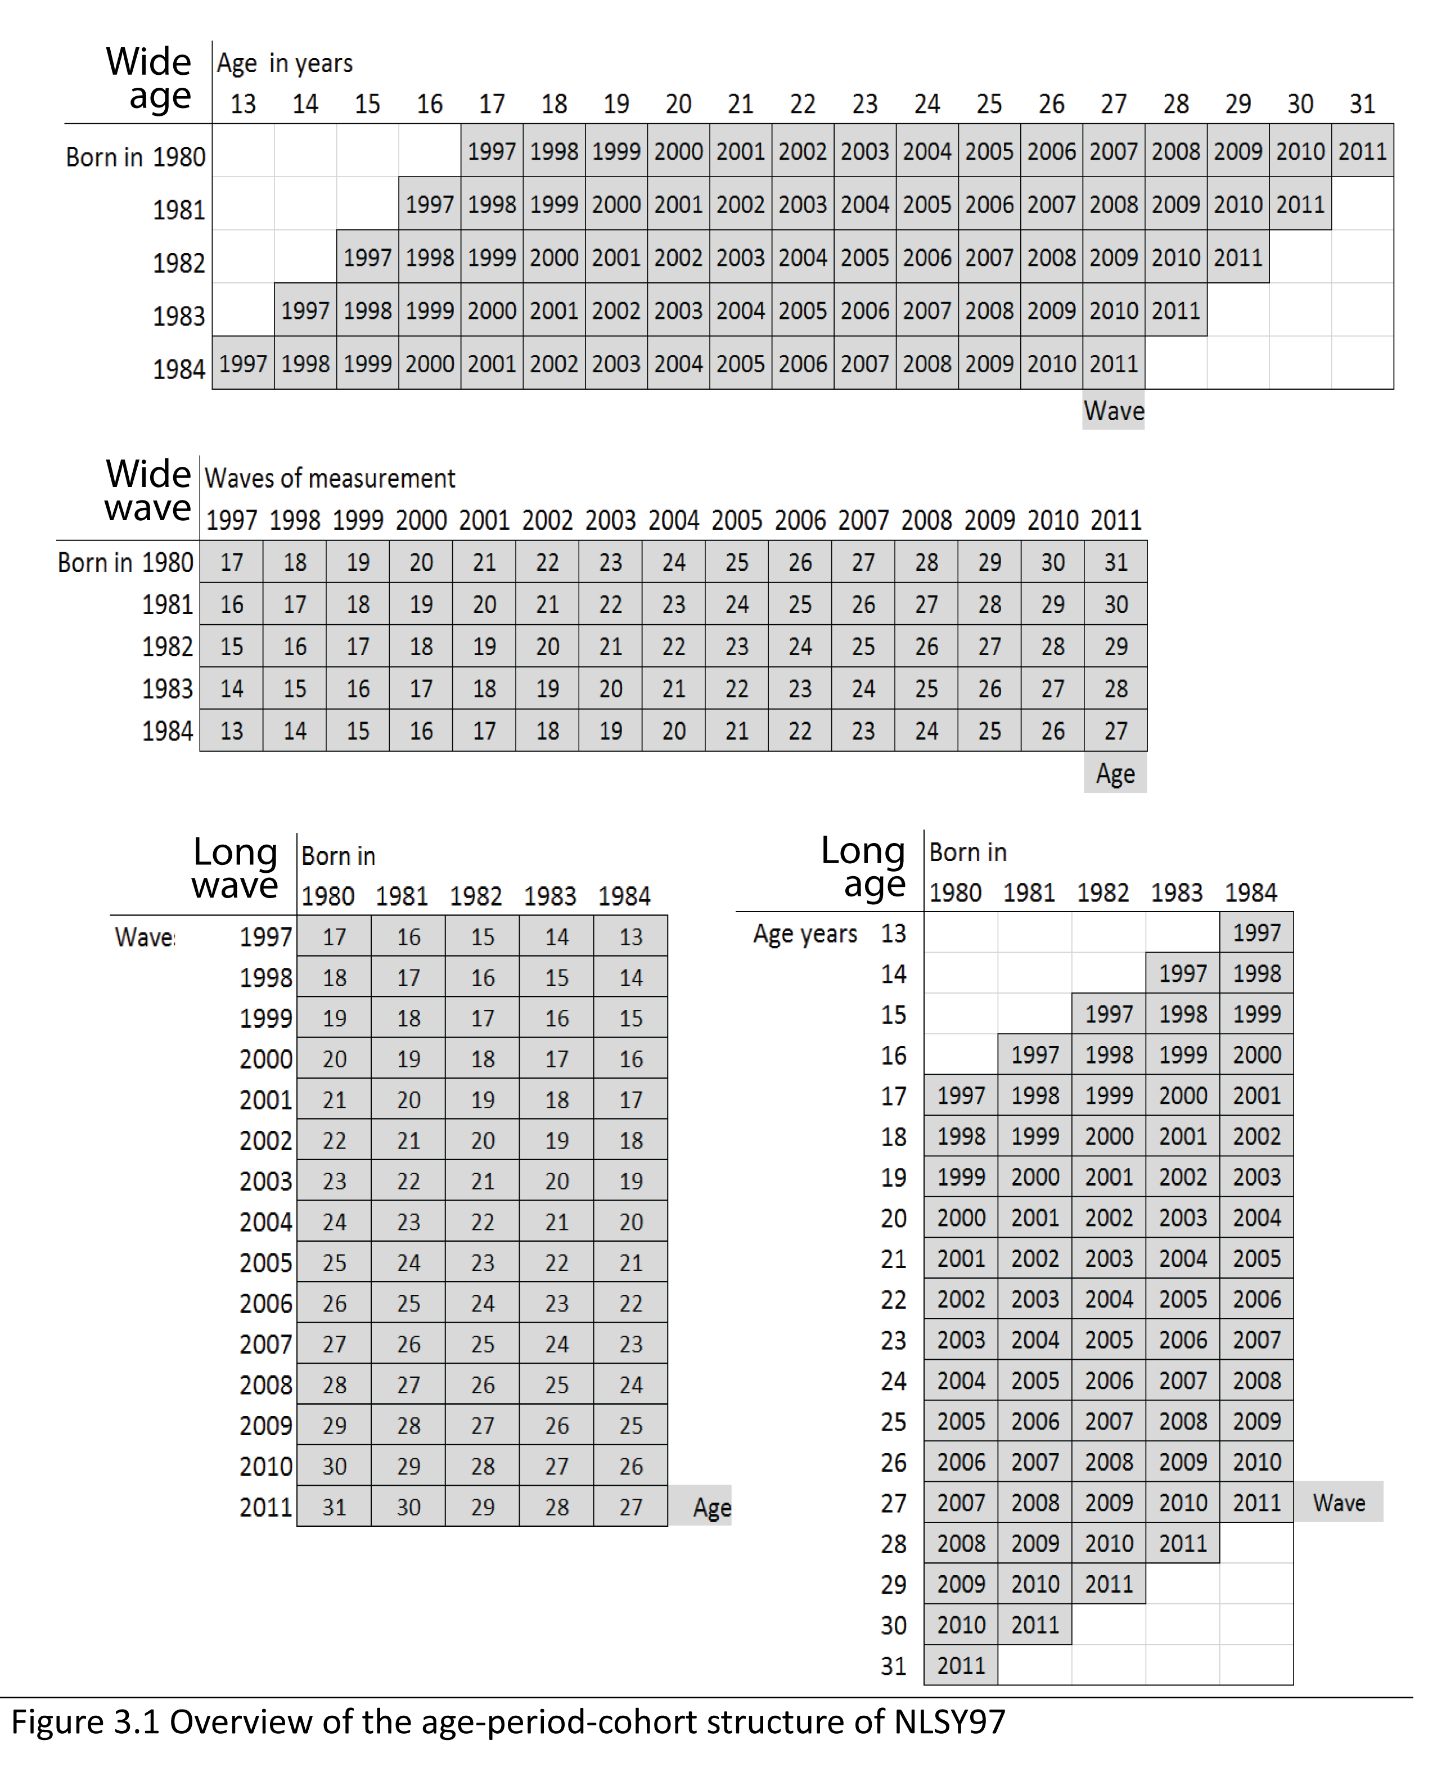

There are several indicators of age in NSLY97 that vary in precision. Birth cohort (**byear**) is the most general one, it was recorded once. Two age variables were recorded at each interview: age at the time of the interview in months (**agemon**) and in years (**ageyear**). Those are not derivatives of each other, but are are closely related. The variable **ageyear** records the full number of years a respondent reached at the time of the interview. Due to difficulties of administering the survey, time intervals between the waves could differ. For example, for one person **id** = 25 the age was recorded as 21 years for both 2003 and 2004 (see **ageyear**). However, when you examine age in months (**agemon**) you can see this rounding issue disappears once a more precise scale is used. To avoid this potentially confusing peculiarity, age in years will be calculated as (**age** = **year** - **byear**) or as (**ageALT** = **agemon**/12).

ds<-dsL[dsL$year %in% c(2000:2011),c('id',"byear","year","attend","ageyear","agemon")]  
ds<- ds[ds$id %in% c(25),]  
ds$age<-ds$year-ds$byear  
ds$ageALT<- ds$agemon/12  
print(ds)

id byear year attend ageyear agemon age ageALT  
364 25 1983 2000 5 17 214 17 17.83  
365 25 1983 2001 7 18 226 18 18.83  
366 25 1983 2002 7 19 236 19 19.67  
367 25 1983 2003 2 21 254 20 21.17  
368 25 1983 2004 7 21 261 21 21.75  
369 25 1983 2005 5 22 272 22 22.67  
370 25 1983 2006 7 23 284 23 23.67  
371 25 1983 2007 5 24 295 24 24.58  
372 25 1983 2008 7 25 307 25 25.58  
373 25 1983 2009 7 26 319 26 26.58  
374 25 1983 2010 7 27 332 27 27.67  
375 25 1983 2011 7 28 342 28 28.50

## Mapping Church Attendance

The focal variable of interest is **attend**, an item measuring church attendance in the current year. The questionnaire recorded the responses on the ordinal scale.  
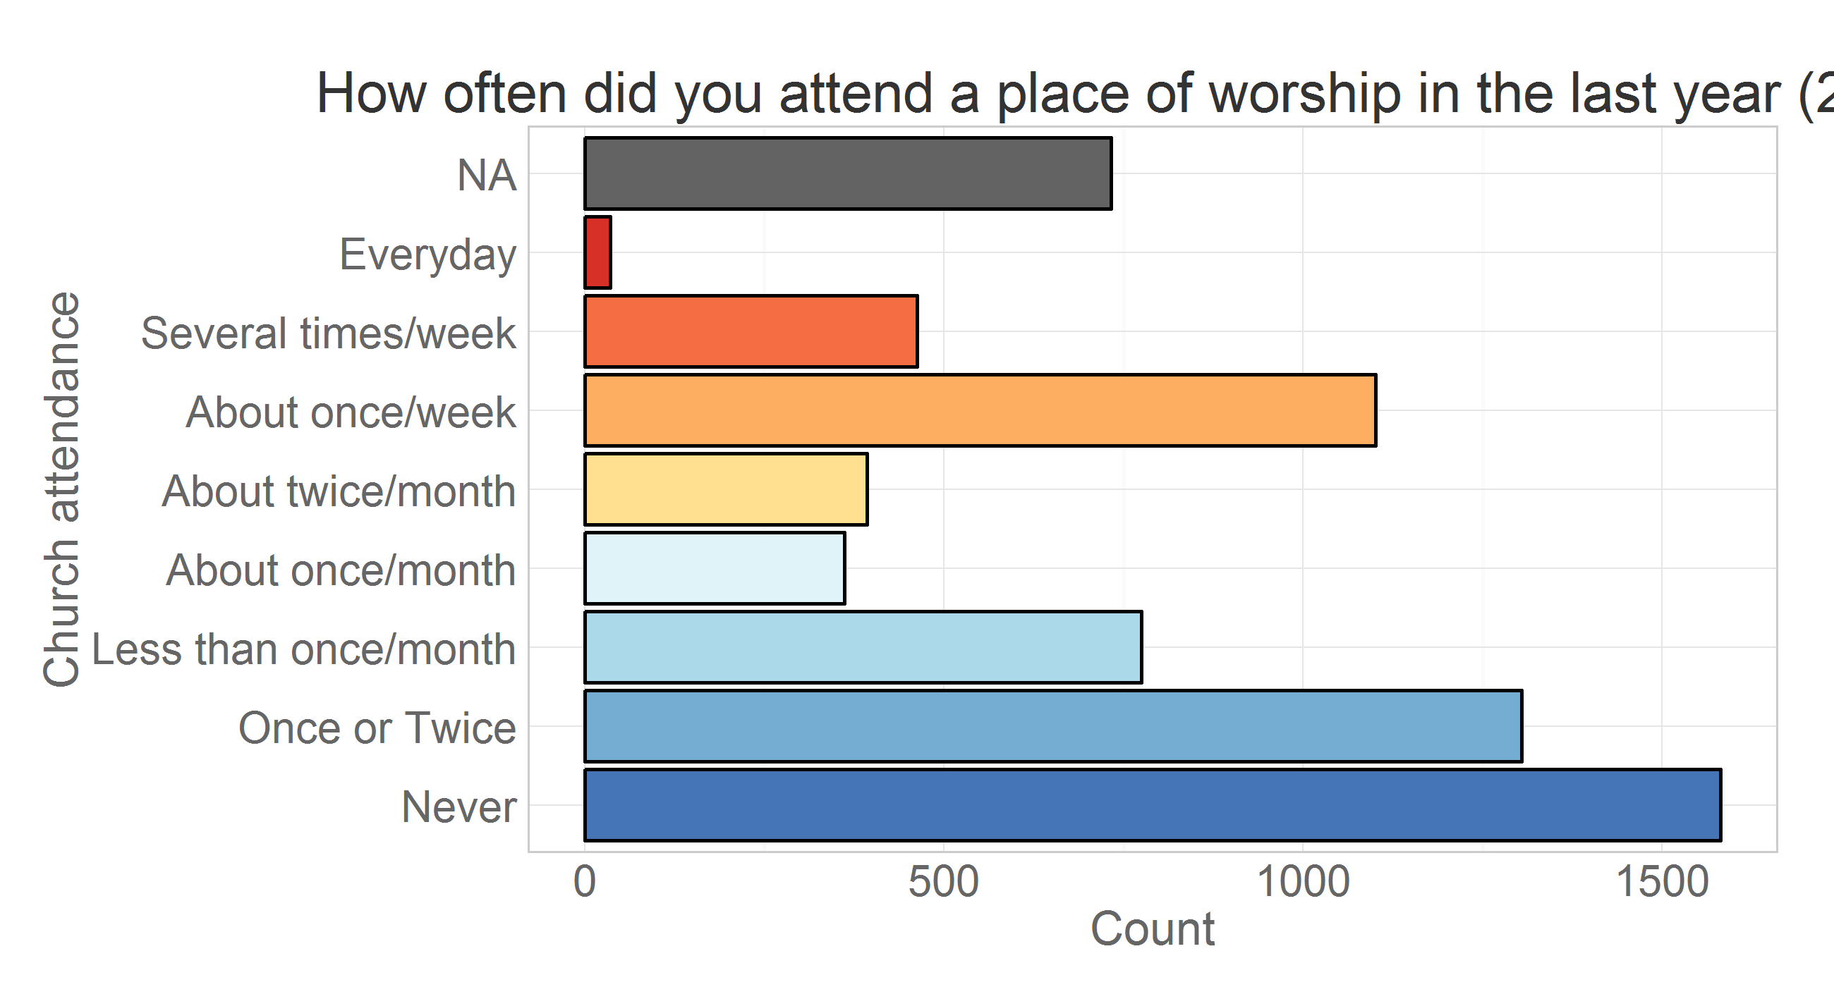

Creating frequency distributions for each of the measurement wave we have:  
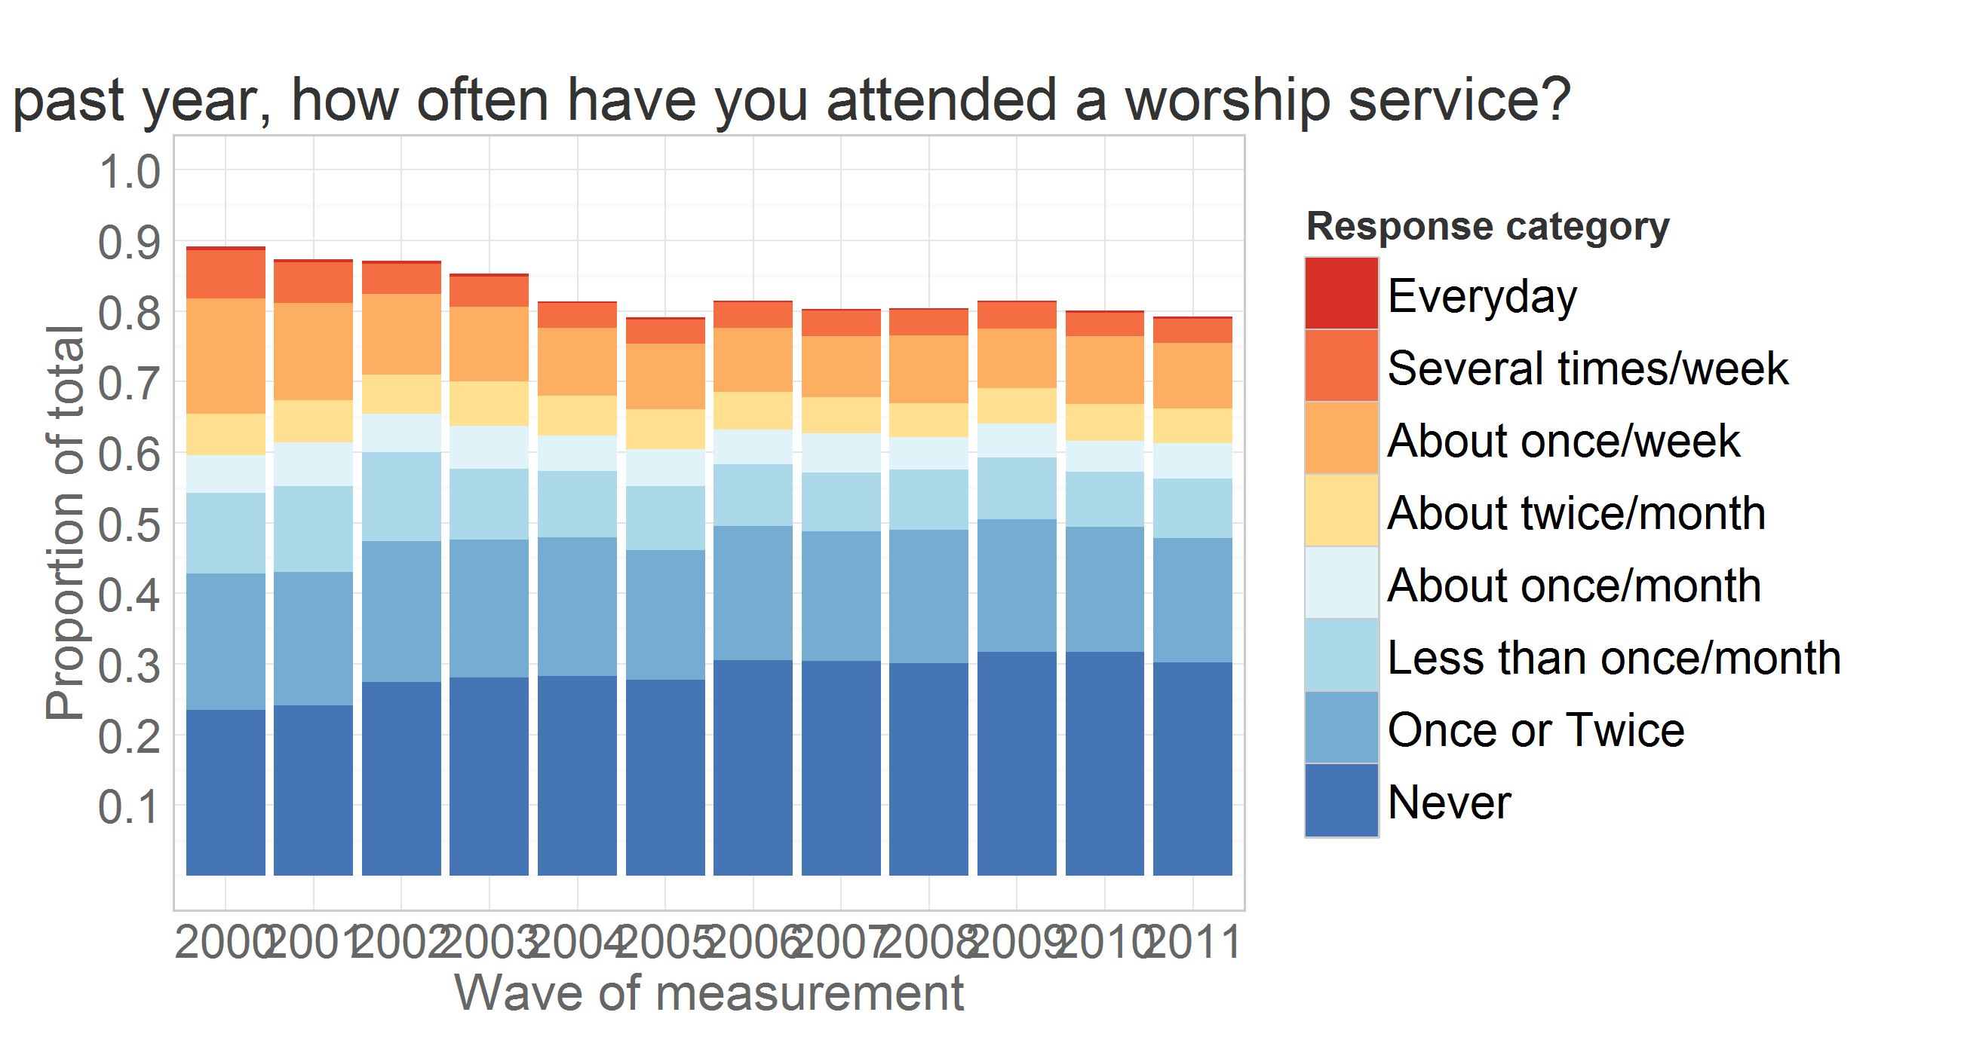

Missing values are used in the calculation of total responses to show the natural attrition in the study. Assumming that attrition is not significantly associated with the outcome measure, we can remove missing values from the calculation of the total and look at prevalence of endorsements over time.

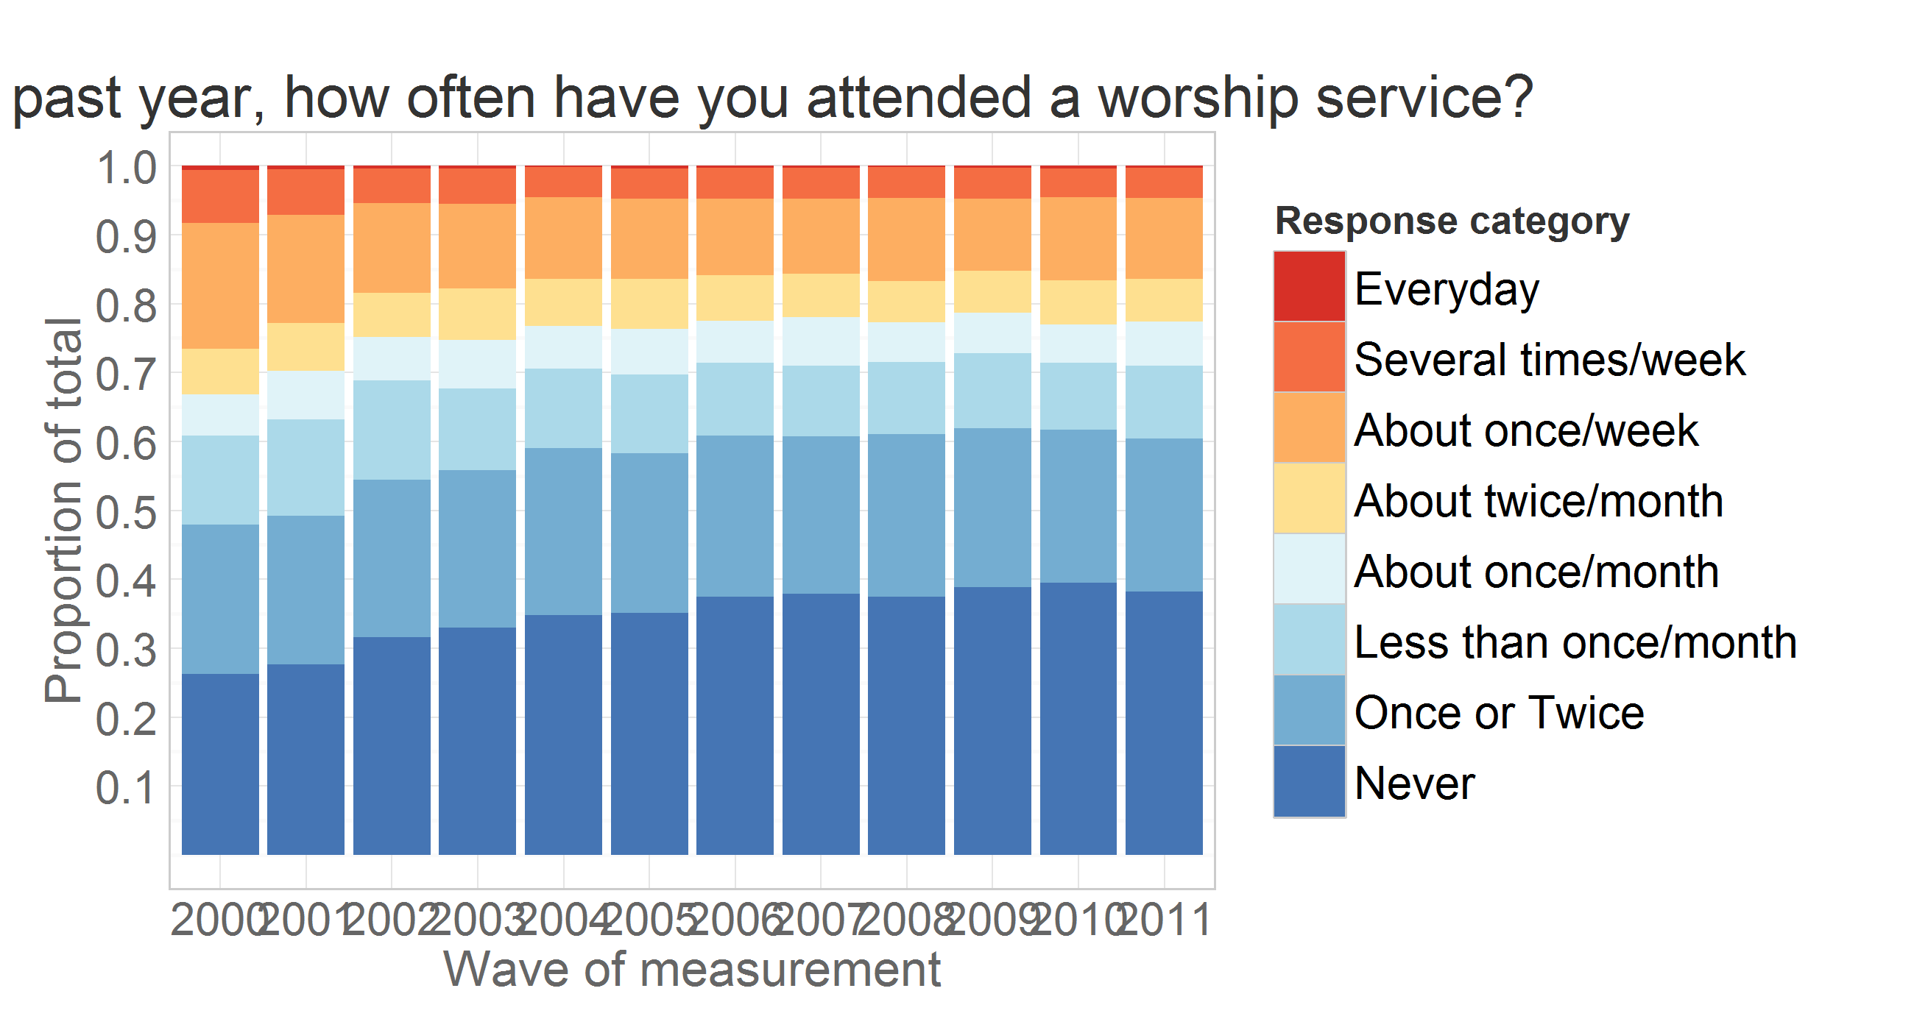 Tracing the rate of change of prevalence in a line graph, we see more clearly which categores increase over time (e.g. "Never"), which decline (e.g. ""About once/week), and which stay relatively stable (e.g. "About twice/month")

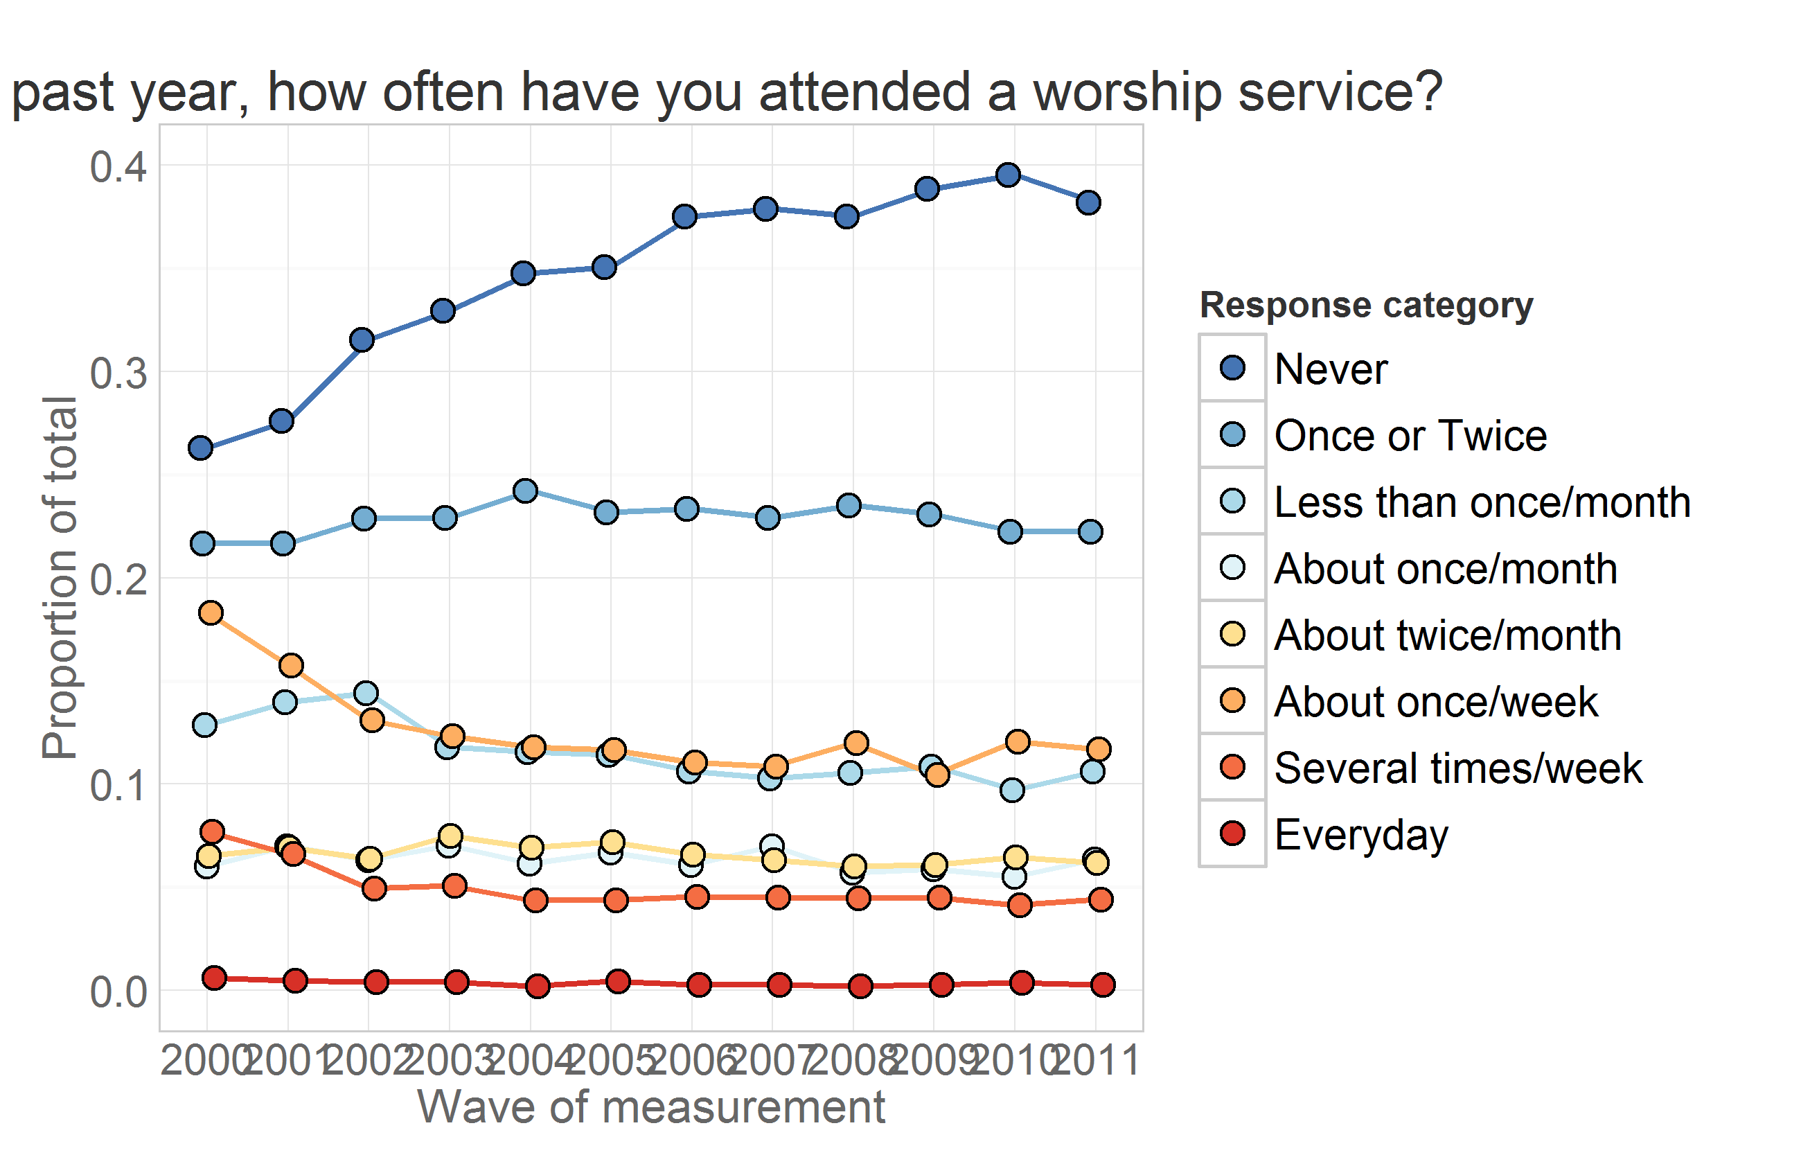

Graphs above shows change in the cross-sectional distribution of responses over the years. Modeling the change in these response frequencies is handled well by Markov models. LCM, however, works with longitudinal data, modeling the trajectory of each individual and treating attendance as a continuous outcome.

To demonstrate mapping of individual trajectories to time, let's select a dataset that would include personal identifyer (**id**), cohort indicator (**byear**), wave of measurement (**year**) and the focal variable of interest - worship attendance (**attend**).

ds<- dsL %>% dplyr::filter(year %in% c(2000:2011), id==47) %>%  
 dplyr:: select(id, byear, year, attend, attendF)  
print(ds)

id byear year attend attendF  
1 47 1982 2000 5 About twice/month  
2 47 1982 2001 2 Once or Twice  
3 47 1982 2002 4 About once/month  
4 47 1982 2003 2 Once or Twice  
5 47 1982 2004 3 Less than once/month  
6 47 1982 2005 2 Once or Twice  
7 47 1982 2006 2 Once or Twice  
8 47 1982 2007 3 Less than once/month  
9 47 1982 2008 2 Once or Twice  
10 47 1982 2009 1 Never  
11 47 1982 2010 1 Never  
12 47 1982 2011 1 Never

The view above lists attendance data for subjust with id = 47. Mapping his attendance to time we have  
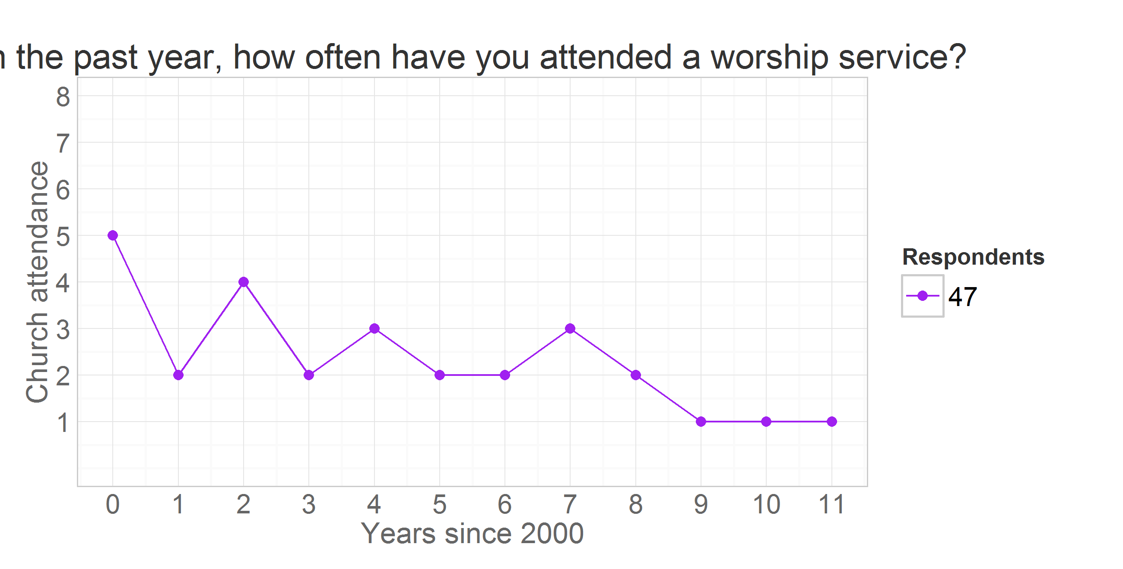

where vertical dimension maps the outcome value and the horizontal maps the time. There will be a trajecory for each of the

length(unique(dsL$id))

[1] 8984

subjects in total. Unless specified otherwise, only individuals from the cross-sample will be used in the model to increase external validity.

ds<- dsL %>% dplyr::filter(sample==1)

Each of such trajectories imply a story, a life scenario. Why one person grows in his religious involvement, while other declines, or never develops an interest in the first place? To demostrate how interpretations of trajectories can vary among individuals consider the following scenario.

Attendance trajectories of subjects with **id**s 4, 25, 35, and 47 are plotted in the next graph

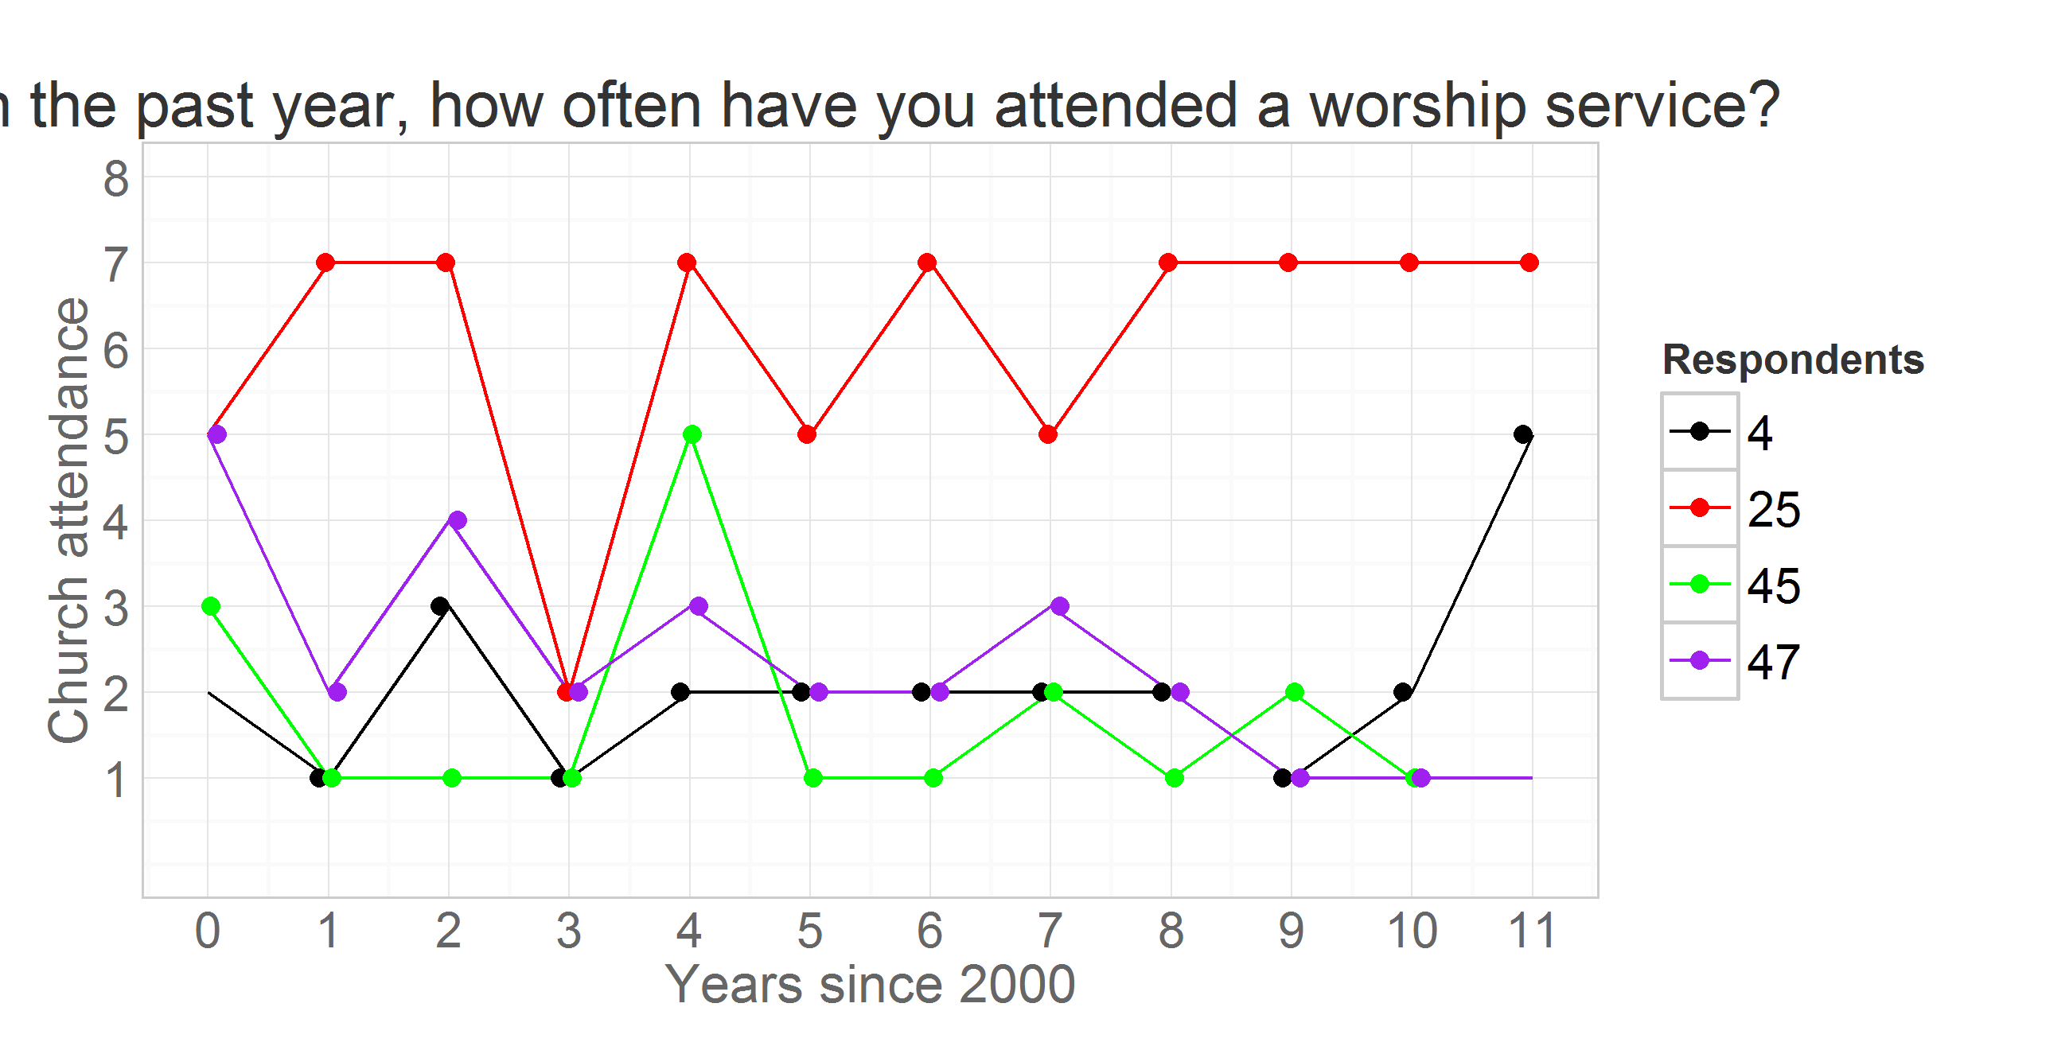

The respondent **id**=35 reported attending no worship services in any of the years, while respodent **id**=25 seemed to frequent it, indicating weekly attendance in 8 out of the 12 years. Individual **id**=47 started as a fairly regular attendee of religious services in 2000 (5= "about twice a month"), then gradually declined his involvement to nill in 2009 and on. Respondent **id**=4, on the other hand started off with a rather passive involvement, reporting attended church only "Once or twice" in 2000, maintained a low level of participation throughout the years, only to surge his attendance in 2011. Latent curve models will describe intraindividual trajectories of change, while summarizinig the interindividual similarities and trends.

Previous research in religiousity indicated that age might be one of the primary factors explaining interindividual differences in church attendance. To examine the role of age, we change the metric of time from waves of measurement, as in the previous graph, to biological age.

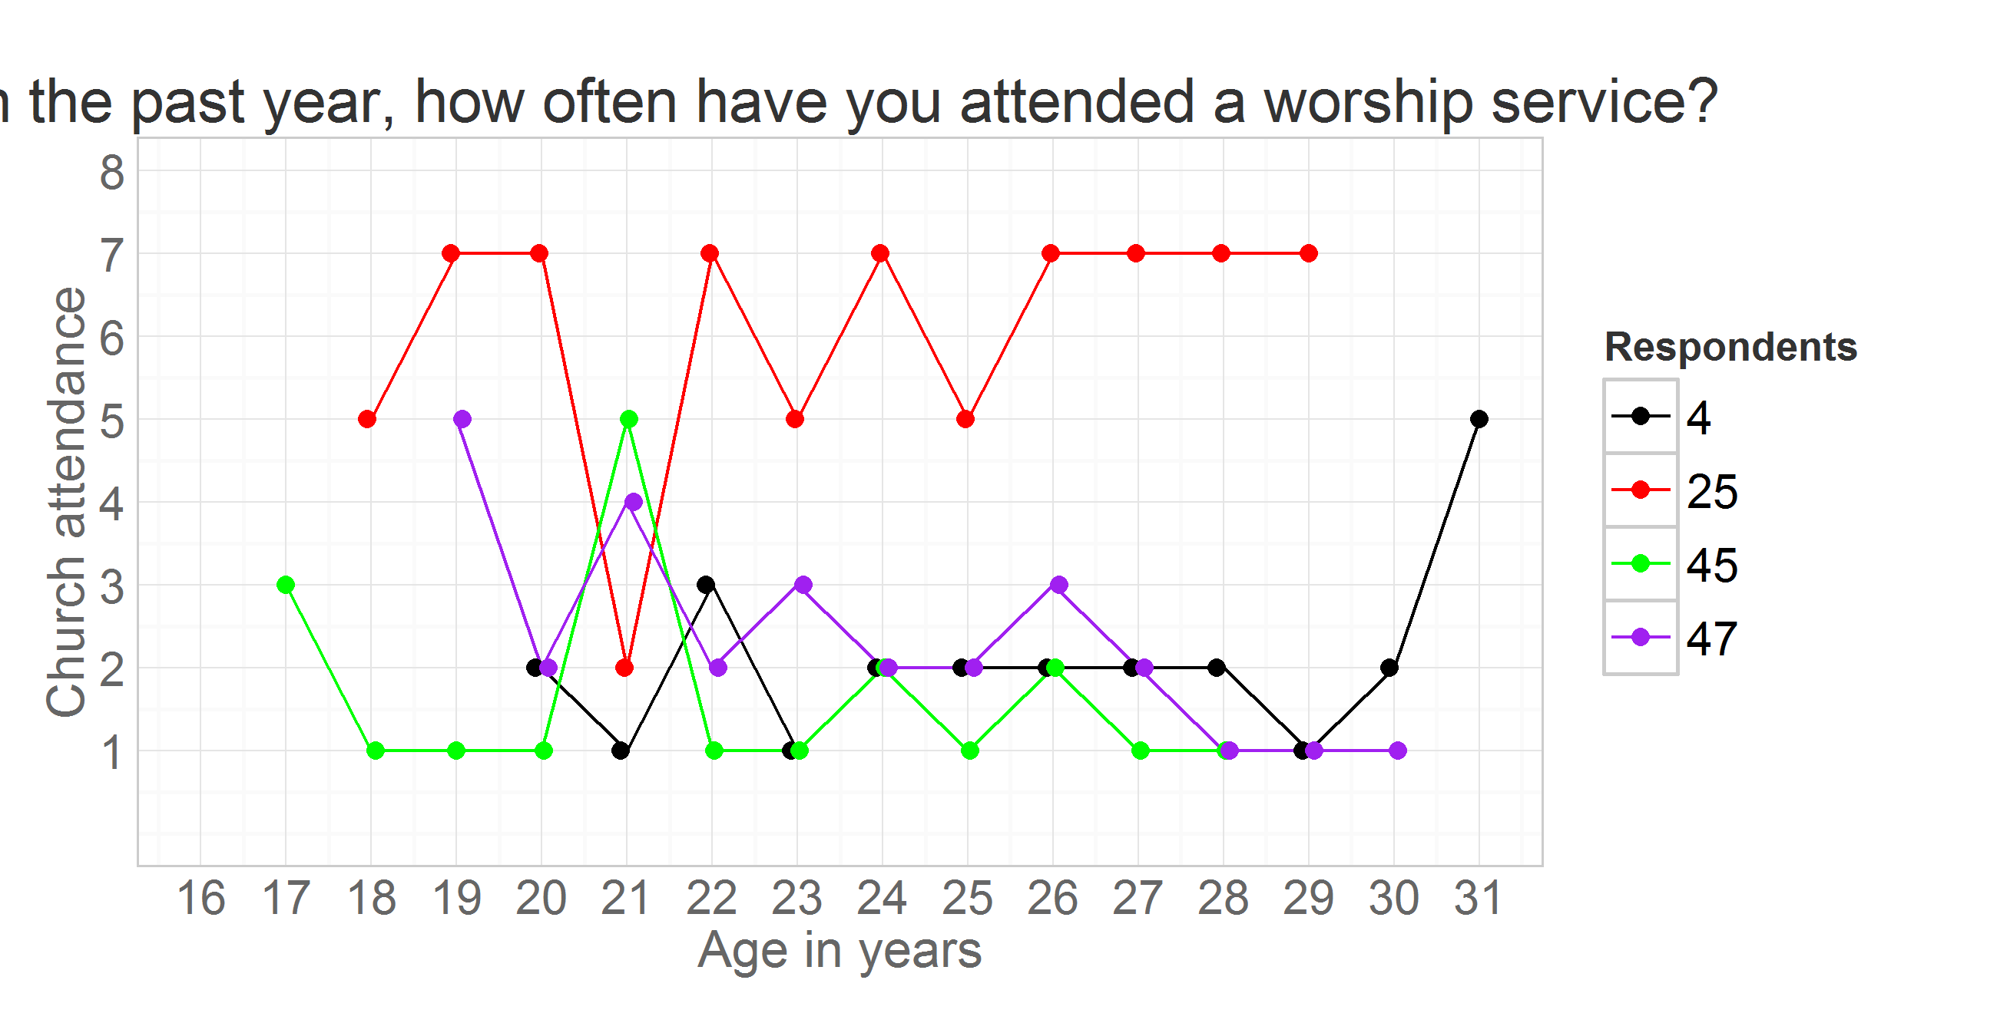

Persons **id** = 35 and **id** = 25 are peers, in 2000 they were both 17. Respondent **id** = 47 is a year older, in 2000 he was 18. The oldest is **id** = 4, who by the last round of measurement in 2011 is 30 years of age. Perhaps, his increased church attendance could be explained by starting a family of his own?

Note that for person **id** = 25 the age was recorded as 21 years for both 2003 and 2004. However, when you examine age in months (**agemon**) you can see this is rounding issue that disappears once a more precise scale is used. To avoid this potentially confusing peculiarity, age in years will be either calculated as (**age** = **year** - **byear**)

ds<- dsL %>% dplyr::filter(id %in% c(4,25,45,47),year %in% c(2000:2011)) %>%   
 dplyr::select(idF,year,attend,agemon,ageyear) %>%   
 mutate(time=year-2000, age=ageyear)  
head(ds,12)

idF year attend agemon ageyear time age  
1 4 2000 2 238 19 0 19  
2 4 2001 1 251 20 1 20  
3 4 2002 3 262 21 2 21  
4 4 2003 1 276 22 3 22  
5 4 2004 2 287 23 4 23  
6 4 2005 2 297 24 5 24  
7 4 2006 2 309 25 6 25  
8 4 2007 2 320 26 7 26  
9 4 2008 2 336 27 8 27  
10 4 2009 1 344 28 9 28  
11 4 2010 2 357 29 10 29  
12 4 2011 5 368 30 11 30

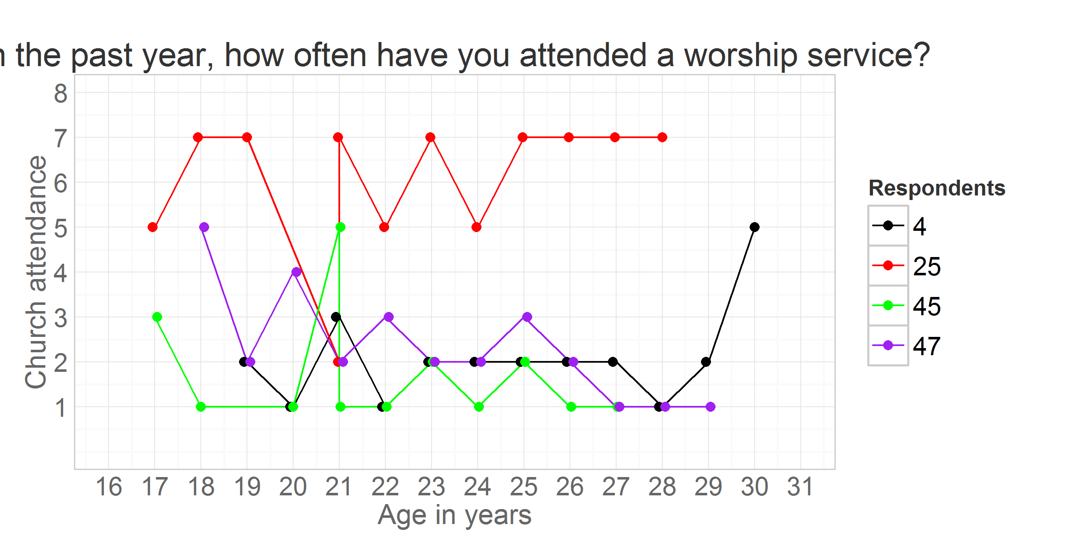

or as (**age** = **agemon**/12).

ds<- dsL %>% dplyr::filter(id %in% c(4,25,45,47),year %in% c(2000:2011)) %>%   
 dplyr::select(idF,year,attend,agemon,ageyear,byear) %>%   
 mutate(time=year-2000, age=agemon/12)  
head(ds,12)

idF year attend agemon ageyear byear time age  
1 4 2000 2 238 19 1981 0 19.83  
2 4 2001 1 251 20 1981 1 20.92  
3 4 2002 3 262 21 1981 2 21.83  
4 4 2003 1 276 22 1981 3 23.00  
5 4 2004 2 287 23 1981 4 23.92  
6 4 2005 2 297 24 1981 5 24.75  
7 4 2006 2 309 25 1981 6 25.75  
8 4 2007 2 320 26 1981 7 26.67  
9 4 2008 2 336 27 1981 8 28.00  
10 4 2009 1 344 28 1981 9 28.67  
11 4 2010 2 357 29 1981 10 29.75  
12 4 2011 5 368 30 1981 11 30.67

